UNIT 1 · LESSON 5 STANDARD 5.OA.B.3

Math is Finding Patterns
Student Notes Packet
Name: ______________________ Date: ____________ Period: ________
Level 1 · Support

Today's Goals
Content: I can find patterns and pattern rules, use them to make generalizations, and check my solutions with a table of values.
Language: I can describe a pattern using the words pattern rule, generalization, and 'each number is ___ more than the one before it.'

Key Vocabulary
Look at the picture, read the word, then read what it means.
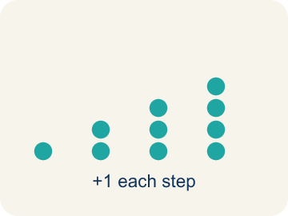 | pattern patrón  Something that repeats or changes in a predictable way.  Example: 1, 3, 7, 15, 31 — each tower's steps follow a predictable jump.
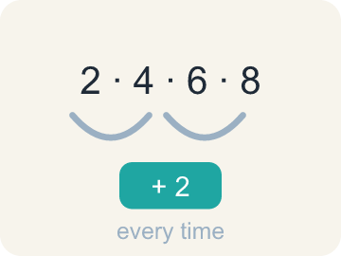 | pattern rule regla del patrón  The instruction that tells how to get from one number in a pattern to the next.  Example: 2, 4, 6, 8 … the rule is “+ 2 every time”.
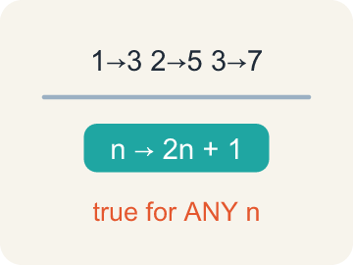 | generalization generalización  A statement that is true for a whole pattern, made by noticing repeated calculations.  Example: 1 → 3, 2 → 5, 3 → 7 … so n → 2n + 1, for ANY n.
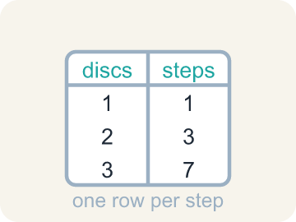 | table of values tabla de valores  A table that lists each step of a pattern so you can check that a solution is reasonable.  Example: discs 1, 2, 3 beside steps 1, 3, 7 — one row per step.
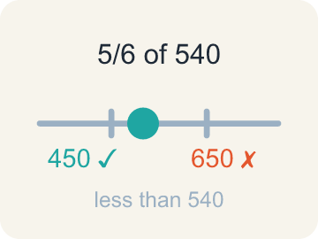 | reasonableness sensatez del resultado  Whether an answer makes sense — checked as you work, with adjustments made when needed.  Example: 5/6 of 540 should land BELOW 540, so 650 fails the check.

Guided Notes
Fill in each blank as we go. Use the Word Bank to help you.
WORD BANK
pattern • pattern rule • generalization • table of values • reasonableness

1. Something that repeats or changes in a predictable way is a ________________.
2. The instruction for getting from one term to the next is the ________________ ________________.
3. A statement true for a whole pattern, not just the cases you tried, is a ________________.
4. A table listing each step of a pattern in order is a ________________ ________________ ________________.
5. Whether an answer makes sense, checked as you work, is its ________________.

Write About the Math
Use the support level you need. Every level answers the same math question.

1. Understand the Question justify
How can pattern rules tell you how many points each player has after the streak — and how can a table of values prove your answer is reasonable?
Your job: Answer the question. Use math evidence. Explain how the evidence proves your answer.
Responde la pregunta. Usa evidencia matemática. Explica cómo la evidencia demuestra tu respuesta.

2. Plan Your Math Words check at least two
☐ pattern — Something that repeats or changes in a predictable way.
patrón — Algo que se repite o cambia de una manera predecible.
☐ pattern rule — The instruction that tells how to get from one number in a pattern to the next.
regla del patrón — La instrucción que dice cómo pasar de un número del patrón al siguiente.
☐ generalization — A statement that is true for a whole pattern, made by noticing repeated calculations.
generalización — Una afirmación verdadera para todo un patrón, hecha al notar cálculos repetidos.
☐ table of values — A table that lists each step of a pattern so you can check that a solution is reasonable.
tabla de valores — Una tabla que muestra cada paso de un patrón para comprobar que una solución es razonable.
☐ reasonableness — Whether an answer makes sense — checked as you work, with adjustments made when needed.
sensatez del resultado — Si una respuesta tiene sentido — se comprueba mientras trabajas y se ajusta cuando es necesario.
Say it first: Say your idea to a partner or quietly to yourself before you write.
Player A's pattern rule leads to a final score of ___ points. Player B's pattern rule leads to a final score of ___ points. Creating a ___ of values that checks each step confirms both totals are correct.
Di tu respuesta primero: Mi respuesta es ___ porque ___.

3. Build Your Explanation choose your support
This model shows the parts of an explanation. It does not answer your writing question.
Claim: The lesson distinguishes patterns that keep going (like coin value scaling) from one-time facts (like the jar's specific total).
Evidence: A strong answer explains a pattern applies to any number of coins (it generalizes), while a fact like $53.50 is fixed to this one jar. A weak answer just labels each card without explaining the difference.
Reasoning: This evidence connects the definition of pattern to the mathematical claim.

Start Most language support
Complete the frames. Use the word bank.
Completa las oraciones. Usa el banco de palabras.
Player A's pattern rule leads to a final score of ___ points. Player B's pattern rule leads to a final score of ___ points. Creating a ___ of values that checks each step confirms both totals are correct.
My answer is ___.
Mi respuesta es ___.

Build Some language support
Write two connected sentences. Use because, so, or but.
Escribe dos oraciones conectadas. Usa porque, entonces o pero.
My claim is ___.
Mi afirmación es ___.
I know because ___.
Lo sé porque ___.
So ___.
Entonces ___.

Explain Light language support
Write a claim, give math evidence, and explain your reasoning.
Escribe una afirmación, da evidencia matemática y explica tu razonamiento.
My claim is ___.
Mi afirmación es ___.
My math evidence is ___.
Mi evidencia matemática es ___.
This proves ___ because ___.
Esto demuestra ___ porque ___.

4. Check Your Explanation five quick checks
☐ I answered the question.
Respondí la pregunta.
☐ I used math evidence: numbers, an equation, a model, or a comparison.
Usé evidencia matemática: números, una ecuación, un modelo o una comparación.
☐ I explained how the evidence proves my answer.
Expliqué cómo la evidencia demuestra mi respuesta.
☐ I used at least two math words.
Usé por lo menos dos palabras matemáticas.
☐ I reread complete sentences and punctuation.
Volví a leer mis oraciones completas y la puntuación.

Worked Example

Watch & Read I Do — follow along with your teacher
Unit 1 · Lesson 5
Akela's change jar is full of pennies, nickels, dimes, and quarters. The value of the coins is $53.50. How many of each coin could be in the jar? There is more than one answer — and patterns are the way in.

Solved Example I Do — watch each step
Problem: Each penny has a value of $0.01. What is the value of 100 pennies?
A) $1.00
B) $0.10
C) $10.00
D) $100.00
Step 1: 100 × $0.01 = $1.00 — one hundred hundredths make one whole dollar.
Answer: A. $1.00

Guided Practice

Solve Together We Do — work with your class
Problem: Each quarter has a value of $0.25. Following the pattern, what is the value of 100 quarters?
A) $25.00
B) $2.50
C) $250.00
D) $100.25
Step 1:

Step 2:

Answer:

Two basketball players make 10 shots in a row after scoring some points. Player A had scored 18 points before making 10 two-pointers in a row. Player B had 6 points before scoring 10 three-pointers in a row.
How can pattern rules tell you how many points each player has after the streak — and how can a table of values prove your answer is reasonable?

Sentence frame: Player A's pattern rule leads to a final score of ___ points. Player B's pattern rule leads to a final score of ___ points. Creating a ___ of values that checks each step confirms both totals are correct.

Turn & Talk discuss with a partner
1. [Launch] Akela's change jar has coins worth $53.50. Why is 'every 100 of a coin is worth 100 times one coin's value' a pattern, while 'Akela's jar holds $53.50' is not?
Start with: This is a pattern because it works for ___ amount of coins.
Esto es un patrón porque funciona para ___ cantidad de monedas.
Word bank: Pattern, Generalization, One-time fact
2. [Explore] The whale card was tricky: 'a sei whale measures 4.5 meters at birth' is a starting value, and the growth pattern adds about 2.5 centimeters each day. Why does a pattern need BOTH a starting value and a rule?
Start with: The starting value is ___, and the rule is ___.
El valor inicial es ___, y la regla es ___.
Word bank: Starting value, Rule, Predict
3. [Connect] Player A had 18 points before making 10 two-pointers in a row. What pattern rule tells you Player A's final score, and how could a table prove it?
Start with: Player A's pattern rule leads to a final score of ___ points.
La regla del patrón de la Jugadora A lleva a un puntaje final de ___ puntos.
Word bank: Pattern rule, Table, Add
4. [Practice] During practice, one problem asked for the value of 100 pennies. What pattern did you use to find $1.00?
Start with: I used the pattern that 100 coins is ___ times one coin's value.
Usé el patrón de que 100 monedas son ___ veces el valor de una moneda.
Word bank: Pattern, Value, Multiply

Independent Practice

On Your Own You Do — show your work
Solve each problem. Show your thinking in the work box.

Level 1 Support extra scaffolding
1. Player A scores a two-pointer on every shot. What is Player A's pattern rule?
A) Add 2
B) Add 3
C) Multiply by 2
D) Add 18

2. Player B had 6 points, then made 10 three-pointers in a row. How many points does Player B have now?
A) 36
B) 16
C) 30
D) 9

3. Name a pattern you noticed in the coin values, and how it could help you count money faster.
4. Where do you look for a pattern first when a problem feels too big to count?

Exit Ticket
Answer on your own. This shows what you learned today.
★ Which statement best captures what this lesson means by 'Math is Finding Patterns'?
A) We look for patterns and relationships, use them to solve problems and make generalizations, and check our solutions for reasonableness
B) Patterns are decorations that make problems look nicer
C) A pattern rule only works if you also count every item one at a time
D) Once you spot a pattern you never need to check your answer

