1.4–1.6 Catch-Up — Homework
Lesson 1-6-catchup • Standard MPP.3
Name: ______________________ Period: ______ Date: ____________

Today's Goals
Content: I can show I am caught up on Lessons 1.4–1.6 by using each lesson's big idea in mixed practice.
Language: I can explain which lesson's big idea I used and how, using key vocabulary from Lessons 1.4–1.6.

Key Words
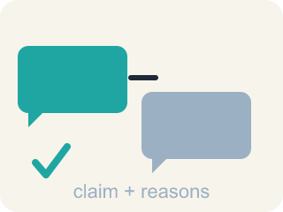
argument (argumento) — A chain of reasons — equations, drawings, or words — used to defend your thinking.
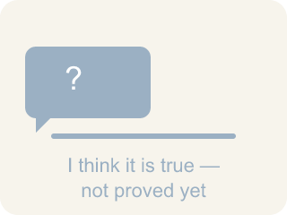
conjecture (conjetura) — A mathematical statement you believe is true but have not yet proven.
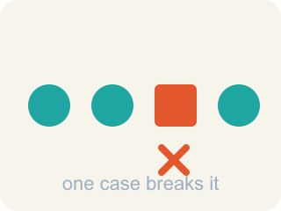
counterexample (contraejemplo) — A single example that shows a statement is not always true.

volume (volumen) — The amount of space a solid figure takes up, measured in cubic units.
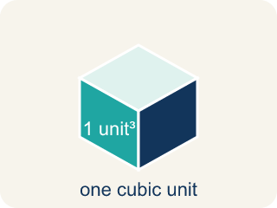
cubic unit (unidad cúbica) — A cube with edges 1 unit long — the unit used to measure volume.
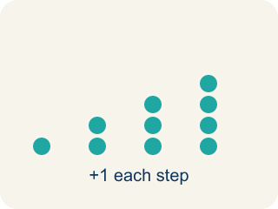
pattern (patrón) — Something that repeats or changes in a predictable way.
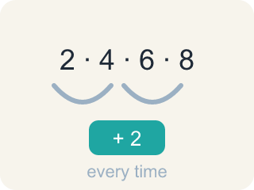
pattern rule (regla del patrón) — The instruction that tells how to get from one number in a pattern to the next.
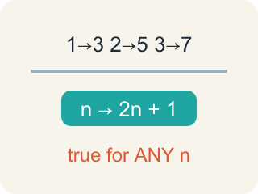
generalization (generalización) — A statement that is true for a whole pattern, made by noticing repeated calculations.

make sense of a problem (comprender un problema) — To figure out what a problem is asking — what you know, and what you don't know yet.
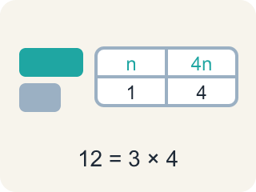
representation (representación) — A way of showing a problem — a drawing, table, equation, or model — that helps you see it.

Practice
Show your work. Use the blank space under each problem.
1. (Lesson 1.4) An egg muffin is about 60 calories. A plate holds 4 egg muffins. About how many calories are on the plate?
A. About 240
B. About 64
C. About 15
D. About 600
______________________________________________________________________
2. (Lesson 1.4) A large cereal box is 8 in long, 3 in wide, and 10 in tall. What is its volume?
A. 240 cubic inches
B. 21 cubic inches
C. 80 cubic inches
D. 240 square inches
______________________________________________________________________
3. (Lesson 1.4) Three large boxes hold 240 cubic inches each. Two jumbo boxes hold 400 cubic inches each. Which is the correct volume comparison?
A. 720 cubic inches vs. 800 cubic inches — the jumbo option holds more
B. 720 cubic inches vs. 800 cubic inches — the large option holds more
C. 240 cubic inches vs. 400 cubic inches — the jumbo option holds more
D. 480 cubic inches vs. 800 cubic inches — the jumbo option holds more
______________________________________________________________________
4. (Lesson 1.4) One garden bed is 4 ft long, 3 ft wide, and 2 ft deep. A second bed is 6 ft long, 2 ft wide, and 2 ft deep. How much soil fills BOTH beds?
A. 48 cubic feet
B. 24 cubic feet
C. 19 cubic feet
D. 96 cubic feet
______________________________________________________________________
5. (Lesson 1.5) Player A had 18 points before making 10 two-pointers in a row. How many points does Player A have after the streak?
A. 38
B. 28
C. 20
D. 48
______________________________________________________________________
6. (Lesson 1.5) Akela's jar totals $53.50. Why can the number of pennies only be a multiple of 5?
A. Because the total's cents end in 0, and only pennies make amounts that aren't multiples of 5 cents
B. Because pennies always come in rolls of 5
C. Because there are exactly 5 kinds of coins in the jar
D. Because $53.50 is divisible by 5
______________________________________________________________________
7. (Lesson 1.6) You are solving a problem and realize your strategy is not making progress. What does the problem-solving process say to do?
A. Notice your progress has stalled and shift to a different strategy
B. Keep using the same strategy no matter what
C. Erase everything and decide the problem is impossible
D. Copy a classmate's paper
______________________________________________________________________
8. (Lesson 1.6) The first rack has 16 wheels and the other rack has 6 times as many. How many BIKES does the bigger rack hold, if every bike has 2 wheels?
A. 48
B. 96
C. 24
D. 192
______________________________________________________________________

Answer Key (Teacher)
1. A. About 240
4 muffins at about 60 calories each is 60 × 4 = 240 calories.
Watch for: Treating 'stuck' as a stop sign instead of a signal — waiting silently instead of trying a strategy: asking a question, drawing the problem, or recalling a similar problem.
2. A. 240 cubic inches
Volume of a rectangular prism is length × width × height: 8 × 3 × 10 = 240 cubic inches.
Watch for: Treating 'stuck' as a stop sign instead of a signal — waiting silently instead of trying a strategy: asking a question, drawing the problem, or recalling a similar problem.
3. A. 720 cubic inches vs. 800 cubic inches — the jumbo option holds more
240 × 3 = 720 and 400 × 2 = 800; since 800 > 720, the two jumbo boxes hold more in total.
Watch for: Treating 'stuck' as a stop sign instead of a signal — waiting silently instead of trying a strategy: asking a question, drawing the problem, or recalling a similar problem.
4. A. 48 cubic feet
First bed: 4 × 3 × 2 = 24 cubic feet. Second bed: 6 × 2 × 2 = 24 cubic feet. Together: 24 + 24 = 48 cubic feet.
Watch for: Treating 'stuck' as a stop sign instead of a signal — waiting silently instead of trying a strategy: asking a question, drawing the problem, or recalling a similar problem.
5. A. 38
Ten two-pointers add 10 × 2 = 20 points, and 18 + 20 = 38 points.
Watch for: Treating 'stuck' as a stop sign instead of a signal — waiting silently instead of trying a strategy: asking a question, drawing the problem, or recalling a similar problem.
6. A. Because the total's cents end in 0, and only pennies make amounts that aren't multiples of 5 cents
Nickels, dimes, and quarters are each worth a multiple of 5 cents. For the total to land on a 0, the pennies must also add up to a multiple of 5 cents — so their count is a multiple of 5.
Watch for: Treating 'stuck' as a stop sign instead of a signal — waiting silently instead of trying a strategy: asking a question, drawing the problem, or recalling a similar problem.
7. A. Notice your progress has stalled and shift to a different strategy
We are aware of our progress in solving the problem and shift strategies when needed.
Watch for: Treating 'stuck' as a stop sign instead of a signal — waiting silently instead of trying a strategy: asking a question, drawing the problem, or recalling a similar problem.
8. A. 48
The bigger rack has 16 × 6 = 96 wheels, and 96 ÷ 2 = 48 bikes.
Watch for: Treating 'stuck' as a stop sign instead of a signal — waiting silently instead of trying a strategy: asking a question, drawing the problem, or recalling a similar problem.

