UNIT 1 · LESSON 6 STANDARD MPP.3

Math is Ours
Student Notes Packet
Name: ______________________ Date: ____________ Period: ________
Level 2 · Standard

Today's Goals
Content: I can describe my problem-solving process, name strategies for getting unstuck, and identify the behaviors that make our class a community of math thinkers.
Language: I can talk about problem solving using the phrases make sense of, get stuck, try a strategy, and work together.

Key Vocabulary
Look at the picture, read the word, then read what it means.
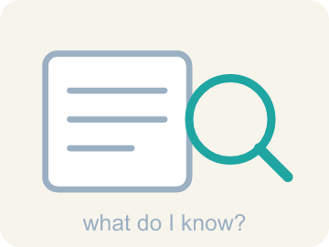 | make sense of a problem comprender un problema  To figure out what a problem is asking — what you know, and what you don't know yet.  Example: KNOW: 16 wheels, 6 times as many. DON'T KNOW: how many bikes.
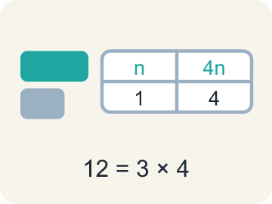 | representation representación  A way of showing a problem — a drawing, table, equation, or model — that helps you see it.  Example: The same 12 shown three ways: a tape diagram, a table, and 3 × 4.
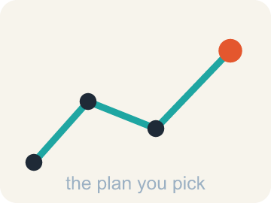 | strategy estrategia  A plan of attack for a problem — and something you can switch when you get stuck.  Example: “I will draw a tape diagram first, then divide” — chosen before computing.
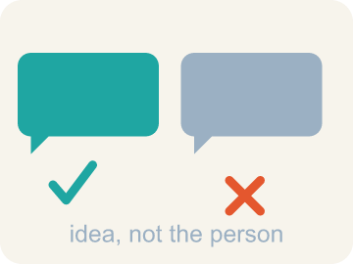 | critique criticar constructivamente  To examine an idea and say what is convincing or not — about the idea, never about the person.  Example: “That step assumes the boxes are full — how do we know?”
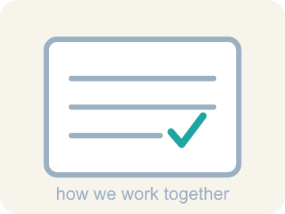 | community agreement acuerdo comunitario  A rule the whole class agrees to so that everyone can learn together.  Example: “We take turns sharing, and we critique ideas, not people.”

Guided Notes
Fill in each blank as we go. Use the Word Bank to help you.
WORD BANK
make sense of a problem • representation • strategy • critique • community agreement

1. To work out what a problem asks — what you know and don't — is to ________________ ________________ ________________ ________________ ________________.
2. A drawing, table, or equation that shows the math in a situation is a ________________.
3. The plan you choose before you start computing is your ________________.
4. To examine an idea and say what is or is not convincing is to ________________ it.
5. A rule the whole class agrees to so everyone can learn is a ________________ ________________.

Write About the Math
Use the support level you need. Every level answers the same math question.

1. Understand the Question explain
What ideas do you recommend that the whole class agrees to so that math class is a community of learners?
Your job: Answer the question. Use math evidence. Explain how the evidence proves your answer.
Responde la pregunta. Usa evidencia matemática. Explica cómo la evidencia demuestra tu respuesta.

2. Plan Your Math Words check at least two
☐ make sense of a problem — To figure out what a problem is asking — what you know, and what you don't know yet.
comprender un problema — Descubrir qué pide un problema: qué sabes y qué no sabes todavía.
☐ representation — A way of showing a problem — a drawing, table, equation, or model — that helps you see it.
representación — Una forma de mostrar un problema — un dibujo, una tabla, una ecuación o un modelo — que te ayuda a verlo.
☐ strategy — A plan of attack for a problem — and something you can switch when you get stuck.
estrategia — Un plan para atacar un problema — y algo que puedes cambiar cuando te atascas.
☐ critique — To examine an idea and say what is convincing or not — about the idea, never about the person.
criticar constructivamente — Examinar una idea y decir qué es convincente o no — sobre la idea, nunca sobre la persona.
☐ community agreement — A rule the whole class agrees to so that everyone can learn together.
acuerdo comunitario — Una norma que toda la clase acepta para que todos puedan aprender juntos.
Say it first: Say your idea to a partner or quietly to yourself before you write.
Propose a class agreement for working ___, and another for working alone, based on showing ___ for classmates. State each idea as a clear class ___ that helps everyone learn.
Di tu respuesta primero: Mi respuesta es ___ porque ___.

3. Build Your Explanation choose your support
This model shows the parts of an explanation. It does not answer your writing question.
Claim: The rack with 8 bikes has 8 × 2 = 16 wheels, and the second rack has 6 times as many wheels as that.
Evidence: A strong answer names a specific first move (like finding 8×2=16 before tackling '6 times as many') rather than jumping to the final answer. A weak answer just states a number with no process described.
Reasoning: This evidence connects the definition of make sense of a problem to the mathematical claim.

Start Most language support
Complete the frames. Use the word bank.
Completa las oraciones. Usa el banco de palabras.
Propose a class agreement for working ___, and another for working alone, based on showing ___ for classmates. State each idea as a clear class ___ that helps everyone learn.
My answer is ___.
Mi respuesta es ___.

Build Some language support
Write two connected sentences. Use because, so, or but.
Escribe dos oraciones conectadas. Usa porque, entonces o pero.
My claim is ___.
Mi afirmación es ___.
I know because ___.
Lo sé porque ___.
So ___.
Entonces ___.

Explain Light language support
Write a claim, give math evidence, and explain your reasoning.
Escribe una afirmación, da evidencia matemática y explica tu razonamiento.
My claim is ___.
Mi afirmación es ___.
My math evidence is ___.
Mi evidencia matemática es ___.
This proves ___ because ___.
Esto demuestra ___ porque ___.

4. Check Your Explanation five quick checks
☐ I answered the question.
Respondí la pregunta.
☐ I used math evidence: numbers, an equation, a model, or a comparison.
Usé evidencia matemática: números, una ecuación, un modelo o una comparación.
☐ I explained how the evidence proves my answer.
Expliqué cómo la evidencia demuestra mi respuesta.
☐ I used at least two math words.
Usé por lo menos dos palabras matemáticas.
☐ I reread complete sentences and punctuation.
Volví a leer mis oraciones completas y la puntuación.

Worked Example

Watch & Read I Do — follow along with your teacher
Unit 1 · Lesson 6
What is math? This lesson's answer: math is about DOING — solving problems, getting stuck, trying again, and doing it together. Think about the last time you worked with someone to solve a math problem. What did you actually do?

Solved Example I Do — watch each step
Problem: A bicycle rack holds 8 bikes, and each bike has 2 wheels. How many wheels are on the rack?
A) 16
B) 10
C) 4
D) 82
Step 1: 8 bikes with 2 wheels each is 8 × 2 = 16 wheels.
Answer: A. 16

Guided Practice

Solve Together We Do — work with your class
Problem: Another bicycle rack has 6 times as many wheels as the rack with 16 wheels. About how many wheels does it have?
A) About 96
B) About 22
C) About 66
D) About 616
Step 1:

Step 2:

Answer:

Communities often have agreements that all members agree to in order to be part of the community. Our math class is a community of thinkers and doers — when we work together we listen attentively, share our thinking, respect others' ideas, critique ideas (not classmates), and take turns. When we work alone we stay focused, seek help when stuck, and respect classmates' boundaries.
What ideas do you recommend that the whole class agrees to so that math class is a community of learners?

Sentence frame: Propose a class agreement for working ___, and another for working alone, based on showing ___ for classmates. State each idea as a clear class ___ that helps everyone learn.

Turn & Talk discuss with a partner
1. [Launch] One bike rack holds 8 bikes with 2 wheels each, and another rack has 6 times as many wheels. Think about the last time you worked with someone to solve a problem like this — what did you actually DO first?
Start with: The first rack has ___ wheels because ___.
El primer estante tiene ___ ruedas porque ___.
Word bank: Make sense, Plan, Wheels
2. [Explore] You sorted moves like 'look for patterns' as making-sense moves and 'ask a classmate a question' as getting-unstuck moves. Why are BOTH columns considered real math, not just the planning column?
Start with: This move belongs in ___ because ___.
Este movimiento pertenece a ___ porque ___.
Word bank: Getting unstuck, Making sense, Strategy
3. [Connect] Our class is a community of thinkers and doers. What class agreement would you propose for working together, and how does it show respect for classmates?
Start with: My proposed agreement for working together is ___.
Mi propuesta de acuerdo para trabajar juntos es ___.
Word bank: Agreement, Respect, Critique ideas
4. [Practice] During practice on the bike rack problem, what strategy did you use when '6 times as many' felt tricky?
Start with: I found the total by first ___, then ___.
Encontré el total primero al ___, y luego ___.
Word bank: Times as many, Multiply, Plan

Independent Practice

On Your Own You Do — show your work
Solve each problem. Show your thinking in the work box.

On Level grade-level practice
1. You are solving a problem and realize your strategy is not making progress. What does the problem-solving process say to do?
A) Notice your progress has stalled and shift to a different strategy
B) Keep using the same strategy no matter what
C) Erase everything and decide the problem is impossible
D) Copy a classmate's paper

2. The first rack has 16 wheels and the other rack has 6 times as many. How many BIKES does the bigger rack hold, if every bike has 2 wheels?
A) 48
B) 96
C) 24
D) 192

3. Describe your problem-solving process in order, from reading the problem to checking your answer. Use at least three steps from this lesson.
4. What part of problem solving is easy for you? What part is challenging?
5. You are working on your own and get stuck. Which move follows BOTH parts of our working-alone agreements?
A) Try a get-unstuck strategy first, then quietly ask for help without interrupting classmates unnecessarily
B) Immediately call across the room to a friend
C) Sit silently for the rest of class without seeking help
D) Take a classmate's paper to see their work

6. What skills and knowledge do you bring to a group that help the group be successful?

Exit Ticket
Answer on your own. This shows what you learned today.
★ Which statement best captures what this lesson means by 'Math is Ours'?
A) We are a community of math thinkers and doers — we work together and on our own, showing respect for our classmates, our community, ourselves, and our math ideas
B) Math belongs to whoever finishes first
C) Working together means one person solves while the others watch
D) Getting stuck means math is not for you

