UNIT 1 · LESSON 6 STANDARD MPP.3

Math is Ours
Student Notes Packet
Name: ______________________ Date: ____________ Period: ________
Level 3 · Enrichment

Today's Goals
Content: I can describe my problem-solving process, name strategies for getting unstuck, and identify the behaviors that make our class a community of math thinkers.
Language: I can talk about problem solving using the phrases make sense of, get stuck, try a strategy, and work together.

Key Vocabulary
Look at the picture, read the word, then read what it means.
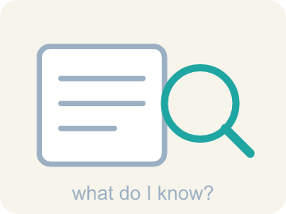 | make sense of a problem comprender un problema  To figure out what a problem is asking — what you know, and what you don't know yet.  Example: KNOW: 16 wheels, 6 times as many. DON'T KNOW: how many bikes.
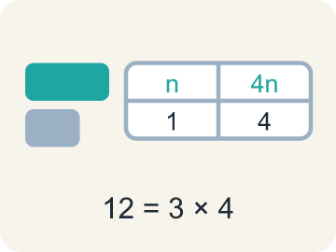 | representation representación  A way of showing a problem — a drawing, table, equation, or model — that helps you see it.  Example: The same 12 shown three ways: a tape diagram, a table, and 3 × 4.
 | strategy estrategia  A plan of attack for a problem — and something you can switch when you get stuck.  Example: “I will draw a tape diagram first, then divide” — chosen before computing.
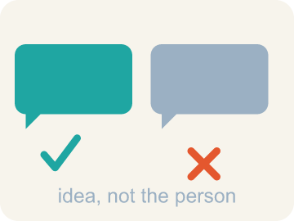 | critique criticar constructivamente  To examine an idea and say what is convincing or not — about the idea, never about the person.  Example: “That step assumes the boxes are full — how do we know?”
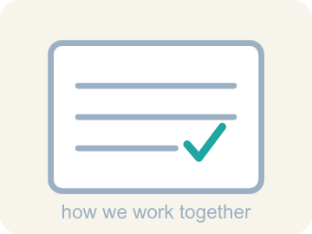 | community agreement acuerdo comunitario  A rule the whole class agrees to so that everyone can learn together.  Example: “We take turns sharing, and we critique ideas, not people.”

Guided Notes
Fill in each blank as we go. Use the Word Bank to help you.
WORD BANK
make sense of a problem • representation • strategy • critique • community agreement

1. To work out what a problem asks — what you know and don't — is to ________________ ________________ ________________ ________________ ________________.
2. A drawing, table, or equation that shows the math in a situation is a ________________.
3. The plan you choose before you start computing is your ________________.
4. To examine an idea and say what is or is not convincing is to ________________ it.
5. A rule the whole class agrees to so everyone can learn is a ________________ ________________.

Write About the Math
Use the support level you need. Every level answers the same math question.

1. Understand the Question explain
What ideas do you recommend that the whole class agrees to so that math class is a community of learners?
Your job: Answer the question. Use math evidence. Explain how the evidence proves your answer.
Responde la pregunta. Usa evidencia matemática. Explica cómo la evidencia demuestra tu respuesta.

2. Plan Your Math Words check at least two
☐ make sense of a problem — To figure out what a problem is asking — what you know, and what you don't know yet.
comprender un problema — Descubrir qué pide un problema: qué sabes y qué no sabes todavía.
☐ representation — A way of showing a problem — a drawing, table, equation, or model — that helps you see it.
representación — Una forma de mostrar un problema — un dibujo, una tabla, una ecuación o un modelo — que te ayuda a verlo.
☐ strategy — A plan of attack for a problem — and something you can switch when you get stuck.
estrategia — Un plan para atacar un problema — y algo que puedes cambiar cuando te atascas.
☐ critique — To examine an idea and say what is convincing or not — about the idea, never about the person.
criticar constructivamente — Examinar una idea y decir qué es convincente o no — sobre la idea, nunca sobre la persona.
☐ community agreement — A rule the whole class agrees to so that everyone can learn together.
acuerdo comunitario — Una norma que toda la clase acepta para que todos puedan aprender juntos.
Say it first: Say your idea to a partner or quietly to yourself before you write.
Propose a class agreement for working ___, and another for working alone, based on showing ___ for classmates. State each idea as a clear class ___ that helps everyone learn.
Di tu respuesta primero: Mi respuesta es ___ porque ___.

3. Build Your Explanation choose your support
This model shows the parts of an explanation. It does not answer your writing question.
Claim: The rack with 8 bikes has 8 × 2 = 16 wheels, and the second rack has 6 times as many wheels as that.
Evidence: A strong answer names a specific first move (like finding 8×2=16 before tackling '6 times as many') rather than jumping to the final answer. A weak answer just states a number with no process described.
Reasoning: This evidence connects the definition of make sense of a problem to the mathematical claim.

Start Most language support
Complete the frames. Use the word bank.
Completa las oraciones. Usa el banco de palabras.
Propose a class agreement for working ___, and another for working alone, based on showing ___ for classmates. State each idea as a clear class ___ that helps everyone learn.
My answer is ___.
Mi respuesta es ___.

Build Some language support
Write two connected sentences. Use because, so, or but.
Escribe dos oraciones conectadas. Usa porque, entonces o pero.
My claim is ___.
Mi afirmación es ___.
I know because ___.
Lo sé porque ___.
So ___.
Entonces ___.

Explain Light language support
Write a claim, give math evidence, and explain your reasoning.
Escribe una afirmación, da evidencia matemática y explica tu razonamiento.
My claim is ___.
Mi afirmación es ___.
My math evidence is ___.
Mi evidencia matemática es ___.
This proves ___ because ___.
Esto demuestra ___ porque ___.

4. Check Your Explanation five quick checks
☐ I answered the question.
Respondí la pregunta.
☐ I used math evidence: numbers, an equation, a model, or a comparison.
Usé evidencia matemática: números, una ecuación, un modelo o una comparación.
☐ I explained how the evidence proves my answer.
Expliqué cómo la evidencia demuestra mi respuesta.
☐ I used at least two math words.
Usé por lo menos dos palabras matemáticas.
☐ I reread complete sentences and punctuation.
Volví a leer mis oraciones completas y la puntuación.

Worked Example

Watch & Read I Do — follow along with your teacher
Unit 1 · Lesson 6
What is math? This lesson's answer: math is about DOING — solving problems, getting stuck, trying again, and doing it together. Think about the last time you worked with someone to solve a math problem. What did you actually do?

Solved Example I Do — watch each step
Problem: A bicycle rack holds 8 bikes, and each bike has 2 wheels. How many wheels are on the rack?
A) 16
B) 10
C) 4
D) 82
Step 1: 8 bikes with 2 wheels each is 8 × 2 = 16 wheels.
Answer: A. 16

Independent Practice

On Your Own You Do — show your work
Solve each problem. Show your thinking in the work box.

Level 2 Enrichment stretch your thinking
1. A group solves a hard problem, but one student did all the talking while three stayed silent. By this lesson's standards, how did the GROUP do?
A) Not well — a community shares thinking and takes turns, so three voices went unheard
B) Perfectly — the answer was right, and that is all that matters
C) Not well — the talker should have stayed silent too
D) Perfectly — silent members were being respectful

2. Write THREE community agreements you would propose for our class — at least one for working together and one for working alone — and for each, say what it protects.
3. Solve this with your full process, narrating each step: a rack has 16 wheels, and another rack has 6 times as many wheels. If a third rack held HALF as many wheels as the big rack, how many bikes would fit on it?
4. A classmate says: 'Math class would be better with no group work — thinking is private.' Using this lesson, write a respectful critique of that IDEA.

Exit Ticket
Answer on your own. This shows what you learned today.
★ Which statement best captures what this lesson means by 'Math is Ours'?
A) We are a community of math thinkers and doers — we work together and on our own, showing respect for our classmates, our community, ourselves, and our math ideas
B) Math belongs to whoever finishes first
C) Working together means one person solves while the others watch
D) Getting stuck means math is not for you

