10.1–10.3 Catch-Up — Homework
Lesson 10-3-catchup • Standard MPP.7
Name: ______________________ Period: ______ Date: ____________

Today's Goals
Content: I can show I am caught up on Lessons 10.1–10.3 by using each lesson's big idea in mixed practice.
Language: I can explain which lesson's big idea I used and how, using key vocabulary from Lessons 10.1–10.3.

Key Words

profession (profesión) — A job someone is trained to do, like chef, nurse, or carpenter.

inventory (inventario) — The supply of items a business keeps on hand, tracked by counting.
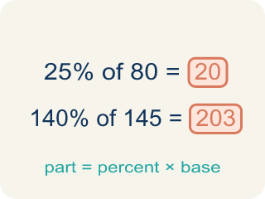
portion (porción) — The measured amount of food served to one person.
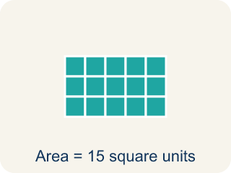
area (área) — The amount of flat space a surface covers, measured in square units.

volume (volumen) — The amount of space something fills, measured in cubic units.
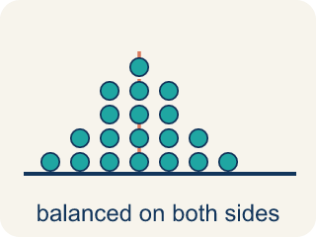
symmetric (simétrico) — Having two halves that match — one side is a mirror image of the other.
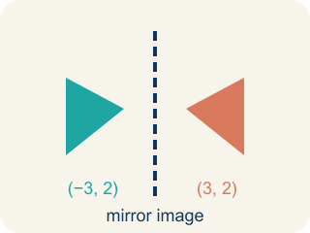
mirror image (imagen reflejada) — A copy of a figure flipped across a line, so the two halves face each other.

bilateral symmetry (simetría bilateral) — Reflective symmetry in plants and animals — the two sides of the body mirror each other.

puzzle (rompecabezas) — A problem designed to be played with — it has rules, a goal, and room to imagine solutions.

Practice
Show your work. Use the blank space under each problem.
1. (Lesson 10.1) A planter is 4 feet long and 2 feet wide. What is its area?
A. 8 square feet
B. 6 square feet
C. 12 square feet
D. 2 square feet
______________________________________________________________________
2. (Lesson 10.1) That same planter is 4 feet long, 2 feet wide, and needs soil 1 foot deep. How much soil does the gardener need?
A. 8 cubic feet
B. 7 cubic feet
C. 8 square feet
D. 4 cubic feet
______________________________________________________________________
3. (Lesson 10.1) One person saves 8 gallons of water a day by turning the water on only to rinse. How much water does that person save in a year (365 days)?
A. 2,920 gallons
B. 373 gallons
C. 1,460 gallons
D. 365 gallons
______________________________________________________________________
4. (Lesson 10.1) If each person in a house saves 2,920 gallons a year, how much does a household of 3 people save in a year?
A. 8,760 gallons
B. 2,923 gallons
C. 973 gallons
D. 5,840 gallons
______________________________________________________________________
5. (Lesson 10.2) Why do people find symmetry pleasing?
A. Our brains are wired to favor balance, and bilateral symmetry provides balance
B. Symmetric things are always brightly colored
C. Symmetry only appears in rare and expensive objects
D. Symmetric shapes are always larger than non-symmetric ones
______________________________________________________________________
6. (Lesson 10.2) There are over 17,000 species of butterflies, and ALL butterflies have reflective symmetry. About how many of those species have reflective symmetry?
A. All 17,000+ of them
B. About half of them
C. Only the most colorful ones
D. None — symmetry is only in plants
______________________________________________________________________
7. (Lesson 10.3) The table shows 1 disc → 1 step, 2 discs → 3 steps, 3 discs → 7 steps. What is the pattern rule for the number of steps when you add one more disc?
A. Double the number of steps and add 1
B. Add 2 to the number of steps
C. Add the number of discs to the steps
D. Multiply the number of steps by 3
______________________________________________________________________
8. (Lesson 10.3) Use the pattern rule to complete the table: how many steps for a four-disc tower?
A. 15 steps
B. 14 steps
C. 9 steps
D. 28 steps
______________________________________________________________________

Answer Key (Teacher)
1. A. 8 square feet
Area of a rectangle is length × width: 4 × 2 = 8 square feet.
Watch for: Doubling the previous number of steps but forgetting to add 1 — answering 14 instead of 15 for four discs, or 30 instead of 31 for five.
2. A. 8 cubic feet
Volume is length × width × depth: 4 × 2 × 1 = 8 cubic feet of soil.
Watch for: Doubling the previous number of steps but forgetting to add 1 — answering 14 instead of 15 for four discs, or 30 instead of 31 for five.
3. A. 2,920 gallons
8 gallons a day × 365 days = 2,920 gallons in a year.
Watch for: Doubling the previous number of steps but forgetting to add 1 — answering 14 instead of 15 for four discs, or 30 instead of 31 for five.
4. A. 8,760 gallons
2,920 gallons per person × 3 people = 8,760 gallons a year.
Watch for: Doubling the previous number of steps but forgetting to add 1 — answering 14 instead of 15 for four discs, or 30 instead of 31 for five.
5. A. Our brains are wired to favor balance, and bilateral symmetry provides balance
The lesson says it directly: our brains are wired to favor balance, and bilateral symmetry provides balance.
Watch for: Doubling the previous number of steps but forgetting to add 1 — answering 14 instead of 15 for four discs, or 30 instead of 31 for five.
6. A. All 17,000+ of them
'All butterflies have reflective symmetry' means every one of the 17,000+ species — no exceptions.
Watch for: Doubling the previous number of steps but forgetting to add 1 — answering 14 instead of 15 for four discs, or 30 instead of 31 for five.
7. A. Double the number of steps and add 1
1 × 2 + 1 = 3 and 3 × 2 + 1 = 7, so each new disc doubles the steps and adds 1.
Watch for: Doubling the previous number of steps but forgetting to add 1 — answering 14 instead of 15 for four discs, or 30 instead of 31 for five.
8. A. 15 steps
A three-disc tower takes 7 steps, so a four-disc tower takes 7 × 2 + 1 = 15 steps.
Watch for: Doubling the previous number of steps but forgetting to add 1 — answering 14 instead of 15 for four discs, or 30 instead of 31 for five.

