UNIT 10 · LESSON 4 STANDARD MPP.4

Math is Ingenuity
Student Notes Packet
Name: ______________________ Date: ____________ Period: ________
Level 3 · Enrichment

Today's Goals
Content: I can use ratios and models to explain how the Penny Farthing and gear-driven bicycles were ingenious solutions to a real problem.
Language: I can explain a gear ratio using the words rotation, teeth, and 'for each ___, the wheel turns ___.'

Key Vocabulary
Look at the picture, read the word, then read what it means.
 | ingenuity ingenio  Coming up with different, and sometimes unique, solutions to problems.  Example: The Penny Farthing's huge wheel, then chains and gears — two clever fixes.
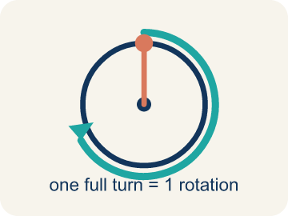 | rotation rotación  One full turn of a wheel, gear, or pedal all the way around.  Example: One full turn of the pedal — 360° all the way around.
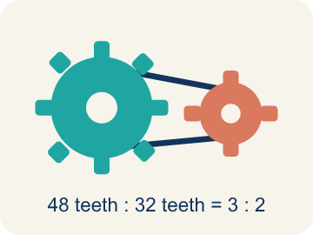 | gear engranaje  A toothed wheel that passes motion to another toothed wheel through a chain.  Example: A 48-tooth pedal gear pulling a 12-tooth wheel gear through the chain.
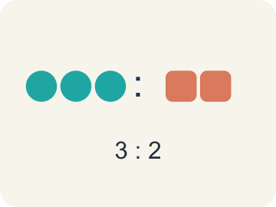 | ratio razón  A comparison of two quantities, like pedal rotations to wheel rotations.  Example: 48 pedal teeth to 12 wheel teeth — 4 wheel turns for every pedal turn.
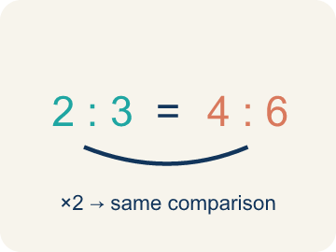 | equivalent ratios razones equivalentes  Ratios that make the same comparison using different numbers.  Example: 1 : 4 and 3 : 12 describe the same gear, at different sizes.

Guided Notes
Fill in each blank as we go. Use the Word Bank to help you.
WORD BANK
ingenuity • rotation • gear • ratio • equivalent ratios

1. Coming up with a different, sometimes unique solution is ________________.
2. One full turn of a wheel, gear, or pedal is a ________________.
3. A toothed wheel that passes motion through a chain is a ________________.
4. A comparison of two quantities, like pedal turns to wheel turns, is a ________________.
5. Ratios that make the same comparison with different numbers are ________________ ________________.

Write About the Math
Use the support level you need. Every level answers the same math question.

1. Understand the Question explain
How will your future vehicle be powered, and what math will be used in its design or use?
Your job: Answer the question. Use math evidence. Explain how the evidence proves your answer.
Responde la pregunta. Usa evidencia matemática. Explica cómo la evidencia demuestra tu respuesta.

2. Plan Your Math Words check at least two
☐ ingenuity — Coming up with different, and sometimes unique, solutions to problems.
ingenio — Idear soluciones diferentes, y a veces únicas, a los problemas.
☐ rotation — One full turn of a wheel, gear, or pedal all the way around.
rotación — Una vuelta completa de una rueda, un engranaje o un pedal.
☐ gear — A toothed wheel that passes motion to another toothed wheel through a chain.
engranaje — Una rueda con dientes que transmite el movimiento a otra rueda con dientes por medio de una cadena.
☐ ratio — A comparison of two quantities, like pedal rotations to wheel rotations.
razón — Una comparación de dos cantidades, como rotaciones del pedal y rotaciones de la rueda.
☐ equivalent ratios — Ratios that make the same comparison using different numbers.
razones equivalentes — Razones que hacen la misma comparación con números diferentes.
Say it first: Say your idea to a partner or quietly to yourself before you write.
Describe a future mode of individual transportation. A complete answer says how it is ___, names a ___ (or rate) that shapes it, and explains where that math appears in the vehicle's ___.
Di tu respuesta primero: Mi respuesta es ___ porque ___.

3. Build Your Explanation choose your support
This model shows the parts of an explanation. It does not answer your writing question.
Claim: One pedal rotation makes one wheel rotation, so a bigger wheel's longer perimeter carries the bicycle farther with each pedal push.
Evidence: A strong answer connects the 1-to-1 ratio to the wheel's perimeter, explaining a bigger wheel travels farther per pedal push. A weak answer just says 'bigger is faster' without naming the ratio or perimeter.
Reasoning: This evidence connects the definition of ingenuity to the mathematical claim.

Start Most language support
Complete the frames. Use the word bank.
Completa las oraciones. Usa el banco de palabras.
Describe a future mode of individual transportation. A complete answer says how it is ___, names a ___ (or rate) that shapes it, and explains where that math appears in the vehicle's ___.
My answer is ___.
Mi respuesta es ___.

Build Some language support
Write two connected sentences. Use because, so, or but.
Escribe dos oraciones conectadas. Usa porque, entonces o pero.
My claim is ___.
Mi afirmación es ___.
I know because ___.
Lo sé porque ___.
So ___.
Entonces ___.

Explain Light language support
Write a claim, give math evidence, and explain your reasoning.
Escribe una afirmación, da evidencia matemática y explica tu razonamiento.
My claim is ___.
Mi afirmación es ___.
My math evidence is ___.
Mi evidencia matemática es ___.
This proves ___ because ___.
Esto demuestra ___ porque ___.

4. Check Your Explanation five quick checks
☐ I answered the question.
Respondí la pregunta.
☐ I used math evidence: numbers, an equation, a model, or a comparison.
Usé evidencia matemática: números, una ecuación, un modelo o una comparación.
☐ I explained how the evidence proves my answer.
Expliqué cómo la evidencia demuestra mi respuesta.
☐ I used at least two math words.
Usé por lo menos dos palabras matemáticas.
☐ I reread complete sentences and punctuation.
Volví a leer mis oraciones completas y la puntuación.

Worked Example

Watch & Read I Do — follow along with your teacher
Unit 10 · Lesson 4
The invention of the bicycle in the late 1800s offered people a way to move about easily. Among the first bicycles created was the Penny Farthing, with a large front wheel and a small rear wheel. Ingenuity in mathematics helps us come up with different, and sometimes unique, solutions to problems.

Solved Example I Do — watch each step
Problem: On the Penny Farthing, what is the ratio of pedal rotations to front-wheel rotations?
A) 1 to 1
B) 1 to 2
C) 2 to 1
D) 1 to 4
Step 1: The pedals are attached directly to the front wheel, so each pedal rotation rotates the wheel one time — a 1 to 1 ratio.
Answer: A. 1 to 1

Independent Practice

On Your Own You Do — show your work
Solve each problem. Show your thinking in the work box.

Level 2 Enrichment stretch your thinking
1. The rider makes 3 full pedal rotations with the chain on the 32-tooth gear. How many rotations does the rear wheel make?
A) 4.5 rotations
B) 3 rotations
C) 96 rotations
D) 6 rotations

2. A designer adds a middle gear so the rear wheel makes exactly 2 rotations per rotation of the 48-tooth pedal gear. How many teeth must the new gear have?
A) 24 teeth
B) 22 teeth
C) 96 teeth
D) 16 teeth

3. How would the distance traveled differ with a smaller front wheel on the Penny Farthing? Use the 1 to 1 pedal ratio in your answer.
4. How did math help the bicycle's designers come up with ingenious solutions — first with the Penny Farthing, then with chains and gears?

Exit Ticket
Answer on your own. This shows what you learned today.
★ Which statement best captures what this lesson means by 'Math is Ingenuity'?
A) Math can help us come up with creative solutions to everyday problems
B) Math is only useful for inventors who lived in the 1800s
C) Ingenuity means avoiding math and just guessing
D) Every bicycle must have a 1 to 1 pedal ratio

