10.4–10.6 Catch-Up — Homework
Lesson 10-6-catchup • Standard MPP.3
Name: ______________________ Period: ______ Date: ____________

Today's Goals
Content: I can show I am caught up on Lessons 10.4–10.6 by using each lesson's big idea in mixed practice.
Language: I can explain which lesson's big idea I used and how, using key vocabulary from Lessons 10.4–10.6.

Key Words

ingenuity (ingenio) — Coming up with different, and sometimes unique, solutions to problems.
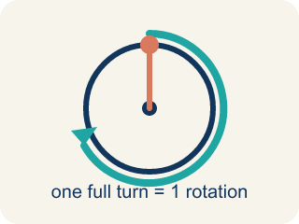
rotation (rotación) — One full turn of a wheel, gear, or pedal all the way around.
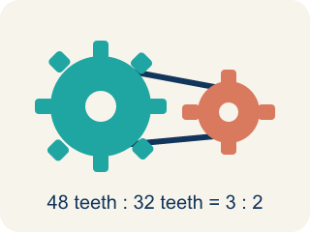
gear (engranaje) — A toothed wheel that passes motion to another toothed wheel through a chain.
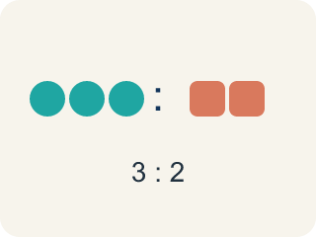
ratio (razón) — A comparison of two quantities, like pedal rotations to wheel rotations.
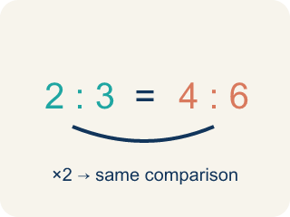
equivalent ratios (razones equivalentes) — Ratios that make the same comparison using different numbers.
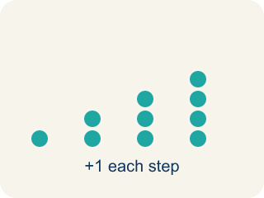
repetition (repetición) — The same object, shape, or form repeated multiple times.

pattern (patrón) — A set of objects or shapes that are repeated and arranged in a regular order.

pattern unit (unidad del patrón) — The smallest chunk of a pattern that repeats.

math biography (biografía matemática) — The story of your relationship with math — and how it has changed over time.

Practice
Show your work. Use the blank space under each problem.
1. (Lesson 10.4) On the Penny Farthing, what is the ratio of pedal rotations to front-wheel rotations?
A. 1 to 1
B. 1 to 2
C. 2 to 1
D. 1 to 4
______________________________________________________________________
2. (Lesson 10.4) How far does the Penny Farthing travel with each pedal rotation?
A. The length of the perimeter of the front wheel
B. The height of the rider
C. The length of the pedal
D. It does not move a fixed distance
______________________________________________________________________
3. (Lesson 10.4) The pedal gear turns 48 teeth per rotation. The largest rear gear needs 32 teeth for one full rotation. How many rotations does the rear wheel make for each pedal rotation?
A. 1.5 rotations
B. 16 rotations
C. 0.5 rotations
D. 2 rotations
______________________________________________________________________
4. (Lesson 10.4) The smallest rear gear has 12 teeth. How many rotations will the rear wheel make for each rotation of the 48-tooth pedal gear?
A. 4 rotations
B. 36 rotations
C. 3 rotations
D. 0.25 rotations
______________________________________________________________________
5. (Lesson 10.5) The pattern unit circle-square-triangle repeats. What is shape number 12?
A. The blue triangle
B. The pink circle
C. The purple square
D. It cannot be determined
______________________________________________________________________
6. (Lesson 10.5) Same pattern. What is shape number 20?
A. The purple square
B. The pink circle
C. The blue triangle
D. The 20th shape starts a new pattern
______________________________________________________________________
7. (Lesson 10.6) Now stretch the September estimate with this year's math: about 80 riders per turn, 6 turns each hour. About how many riders per hour?
A. About 480
B. About 86
C. About 13
D. About 800
______________________________________________________________________
8. (Lesson 10.6) Percents were new this year. What is 50% of 157?
A. 78.5
B. 77.5
C. 31.4
D. 107
______________________________________________________________________

Answer Key (Teacher)
1. A. 1 to 1
The pedals are attached directly to the front wheel, so each pedal rotation rotates the wheel one time — a 1 to 1 ratio.
Watch for: Treating your math story as finished — writing the same answers you wrote in Lesson 1-1 instead of looking for what actually changed. The story grows and evolves; a retrospective that copies September has missed the point.
2. A. The length of the perimeter of the front wheel
One wheel rotation rolls the bike forward exactly the perimeter of the wheel, and one pedal rotation makes one wheel rotation.
Watch for: Treating your math story as finished — writing the same answers you wrote in Lesson 1-1 instead of looking for what actually changed. The story grows and evolves; a retrospective that copies September has missed the point.
3. A. 1.5 rotations
48 ÷ 32 = 1.5, so the rear wheel makes 1.5 rotations for each pedal rotation.
Watch for: Treating your math story as finished — writing the same answers you wrote in Lesson 1-1 instead of looking for what actually changed. The story grows and evolves; a retrospective that copies September has missed the point.
4. A. 4 rotations
48 ÷ 12 = 4, so the rear wheel makes 4 rotations for each pedal rotation.
Watch for: Treating your math story as finished — writing the same answers you wrote in Lesson 1-1 instead of looking for what actually changed. The story grows and evolves; a retrospective that copies September has missed the point.
5. A. The blue triangle
12 ÷ 3 = 4 with no remainder, so shape 12 ends a complete unit — the triangle, which is the last shape of the unit.
Watch for: Treating your math story as finished — writing the same answers you wrote in Lesson 1-1 instead of looking for what actually changed. The story grows and evolves; a retrospective that copies September has missed the point.
6. A. The purple square
20 ÷ 3 = 6 remainder 2 (since 6 × 3 = 18 and 20 − 18 = 2), and the second shape in the unit is the purple square.
Watch for: Treating your math story as finished — writing the same answers you wrote in Lesson 1-1 instead of looking for what actually changed. The story grows and evolves; a retrospective that copies September has missed the point.
7. A. About 480
80 riders on each of 6 turns is 80 × 6 = 480 riders per hour — a rate, one of this year's tools.
Watch for: Treating your math story as finished — writing the same answers you wrote in Lesson 1-1 instead of looking for what actually changed. The story grows and evolves; a retrospective that copies September has missed the point.
8. A. 78.5
50% means half, and 157 ÷ 2 = 78.5 — the very number you decomposed back in Lesson 1-1.
Watch for: Treating your math story as finished — writing the same answers you wrote in Lesson 1-1 instead of looking for what actually changed. The story grows and evolves; a retrospective that copies September has missed the point.

