UNIT 2 · LESSON 1 STANDARD 6.DS.1

Understand Statistical Questions (Flagship)
Student Notes Packet
Name: ______________________ Date: ____________ Period: ________
Level 1 · Support

Today's Goals
Content: I can tell the difference between a statistical question and a non-statistical question.
Language: I can explain my reasoning using the words statistical question, data, variability, and survey.

Key Vocabulary
Look at the picture, read the word, then read what it means.
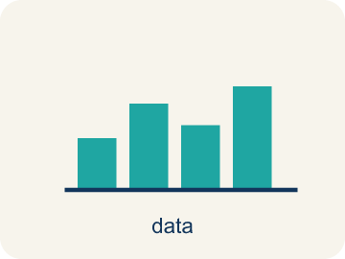 | Statistical Questions and Data Preguntas estadísticas y datos  A statistical question expects varied answers that can be collected as data.  Example: How many minutes do students in our class read each night?
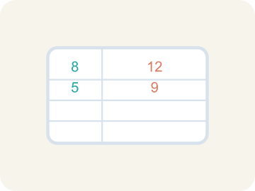 | Statistical Question Pregunta estadística  A question where the answers will be different for different people.  Example: “How tall are the players on the team?” → answers vary: 60 in, 63 in, 58 in, 65 in
 | Non-statistical Question Pregunta no estadística  A question that has just one fixed answer that is the same no matter who you ask, so there is no data to collect.  Example: “How tall am I?” → one answer: 60 in. Everyone who measures gets the same number.
 | Data Datos  Facts and numbers you collect, like answers to a survey.  Example: Player heights: 60 in, 63 in, 58 in, 65 in — four different measurements
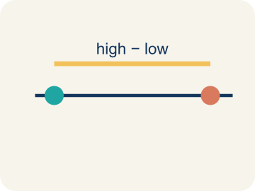 | Variability Variabilidad  How spread out the numbers are.  Example: Scores 10, 12, 11 are close together (low variability); scores 2, 15, 30 are far apart (high variability)
 | Survey Encuesta  Collecting facts by asking people questions.  Example: Asking 50 students 'What is your favorite sport?' and recording the answers
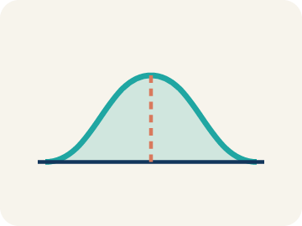 | Data distribution Distribución de datos  How the data looks: where it sits and how spread out it is.  Example: If most scores cluster in the middle with fewer at the edges, the distribution is symmetric

Guided Notes
Fill in each blank as we go. Use the Word Bank to help you.
WORD BANK
Statistical Questions and Data • Statistical Question • Non-statistical Question • Data • Variability • Survey • Data distribution

1. A question that expects varied answers you can collect is a ________________ ________________.
2. A question that expects a variety of answers and is answered by collecting data is a ________________.
3. A question that has one fixed answer and does not need data collection is a ________________.
4. Facts or numbers collected to answer a question are ________________.
5. How much the values in a data set differ from one another is the ________________.
6. A way to collect data by asking many people the same question is a ________________.
7. The way data values are spread out across a range is the ________________.

Write About the Math
Use the support level you need. Every level answers the same math question.

1. Understand the Question explain
Which question is statistical? Why would the editor's question give the newspaper more interesting data?
Your job: Answer the question. Use math evidence. Explain how the evidence proves your answer.
Responde la pregunta. Usa evidencia matemática. Explica cómo la evidencia demuestra tu respuesta.

2. Plan Your Math Words check at least two
☐ Statistical Questions and Data — A statistical question expects varied answers that can be collected as data.
Preguntas estadísticas y datos — Una pregunta estadística espera respuestas variadas que se pueden recopilar como datos.
☐ Statistical Question — A question where the answers will be different for different people.
Pregunta estadística — Una pregunta cuyas respuestas serán distintas para distintas personas.
☐ Non-statistical Question — A question that has just one fixed answer that is the same no matter who you ask, so there is no data to collect.
Pregunta no estadística — Una pregunta que tiene una sola respuesta fija, igual sin importar a quién le preguntes, por lo que no hay datos que recolectar.
☐ Data — Facts and numbers you collect, like answers to a survey.
Datos — Datos y números que recoges, como respuestas a una encuesta.
☐ Variability — How spread out the numbers are.
Variabilidad — Qué tan separados están los números.
Say it first: Say your idea to a partner or quietly to yourself before you write.
The reporter's question is ___ because ___. The editor's question is ___ because ___. The editor's question is better for a story because ___.
Di tu respuesta primero: Mi respuesta es ___ porque ___.

3. Build Your Explanation choose your support
This model shows the parts of an explanation. It does not answer your writing question.
Claim: A statistical question expects answers that vary across many cases.
Evidence: Students identify "How tall is each player?" as statistical because heights vary, while "How tall is our point guard?" has one fixed answer.
Reasoning: This evidence connects the definition of statistical question to the mathematical claim.

Start Most language support
Complete the frames. Use the word bank.
Completa las oraciones. Usa el banco de palabras.
The reporter's question is ___ because ___. The editor's question is ___ because ___. The editor's question is better for a story because ___.
My answer is ___.
Mi respuesta es ___.

Build Some language support
Write two connected sentences. Use because, so, or but.
Escribe dos oraciones conectadas. Usa porque, entonces o pero.
My claim is ___.
Mi afirmación es ___.
I know because ___.
Lo sé porque ___.
So ___.
Entonces ___.

Explain Light language support
Write a claim, give math evidence, and explain your reasoning.
Escribe una afirmación, da evidencia matemática y explica tu razonamiento.
My claim is ___.
Mi afirmación es ___.
My math evidence is ___.
Mi evidencia matemática es ___.
This proves ___ because ___.
Esto demuestra ___ porque ___.

4. Check Your Explanation five quick checks
☐ I answered the question.
Respondí la pregunta.
☐ I used math evidence: numbers, an equation, a model, or a comparison.
Usé evidencia matemática: números, una ecuación, un modelo o una comparación.
☐ I explained how the evidence proves my answer.
Expliqué cómo la evidencia demuestra mi respuesta.
☐ I used at least two math words.
Usé por lo menos dos palabras matemáticas.
☐ I reread complete sentences and punctuation.
Volví a leer mis oraciones completas y la puntuación.

Worked Example

Watch & Read I Do — follow along with your teacher
Scouting Report
You've just been hired as the data analyst for a youth basketball league. The head coach hands you a list of questions the staff wants to investigate about their players. Some questions will give you interesting data with variety, while others have just one fixed answer. Your job: figure out which questions are worth investigating with data.

Think about:
• Which questions could have many different answers?
• Which questions have only one exact answer?
• What makes a question good for collecting data?
• Why would a coach care about questions with variability?
• Could a question be reworded to become statistical?

Solved Example I Do — watch each step
Problem: Which of the following is a statistical question?
A) How many points did each player score this season?
B) How many points are scored for a free throw?
C) What sport does this team play?
D) How many halves are in a soccer game?
Step 1: "How many points did each player score?" is statistical because different players will have different scores — there is variability in the data.
Answer: A. How many points did each player score this season?

Guided Practice

Solve Together We Do — work with your class
Problem: Which question is NOT a statistical question?
A) How many innings are in a baseball game?
B) How many home runs did each player hit this year?
C) How many miles does each runner train per week?
D) How tall is each player on the basketball team?
Step 1:

Step 2:

Answer:

The school newspaper wants to write a story about the girls' soccer team. A reporter suggests asking: "How many goals has the team scored total?" The editor says they should ask: "How many goals did each player score this season?"
Which question is statistical? Why would the editor's question give the newspaper more interesting data?

Sentence frame: The reporter's question is ___ because ___. The editor's question is ___ because ___. The editor's question is better for a story because ___.

Turn & Talk discuss with a partner
1. [Launch] The coach asks, "How tall is our point guard?" and "How tall is each player on the roster?" Which one is a statistical question, and why?
Start with: The question "___" is statistical because ___.
La pregunta "___" es estadística porque ___.
Word bank: statistical question, variability, data, survey, answer
2. [Explore] While sorting the questions, what clue tells you instantly that a question will need DATA from many players to answer?
Start with: I know it needs data because it asks about ___.
Sé que necesita datos porque pregunta sobre ___.
Word bank: statistical question, variability, data, survey, vary
3. [Connect] The newspaper editor prefers "How many goals did each player score?" over "How many goals did the team score total?" Which gives more interesting data for a story?
Start with: The editor's question is better because it shows ___ among players.
La pregunta del editor es mejor porque muestra ___ entre los jugadores.
Word bank: statistical question, variability, data, survey, total
4. [Reflect] Think of one statistical question you could ask about students in this room. What variability do you expect in the answers?
Start with: My statistical question is "___".
Mi pregunta estadística es "___".
Word bank: statistical question, variability, data, survey, collect
5. [Practice] During practice on Statistical Questions and Data, what strategy did you use when a problem felt tricky?
Start with: I know it needs data because it asks about ___.
Sé que necesita datos porque pregunta sobre ___.
Word bank: Statistical Question, Data, Variability, Survey

Independent Practice

On Your Own You Do — show your work
Solve each problem. Show your thinking in the work box.

Level 1 Support extra scaffolding
1. Why is 'How many hours of sleep did each student get last night?' a statistical question?
A) Because different students got different amounts of sleep
B) Because it asks about sleep
C) Because hours are numbers
D) Because the answer is always 8 hours

2. Match each question to its type.

Exit Ticket
Answer on your own. This shows what you learned today.
★ Which question is a statistical question?
A) How many students are in the school?
B) How many hours does each student in 6th grade exercise per week?
C) What time does school start?
D) How many days are in a week?
A) B) How many hours does each student exercise per week?
B) A) How many students are in the school?
C) C) What time does school start?
D) D) How many days are in a week?

Answer Key & Teacher Guide
Teacher reference — remove or fold back before distributing to students.

Guided Notes (Fill-in)
Notes 1: Statistical Questions and Data
Notes 2: Statistical Question
Notes 3: Non-statistical Question
Notes 4: Data
Notes 5: Variability
Notes 6: Survey
Notes 7: Data distribution

Worked Notes (I Do / We Do)
I Do: A. How many points did each player score this season?
We Do: A. How many innings are in a baseball game?

Independent Practice
Watch for this mistake: A common mistake in Statistical Questions and Data is judging a question by its topic or its numbers instead of its variability. Students see a question about ONE player, ONE game, or ONE fixed fact — like "How many points does the team need to win a game?" — and call it statistical just because it has a number or is about sports. Or they see a question about a single player's whole season, like "How many touchdowns did the quarterback throw this season?", and call it NOT statistical because only one player is named, forgetting that a season covers many games with a different result each time. Both errors skip the real test: will the answers actually differ from case to case (game to game, player to player)? If yes, it is a statistical question; if there is one fixed answer, it is not.

Level 1 Support
1. A) Because different students got different amounts of sleep — A statistical question anticipates variability — different students slept different amounts, so the data will vary.
2. Answers vary. — A question is statistical when the answers are expected to differ from person to person, and non-statistical when there is one fixed answer for everyone.

On Level
3. A) Because the answers will vary from athlete to athlete — A statistical question anticipates variability. Different athletes sleep different amounts, so the data collected will vary.
4. Answers vary. — The deciding feature is variability: if asking many people would produce different answers, the question is statistical; if everyone gives the same answer, it is not.
5. B) How tall are the students in my class? — A statistical question anticipates variability — students' heights differ, so the data will vary.
6. B) How many siblings does each student in the class have? — Number of siblings varies from student to student, so the collected data will vary — that makes it statistical. The others each have one fixed answer.

Exit Ticket
A) B) How many hours does each student exercise per week? — "How many hours does each student exercise per week?" is statistical because different students exercise different amounts — the data has variability.

Math Writing Criteria
The support level changes the amount of language scaffolding, not the mathematical expectation.
☐ I answered the question.
☐ I used math evidence: numbers, an equation, a model, or a comparison.
☐ I explained how the evidence proves my answer.
☐ I used at least two math words.
☐ I reread complete sentences and punctuation.

