UNIT 2 · LESSON 11 STANDARD 6.NOS.3

Add and Subtract Decimals
Student Notes Packet
Name: ______________________ Date: ____________ Period: ________
Level 2 · Standard

Today's Goals
Content: I can add and subtract decimals by lining up the place values and the decimal points.
Language: I can explain my steps using the words decimal, place value, tenths, hundredths, and add zeros.

Key Vocabulary
Look at the picture, read the word, then read what it means.
 | Add and Subtract Decimals Sumar y restar decimales  Combine or find the difference between decimals by lining up equal place values.  Example: 15.70 − 8.36 = 7.34; line up the decimal points.
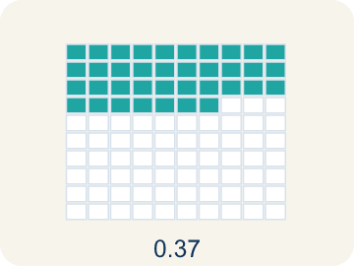 | Decimal Decimal  A number with a dot, like 0.5, that shows a part less than one.  Example: 3.75 means 3 ones + 7 tenths + 5 hundredths — it is between 3 and 4
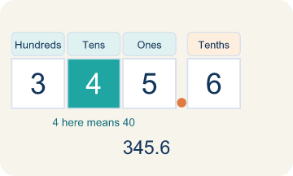 | Place value Valor posicional  What a digit is worth based on where it sits in a number.  Example: In 4.38: the 4 = 4 ones, the 3 = 3 tenths (0.3), the 8 = 8 hundredths (0.08)
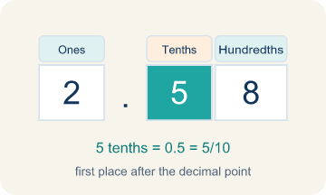 | Tenths Décimas  The first spot after the decimal point. It shows parts out of 10.  Example: 0.7 = 7/10 — like 7 slices of a pizza cut into 10 equal slices
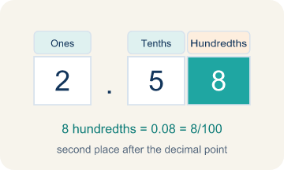 | Hundredths Centésimas  The second spot after the decimal point. It shows parts out of 100.  Example: 0.05 = 5/100 — like 5 pennies out of a dollar (100 pennies)
 | Annex zeros Agregar ceros  Adding zeros at the end of a decimal so numbers line up evenly.  Example: 15.7 becomes 15.70 so you can subtract 15.70 − 8.36 with aligned place values

Guided Notes
Fill in each blank as we go. Use the Word Bank to help you.
WORD BANK
Add and Subtract Decimals • Decimal • Place value • Tenths • Hundredths • Annex zeros

1. Line up equal ________________ ________________ before you add or subtract decimals.
2. A number that uses a point to show a value less than one whole is a ________________.
3. The value a digit has based on its position in a number is its ________________.
4. The first place to the right of the decimal point is the ________________ place.
5. The second place to the right of the decimal point is the ________________ place.
6. Writing extra zeros at the end of a decimal so the places line up is called ________________.

Write About the Math
Use the support level you need. Every level answers the same math question.

1. Understand the Question compare
How do you add decimals with different numbers of decimal places to find her total time?
Your job: Answer the question. Use math evidence. Explain how the evidence proves your answer.
Responde la pregunta. Usa evidencia matemática. Explica cómo la evidencia demuestra tu respuesta.

2. Plan Your Math Words check at least two
☐ Add and Subtract Decimals — Combine or find the difference between decimals by lining up equal place values.
Sumar y restar decimales — Combinar o hallar la diferencia entre decimales alineando valores posicionales iguales.
☐ Decimal — A number with a dot, like 0.5, that shows a part less than one.
Decimal — Un número con un punto, como 0.5, que muestra una parte menor que uno.
☐ Place value — What a digit is worth based on where it sits in a number.
Valor posicional — Lo que vale un dígito según el lugar que ocupa en el número.
☐ Tenths — The first spot after the decimal point. It shows parts out of 10.
Décimas — El primer lugar después del punto decimal. Muestra partes de 10.
☐ Hundredths — The second spot after the decimal point. It shows parts out of 100.
Centésimas — El segundo lugar después del punto decimal. Muestra partes de 100.
Say it first: Say your idea to a partner or quietly to yourself before you write.
The runner's total time is ___ minutes because 2.45 + 2.60 + 2.38 = ___.
Di tu respuesta primero: Mi respuesta es ___ porque ___.

3. Build Your Explanation choose your support
This model shows the parts of an explanation. It does not answer your writing question.
Claim: Lining up the decimal points keeps each place value matched.
Evidence: Students explain that aligning decimal points lines up matching place values (tenths under tenths, hundredths under hundredths) so the addition and subtraction are correct.
Reasoning: This evidence connects the definition of add and subtract decimals to the mathematical claim.

Start Most language support
Complete the frames. Use the word bank.
Completa las oraciones. Usa el banco de palabras.
The runner's total time is ___ minutes because 2.45 + 2.60 + 2.38 = ___.
My answer is ___.
Mi respuesta es ___.

Build Some language support
Write two connected sentences. Use because, so, or but.
Escribe dos oraciones conectadas. Usa porque, entonces o pero.
My claim is ___.
Mi afirmación es ___.
I know because ___.
Lo sé porque ___.
So ___.
Entonces ___.

Explain Light language support
Write a claim, give math evidence, and explain your reasoning.
Escribe una afirmación, da evidencia matemática y explica tu razonamiento.
My claim is ___.
Mi afirmación es ___.
My math evidence is ___.
Mi evidencia matemática es ___.
This proves ___ because ___.
Esto demuestra ___ porque ___.

4. Check Your Explanation five quick checks
☐ I answered the question.
Respondí la pregunta.
☐ I used math evidence: numbers, an equation, a model, or a comparison.
Usé evidencia matemática: números, una ecuación, un modelo o una comparación.
☐ I explained how the evidence proves my answer.
Expliqué cómo la evidencia demuestra mi respuesta.
☐ I used at least two math words.
Usé por lo menos dos palabras matemáticas.
☐ I reread complete sentences and punctuation.
Volví a leer mis oraciones completas y la puntuación.

Worked Example

Watch & Read I Do — follow along with your teacher
Space Station Fuel Monitor
The space station's main fuel tank reads 128.75 liters. A resupply shuttle delivers 46.8 liters of fuel, but the thrusters used 19.35 liters during docking. What is the fuel level after both events?

Think about:
• What is the starting fuel amount?
• Which operation adds fuel and which removes fuel?
• Why is it important to line up the decimal points?
• How do you handle adding 46.8 (one decimal place) to 128.75 (two decimal places)?

Solved Example I Do — watch each step
Problem: What is 14.6 + 3.85?
A) 18.45
B) 18.35
C) 17.45
D) 18.55
Step 1: Line up decimals: 14.60 + 3.85.
Step 2: Hundredths: 0 + 5 = 5.
Step 3: Tenths: 6 + 8 = 14, write 4 carry 1.
Step 4: Ones: 4 + 3 + 1 = 8.
Step 5: Tens: 1.
Step 6: Answer: 18.45.
Answer: A. 18.45

Guided Practice

Solve Together We Do — work with your class
Problem: What is 20.3 − 7.48?
A) 12.82
B) 13.82
C) 12.92
D) 12.18
Step 1:

Step 2:

Step 3:

Answer:

A runner's times for three laps are 2.45 minutes, 2.6 minutes, and 2.38 minutes. She wants to find her total time to see if she beat her personal record of 7.5 minutes.
How do you add decimals with different numbers of decimal places to find her total time?

Sentence frame: The runner's total time is ___ minutes because 2.45 + 2.60 + 2.38 = ___.

Turn & Talk discuss with a partner
1. [Launch] A fuel tank holds 128.75 liters. A shuttle adds 46.8 liters, and the docking thrusters use 19.35 liters. Why must you line up the decimal points — not the last digits — before you add and subtract these amounts?
Start with: I line up the ___ so each digit stays in its matching place value (tenths with tenths, hundredths with hundredths).
Alineo los ___ para que cada dígito quede en su valor posicional correspondiente (décimos con décimos, centésimos con centésimos).
Word bank: decimal, place value, tenths, hundredths, add zeros
2. [Explore] When you added 128.75 and 46.8, how did you handle 46.8 having fewer decimal places, and when did you need to regroup?
Start with: I annexed a zero to write 46.8 as ___ so the place values matched.
Agregué un cero para escribir 46.8 como ___ para que los valores posicionales coincidieran.
Word bank: decimal, place value, tenths, hundredths, add zeros
3. [Connect] A runner's three laps are 2.45, 2.6, and 2.38 minutes. How do you add decimals with different numbers of places to find her total time?
Start with: Her total time is ___ minutes because I added ___, ___, and ___.
Su tiempo total es ___ minutos porque sumé ___, ___ y ___.
Word bank: decimal, place value, tenths, hundredths, add zeros
4. [Reflect] Why does lining up place values matter MORE with decimals than with whole numbers, where you can just line up the right edge?
Start with: With decimals I must line up the ___, not just the right edge, because ___.
Con decimales debo alinear los ___, no solo el borde derecho, porque ___.
Word bank: decimal, place value, tenths, hundredths, add zeros
5. [Practice] During practice on Add and Subtract Decimals, what strategy did you use when a problem felt tricky?
Start with: I annexed a zero to write 46.8 as ___ so the place values matched.
Agregué un cero para escribir 46.8 como ___ para que los valores posicionales coincidieran.
Word bank: Decimal, Place value, Tenths, Hundredths

Independent Practice

On Your Own You Do — show your work
Solve each problem. Show your thinking in the work box.

On Level grade-level practice
1. A student buys items costing $4.59, $12.75, and $3.80. What is the total cost?
A) $21.14
B) $20.14
C) $21.04
D) $21.24

Exit Ticket
Answer on your own. This shows what you learned today.
★ What is 32.6 − 14.85?
A) 17.75
B) 18.75
C) 17.85
D) 17.25

