2.4–2.12 Catch-Up — Homework
Lesson 2-12-catchup • Standard 6.NOS.3
Name: ______________________ Period: ______ Date: ____________

Today's Goals
Content: I can show I am caught up on Lessons 2.4–2.12 by using each lesson's big idea in mixed practice.
Language: I can explain which lesson's big idea I used and how, using key vocabulary from Lessons 2.4–2.12.

Key Words
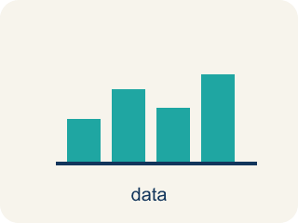
Display Data with Box Plots (Representar datos con diagramas de caja) — Show a data set's five-number summary in a box-and-whisker display.
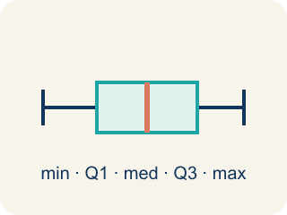
Box Plot (Diagrama de caja) — A graph that shows how data is spread using five key numbers.
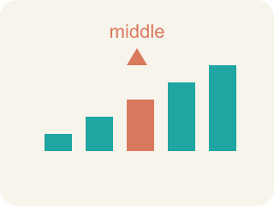
Median (Mediana) — The middle number when you put them in order.
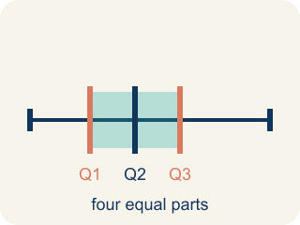
Quartile (Cuartil) — Numbers that split the data into four equal parts.
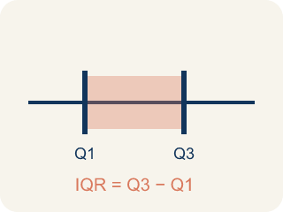
Interquartile Range (Rango intercuartílico) — The spread of the middle half of the data (Q3 − Q1).
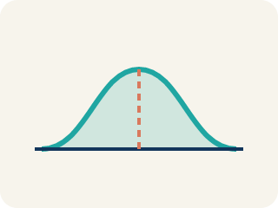
Data distribution (Distribución de datos) — How the data looks: where it sits and how spread out it is.
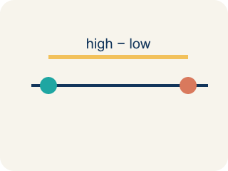
Variability (Variabilidad) — How spread out the numbers are.

Range and Interquartile Range (Rango y rango intercuartílico) — Two numbers that describe spread: the range covers all the data, and the interquartile range covers only the middle half.
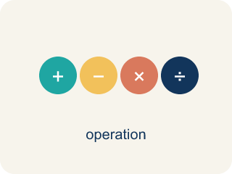
Divide Multi-Digit Numbers (Dividir números de varias cifras) — Separate a multi-digit number into equal groups to find a quotient.

Divide Decimals (Dividir decimales) — Find a quotient with decimals by making the divisor a whole number first.
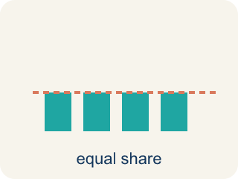
Mean (Media) — The average of a data set. Add all the values, then divide by how many values there are.
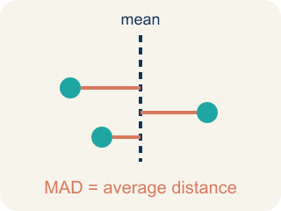
Mean Absolute Deviation (Desviación media absoluta) — The average distance of data values from the mean; it describes spread.
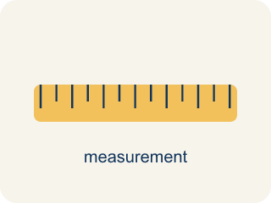
Appropriate Measures of Center (Medidas de centro apropiadas) — A mean, median, or mode chosen because it describes a data set fairly.

Add and Subtract Decimals (Sumar y restar decimales) — Combine or find the difference between decimals by lining up equal place values.

Multiply Decimals (Multiplicar decimales) — Find the product of decimals, then use place value to place the decimal point.

Range (Rango) — The distance from the least value to the greatest value, found by subtracting: greatest − least.
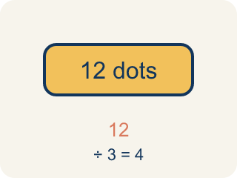
Dividend (Dividendo) — The number you are splitting up in a division problem.

Average (Promedio) — Another word for the mean — the amount each value would be if the total were shared equally.

Deviation (Desviación) — How far a number is from the mean.
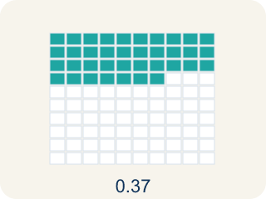
Decimal (Decimal) — A number with a dot, like 0.5, that shows a part less than one.
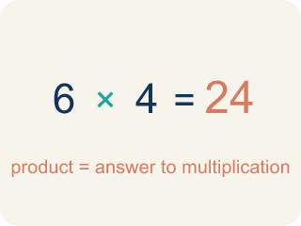
Product (Producto) — The answer when you multiply.

Practice
Show your work. Use the blank space under each problem.
1. (Lesson 2.4) A box plot shows: Min = 10, Q1 = 15, Median = 20, Q3 = 28, Max = 35. What is the interquartile range (IQR)?
A. 13
B. 25
C. 10
D. 20
______________________________________________________________________
2. (Lesson 2.4) On a box plot, what does the line inside the box represent?
A. The median
B. The mean
C. The mode
D. The range
______________________________________________________________________
3. (Lesson 2.4) Two box plots show: Team A has IQR = 8, Team B has IQR = 22. What does this tell you?
A. Team A's middle 50% is more consistent; Team B's is more spread out
B. Team B is a better team
C. Team A has a higher median
D. The IQRs don't tell you about consistency
______________________________________________________________________
4. (Lesson 2.4) The Quartile-Is-One-Value Mistake
Step 1 (Data (ordered)): Eagles' game scores: 4, 8, 10, 14, 18, 22, 26, 30 (8 values)
Step 2 (Median): With 8 values, Median = (14 + 18) ÷ 2 = 16 ✓
Step 3 (Q1): Lower half = 4, 8, 10, 14 → Q1 = 10
Step 4 (Q3): Upper half = 18, 22, 26, 30 → Q3 = (22 + 26) ÷ 2 = 24
Which step has the mistake? Explain and fix it:
______________________________________________________________________
______________________________________________________________________
______________________________________________________________________
5. (Lesson 2.5) A box plot shows: least 68, Q1 75.5, median 83.5, Q3 88, greatest 94. What are the range and the IQR?
A. Range 26, IQR 12.5
B. Range 12.5, IQR 26
C. Range 26, IQR 83.5
D. Range 20, IQR 12.5
______________________________________________________________________
6. (Lesson 2.5) Team A's salaries have a range of $14M and an IQR of $7M. Team B's have a range of $7M and an IQR of $2.5M. Both teams have the same median salary. What does this tell a player?
A. Team B's salaries cluster much more tightly around the median
B. Team B pays more overall
C. Team A has more players
D. Team B's highest salary is greater
______________________________________________________________________
7. (Lesson 2.6) A warehouse has 2,184 items to pack into boxes of 14. How many boxes are needed?
A. 156 boxes
B. 146 boxes
C. 166 boxes
D. 155 boxes
______________________________________________________________________
8. (Lesson 2.6) Spot the Mistake in 2,058 ÷ 14
Step 1 (Problem): Divide 2,058 ÷ 14 with long division. Dividend = 2,058, divisor = 14.
Step 2 (Divide, Multiply, Subtract): 14 does not fit into 2, so start with 20. 20 ÷ 14 → 1. 1 × 14 = 14, and 20 − 14 = 6
Step 3 (Bring down, repeat): Bring down the 5 to make 65. 65 ÷ 14 → 4. 4 × 14 = 56, and 65 − 56 = 9
Step 4 (Bring down, repeat): Bring down the 8 to make 98. 98 ÷ 14 → 8. 8 × 14 = 112, and 98 − 112 = −14
Step 5 (Final answer): Quotient = 148
Which step has the mistake? Explain and fix it:
______________________________________________________________________
______________________________________________________________________
______________________________________________________________________
9. (Lesson 2.7) A water tank holds 19.2 liters. It is poured into bottles that each hold 1.6 liters. How many bottles can be filled?
A. 12 bottles
B. 11 bottles
C. 13 bottles
D. 1.2 bottles
______________________________________________________________________
10. (Lesson 2.7) Spot the Common Mistake
Step 1 (Problem): Solve 9.6 ÷ 0.12.
Step 2 (Count how far to move): 0.12 has 2 decimal places, so BOTH numbers move 2 places right. The divisor: 0.12 → 12.
Step 3 (Move the dividend the same 2 places): 9.6 only has one digit after the point, so the student moved it just 1 place: 9.6 → 96. New problem: 96 ÷ 12 = 8.
Which step has the mistake? Explain and fix it:
______________________________________________________________________
______________________________________________________________________
______________________________________________________________________

Answer Key (Teacher)
1. A. 13
IQR = Q3 − Q1 = 28 − 15 = 13.
Watch for: A common mistake in Multiply Decimals is counting decimal places from only one factor instead of adding the decimal places from BOTH factors. For example, in 0.4 × 0.06, a student multiplies 4 × 6 = 24, then places the decimal point using just one factor's place count (1 place), writing 0.24 instead of the correct answer: 0.4 has 1 decimal place and 0.06 has 2 decimal places, for a total of 3, so 24 becomes 0.024. Before you submit, count the decimal places in EACH factor separately and add them together — that total is how many decimal places belong in your final answer.
2. A. The median
The line inside the box of a box plot always represents the median.
Watch for: A common mistake in Multiply Decimals is counting decimal places from only one factor instead of adding the decimal places from BOTH factors. For example, in 0.4 × 0.06, a student multiplies 4 × 6 = 24, then places the decimal point using just one factor's place count (1 place), writing 0.24 instead of the correct answer: 0.4 has 1 decimal place and 0.06 has 2 decimal places, for a total of 3, so 24 becomes 0.024. Before you submit, count the decimal places in EACH factor separately and add them together — that total is how many decimal places belong in your final answer.
3. A. Team A's middle 50% is more consistent; Team B's is more spread out
A smaller IQR means the middle 50% of data is more tightly clustered. Team A's scoring is more consistent in the middle range.
Watch for: A common mistake in Multiply Decimals is counting decimal places from only one factor instead of adding the decimal places from BOTH factors. For example, in 0.4 × 0.06, a student multiplies 4 × 6 = 24, then places the decimal point using just one factor's place count (1 place), writing 0.24 instead of the correct answer: 0.4 has 1 decimal place and 0.06 has 2 decimal places, for a total of 3, so 24 becomes 0.024. Before you submit, count the decimal places in EACH factor separately and add them together — that total is how many decimal places belong in your final answer.
4. (Lesson 2.4) The Quartile-Is-One-Value Mistake
The mistake is in Step 3.
Correct work: Q1 is the MEDIAN of the lower half, not just one of its values. The lower half is 4, 8, 10, 14 — an even-sized group — so Q1 = (8 + 10) ÷ 2 = 9, not 10. The student grabbed a single value instead of averaging the two middle numbers of the half.
Watch for: The Q1 step grabbed a single number out of the lower half instead of finding that half's median. The lower half 4, 8, 10, 14 has an even count, so Q1 averages its two middle values: (8 + 10) ÷ 2 = 9 — the same averaging move already used correctly for the median and for Q3.
5. A. Range 26, IQR 12.5
Range = 94 − 68 = 26. IQR = 88 − 75.5 = 12.5. The range covers the whole span; the IQR covers only the box.
Watch for: A common mistake in Multiply Decimals is counting decimal places from only one factor instead of adding the decimal places from BOTH factors. For example, in 0.4 × 0.06, a student multiplies 4 × 6 = 24, then places the decimal point using just one factor's place count (1 place), writing 0.24 instead of the correct answer: 0.4 has 1 decimal place and 0.06 has 2 decimal places, for a total of 3, so 24 becomes 0.024. Before you submit, count the decimal places in EACH factor separately and add them together — that total is how many decimal places belong in your final answer.
6. A. Team B's salaries cluster much more tightly around the median
Both measures of variation are smaller for Team B, so its salaries vary less: a typical player is more likely to earn close to the median. Team A spreads much wider in both directions.
Watch for: A common mistake in Multiply Decimals is counting decimal places from only one factor instead of adding the decimal places from BOTH factors. For example, in 0.4 × 0.06, a student multiplies 4 × 6 = 24, then places the decimal point using just one factor's place count (1 place), writing 0.24 instead of the correct answer: 0.4 has 1 decimal place and 0.06 has 2 decimal places, for a total of 3, so 24 becomes 0.024. Before you submit, count the decimal places in EACH factor separately and add them together — that total is how many decimal places belong in your final answer.
7. A. 156 boxes
2,184 ÷ 14 = 156. Check: 14 × 156 = 14 × 150 + 14 × 6 = 2,100 + 84 = 2,184.
Watch for: A common mistake in Multiply Decimals is counting decimal places from only one factor instead of adding the decimal places from BOTH factors. For example, in 0.4 × 0.06, a student multiplies 4 × 6 = 24, then places the decimal point using just one factor's place count (1 place), writing 0.24 instead of the correct answer: 0.4 has 1 decimal place and 0.06 has 2 decimal places, for a total of 3, so 24 becomes 0.024. Before you submit, count the decimal places in EACH factor separately and add them together — that total is how many decimal places belong in your final answer.
8. (Lesson 2.6) Spot the Mistake in 2,058 ÷ 14
The mistake is in Step 4.
Correct work: The DIVIDE step in the last cycle chose a digit that is too big: 8 × 14 = 112 is more than the 98 you have to subtract from, and you can never subtract more than the working number. The right digit is 7, since 7 × 14 = 98 and 98 − 98 = 0. The quotient is 147 with remainder 0, and 14 × 147 = 2,058 rebuilds the dividend.
Watch for: The last DIVIDE step is where it breaks: the student wrote 8, but 8 × 14 = 112 is larger than the 98 they had to subtract from, so the difference came out negative. The largest digit that fits is 7, since 7 × 14 = 98 leaves 0, so the quotient is 147 and 14 × 147 = 2,058 checks out.
9. A. 12 bottles
19.2 ÷ 1.6: multiply both by 10 → 192 ÷ 16 = 12 bottles.
Watch for: A common mistake in Multiply Decimals is counting decimal places from only one factor instead of adding the decimal places from BOTH factors. For example, in 0.4 × 0.06, a student multiplies 4 × 6 = 24, then places the decimal point using just one factor's place count (1 place), writing 0.24 instead of the correct answer: 0.4 has 1 decimal place and 0.06 has 2 decimal places, for a total of 3, so 24 becomes 0.024. Before you submit, count the decimal places in EACH factor separately and add them together — that total is how many decimal places belong in your final answer.
10. (Lesson 2.7) Spot the Common Mistake
The mistake is in Step 3.
Correct work: Both numbers must move the SAME number of places — 2, not 1. 9.6 runs out of digits after one place, so you add a placeholder zero to move the second place: 9.6 → 96 → 960. The real problem is 960 ÷ 12 = 80, so 9.6 ÷ 0.12 = 80. Estimate to confirm: 0.12 is tiny, so many of them fit in 9.6 — the quotient must be large, not 8. Check: 80 × 0.12 = 9.6. ✓
Watch for: In the last step the dividend moved only 1 place while the divisor moved 2, so the two numbers no longer match. Adding a placeholder zero lets 9.6 move both places to 960, making the real problem 960 ÷ 12 = 80. That size is reasonable, because a great many 0.12s fit inside 9.6.

