UNIT 2 · LESSON 12 STANDARD 6.NOS.3

Multiply Decimals
Student Notes Packet
Name: ______________________ Date: ____________ Period: ________
Level 2 · Standard

Today's Goals
Content: I can multiply decimals and place the decimal point correctly in the product.
Language: I can explain my work using the words product, decimal point, estimate, and decimal places.

Key Vocabulary
Look at the picture, read the word, then read what it means.
 | Multiply Decimals Multiplicar decimales  Find the product of decimals, then use place value to place the decimal point.  Example: 3.4 × 2.6 = 8.84
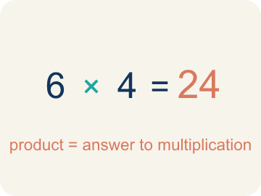 | Product Producto  The answer when you multiply.  Example: 4 × 7 = 28, so the product is 28
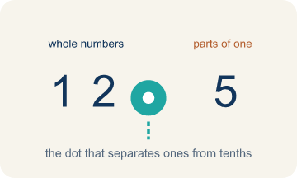 | Decimal point Punto decimal  The dot that splits the whole number from the part after it.  Example: In 3.25, the decimal point separates 3 (ones) from 25 (tenths and hundredths)
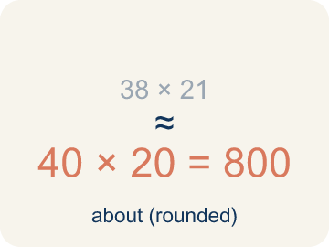 | Estimate Estimar  A close answer you get by rounding first.  Example: 3.7 × 4.2: round to 4 × 4 = 16, so the exact answer should be near 16
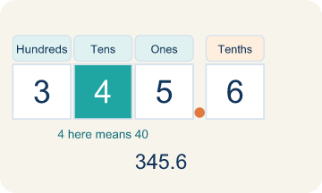 | Place value Valor posicional  What a digit is worth based on where it sits in a number.  Example: In 0.36: the 3 is in the tenths place (0.3) and the 6 is in the hundredths place (0.06)
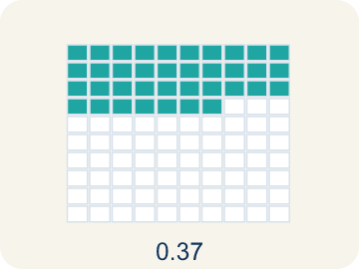 | Decimal places Cifras decimales  How many digits come after the decimal point.  Example: 3.4 (1 place) × 2.6 (1 place) = 8.84 (2 places total)

Guided Notes
Fill in each blank as we go. Use the Word Bank to help you.
WORD BANK
Multiply Decimals • Product • Decimal point • Estimate • Place value • Decimal places

1. Count the decimal places in BOTH factors to place the ________________ ________________.
2. The answer to a multiplication problem is the ________________.
3. The dot that separates whole numbers from parts of a whole is the ________________.
4. Finding an answer that is close but not exact, to check if a product is reasonable, is to ________________.
5. The value a digit has based on its position is its ________________.
6. To place the point in a product, I count the total number of ________________ in both factors.

Write About the Math
Use the support level you need. Every level answers the same math question.

1. Understand the Question explain
How do you multiply decimals to find the total cost? How can estimation help you check?
Your job: Answer the question. Use math evidence. Explain how the evidence proves your answer.
Responde la pregunta. Usa evidencia matemática. Explica cómo la evidencia demuestra tu respuesta.

2. Plan Your Math Words check at least two
☐ Multiply Decimals — Find the product of decimals, then use place value to place the decimal point.
Multiplicar decimales — Hallar el producto de decimales y luego usar el valor posicional para colocar el punto decimal.
☐ Product — The answer when you multiply.
Producto — La respuesta cuando multiplicas.
☐ Decimal point — The dot that splits the whole number from the part after it.
Punto decimal — El punto que separa el número entero de la parte que sigue.
☐ Estimate — A close answer you get by rounding first.
Estimar — Una respuesta cercana que obtienes al redondear primero.
☐ Place value — What a digit is worth based on where it sits in a number.
Valor posicional — Lo que vale un dígito según el lugar que ocupa en el número.
Say it first: Say your idea to a partner or quietly to yourself before you write.
The total cost is $___ because 3.5 × $6.80 = $___, and I can estimate by rounding to ___ × ___ = ___.
Di tu respuesta primero: Mi respuesta es ___ porque ___.

3. Build Your Explanation choose your support
This model shows the parts of an explanation. It does not answer your writing question.
Claim: Rounding the factors gives a reasonable estimate of the product.
Evidence: Students round to about 5 × $13 = $65 (or 4 × $13) to predict the cost is in the $50-$65 range, naming 4.5 and 12.60 as the factors.
Reasoning: This evidence connects the definition of multiply decimals to the mathematical claim.

Start Most language support
Complete the frames. Use the word bank.
Completa las oraciones. Usa el banco de palabras.
The total cost is $___ because 3.5 × $6.80 = $___, and I can estimate by rounding to ___ × ___ = ___.
My answer is ___.
Mi respuesta es ___.

Build Some language support
Write two connected sentences. Use because, so, or but.
Escribe dos oraciones conectadas. Usa porque, entonces o pero.
My claim is ___.
Mi afirmación es ___.
I know because ___.
Lo sé porque ___.
So ___.
Entonces ___.

Explain Light language support
Write a claim, give math evidence, and explain your reasoning.
Escribe una afirmación, da evidencia matemática y explica tu razonamiento.
My claim is ___.
Mi afirmación es ___.
My math evidence is ___.
Mi evidencia matemática es ___.
This proves ___ because ___.
Esto demuestra ___ porque ___.

4. Check Your Explanation five quick checks
☐ I answered the question.
Respondí la pregunta.
☐ I used math evidence: numbers, an equation, a model, or a comparison.
Usé evidencia matemática: números, una ecuación, un modelo o una comparación.
☐ I explained how the evidence proves my answer.
Expliqué cómo la evidencia demuestra mi respuesta.
☐ I used at least two math words.
Usé por lo menos dos palabras matemáticas.
☐ I reread complete sentences and punctuation.
Volví a leer mis oraciones completas y la puntuación.

Worked Example

Watch & Read I Do — follow along with your teacher
Space Station Material Costs
The station needs 4.5 meters of heat shielding that costs $12.60 per meter. Commander Diaz needs to calculate the total cost before submitting the supply order. What is the total cost of the shielding?

Think about:
• What two quantities are being multiplied?
• How many total decimal places do the two factors have?
• How can estimating help you check if your answer is reasonable?
• Where does the decimal point go in the product?

Solved Example I Do — watch each step
Problem: What is 3.4 × 2.6?
A) 8.84
B) 88.4
C) 0.884
D) 8.48
Step 1: 34 × 26 = 884.
Step 2: There are 2 total decimal places (1 + 1), so place the decimal to get 8.84.
Answer: A. 8.84

Guided Practice

Solve Together We Do — work with your class
Problem: What is 0.7 × 1.5?
A) 1.05
B) 10.5
C) 0.105
D) 1.50
Step 1:

Step 2:

Answer:

A family is buying 3.5 pounds of deli meat that costs $6.80 per pound at the grocery store.
How do you multiply decimals to find the total cost? How can estimation help you check?

Sentence frame: The total cost is $___ because 3.5 × $6.80 = $___, and I can estimate by rounding to ___ × ___ = ___.

Turn & Talk discuss with a partner
1. [Launch] The station needs 4.5 meters of heat shielding at $12.60 per meter. About how much will it cost, and how did you estimate before multiplying?
Start with: I estimate about $___ because 4.5 is close to ___ and $12.60 is close to ___.
Estimo unos $___ porque 4.5 está cerca de ___ y $12.60 está cerca de ___.
Word bank: product, decimal point, estimate, place value, decimal places
2. [Explore] When you multiplied 4.5 × 12.60, how did you decide where to put the decimal point in the product?
Start with: I counted ___ decimal places in the factors.
Conté ___ lugares decimales en los factores.
Word bank: product, decimal point, estimate, place value, decimal places
3. [Connect] A family buys 3.5 pounds of deli meat at $6.80 per pound. How do you multiply the decimals to find the total cost, and how can estimating check it?
Start with: The total cost is $___ because I multiplied ___ × ___.
El costo total es $___ porque multipliqué ___ × ___.
Word bank: product, decimal point, estimate, place value, decimal places
4. [Reflect] How is placing the decimal point in a product different from lining up decimals when adding? Why don't you line up the points to multiply?
Start with: To multiply I ___ the decimal places, but to add I ___ the decimal points.
Para multiplicar ___ los lugares decimales, pero para sumar ___ los puntos decimales.
Word bank: product, decimal point, estimate, place value, decimal places
5. [Practice] During practice on Multiply Decimals, what strategy did you use when a problem felt tricky?
Start with: I counted ___ decimal places in the factors.
Conté ___ lugares decimales en los factores.
Word bank: product, decimal point, estimate, place value, decimal places

Independent Practice

On Your Own You Do — show your work
Solve each problem. Show your thinking in the work box.

On Level grade-level practice
1. A car travels 55.5 miles per hour for 2.4 hours. How far does it go?
A) 133.2 miles
B) 13.32 miles
C) 1,332 miles
D) 57.9 miles

Exit Ticket
Answer on your own. This shows what you learned today.
★ What is 4.6 × 2.3?
A) 10.58
B) 105.8
C) 1.058
D) 10.48

Answer Key & Teacher Guide
Teacher reference — remove or fold back before distributing to students.

Guided Notes (Fill-in)
Notes 1: Multiply Decimals
Notes 2: Product
Notes 3: Decimal point
Notes 4: Estimate
Notes 5: Place value
Notes 6: Decimal places

Worked Notes (I Do / We Do)
I Do: A. 8.84
We Do: A. 1.05

Independent Practice
Watch for this mistake: A common mistake in Multiply Decimals is counting decimal places from only one factor instead of adding the decimal places from BOTH factors. For example, in 0.4 × 0.06, a student multiplies 4 × 6 = 24, then places the decimal point using just one factor's place count (1 place), writing 0.24 instead of the correct answer: 0.4 has 1 decimal place and 0.06 has 2 decimal places, for a total of 3, so 24 becomes 0.024. Before you submit, count the decimal places in EACH factor separately and add them together — that total is how many decimal places belong in your final answer.

Level 1 Support
1. A) 21.2 — 53 × 4 = 212. There is 1 total decimal place, so place the decimal to get 21.2.
2. A) 5 × 3 = 15 — Round 4.8 to 5 and 3.2 to 3. The estimate 5 × 3 = 15 is closest to the exact answer 15.36.

On Level
3. A) 133.2 miles — 555 × 24 = 13,320. Total decimal places: 1 + 1 = 2. Answer: 133.20 = 133.2 miles.

Exit Ticket
A) 10.58 — 46 × 23 = 1,058. There are 2 total decimal places (1 + 1), so the answer is 10.58.

Math Writing Criteria
The support level changes the amount of language scaffolding, not the mathematical expectation.
☐ I answered the question.
☐ I used math evidence: numbers, an equation, a model, or a comparison.
☐ I explained how the evidence proves my answer.
☐ I used at least two math words.
☐ I reread complete sentences and punctuation.

