UNIT 2 · LESSON 2 STANDARD 6.DS.5

Represent and Describe Data in a Histogram
Student Notes Packet
Name: ______________________ Date: ____________ Period: ________
Level 1 · Support

Today's Goals
Content: I can make and read a histogram to display data in intervals.
Language: I can explain my histogram using the words histogram, frequency, interval, and distribution.

Key Vocabulary
Look at the picture, read the word, then read what it means.
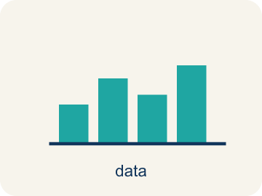 | Display Data with Histograms Representar datos con histogramas  Group numerical data into intervals and show each interval's frequency with a bar.  Example: Each touching bar shows how many values fall in one interval.
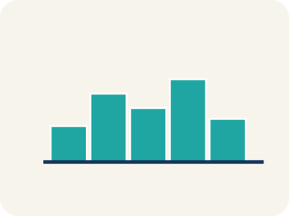 | Histogram Histograma  A bar graph that groups data into equal ranges. The bars touch.  Example: Bars side by side: 0-9 pts (3 players), 10-19 pts (8 players), 20-29 pts (4 players)
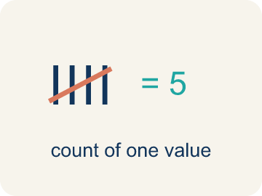 | Frequency Frecuencia  How many times a value shows up.  Example: If 5 players scored 10-19 points, the frequency for that interval is 5
 | Interval Intervalo  A range of numbers used to group data.  Example: 0-9, 10-19, 20-29 are intervals of width 10 — each covers 10 values
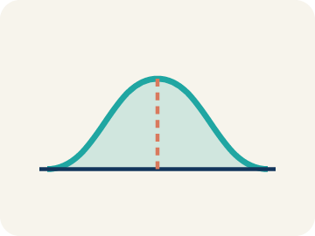 | Distribution Distribución  How the data is spread out.  Example: Most data in the middle with fewer at the ends = bell-shaped; most on one side with a tail = skewed
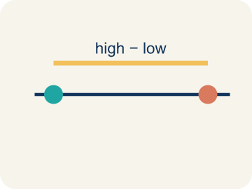 | Variability Variabilidad  How spread out the numbers are.  Example: Data in just 2 intervals = low variability. Data across 6 intervals = high variability

Guided Notes
Fill in each blank as we go. Use the Word Bank to help you.
WORD BANK
Display Data with Histograms • Histogram • Frequency • Interval • Distribution • Variability

1. A histogram groups numerical data into equal ________________ and shows each one's ________________.
2. A bar graph that shows how often data falls into equal intervals is a ________________.
3. How many data values fall in an interval is the ________________.
4. An equal-sized range of values used to group data is an ________________.
5. The overall pattern of how data is spread out is the ________________.
6. How much the data values differ is the ________________.

Write About the Math
Use the support level you need. Every level answers the same math question.

1. Understand the Question explain
Does the histogram support the coach's claim? What does the shape of the data tell you?
Your job: Answer the question. Use math evidence. Explain how the evidence proves your answer.
Responde la pregunta. Usa evidencia matemática. Explica cómo la evidencia demuestra tu respuesta.

2. Plan Your Math Words check at least two
☐ Display Data with Histograms — Group numerical data into intervals and show each interval's frequency with a bar.
Representar datos con histogramas — Agrupar datos numéricos en intervalos y mostrar la frecuencia de cada intervalo con una barra.
☐ Histogram — A bar graph that groups data into equal ranges. The bars touch.
Histograma — Una gráfica de barras que agrupa datos en rangos iguales. Las barras se tocan.
☐ Frequency — How many times a value shows up.
Frecuencia — Cuántas veces aparece un valor.
☐ Interval — A range of numbers used to group data.
Intervalo — Un rango de números para agrupar datos.
☐ Distribution — How the data is spread out.
Distribución — Cómo están repartidos los datos.
Say it first: Say your idea to a partner or quietly to yourself before you write.
The histogram peaks at the ___ interval with ___ players. The shape is approximately ___. This ___ the coach's claim because ___.
Di tu respuesta primero: Mi respuesta es ___ porque ___.

3. Build Your Explanation choose your support
This model shows the parts of an explanation. It does not answer your writing question.
Claim: A histogram groups data into equal intervals so large data sets become readable.
Evidence: Students explain grouping into intervals makes 30 values readable and that each bar's height is the frequency for that interval.
Reasoning: This evidence connects the definition of histogram to the mathematical claim.

Start Most language support
Complete the frames. Use the word bank.
Completa las oraciones. Usa el banco de palabras.
The histogram peaks at the ___ interval with ___ players. The shape is approximately ___. This ___ the coach's claim because ___.
My answer is ___.
Mi respuesta es ___.

Build Some language support
Write two connected sentences. Use because, so, or but.
Escribe dos oraciones conectadas. Usa porque, entonces o pero.
My claim is ___.
Mi afirmación es ___.
I know because ___.
Lo sé porque ___.
So ___.
Entonces ___.

Explain Light language support
Write a claim, give math evidence, and explain your reasoning.
Escribe una afirmación, da evidencia matemática y explica tu razonamiento.
My claim is ___.
Mi afirmación es ___.
My math evidence is ___.
Mi evidencia matemática es ___.
This proves ___ because ___.
Esto demuestra ___ porque ___.

4. Check Your Explanation five quick checks
☐ I answered the question.
Respondí la pregunta.
☐ I used math evidence: numbers, an equation, a model, or a comparison.
Usé evidencia matemática: números, una ecuación, un modelo o una comparación.
☐ I explained how the evidence proves my answer.
Expliqué cómo la evidencia demuestra mi respuesta.
☐ I used at least two math words.
Usé por lo menos dos palabras matemáticas.
☐ I reread complete sentences and punctuation.
Volví a leer mis oraciones completas y la puntuación.

Worked Example

Watch & Read I Do — follow along with your teacher
League Stats Organizer
The basketball league has 30 players and wants to display everyone's points-per-game average in a way that shows how the data is distributed. The raw averages are: 2, 5, 7, 8, 9, 10, 11, 11, 12, 13, 13, 14, 14, 15, 15, 16, 16, 17, 18, 18, 19, 20, 21, 22, 23, 24, 25, 28, 30, 32. Listing all 30 numbers is hard to read — a histogram will reveal the pattern!

Think about:
• Where do most of the scoring averages seem to cluster?
• Are there many players at the very low or very high end?
• How could you group these numbers to see a pattern?
• What size intervals would work best for this data?
• What shape will the data make when grouped into a histogram?

Solved Example I Do — watch each step
Problem: A histogram shows these frequencies: 0–4: 3 players, 5–9: 8 players, 10–14: 12 players, 15–19: 5 players. How many players are represented in total?
A) 20
B) 15
C) 28
D) 12
Step 1: Add all frequencies: 3 + 8 + 12 + 5 = 28 players.
Answer: C. 28

Guided Practice

Solve Together We Do — work with your class
Problem: In a histogram, what does the height of each bar represent?
A) The average of the data in that interval
B) The range of the interval
C) The median of the data
D) The frequency (count) of data in that interval
Step 1:

Step 2:

Answer:

A soccer coach looks at a histogram of shots-per-game for the team: 0–2 shots: 1 player, 3–5 shots: 8 players, 6–8 shots: 10 players, 9–11 shots: 3 players, 12–14 shots: 1 player. The coach says, 'Most of my players take a good number of shots.'
Does the histogram support the coach's claim? What does the shape of the data tell you?

Sentence frame: The histogram peaks at the ___ interval with ___ players. The shape is approximately ___. This ___ the coach's claim because ___.

Turn & Talk discuss with a partner
1. [Launch] You have 30 players' points-per-game averages. Why is it easier to display them in a histogram with intervals than to list all 30 numbers?
Start with: A histogram is easier because it groups the data into ___.
Un histograma es más fácil porque agrupa los datos en ___.
Word bank: histogram, frequency, interval, distribution, bar
2. [Explore] As you build the frequency table with intervals of 10, what does the height of each bar in the histogram represent?
Start with: The height of each bar shows the ___ of that interval.
La altura de cada barra muestra la ___ de ese intervalo.
Word bank: histogram, frequency, interval, distribution, bar
3. [Connect] A histogram of shots-per-game shows 0-2: 1 player, 3-5: 8, 6-8: 10, 9-11: 3, 12-14: 1. The coach says 'most players take a good number of shots.' Does the shape support that claim?
Start with: The histogram ___ the coach's claim because most players are in the ___ intervals.
El histograma ___ la afirmación porque la mayoría está en los intervalos ___.
Word bank: histogram, frequency, interval, distribution, shape
4. [Reflect] A histogram of heights shows 60-63 in: 2, 64-67 in: 7, 68-71 in: 9, 72-75 in: 4. Which interval has the most players, and how do you know?
Start with: The ___ interval has the most players because its bar is ___.
El intervalo ___ tiene más jugadores porque su barra es ___.
Word bank: histogram, frequency, interval, distribution, bar
5. [Practice] During practice on Display Data: Histograms, what strategy did you use when a problem felt tricky?
Start with: The height of each bar shows the ___ of that interval.
La altura de cada barra muestra la ___ de ese intervalo.
Word bank: Histogram, Frequency, Interval, Distribution

Independent Practice

On Your Own You Do — show your work
Solve each problem. Show your thinking in the work box.

Level 1 Support extra scaffolding
1. How is a histogram different from a regular bar graph?
A) There is no difference
B) Histogram bars touch (no gaps) because the intervals are continuous ranges
C) Histograms use colors and bar graphs don't
D) Bar graphs show numbers and histograms show words

2. A histogram has intervals: 0–4, 5–9, 10–14, 15–19. What is the width of each interval?
A) 10
B) 19
C) 5
D) 4

3. A histogram bar for the interval 20–29 reaches a height of 7. What does the 7 tell you?
A) The largest value is 7
B) There are 7 intervals
C) The interval is 7 wide
D) 7 data values fall between 20 and 29

Exit Ticket
Answer on your own. This shows what you learned today.
★ A histogram of player heights shows: 60–63 in: 2, 64–67 in: 7, 68–71 in: 9, 72–75 in: 4. Which interval has the most players?
A) 72–75 inches
B) 60–63 inches
C) 68–71 inches
D) 64–67 inches

Answer Key & Teacher Guide
Teacher reference — remove or fold back before distributing to students.

Guided Notes (Fill-in)
Notes 1: Display Data with Histograms
Notes 2: Histogram
Notes 3: Frequency
Notes 4: Interval
Notes 5: Distribution
Notes 6: Variability

Worked Notes (I Do / We Do)
I Do: C. 28
We Do: D. The frequency (count) of data in that interval

Independent Practice
Watch for this mistake: A common mistake in Display Data: Histograms is counting a boundary value in two intervals at once — for example, putting the value 10 in both the '0–9' bin and the '10–19' bin. Each data value belongs to exactly ONE interval. Before you submit, add up all your frequencies and check that the total matches the number of data values you started with.

Level 1 Support
1. B) Histogram bars touch (no gaps) because the intervals are continuous ranges — In a histogram, bars touch because each interval connects to the next (0–9, 10–19, etc.) — the data is continuous.
2. C) 5 — Each interval covers 5 values (0,1,2,3,4 then 5,6,7,8,9 etc.), so the width is 5.
3. D) 7 data values fall between 20 and 29 — A bar's height is the frequency — here, 7 values land in the 20–29 interval.

On Level
4. B) 70–79 with 10 students — The 70–79 interval has the highest frequency of 10 students.
5. C) Skewed right (most players low, tail toward high values) — The tallest bars are at the low end (0–1) and the bars shrink as goals increase — the tail points right, so it is skewed right.

Level 2 Enrichment
6. D) Skewed right — The tail points right (toward the high values), so it is skewed right — most players are clustered at the low end.

Exit Ticket
C) 68–71 inches — The 68–71 inch interval has the highest frequency of 9 players.

Math Writing Criteria
The support level changes the amount of language scaffolding, not the mathematical expectation.
☐ I answered the question.
☐ I used math evidence: numbers, an equation, a model, or a comparison.
☐ I explained how the evidence proves my answer.
☐ I used at least two math words.
☐ I reread complete sentences and punctuation.

