2.1–2.3 Catch-Up — Homework
Lesson 2-3-catchup • Standard 6.DS.4
Name: ______________________ Period: ______ Date: ____________

Today's Goals
Content: I can show I am caught up on Lessons 2.1–2.3 by using each lesson's big idea in mixed practice.
Language: I can explain which lesson's big idea I used and how, using key vocabulary from Lessons 2.1–2.3.

Key Words
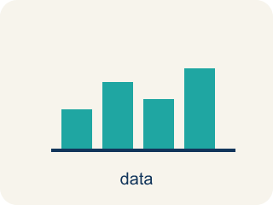
Statistical Questions and Data (Preguntas estadísticas y datos) — A statistical question expects varied answers that can be collected as data.
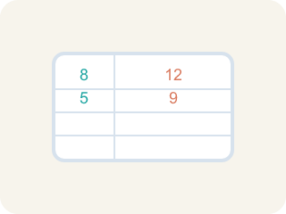
Statistical Question (Pregunta estadística) — A question where the answers will be different for different people.

Non-statistical Question (Pregunta no estadística) — A question that has just one fixed answer that is the same no matter who you ask, so there is no data to collect.

Data (Datos) — Facts and numbers you collect, like answers to a survey.
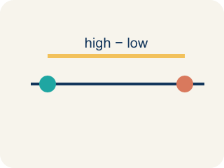
Variability (Variabilidad) — How spread out the numbers are.

Survey (Encuesta) — Collecting facts by asking people questions.
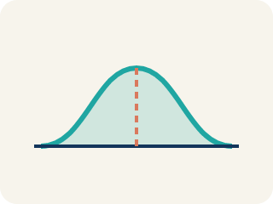
Data distribution (Distribución de datos) — How the data looks: where it sits and how spread out it is.

Display Data with Histograms (Representar datos con histogramas) — Group numerical data into intervals and show each interval's frequency with a bar.

Describe the Data Using the Median (Describir los datos con la mediana) — Using the middle value of the ordered data to say what is typical for the whole set.
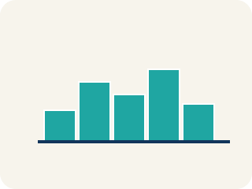
Histogram (Histograma) — A bar graph that groups data into equal ranges. The bars touch.
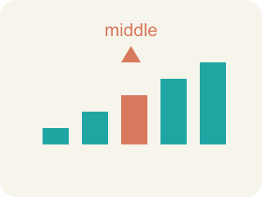
Median (Mediana) — The middle number when you put them in order.

Practice
Show your work. Use the blank space under each problem.
1. (Lesson 2.1) Which of the following is a statistical question?
A. How many points did each player score this season?
B. How many points are scored for a free throw?
C. What sport does this team play?
D. How many halves are in a soccer game?
______________________________________________________________________
2. (Lesson 2.1) Which question is NOT a statistical question?
A. How many innings are in a baseball game?
B. How many home runs did each player hit this year?
C. How many miles does each runner train per week?
D. How tall is each player on the basketball team?
______________________________________________________________________
3. (Lesson 2.1) A coach asks: "How many hours does each athlete on the track team sleep the night before a meet?" Why is this a statistical question?
A. Because the answers will vary from athlete to athlete
B. Because it is about sports
C. Because it has a numerical answer
D. Because the coach asked it
______________________________________________________________________
4. (Lesson 2.1) Spot the Common Mistake
Step 1 (Question): How many points does the team need to win a game?
Step 2 (Student decision): This IS a statistical question.
Step 3 (Student reason): It is about basketball and the answer is a number, so it must be statistical.
Which step has the mistake? Explain and fix it:
______________________________________________________________________
______________________________________________________________________
______________________________________________________________________
5. (Lesson 2.2) A histogram of test scores shows: 50–59: 2, 60–69: 5, 70–79: 10, 80–89: 8, 90–99: 3. Which interval has the most students?
A. 90–99 with 3 students
B. 70–79 with 10 students
C. 80–89 with 8 students
D. 60–69 with 5 students
______________________________________________________________________
6. (Lesson 2.2) A histogram of goals-per-game shows: 0–1: 9 players, 2–3: 6, 4–5: 3, 6–7: 1. What shape is this distribution?
A. Perfectly symmetric
B. Flat / uniform (all bars equal)
C. Skewed right (most players low, tail toward high values)
D. Skewed left (most players high, tail toward low values)
______________________________________________________________________
7. (Lesson 2.3) Data set: 4, 6, 6, 8, 10, 12. What is the median?
A. 7
B. 6
C. 8
D. 7.67
______________________________________________________________________
8. (Lesson 2.3) The Even-Count Median Mistake
Step 1 (Data set): Points per game, in order: 3, 8, 10, 14, 16, 20 (6 values)
Step 2 (Goal): Find the MEDIAN number of points.
Step 3 (Pick the middle): With 6 values the student grabs a single middle number and says median = 10.
Step 4 (Answer): Median = 10
Which step has the mistake? Explain and fix it:
______________________________________________________________________
______________________________________________________________________
______________________________________________________________________
9. (Lesson 2.1) The team analyst writes four questions for the scouting report. Which one is a statistical question?
A. How many rebounds does each player grab per game?
B. How many points is a single free throw worth?
C. What is the height of the basketball rim?
D. How many timeouts does each team get per half?
______________________________________________________________________
10. (Lesson 2.2) Data: 4, 8, 9, 12, 14, 15, 17, 18, 19, 22, 24, 27, 31, 33. How many values fall in the 10–19 interval?
A. 9
B. 5
C. 6
D. 3
______________________________________________________________________

Answer Key (Teacher)
1. A. How many points did each player score this season?
"How many points did each player score?" is statistical because different players will have different scores — there is variability in the data.
Watch for: A common mistake in Mean, Median, and Mode is finding the median without ordering the data first — students pick the middle number straight from the list as given (for 9, 4, 7, 2, 6 they say the median is 7, the middle position in that original order) instead of sorting least to greatest (2, 4, 6, 7, 9) and finding the true middle value, 6. Before finalizing a median, always reorder the data smallest to largest, then count to the middle position — and if there is an even number of values, average the two middle numbers.
2. A. How many innings are in a baseball game?
"How many innings are in a baseball game?" has one fixed answer (9) — no variability. The other questions all produce different answers for different people.
Watch for: A common mistake in Mean, Median, and Mode is finding the median without ordering the data first — students pick the middle number straight from the list as given (for 9, 4, 7, 2, 6 they say the median is 7, the middle position in that original order) instead of sorting least to greatest (2, 4, 6, 7, 9) and finding the true middle value, 6. Before finalizing a median, always reorder the data smallest to largest, then count to the middle position — and if there is an even number of values, average the two middle numbers.
3. A. Because the answers will vary from athlete to athlete
A statistical question anticipates variability. Different athletes sleep different amounts, so the data collected will vary.
Watch for: A common mistake in Mean, Median, and Mode is finding the median without ordering the data first — students pick the middle number straight from the list as given (for 9, 4, 7, 2, 6 they say the median is 7, the middle position in that original order) instead of sorting least to greatest (2, 4, 6, 7, 9) and finding the true middle value, 6. Before finalizing a median, always reorder the data smallest to largest, then count to the middle position — and if there is an even number of values, average the two middle numbers.
4. (Lesson 2.1) Spot the Common Mistake
The mistake is in Step 3.
Correct work: The reason is wrong. Being about basketball or having a number does not make a question statistical. "How many points does the team need to win a game?" has one fixed answer — you only need to score more than the other team — so the answers do not vary. This is NOT a statistical question.
Watch for: The reasoning step says a basketball topic and a numerical answer make a question statistical, but neither one does. The points needed to win has a single fixed answer — more than the other team — so nothing varies, and the question is not statistical.
5. B. 70–79 with 10 students
The 70–79 interval has the highest frequency of 10 students.
Watch for: A common mistake in Mean, Median, and Mode is finding the median without ordering the data first — students pick the middle number straight from the list as given (for 9, 4, 7, 2, 6 they say the median is 7, the middle position in that original order) instead of sorting least to greatest (2, 4, 6, 7, 9) and finding the true middle value, 6. Before finalizing a median, always reorder the data smallest to largest, then count to the middle position — and if there is an even number of values, average the two middle numbers.
6. C. Skewed right (most players low, tail toward high values)
The tallest bars are at the low end (0–1) and the bars shrink as goals increase — the tail points right, so it is skewed right.
Watch for: A common mistake in Mean, Median, and Mode is finding the median without ordering the data first — students pick the middle number straight from the list as given (for 9, 4, 7, 2, 6 they say the median is 7, the middle position in that original order) instead of sorting least to greatest (2, 4, 6, 7, 9) and finding the true middle value, 6. Before finalizing a median, always reorder the data smallest to largest, then count to the middle position — and if there is an even number of values, average the two middle numbers.
7. A. 7
With 6 values, the median is the average of the 3rd and 4th values: (6 + 8) ÷ 2 = 7.
Watch for: A common mistake in Mean, Median, and Mode is finding the median without ordering the data first — students pick the middle number straight from the list as given (for 9, 4, 7, 2, 6 they say the median is 7, the middle position in that original order) instead of sorting least to greatest (2, 4, 6, 7, 9) and finding the true middle value, 6. Before finalizing a median, always reorder the data smallest to largest, then count to the middle position — and if there is an even number of values, average the two middle numbers.
8. (Lesson 2.3) The Even-Count Median Mistake
The mistake is in Step 3.
Correct work: When a data set has an EVEN number of values there is no single middle number. You must average the TWO middle values. Here the 3rd and 4th values are 10 and 14, so the median = (10 + 14) ÷ 2 = 12, not 10.
Watch for: With 6 values there is no single number sitting in the middle — positions 3 and 4 tie for the center. The 3rd and 4th values are 10 and 14, so the median is their average, (10 + 14) ÷ 2 = 12, not just the lower one.
9. A. How many rebounds does each player grab per game?
"How many rebounds does each player grab per game?" anticipates variability — different players grab different numbers of rebounds, so you must collect data. The other three each have one fixed answer.
Watch for: A common mistake in Mean, Median, and Mode is finding the median without ordering the data first — students pick the middle number straight from the list as given (for 9, 4, 7, 2, 6 they say the median is 7, the middle position in that original order) instead of sorting least to greatest (2, 4, 6, 7, 9) and finding the true middle value, 6. Before finalizing a median, always reorder the data smallest to largest, then count to the middle position — and if there is an even number of values, average the two middle numbers.
10. C. 6
The values 12, 14, 15, 17, 18, and 19 all fall between 10 and 19, so the frequency for that bin is 6.
Watch for: A common mistake in Mean, Median, and Mode is finding the median without ordering the data first — students pick the middle number straight from the list as given (for 9, 4, 7, 2, 6 they say the median is 7, the middle position in that original order) instead of sorting least to greatest (2, 4, 6, 7, 9) and finding the true middle value, 6. Before finalizing a median, always reorder the data smallest to largest, then count to the middle position — and if there is an even number of values, average the two middle numbers.

