UNIT 2 · LESSON 3 STANDARD 6.DS.4

Describe the Data Using the Median
Student Notes Packet
Name: ______________________ Date: ____________ Period: ________
Level 2 · Standard

Today's Goals
Content: I can find the median of a data set and use it to describe what is typical.
Language: I can explain the median using the words order, middle, typical, and half.

Key Vocabulary
Look at the picture, read the word, then read what it means.
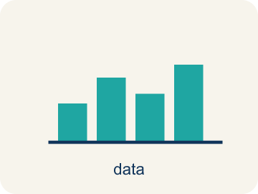 | Describe the Data Using the Median Describir los datos con la mediana  Using the middle value of the ordered data to say what is typical for the whole set.  Example: 2, 4, 4, 6, 9 → median 4
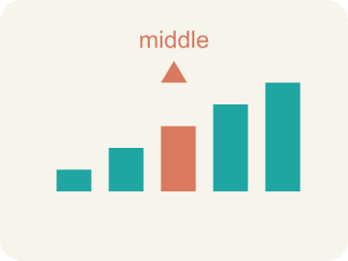 | Median Mediana  The middle number when you put them in order.  Example: Data: 1, 3, 5, 7, 9 → the middle (3rd) value is 5, so median = 5
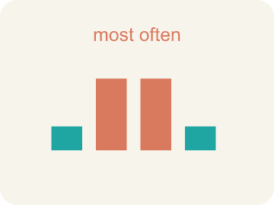 | Mode Moda  The number that shows up most often.  Example: Data: 2, 3, 3, 5, 7 → 3 appears twice (most often), so mode = 3
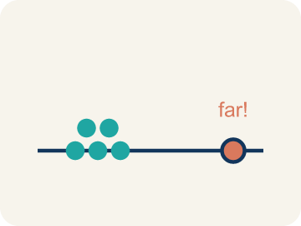 | Outlier Valor atípico  A number that is much bigger or smaller than the rest.  Example: Data: 10, 12, 11, 13, 50 → 50 is far from the others, so 50 is an outlier
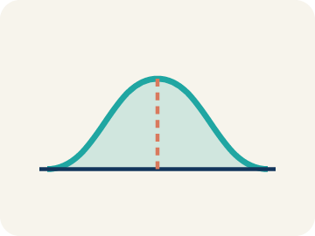 | Data distribution Distribución de datos  How the data looks: where it sits and how spread out it is.  Example: If most values cluster in the center with fewer at the ends, the distribution is symmetric
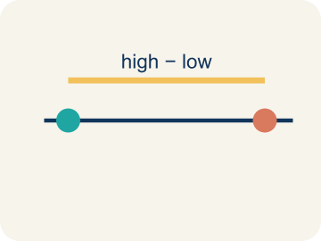 | Variability Variabilidad  How spread out the numbers are.  Example: 8, 9, 10, 11 has low variability (close together); 2, 10, 25, 40 has high variability (far apart)

Guided Notes
Fill in each blank as we go. Use the Word Bank to help you.
WORD BANK
Describe the Data Using the Median • Median • Mode • Outlier • Data distribution • Variability

1. When one value sits far from the rest, describe the typical value with the ________________.
2. The middle value of a data set when the numbers are in order is the ________________.
3. The value that appears most often in a data set is the ________________.
4. A value that is much larger or smaller than the rest of the data is an ________________.
5. The way data values are spread out is the ________________.
6. How spread out the data values are is the ________________.

Write About the Math
Use the support level you need. Every level answers the same math question.

1. Understand the Question explain
Who is using the mean, and who is using the mode? Which is more useful here?
Your job: Answer the question. Use math evidence. Explain how the evidence proves your answer.
Responde la pregunta. Usa evidencia matemática. Explica cómo la evidencia demuestra tu respuesta.

2. Plan Your Math Words check at least two
☐ Describe the Data Using the Median — Using the middle value of the ordered data to say what is typical for the whole set.
Describir los datos con la mediana — Usar el valor del medio de los datos ordenados para decir qué es típico en todo el conjunto.
☐ Median — The middle number when you put them in order.
Mediana — El número del medio cuando los pones en orden.
☐ Mode — The number that shows up most often.
Moda — El número que aparece más veces.
☐ Outlier — A number that is much bigger or smaller than the rest.
Valor atípico — Un número mucho mayor o menor que los demás.
☐ Data distribution — How the data looks: where it sits and how spread out it is.
Distribución de datos — Cómo se ven los datos: dónde están y qué tan separados están.
Say it first: Say your idea to a partner or quietly to yourself before you write.
The teacher used the ___ (about 86.6). The student used the ___ (92). The ___ is more useful here because ___.
Di tu respuesta primero: Mi respuesta es ___ porque ___.

3. Build Your Explanation choose your support
This model shows the parts of an explanation. It does not answer your writing question.
Claim: Mean, median, and mode each describe the center of the data in a different way.
Evidence: Students distinguish the three measures and justify a choice, noting the mode (38) is the most repeated and the mean/median sit near the center.
Reasoning: This evidence connects the definition of describe the data using the median to the mathematical claim.

Start Most language support
Complete the frames. Use the word bank.
Completa las oraciones. Usa el banco de palabras.
The teacher used the ___ (about 86.6). The student used the ___ (92). The ___ is more useful here because ___.
My answer is ___.
Mi respuesta es ___.

Build Some language support
Write two connected sentences. Use because, so, or but.
Escribe dos oraciones conectadas. Usa porque, entonces o pero.
My claim is ___.
Mi afirmación es ___.
I know because ___.
Lo sé porque ___.
So ___.
Entonces ___.

Explain Light language support
Write a claim, give math evidence, and explain your reasoning.
Escribe una afirmación, da evidencia matemática y explica tu razonamiento.
My claim is ___.
Mi afirmación es ___.
My math evidence is ___.
Mi evidencia matemática es ___.
This proves ___ because ___.
Esto demuestra ___ porque ___.

4. Check Your Explanation five quick checks
☐ I answered the question.
Respondí la pregunta.
☐ I used math evidence: numbers, an equation, a model, or a comparison.
Usé evidencia matemática: números, una ecuación, un modelo o una comparación.
☐ I explained how the evidence proves my answer.
Expliqué cómo la evidencia demuestra mi respuesta.
☐ I used at least two math words.
Usé por lo menos dos palabras matemáticas.
☐ I reread complete sentences and punctuation.
Volví a leer mis oraciones completas y la puntuación.

Worked Example

Watch & Read I Do — follow along with your teacher
Game Day Stats
You're the stats analyst for the school basketball team. Coach needs a report on the team's scoring: in the last 7 games they scored 42, 38, 55, 41, 38, 44, and 40 points. Which average best represents the team's typical performance?

Think about:
• What are the highest and lowest scores?
• Do any scores repeat?
• Which score seems like a typical game for this team?
• Will the mean and median be the same number?
• How does the 55-point game affect the average?

Solved Example I Do — watch each step
Problem: Find the mean of: 10, 14, 8, 12, 16
A) 12
B) 14
C) 10
D) 60
Step 1: Sum = 10 + 14 + 8 + 12 + 16 = 60.
Step 2: Mean = 60 ÷ 5 = 12.
Answer: A. 12

Guided Practice

Solve Together We Do — work with your class
Problem: Find the median of: 3, 7, 2, 9, 5
A) 5
B) 3
C) 7
D) 5.2
Step 1:

Step 2:

Answer:

Your class took a math quiz. The scores were: 85, 92, 78, 88, 92, 95, 72, 88, 92, 84. The teacher says 'most students scored around 87.' A student disagrees and says 'the most common score was 92.'
Who is using the mean, and who is using the mode? Which is more useful here?

Sentence frame: The teacher used the ___ (about 86.6). The student used the ___ (92). The ___ is more useful here because ___.

Turn & Talk discuss with a partner
1. [Launch] The team scored 42, 38, 55, 41, 38, 44, 40 points over 7 games. Which 'average' would best tell the coach the team's typical scoring: mean, median, or mode?
Start with: I would use the ___ because it best shows the typical score.
Usaría la ___ porque muestra mejor el puntaje típico.
Word bank: mean, median, mode, average, data set
2. [Explore] After ordering the scores on the number line, how do you find the median, and how is it different from the mean you calculated?
Start with: To find the median, I first ___ the scores, then pick the ___.
Para hallar la mediana, primero ___ los puntajes y luego elijo el ___.
Word bank: mean, median, mode, order, data set
3. [Connect] Quiz scores were 85, 92, 78, 88, 92, 95, 72, 88, 92, 84. The teacher says 'most scored around 87'; a student says 'the most common score was 92.' Who used the mean, and who used the mode?
Start with: The teacher used the ___, and the student used the ___.
El maestro usó la ___, y el estudiante usó la ___.
Word bank: mean, median, mode, average, data set
4. [Reflect] For the data set 4, 7, 10, 7, 12, talk through how you find the median.
Start with: First I order the values: ___.
Primero ordeno los valores: ___.
Word bank: median, mean, mode, order, middle
5. [Practice] During practice on Mean, Median, and Mode, what strategy did you use when a problem felt tricky?
Start with: To find the median, I first ___ the scores, then pick the ___.
Para hallar la mediana, primero ___ los puntajes y luego elijo el ___.
Word bank: Mean, Median, Mode, Outlier

Independent Practice

On Your Own You Do — show your work
Solve each problem. Show your thinking in the work box.

On Level grade-level practice
1. Data set: 4, 6, 6, 8, 10, 12. What is the median?
A) 7
B) 6
C) 8
D) 7.67

Exit Ticket
Answer on your own. This shows what you learned today.
★ Data set: 4, 7, 10, 7, 12. What is the median, and what does it tell you?
A) 7 — a typical value in this set is about 7
B) 10 — it is the middle number as the list is written
C) 8 — it is the average of all five values
D) 12 — it is the largest value

Answer Key & Teacher Guide
Teacher reference — remove or fold back before distributing to students.

Guided Notes (Fill-in)
Notes 1: Describe the Data Using the Median
Notes 2: Median
Notes 3: Mode
Notes 4: Outlier
Notes 5: Data distribution
Notes 6: Variability

Worked Notes (I Do / We Do)
I Do: A. 12
We Do: A. 5

Independent Practice
Watch for this mistake: A common mistake in Mean, Median, and Mode is finding the median without ordering the data first — students pick the middle number straight from the list as given (for 9, 4, 7, 2, 6 they say the median is 7, the middle position in that original order) instead of sorting least to greatest (2, 4, 6, 7, 9) and finding the true middle value, 6. Before finalizing a median, always reorder the data smallest to largest, then count to the middle position — and if there is an even number of values, average the two middle numbers.

Level 1 Support
1. A) 4 — 4 appears three times — more than any other value. Mode = 4.
2. A) 10 — Sum = 6 + 8 + 10 + 12 + 14 = 50. Mean = 50 ÷ 5 = 10.

On Level
3. A) 7 — With 6 values, the median is the average of the 3rd and 4th values: (6 + 8) ÷ 2 = 7.

Exit Ticket
A) 7 — a typical value in this set is about 7 — Put the values in order first: 4, 7, 7, 10, 12. With five values the middle is the 3rd, so the median is 7 — half the values sit at or below it.

Math Writing Criteria
The support level changes the amount of language scaffolding, not the mathematical expectation.
☐ I answered the question.
☐ I used math evidence: numbers, an equation, a model, or a comparison.
☐ I explained how the evidence proves my answer.
☐ I used at least two math words.
☐ I reread complete sentences and punctuation.

