UNIT 2 · LESSON 4 STANDARD 6.DS.5

Represent and Describe Data in a Box Plot
Student Notes Packet
Name: ______________________ Date: ____________ Period: ________
Level 1 · Support

Today's Goals
Content: I can make and read a box plot to summarize a data set.
Language: I can explain my box plot using the words box plot, median, quartile, and interquartile range.

Key Vocabulary
Look at the picture, read the word, then read what it means.
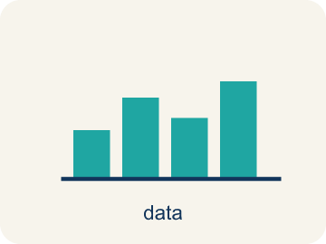 | Display Data with Box Plots Representar datos con diagramas de caja  Show a data set's five-number summary in a box-and-whisker display.  Example: minimum | Q1 [ median ] Q3 | maximum
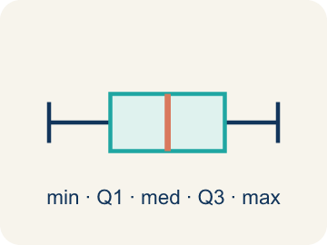 | Box Plot Diagrama de caja  A graph that shows how data is spread using five key numbers.  Example: A box from Q1 to Q3 with a line at the median, and whiskers from min to max
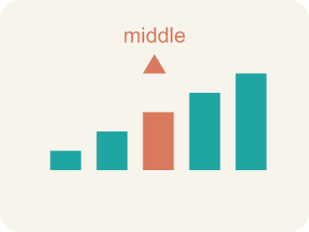 | Median Mediana  The middle number when you put them in order.  Example: Data: 10, 15, 20, 25, 30 → median is 20 (the 3rd value)
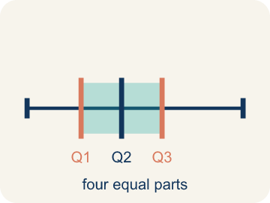 | Quartile Cuartil  Numbers that split the data into four equal parts.  Example: Data: 2, 4, 6, 8, 10, 12, 14 → Q1 = 4 (median of lower half), Q3 = 12 (median of upper half)
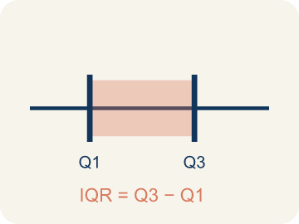 | Interquartile Range Rango intercuartílico  The spread of the middle half of the data (Q3 − Q1).  Example: If Q1 = 12 and Q3 = 20, then IQR = 20 − 12 = 8 — the middle 50% spans 8 units
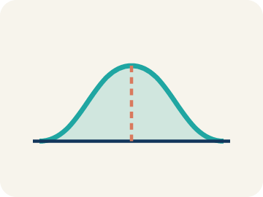 | Data distribution Distribución de datos  How the data looks: where it sits and how spread out it is.  Example: A box plot where the median is centered in the box shows symmetric distribution
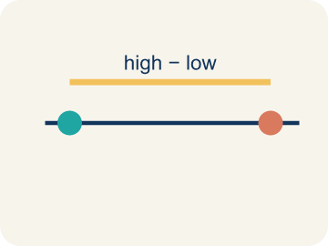 | Variability Variabilidad  How spread out the numbers are.  Example: Small IQR = low variability in the middle 50%. Large IQR = high variability

Guided Notes
Fill in each blank as we go. Use the Word Bank to help you.
WORD BANK
Display Data with Box Plots • Box Plot • Median • Quartile • Interquartile Range • Data distribution • Variability

1. A box plot shows the ________________-number summary: least, Q1, median, Q3, greatest.
2. A graph that shows data with a box and whiskers based on the five-number summary is a ________________.
3. The middle value of the data, shown as a line inside the box, is the ________________.
4. A value that divides the data into four equal parts is a ________________.
5. The distance between the first and third quartiles, showing the middle 50% of data, is the ________________.
6. The way data values are spread out is the ________________.
7. How spread out the data values are is the ________________.

Write About the Math
Use the support level you need. Every level answers the same math question.

1. Understand the Question explain
Which team is more consistently scoring high? Use the box plot values to support your answer?
Your job: Answer the question. Use math evidence. Explain how the evidence proves your answer.
Responde la pregunta. Usa evidencia matemática. Explica cómo la evidencia demuestra tu respuesta.

2. Plan Your Math Words check at least two
☐ Display Data with Box Plots — Show a data set's five-number summary in a box-and-whisker display.
Representar datos con diagramas de caja — Mostrar el resumen de cinco números de un conjunto de datos en un diagrama de caja y bigotes.
☐ Box Plot — A graph that shows how data is spread using five key numbers.
Diagrama de caja — Una gráfica que muestra cómo se reparten los datos con cinco números clave.
☐ Median — The middle number when you put them in order.
Mediana — El número del medio cuando los pones en orden.
☐ Quartile — Numbers that split the data into four equal parts.
Cuartil — Números que dividen los datos en cuatro partes iguales.
☐ Interquartile Range — The spread of the middle half of the data (Q3 − Q1).
Rango intercuartílico — La extensión de la mitad central de los datos (Q3 − Q1).
Say it first: Say your idea to a partner or quietly to yourself before you write.
Team A's IQR is ___ and Team B's IQR is ___. Team B's middle 50% scores between ___ and ___. The fan is wrong because ___. The box plot shows that Team B is more consistent because its Q1 and median are higher and its IQR (10) is smaller, while ___.
Di tu respuesta primero: Mi respuesta es ___ porque ___.

3. Build Your Explanation choose your support
This model shows the parts of an explanation. It does not answer your writing question.
Claim: A box plot is built from the minimum, Q1, median, Q3, and maximum.
Evidence: Students name the five-number summary (min, Q1, median, Q3, max) and find the median (14) for the 11 ordered scores.
Reasoning: This evidence connects the definition of box plot to the mathematical claim.

Start Most language support
Complete the frames. Use the word bank.
Completa las oraciones. Usa el banco de palabras.
Team A's IQR is ___ and Team B's IQR is ___. Team B's middle 50% scores between ___ and ___. The fan is wrong because ___. The box plot shows that Team B is more consistent because its Q1 and median are higher and its IQR (10) is smaller, while ___.
My answer is ___.
Mi respuesta es ___.

Build Some language support
Write two connected sentences. Use because, so, or but.
Escribe dos oraciones conectadas. Usa porque, entonces o pero.
My claim is ___.
Mi afirmación es ___.
I know because ___.
Lo sé porque ___.
So ___.
Entonces ___.

Explain Light language support
Write a claim, give math evidence, and explain your reasoning.
Escribe una afirmación, da evidencia matemática y explica tu razonamiento.
My claim is ___.
Mi afirmación es ___.
My math evidence is ___.
Mi evidencia matemática es ___.
This proves ___ because ___.
Esto demuestra ___ porque ___.

4. Check Your Explanation five quick checks
☐ I answered the question.
Respondí la pregunta.
☐ I used math evidence: numbers, an equation, a model, or a comparison.
Usé evidencia matemática: números, una ecuación, un modelo o una comparación.
☐ I explained how the evidence proves my answer.
Expliqué cómo la evidencia demuestra mi respuesta.
☐ I used at least two math words.
Usé por lo menos dos palabras matemáticas.
☐ I reread complete sentences and punctuation.
Volví a leer mis oraciones completas y la puntuación.

Worked Example

Watch & Read I Do — follow along with your teacher
Team Scoring Breakdown
The basketball league wants to compare scoring across teams. Here are the points scored by each player on the Wildcats in their last game: 4, 6, 8, 10, 12, 14, 15, 18, 22, 24, 28. The league needs a quick visual that shows the spread, the middle 50%, and any high or low scorers. Time to build a box plot!

Think about:
• What are the lowest and highest scores?
• What score is in the middle of the data?
• Are the scores bunched together or spread out?
• How can you show the spread of all this data in one picture?
• What does the 'middle half' of the data look like?

Solved Example I Do — watch each step
Problem: A box plot shows: Min = 10, Q1 = 15, Median = 20, Q3 = 28, Max = 35. What is the interquartile range (IQR)?
A) 13
B) 25
C) 10
D) 20
Step 1: IQR = Q3 − Q1 = 28 − 15 = 13.
Answer: A. 13

Guided Practice

Solve Together We Do — work with your class
Problem: On a box plot, what does the line inside the box represent?
A) The median
B) The mean
C) The mode
D) The range
Step 1:

Step 2:

Answer:

Two basketball teams' scoring data are displayed as box plots. Team A: Min=40, Q1=52, Median=60, Q3=68, Max=75. Team B: Min=35, Q1=55, Median=61, Q3=65, Max=80. A fan says Team B is better because they scored 80 points once.
Which team is more consistently scoring high? Use the box plot values to support your answer.

Sentence frame: Team A's IQR is ___ and Team B's IQR is ___. Team B's middle 50% scores between ___ and ___. The fan is wrong because ___. The box plot shows that Team B is more consistent because its Q1 and median are higher and its IQR (10) is smaller, while ___.

Turn & Talk discuss with a partner
1. [Launch] The Wildcats' scores are 4, 6, 8, 10, 12, 14, 15, 18, 22, 24, 28. To build a box plot you need a five-number summary. What five numbers will you need?
Start with: A box plot needs the ___, Q1, median, Q3, and ___.
Un diagrama de caja necesita el ___, Q1, mediana, Q3 y el ___.
Word bank: box plot, median, quartile, interquartile range, minimum
2. [Explore] As you draw the box from Q1 to Q3, what does the length of the box tell you about the players' scores?
Start with: The box covers the middle ___ of the scores.
La caja cubre el ___ medio de los puntajes.
Word bank: box plot, median, quartile, interquartile range, spread
3. [Connect] Team A: Min=40, Q1=52, Med=60, Q3=68, Max=75. Team B: Min=35, Q1=55, Med=61, Q3=65, Max=80. A fan says Team B is better because they scored 80 once. Which team scores high more consistently?
Start with: Team ___ scores high more consistently because their ___ is higher.
El Equipo ___ anota alto más consistentemente porque su ___ es mayor.
Word bank: box plot, median, quartile, interquartile range, maximum
4. [Reflect] A box plot has Q1 = 20 and Q3 = 36. What is the IQR, and what does it represent?
Start with: The IQR is ___ because Q3 minus Q1 equals ___.
El RIC es ___ porque Q3 menos Q1 es ___.
Word bank: interquartile range, quartile, median, box plot, spread
5. [Practice] During practice on Display Data: Box Plots, what strategy did you use when a problem felt tricky?
Start with: The box covers the middle ___ of the scores.
La caja cubre el ___ medio de los puntajes.
Word bank: Box Plot, Median, Quartile, Interquartile Range

Independent Practice

On Your Own You Do — show your work
Solve each problem. Show your thinking in the work box.

Level 1 Support extra scaffolding
1. What percentage of data falls between Q1 and Q3 on a box plot?
A) 50%
B) 25%
C) 75%
D) 100%

2. Find the range of: 14, 22, 8, 31, 17
A) 23
B) 31
C) 8
D) 18

Exit Ticket
Answer on your own. This shows what you learned today.
★ A box plot has Q1 = 20 and Q3 = 36. What is the IQR and what does it represent?
A) IQR = 16; it is the spread of the middle 50% of the data
B) IQR = 56; it is the total of Q1 and Q3
C) IQR = 28; it is the median between Q1 and Q3
D) IQR = 36; it is the value of Q3

Answer Key & Teacher Guide
Teacher reference — remove or fold back before distributing to students.

Guided Notes (Fill-in)
Notes 1: Display Data with Box Plots
Notes 2: Box Plot
Notes 3: Median
Notes 4: Quartile
Notes 5: Interquartile Range
Notes 6: Data distribution
Notes 7: Variability

Worked Notes (I Do / We Do)
I Do: A. 13
We Do: A. The median

Independent Practice
Watch for this mistake: A common mistake in Display Data: Box Plots is treating a quartile as just one data point instead of the median of a half — for the lower half 4, 8, 10, 14, some students pick 10 (the last value) as Q1 instead of finding the median of that half: Q1 = (8 + 10) ÷ 2 = 9. A second common slip is finding IQR by adding the quartiles instead of subtracting, writing IQR = Q3 + Q1 (like 30 + 18 = 48) instead of IQR = Q3 − Q1 (30 − 18 = 12) — always order the data first, then subtract Q1 from Q3 to find the spread of the middle 50%.

Level 1 Support
1. A) 50% — The box in a box plot contains the middle 50% of the data (from Q1 to Q3).
2. A) 23 — Range = max − min = 31 − 8 = 23.

On Level
3. A) Team A's middle 50% is more consistent; Team B's is more spread out — A smaller IQR means the middle 50% of data is more tightly clustered. Team A's scoring is more consistent in the middle range.

Exit Ticket
A) IQR = 16; it is the spread of the middle 50% of the data — IQR = Q3 − Q1 = 36 − 20 = 16. The IQR tells you the range of the middle 50% of the data.

Math Writing Criteria
The support level changes the amount of language scaffolding, not the mathematical expectation.
☐ I answered the question.
☐ I used math evidence: numbers, an equation, a model, or a comparison.
☐ I explained how the evidence proves my answer.
☐ I used at least two math words.
☐ I reread complete sentences and punctuation.

