UNIT 2 · LESSON 5 STANDARD 6.DS.3

Describe Data by Range and Interquartile Range
Student Notes Packet
Name: ______________________ Date: ____________ Period: ________
Level 2 · Standard

Today's Goals
Content: I can find the range and the interquartile range of a data set and use them to describe how spread out the data is.
Language: I can explain what the spread of a data set is using the words range, quartile, interquartile range, and vary.

Key Vocabulary
Look at the picture, read the word, then read what it means.
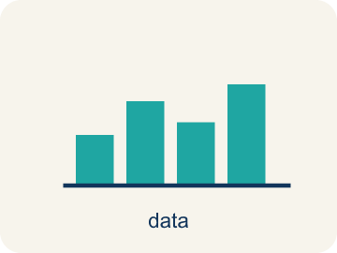 | Range and Interquartile Range Rango y rango intercuartílico  Two numbers that describe spread: the range covers all the data, and the interquartile range covers only the middle half.  Example: Range 26 covers 68 to 94; IQR 12.5 covers only 75.5 to 88
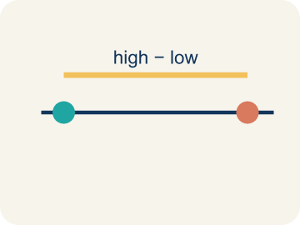 | Range Rango  The distance from the least value to the greatest value, found by subtracting: greatest − least.  Example: 94 − 68 = 26
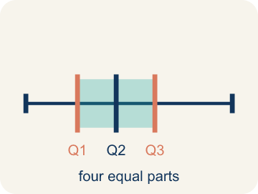 | Quartile Cuartil  One of the three values that cut an ordered data set into four equal-sized groups.  Example: Q1 = 75.5, median = 83.5, Q3 = 88
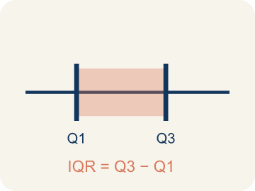 | Interquartile range Rango intercuartílico  The distance across the middle half of the data, found by subtracting the first quartile from the third: Q3 − Q1.  Example: 88 − 75.5 = 12.5 — the width of the box on a box plot
 | Variability Variabilidad  How much the values in a data set differ from one another — whether they sit close together or far apart.  Example: Close together = low variability; spread apart = high variability
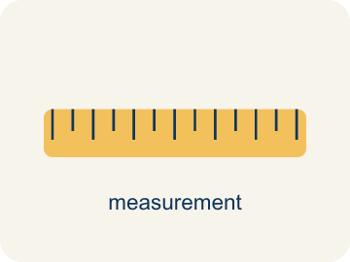 | Measure of variation Medida de variación  A single number that describes the spread of a whole data set. The range and the IQR are both measures of variation.  Example: One number stands in for the spread of all 20 scores

Guided Notes
Fill in each blank as we go. Use the Word Bank to help you.
WORD BANK
Range and Interquartile Range • Range • Quartile • Interquartile range • Variability • Measure of variation

1. The range uses the ________________ values; the interquartile range uses the ________________.
2. Subtract the least value from the ________________ value to find the range.
3. Numbers that split ordered data into four equal parts are ________________.
4. The spread of the middle half of the data, Q3 − Q1, is the ________________ ________________.
5. How spread out the numbers in a data set are is its ________________.
6. A single number describing how spread out a data set is is a ________________ ________________ ________________.

Write About the Math
Use the support level you need. Every level answers the same math question.

1. Understand the Question explain
Which class scored better overall, and how do the range and the IQR show it?
Your job: Answer the question. Use math evidence. Explain how the evidence proves your answer.
Responde la pregunta. Usa evidencia matemática. Explica cómo la evidencia demuestra tu respuesta.

2. Plan Your Math Words check at least two
☐ Range and Interquartile Range — Two numbers that describe spread: the range covers all the data, and the interquartile range covers only the middle half.
Rango y rango intercuartílico — Dos números que describen la dispersión: el rango cubre todos los datos y el rango intercuartílico solo la mitad central.
☐ Range — The distance from the least value to the greatest value, found by subtracting: greatest − least.
Rango — La distancia del valor menor al mayor, que se halla restando: mayor − menor.
☐ Quartile — One of the three values that cut an ordered data set into four equal-sized groups.
Cuartil — Uno de los tres valores que dividen un conjunto ordenado de datos en cuatro grupos del mismo tamaño.
☐ Interquartile range — The distance across the middle half of the data, found by subtracting the first quartile from the third: Q3 − Q1.
Rango intercuartílico — La distancia a lo largo de la mitad central de los datos: se resta el primer cuartil del tercero: Q3 − Q1.
☐ Variability — How much the values in a data set differ from one another — whether they sit close together or far apart.
Variabilidad — Cuánto se diferencian entre sí los valores de un conjunto de datos: si están juntos o muy separados.
Say it first: Say your idea to a partner or quietly to yourself before you write.
Class A's range is ___ and Class B's range is ___, so Class A's scores are more ___. Class A's IQR is ___ and Class B's IQR is ___, so the middle half of Class B is packed into a ___ stretch of points. Because 75% of Class B scored ___ or more, Class B did better ___.
Di tu respuesta primero: Mi respuesta es ___ porque ___.

3. Build Your Explanation choose your support
This model shows the parts of an explanation. It does not answer your writing question.
Claim: Equal medians do not make two data sets the same — you still need to know how spread out the scores are.
Evidence: Students name a measure of spread rather than another measure of center.
Reasoning: This evidence connects the definition of range and interquartile range to the mathematical claim.

Start Most language support
Complete the frames. Use the word bank.
Completa las oraciones. Usa el banco de palabras.
Class A's range is ___ and Class B's range is ___, so Class A's scores are more ___. Class A's IQR is ___ and Class B's IQR is ___, so the middle half of Class B is packed into a ___ stretch of points. Because 75% of Class B scored ___ or more, Class B did better ___.
My answer is ___.
Mi respuesta es ___.

Build Some language support
Write two connected sentences. Use because, so, or but.
Escribe dos oraciones conectadas. Usa porque, entonces o pero.
My claim is ___.
Mi afirmación es ___.
I know because ___.
Lo sé porque ___.
So ___.
Entonces ___.

Explain Light language support
Write a claim, give math evidence, and explain your reasoning.
Escribe una afirmación, da evidencia matemática y explica tu razonamiento.
My claim is ___.
Mi afirmación es ___.
My math evidence is ___.
Mi evidencia matemática es ___.
This proves ___ because ___.
Esto demuestra ___ porque ___.

4. Check Your Explanation five quick checks
☐ I answered the question.
Respondí la pregunta.
☐ I used math evidence: numbers, an equation, a model, or a comparison.
Usé evidencia matemática: números, una ecuación, un modelo o una comparación.
☐ I explained how the evidence proves my answer.
Expliqué cómo la evidencia demuestra mi respuesta.
☐ I used at least two math words.
Usé por lo menos dos palabras matemáticas.
☐ I reread complete sentences and punctuation.
Volví a leer mis oraciones completas y la puntuación.

Worked Example

Watch & Read I Do — follow along with your teacher
Spread Detective
The league analyst is comparing two sixth-grade classes that took the same math test. Both classes have the SAME median score, 81 — so the medians alone cannot tell them apart. Your job is to measure how spread out each class's scores are, using the range and the interquartile range, and decide which class did better overall.

Think about:
• I notice the lowest score in the data set is ___.
• I notice the highest score in the data set is ___.
• I notice the middle half of the scores runs from ___ to ___.
• I wonder what one number could describe how spread out all the scores are ___.
• I wonder why the middle half might describe the class better than ___.

Solved Example I Do — watch each step
Problem: A data set runs from a least value of 12 to a greatest value of 30. What is the range?
A) 18
B) 30
C) 12
D) 21
Step 1: Range = greatest − least = 30 − 12 = 18.
Answer: A. 18

Guided Practice

Solve Together We Do — work with your class
Problem: On a box plot, Q1 = 20 and Q3 = 36. What is the interquartile range?
A) 16
B) 56
C) 28
D) 36
Step 1:

Step 2:

Answer:

Two sixth-grade classes took the same math test. Class A's box plot reads least 62, Q1 74, median 81, Q3 87, greatest 90. Class B's reads least 70, Q1 76, median 81, Q3 84, greatest 90. Both classes have a median of 81, so the median alone cannot tell you which class did better overall.
Which class scored better overall, and how do the range and the IQR show it?

Sentence frame: Class A's range is ___ and Class B's range is ___, so Class A's scores are more ___. Class A's IQR is ___ and Class B's IQR is ___, so the middle half of Class B is packed into a ___ stretch of points. Because 75% of Class B scored ___ or more, Class B did better ___.

Turn & Talk discuss with a partner
1. [Launch] Two classes have the same median score, 81. Can you tell which class did better? What else would you need to know?
Start with: The medians are the same, so I still need to know how ___ the scores are.
Las medianas son iguales, así que todavía necesito saber qué tan ___ están los puntajes.
Word bank: median, spread out, range, interquartile range, vary
2. [Explore] Why does the range change a lot when one unusual value is added, but the IQR barely moves?
Start with: The range uses the ___ and ___ values, so one unusual value ___ it.
El rango usa los valores ___ y ___, así que un valor inusual lo ___.
Word bank: least, greatest, Q1, Q3, stretches, middle half
3. [Connect] Class A's IQR is 13 and Class B's is 8. Say what that means in the context of the test, not just in numbers.
Start with: An IQR of ___ means the middle half of that class differed by only ___ points.
Un RIC de ___ significa que la mitad central de esa clase se diferenció por solo ___ puntos.
Word bank: interquartile range, middle half, points, consistent, narrower
4. [Practice] How would you explain the difference between range and IQR to someone who missed today?
Start with: The range is ___ minus ___, and it covers ___ the data.
El rango es ___ menos ___, y cubre ___ los datos.
Word bank: greatest, least, all of, Q3, Q1, middle half

Independent Practice

On Your Own You Do — show your work
Solve each problem. Show your thinking in the work box.

On Level grade-level practice
1. A box plot shows: least 68, Q1 75.5, median 83.5, Q3 88, greatest 94. What are the range and the IQR?
A) Range 26, IQR 12.5
B) Range 12.5, IQR 26
C) Range 26, IQR 83.5
D) Range 20, IQR 12.5

2. Match each value from the history test data (68, 70, 73, 74, 75, 76, 77, 80, 82, 83, 84, 85, 86, 86, 88, 88, 90, 90, 93, 94) with what it is.
3. Team A's salaries have a range of $14M and an IQR of $7M. Team B's have a range of $7M and an IQR of $2.5M. Both teams have the same median salary. What does this tell a player?
A) Team B's salaries cluster much more tightly around the median
B) Team B pays more overall
C) Team A has more players
D) Team B's highest salary is greater

4. A value far above the rest is added to a data set. Sort what happens.

Exit Ticket
Answer on your own. This shows what you learned today.
★ A box plot has Q1 = 20 and Q3 = 36, with a least value of 10 and a greatest value of 50. What is the IQR, and what does it tell you?
A) IQR = 16; the middle half of the data spans 16 units
B) IQR = 40; the data spans 40 units from end to end
C) IQR = 56; the quartiles add to 56
D) IQR = 28; 28 is halfway between the quartiles

Answer Key & Teacher Guide
Teacher reference — remove or fold back before distributing to students.

Guided Notes (Fill-in)
Notes 1: Range and Interquartile Range
Notes 2: Range
Notes 3: Quartile
Notes 4: Interquartile range
Notes 5: Variability
Notes 6: Measure of variation

Worked Notes (I Do / We Do)
I Do: A. 18
We Do: A. 16

Independent Practice
Watch for this mistake: A common mistake with Range and Interquartile Range is adding the two quartiles instead of subtracting them — writing IQR = Q3 + Q1. With Q1 = 42 and Q3 = 58 that gives 100, which is larger than the data set's entire range of 20. Every measure of variation is a DIFFERENCE, and the IQR can never exceed the range, because the middle half is part of the whole span. If your IQR comes out bigger than your range, you added when you should have subtracted.

Level 1 Support
1. A) The interquartile range — The IQR runs from Q1 to Q3, which is exactly the middle half of the values. The range uses every value, including the extremes.
2. A) The middle half of Class B's scores is less spread out — A smaller IQR means the middle half of the data is packed into a shorter stretch, so Class B's middle half varies less. The medians are equal, so nothing there separates them.
3. Answers vary. — The range uses the two extreme values, so an unusual value moves it. The IQR uses only the quartiles, so it describes the middle half no matter what happens at the ends.

On Level
4. A) Range 26, IQR 12.5 — Range = 94 − 68 = 26. IQR = 88 − 75.5 = 12.5. The range covers the whole span; the IQR covers only the box.
5. Answers vary. — The median splits the 20 ordered values; Q1 is the median of the lower 10 and Q3 the median of the upper 10. Range and IQR are then both subtractions.
6. A) Team B's salaries cluster much more tightly around the median — Both measures of variation are smaller for Team B, so its salaries vary less: a typical player is more likely to earn close to the median. Team A spreads much wider in both directions.

Exit Ticket
A) IQR = 16; the middle half of the data spans 16 units — IQR = Q3 − Q1 = 36 − 20 = 16. Because it runs from Q1 to Q3, it describes only the middle half of the values — the width of the box.

Math Writing Criteria
The support level changes the amount of language scaffolding, not the mathematical expectation.
☐ I answered the question.
☐ I used math evidence: numbers, an equation, a model, or a comparison.
☐ I explained how the evidence proves my answer.
☐ I used at least two math words.
☐ I reread complete sentences and punctuation.

