UNIT 2 · LESSON 7 STANDARD 6.NOS.3

Divide Decimals Using an Algorithm
Student Notes Packet
Name: ______________________ Date: ____________ Period: ________
Level 2 · Standard

Today's Goals
Content: I can divide with decimals by making the divisor a whole number first.
Language: I can explain my work using the words dividend, divisor, quotient, and equivalent division.

Key Vocabulary
Look at the picture, read the word, then read what it means.
 | Divide Decimals Dividir decimales  Find a quotient with decimals by making the divisor a whole number first.  Example: 8.4 ÷ 2.1 = 84 ÷ 21 = 4
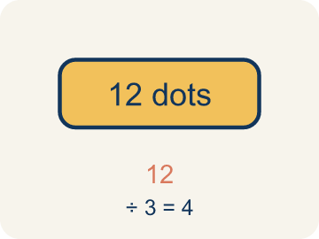 | Dividend Dividendo  The number you are splitting up in a division problem.  Example: In 8.4 ÷ 2.1 = 4, the dividend is 8.4 — it is the total being split
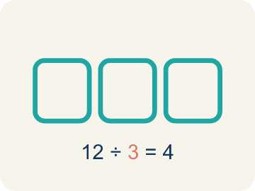 | Divisor Divisor  The number you split by in a division problem.  Example: In 8.4 ÷ 2.1 = 4, the divisor is 2.1 — it is the size of each group
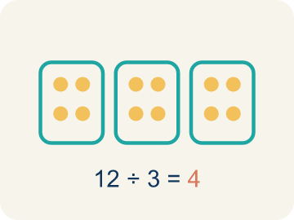 | Quotient Cociente  The answer when you divide.  Example: In 8.4 ÷ 2.1 = 4, the quotient is 4 — there are 4 groups
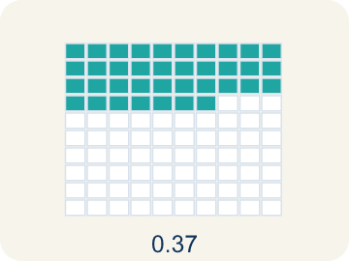 | Decimal division División decimal  Dividing with decimals. First move the point to make the number you divide by whole, then run the long-division cycle.  Example: 8.4 ÷ 2.1 → move the point in both → 84 ÷ 21 → divide, multiply, subtract, bring down → 4
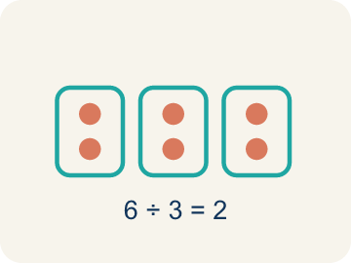 | Equivalent division División equivalente  Multiplying both numbers by 10 or 100 gives the same answer.  Example: 7.56 ÷ 0.12 = 756 ÷ 12 = 63 (both multiplied by 100)

Guided Notes
Fill in each blank as we go. Use the Word Bank to help you.
WORD BANK
Divide Decimals • Dividend • Divisor • Quotient • Decimal division • Equivalent division

1. Make the ________________ a whole number first, then move the dividend's point the same number of places.
2. In a division problem, the number being divided is the ________________.
3. In a division problem, the number we divide by is the ________________.
4. The answer to a division problem is the ________________.
5. Dividing numbers that include a decimal point is called ________________.
6. Multiplying both the dividend and divisor by the same power of 10 creates an ________________ that is easier to solve.

Write About the Math
Use the support level you need. Every level answers the same math question.

1. Understand the Question explain
How does decimal division help you figure out how many pieces you can cut?
Your job: Answer the question. Use math evidence. Explain how the evidence proves your answer.
Responde la pregunta. Usa evidencia matemática. Explica cómo la evidencia demuestra tu respuesta.

2. Plan Your Math Words check at least two
☐ Divide Decimals — Find a quotient with decimals by making the divisor a whole number first.
Dividir decimales — Hallar un cociente con decimales convirtiendo primero el divisor en un número entero.
☐ Dividend — The number you are splitting up in a division problem.
Dividendo — El número que estás repartiendo en una división.
☐ Divisor — The number you split by in a division problem.
Divisor — El número entre el que divides en una división.
☐ Quotient — The answer when you divide.
Cociente — La respuesta cuando divides.
☐ Decimal division — Dividing with decimals. First move the point to make the number you divide by whole, then run the long-division cycle.
División decimal — Dividir con decimales. Primero mueve el punto para hacer entero el número entre el que divides y luego repite el ciclo de la división larga.
Say it first: Say your idea to a partner or quietly to yourself before you write.
I can cut ___ pieces because 16.8 ÷ 2.4 = ___.
Di tu respuesta primero: Mi respuesta es ___ porque ___.

3. Build Your Explanation choose your support
This model shows the parts of an explanation. It does not answer your writing question.
Claim: You first make the divisor a whole number using equivalent division.
Evidence: Students explain you move the decimal in the divisor to make it whole (6.3 to 63) and move the dividend the same way, naming 18.9 as the dividend and 6.3 as the divisor.
Reasoning: This evidence connects the definition of divide decimals to the mathematical claim.

Start Most language support
Complete the frames. Use the word bank.
Completa las oraciones. Usa el banco de palabras.
I can cut ___ pieces because 16.8 ÷ 2.4 = ___.
My answer is ___.
Mi respuesta es ___.

Build Some language support
Write two connected sentences. Use because, so, or but.
Escribe dos oraciones conectadas. Usa porque, entonces o pero.
My claim is ___.
Mi afirmación es ___.
I know because ___.
Lo sé porque ___.
So ___.
Entonces ___.

Explain Light language support
Write a claim, give math evidence, and explain your reasoning.
Escribe una afirmación, da evidencia matemática y explica tu razonamiento.
My claim is ___.
Mi afirmación es ___.
My math evidence is ___.
Mi evidencia matemática es ___.
This proves ___ because ___.
Esto demuestra ___ porque ___.

4. Check Your Explanation five quick checks
☐ I answered the question.
Respondí la pregunta.
☐ I used math evidence: numbers, an equation, a model, or a comparison.
Usé evidencia matemática: números, una ecuación, un modelo o una comparación.
☐ I explained how the evidence proves my answer.
Expliqué cómo la evidencia demuestra mi respuesta.
☐ I used at least two math words.
Usé por lo menos dos palabras matemáticas.
☐ I reread complete sentences and punctuation.
Volví a leer mis oraciones completas y la puntuación.

Worked Example

Watch & Read I Do — follow along with your teacher
Space Station Pod Splitter
The space station has 18.9 kilograms of a rare mineral sample that must be divided equally among 6.3-kilogram storage pods. How many pods can be completely filled?

Think about:
• What total amount is being divided?
• What is the size of each pod?
• How do you divide when the divisor is a decimal?
• Can you turn this into a whole number division problem?

Solved Example I Do — watch each step
Problem: What is 14.4 ÷ 1.2?
A) 12
B) 1.2
C) 120
D) 0.12
Step 1: Multiply both by 10: 144 ÷ 12 = 12.
Answer: A. 12

Guided Practice

Solve Together We Do — work with your class
Problem: What is 3.78 ÷ 0.6?
A) 6.3
B) 63
C) 0.63
D) 0.063
Step 1:

Step 2:

Answer:

A ribbon is 16.8 feet long. You need to cut it into pieces that are each 2.4 feet long for a craft project.
How does decimal division help you figure out how many pieces you can cut?

Sentence frame: I can cut ___ pieces because 16.8 ÷ 2.4 = ___.

Turn & Talk discuss with a partner
1. [Launch] The station has 18.9 kilograms of mineral to divide into 6.3-kilogram pods. Why can't you divide by the decimal 6.3 directly the same way you divide by a whole number?
Start with: I make the divisor 6.3 into a ___ before dividing.
Convierto el divisor 6.3 en un ___ antes de dividir.
Word bank: dividend, divisor, quotient, decimal division, equivalent division
2. [Explore] When you divided 18.9 by 6.3, how did you use equivalent division to make the divisor a whole number?
Start with: I moved both decimal points ___ place, changing it to ___ ÷ ___.
Moví ambos puntos decimales ___ lugar, cambiándolo a ___ ÷ ___.
Word bank: dividend, divisor, quotient, decimal division, equivalent division
3. [Connect] The station has 22.5 meters of oxygen tubing, cut into hoses that are each 1.5 meters long. How does decimal division tell you how many hoses you can make?
Start with: I can make ___ hoses because I divided 22.5 by ___.
Puedo hacer ___ mangueras porque dividí 22.5 entre ___.
Word bank: dividend, divisor, quotient, decimal division, equivalent division
4. [Reflect] Why does making the divisor a whole number first make dividing by a decimal so much easier?
Start with: Making the divisor a whole number helps because ___.
Convertir el divisor en un número entero ayuda porque ___.
Word bank: dividend, divisor, quotient, decimal division, equivalent division
5. [Practice] During practice on Divide Decimals, what strategy did you use when a problem felt tricky?
Start with: I moved both decimal points ___ place, changing it to ___ ÷ ___.
Moví ambos puntos decimales ___ lugar, cambiándolo a ___ ÷ ___.
Word bank: Dividend, Divisor, Quotient, Decimal division

Independent Practice

On Your Own You Do — show your work
Solve each problem. Show your thinking in the work box.

On Level grade-level practice
1. A water tank holds 19.2 liters. It is poured into bottles that each hold 1.6 liters. How many bottles can be filled?
A) 12 bottles
B) 11 bottles
C) 13 bottles
D) 1.2 bottles

Exit Ticket
Answer on your own. This shows what you learned today.
★ What is 19.2 ÷ 0.8?
A) 24
B) 2.4
C) 240
D) 0.24

Answer Key & Teacher Guide
Teacher reference — remove or fold back before distributing to students.

Guided Notes (Fill-in)
Notes 1: Divide Decimals
Notes 2: Dividend
Notes 3: Divisor
Notes 4: Quotient
Notes 5: Decimal division
Notes 6: Equivalent division

Worked Notes (I Do / We Do)
I Do: A. 12
We Do: A. 6.3

Independent Practice
Watch for this mistake: A common mistake in Divide Decimals is moving the decimal point in the divisor but forgetting to move it the same number of places in the dividend. For example, in 6.4 ÷ 0.8 a student changes 0.8 to 8 but leaves the dividend as 6.4, then divides 6.4 ÷ 8 = 0.8 instead of moving both points to get 64 ÷ 8 = 8. A second version of this mistake happens when the divisor has two decimal places, like 0.12: students move both points only 1 place instead of 2, turning 9.6 ÷ 0.12 into 96 ÷ 1.2 instead of the correct 960 ÷ 12. Count the divisor's decimal places first, then move BOTH points that same number of places.

Level 1 Support
1. A) 12 — 8.4 ÷ 0.7 = 84 ÷ 7 = 12.
2. A) 12 — Multiply both by 10: 156 ÷ 13 = 12.

On Level
3. A) 12 bottles — 19.2 ÷ 1.6: multiply both by 10 → 192 ÷ 16 = 12 bottles.

Exit Ticket
A) 24 — Multiply both by 10: 192 ÷ 8 = 24.

Math Writing Criteria
The support level changes the amount of language scaffolding, not the mathematical expectation.
☐ I answered the question.
☐ I used math evidence: numbers, an equation, a model, or a comparison.
☐ I explained how the evidence proves my answer.
☐ I used at least two math words.
☐ I reread complete sentences and punctuation.

