UNIT 3 · LESSON 1 STANDARD 6.AT.1

Understand Ratios (Flagship)
Student Notes Packet
Name: ______________________ Date: ____________ Period: ________
Level 1 · Support

Today's Goals
Content: I can write and describe a ratio that compares two quantities.
Language: I can explain a comparison using the words ratio, part-to-part, part-to-whole, and colon notation.

Key Vocabulary
Look at the picture, read the word, then read what it means.
 | Understand Ratios Comprender razones  Use a ratio to compare two quantities by division.  Example: 3 red tiles to 5 blue tiles can be written 3:5 or 3/5.
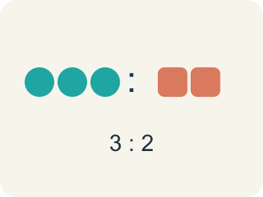 | Ratio Razón  A way to compare two amounts, like 3 to 2.  Example: 3 cups flour to 2 cups sugar → 3:2
 | Comparison Comparación  Looking at two or more amounts to see how they are related.  Example: 5 eggs vs. 3 eggs — which recipe uses more?
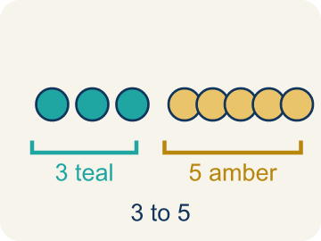 | Part-to-part Parte a parte  A ratio comparing one part of a group to another part.  Example: 3 cups flour : 2 cups sugar (ingredient to ingredient)
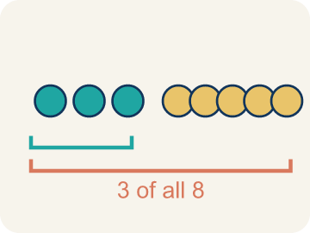 | Part-to-whole Parte a todo  A ratio comparing one part to the whole group.  Example: 3 cups flour out of 5 cups total → 3:5
 | Colon notation Notación con dos puntos  Writing a ratio with two dots between the numbers, like 3:2.  Example: 3 to 2 can be written as 3:2
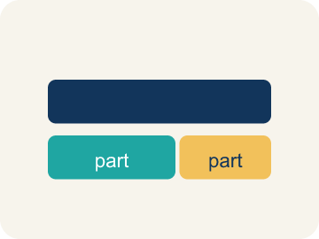 | Tape diagram Diagrama de cintas  A bar cut into equal parts that shows how two amounts in a ratio compare, and how they make up the whole.  Example: 3 equal parts of apple juice beside 2 equal parts of sparkling water — 5 parts of fruit drink in all.
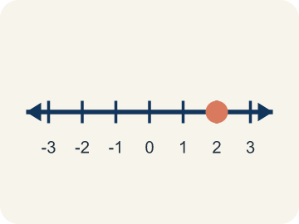 | Double number line Recta numérica doble  Two number lines lined up so matching tick marks show the two quantities in a ratio at the same time.  Example: Cups of apple juice 0, 3, 6, 12 above cups of fruit drink 0, 5, 10, 20.

Guided Notes
Fill in each blank as we go. Use the Word Bank to help you.
WORD BANK
Understand Ratios • Ratio • Comparison • Part-to-part • Part-to-whole • Colon notation • Tape diagram • Double number line

1. A comparison of two quantities by division is a ________________.
2. A comparison of two quantities, like 3 to 5, is a ________________.
3. Showing how two amounts relate to each other is a ________________.
4. A ratio that compares one part of a group to another part is a ________________ ratio.
5. A ratio that compares one part of a group to the total is a ________________ ratio.
6. Writing a ratio with a colon, like 3:5, is using ________________.
7. A bar cut into equal parts that shows how a ratio breaks apart is a ________________ ________________.
8. Two lines whose matching ticks pair the two amounts in a ratio form a ________________ ________________ ________________.

Write About the Math
Use the support level you need. Every level answers the same math question.

1. Understand the Question explain
The school cafeteria is planning a new lunch menu. They want to offer 3 main dishes for every 2 side dishes. If they have 10 side dishes, the cafeteria manager needs to figure out how many main dishes to prepare?
Your job: Answer the question. Use math evidence. Explain how the evidence proves your answer.
Responde la pregunta. Usa evidencia matemática. Explica cómo la evidencia demuestra tu respuesta.

2. Plan Your Math Words check at least two
☐ Understand Ratios — Use a ratio to compare two quantities by division.
Comprender razones — Usar una razón para comparar dos cantidades mediante la división.
☐ Ratio — A way to compare two amounts, like 3 to 2.
Razón — Una manera de comparar dos cantidades, como 3 a 2.
☐ Comparison — Looking at two or more amounts to see how they are related.
Comparación — Mirar dos o más cantidades para ver cómo se relacionan.
☐ Part-to-part — A ratio comparing one part of a group to another part.
Parte a parte — Una razón que compara una parte de un grupo con otra parte.
☐ Part-to-whole — A ratio comparing one part to the whole group.
Parte a todo — Una razón que compara una parte con todo el grupo.
Say it first: Say your idea to a partner or quietly to yourself before you write.
For every ___ main dishes the cafeteria serves ___ side dishes, so with 10 side dishes they need ___ main dishes.
Di tu respuesta primero: Mi respuesta es ___ porque ___.

3. Build Your Explanation choose your support
This model shows the parts of an explanation. It does not answer your writing question.
Claim: The recipe uses 3 cups of apple juice for every 2 cups of sparkling water.
Evidence: A strong answer names that apple juice and sparkling water are being compared and states the relationship as 3 to 2 (or 'for every 3 apple juice, 2 sparkling water'), not just that there is more apple juice.
Reasoning: This evidence connects the definition of understand ratios to the mathematical claim.

Start Most language support
Complete the frames. Use the word bank.
Completa las oraciones. Usa el banco de palabras.
For every ___ main dishes the cafeteria serves ___ side dishes, so with 10 side dishes they need ___ main dishes.
My answer is ___.
Mi respuesta es ___.

Build Some language support
Write two connected sentences. Use because, so, or but.
Escribe dos oraciones conectadas. Usa porque, entonces o pero.
My claim is ___.
Mi afirmación es ___.
I know because ___.
Lo sé porque ___.
So ___.
Entonces ___.

Explain Light language support
Write a claim, give math evidence, and explain your reasoning.
Escribe una afirmación, da evidencia matemática y explica tu razonamiento.
My claim is ___.
Mi afirmación es ___.
My math evidence is ___.
Mi evidencia matemática es ___.
This proves ___ because ___.
Esto demuestra ___ porque ___.

4. Check Your Explanation five quick checks
☐ I answered the question.
Respondí la pregunta.
☐ I used math evidence: numbers, an equation, a model, or a comparison.
Usé evidencia matemática: números, una ecuación, un modelo o una comparación.
☐ I explained how the evidence proves my answer.
Expliqué cómo la evidencia demuestra mi respuesta.
☐ I used at least two math words.
Usé por lo menos dos palabras matemáticas.
☐ I reread complete sentences and punctuation.
Volví a leer mis oraciones completas y la puntuación.

Worked Example

Watch & Read I Do — follow along with your teacher
Chef Academy Ratio Rookie
Welcome to Chef Academy! Head Chef Reyes is teaching new students how to read recipes like a pro. Her sparkling cranberry-apple fruit drink calls for 3 cups of apple juice for every 2 cups of sparkling water. Before the students can mix the drink, they need to understand how these ingredient amounts compare to each other.

Think about:
• What two ingredients are being compared in the recipe?
• How could you describe the relationship between apple juice and sparkling water?
• Is the amount of apple juice more than, less than, or equal to the amount of sparkling water?
• What if we compared the sparkling water to the apple juice instead — would the ratio change?
• Could we compare one ingredient to the total amount of both?

Solved Example I Do — watch each step
Problem: A recipe uses 4 cups of milk and 1 cup of cream. What is the ratio of milk to cream?
A) 4:1
B) 1:4
C) 4:5
D) 5:1
Step 1: A ratio compares quantities in the order given.
Step 2: Milk to cream = 4 to 1, or 4:1.
Answer: A. 4:1

Guided Practice

Solve Together We Do — work with your class
Problem: Chef Reyes uses 6 strawberries and 2 bananas in a smoothie. What is the part-to-whole ratio of bananas to total fruit?
A) 2:8
B) 6:2
C) 2:6
D) 8:2
Step 1:

Step 2:

Answer:

The school cafeteria is planning a new lunch menu. They want to offer 3 main dishes for every 2 side dishes. If they have 10 side dishes, the cafeteria manager needs to figure out how many main dishes to prepare.

Sentence frame: For every ___ main dishes the cafeteria serves ___ side dishes, so with 10 side dishes they need ___ main dishes.

Turn & Talk discuss with a partner
1. [Launch] Chef Reyes's drink recipe uses 3 cups of apple juice for every 2 cups of sparkling water. How would you describe how these two ingredient amounts compare?
Start with: The recipe compares ___ to ___.
La receta compara ___ con ___.
Word bank: Ratio, Comparison, Part-to-part
2. [Explore] When you sorted the board statements, what made something a ratio instead of NOT a ratio (like '12 cookies on the tray')?
Start with: This is a ratio because it compares ___ to ___.
Esto es una razón porque compara ___ con ___.
Word bank: Ratio, Comparison, Colon notation, Part-to-whole
3. [Connect] The cafeteria wants 3 main dishes for every 2 side dishes. How is this the same kind of thinking as Chef Reyes's apple-juice-to-sparkling-water ratio?
Start with: This is like our ratio work because ___ and ___ are compared.
Esto es como nuestro trabajo con razones porque se comparan ___ y ___.
Word bank: Ratio, Part-to-part, Comparison, Colon notation
4. [Practice] During practice on Understand Ratios, what strategy did you use when a problem felt tricky?
Start with: This is a ratio because it compares ___ to ___.
Esto es una razón porque compara ___ con ___.
Word bank: Ratio, Comparison, Part-to-part, Part-to-whole

Independent Practice

On Your Own You Do — show your work
Solve each problem. Show your thinking in the work box.

Level 1 Support extra scaffolding
1. In a class of 30 students, 18 are girls. What is the part-to-part ratio of boys to girls?
A) 12:18
B) 18:12
C) 18:30
D) 12:30

2. A pet store has 5 dogs and 9 cats. What is the ratio of dogs to cats?
A) 5:9
B) 9:5
C) 5:14
D) 14:5

Exit Ticket
Answer on your own. This shows what you learned today.
★ A bag of trail mix contains 8 peanuts and 5 raisins. What is the ratio of raisins to total pieces?
A) 5:13
B) 8:5
C) 5:8
D) 13:5

