3.4–3.10 Catch-Up — Homework
Lesson 3-10-catchup • Standard 6.AT.3c
Name: ______________________ Period: ______ Date: ____________

Today's Goals
Content: I can show I am caught up on Lessons 3.4–3.10 by using each lesson's big idea in mixed practice.
Language: I can explain which lesson's big idea I used and how, using key vocabulary from Lessons 3.4–3.10.

Key Words
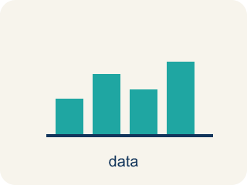
Graph Ratio Tables (Representar tablas de razones en una gráfica) — Plot the paired values from a ratio table as ordered pairs.
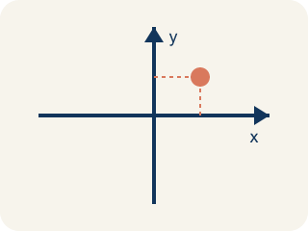
Coordinate plane (Plano cartesiano) — A grid with a line going across and a line going up to plot points.
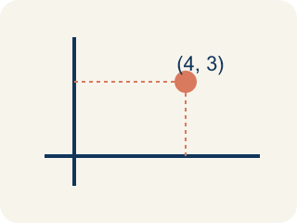
Ordered pair (Par ordenado) — Two numbers (x, y) that tell where a point is on a grid.
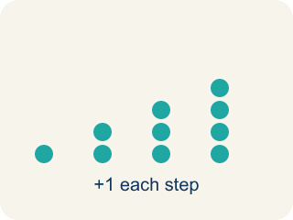
Linear pattern (Patrón lineal) — Points that make a straight line on a grid.
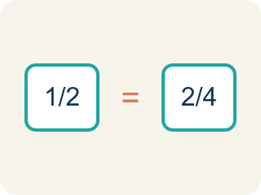
Proportional (Proporcional) — Two amounts that grow together at the same rate.
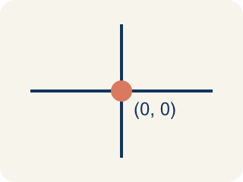
Origin (Origen) — The point (0, 0) where the two grid lines cross.
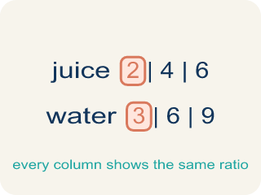
Ratio table (Tabla de razones) — A table of equal ratios that shows a pattern.
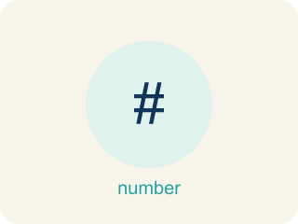
Compare Ratios (Comparar razones) — Decide which ratio is greater, less, or equal by using equivalent ratios or unit rates.
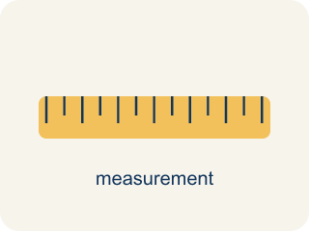
Convert Measurements within the Same System (Convertir medidas dentro del mismo sistema) — Rewriting a measurement in a different unit of the SAME system, such as feet into inches or liters into milliliters.

Convert Measurements Between Systems (Convertir medidas entre sistemas) — Rewriting a customary measurement as a metric one, or the reverse, so two amounts can be compared.

Unit Rate Problem Solving (Resolución de problemas con tasas unitarias) — Find an amount per 1 unit and use it to compare choices or solve a problem.
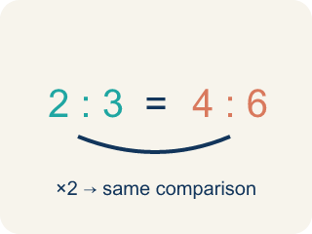
Equivalent Ratios (Razones equivalentes) — Ratios that compare quantities in the same relationship.

Convert Measurement Units (Convertir unidades de medida) — Rename a measurement in a different unit without changing its amount.
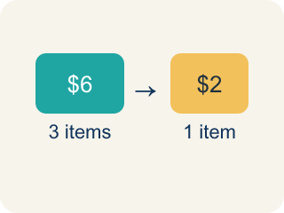
Unit rate (Tasa unitaria) — A rate for just 1 of something, like cost for 1 item.

Unit ratio (Razón unitaria) — A ratio that compares an amount to exactly 1 unit of another quantity, like 12 inches to 1 foot.
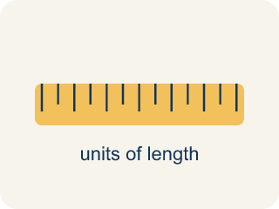
Conversion factor (Factor de conversión) — The ratio that links a unit in one system to a unit in the other, such as 1 mile to about 1.609 kilometers.
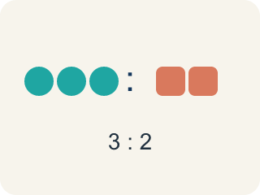
Ratio (Razón) — A way to compare two amounts, like 3 to 2.

Practice
Show your work. Use the blank space under each problem.
1. (Lesson 3.4) A ratio table shows (2, 6), (4, 12), and (6, 18). Which ordered pair comes next if the pattern continues?
A. (8, 24)
B. (7, 20)
C. (8, 22)
D. (10, 24)
______________________________________________________________________
2. (Lesson 3.4) When you graph equivalent ratios, the points will always form what shape?
A. A straight line through the origin
B. A curved line
C. A zigzag
D. A circle
______________________________________________________________________
3. (Lesson 3.4) Points from a ratio table are plotted at (1, 4), (2, 8), and (3, 12). What is the ratio of y to x for each point?
A. 4:1
B. 1:4
C. 2:8
D. 3:4
______________________________________________________________________
4. (Lesson 3.4) Two students graph ratio tables. Student A plots (1,2), (2,4), (3,6). Student B plots (1,3), (2,6), (3,9). Whose line is steeper?
A. Student B
B. Student A
C. Same steepness
D. Cannot tell
______________________________________________________________________
5. (Lesson 3.5) Store A sells 3 mangoes for $6. Store B sells 5 mangoes for $9. Which store offers a better price per mango?
A. Store B
B. Store A
C. Same price
D. Cannot determine
______________________________________________________________________
6. (Lesson 3.5) Spot the Common Mistake
Step 1 (Read the problem): Compare Chef Reyes's dressing (4 tbsp oil : 6 tbsp vinegar) to Chef Tran's dressing (5 tbsp oil : 8 tbsp vinegar). Which dressing is oilier?
Step 2 (Find a common denominator): LCD of 6 and 8 is 24.
Step 3 (Scale each ratio): Chef Reyes: 6 × 4 = 24, so oil = 4 × 4 = 16, giving 16:24. Chef Tran: to reach 24 he also multiplies by 4: oil = 5 × 4 = 20, giving 20:24.
Step 4 (Conclusion): Since 20 > 16, Chef Tran's dressing is oilier.
Which step has the mistake? Explain and fix it:
______________________________________________________________________
______________________________________________________________________
______________________________________________________________________
7. (Lesson 3.6) Diamond needs 4 liters of water. Her bottle holds 500 milliliters. How many times must she fill it?
A. 8 times
B. 4 times
C. 2 times
D. 40 times
______________________________________________________________________
8. (Lesson 3.6) Find the error
Step 1 (Setup): A recipe needs 2 pounds of flour. The scale reads in ounces (16 oz = 1 lb).
Step 2 (Step 1): The unit ratio is 16 ounces : 1 pound.
Step 3 (Step 2): 2 × 16 = 32, so 2 pounds = 32 ounces.
Step 4 (Step 3): The scale reads 40 ounces, so there is not enough flour.
Which step has the mistake? Explain and fix it:
______________________________________________________________________
______________________________________________________________________
______________________________________________________________________
9. (Lesson 3.7) A dog weighs 31 pounds. Flea medicine comes in packages for 4–10 kg, 10–25 kg, and 25–40 kg. Which package is correct?
A. The 10–25 kg package
B. The 4–10 kg package
C. The 25–40 kg package
D. None — 31 is above every range
______________________________________________________________________
10. (Lesson 3.7) Find the error
Step 1 (Setup): A recipe calls for 2 pounds of flour. The scale is metric. (1 lb ≈ 0.45 kg)
Step 2 (Step 1): The conversion factor is 1 : 0.45.
Step 3 (Step 2): 0.45 × 2 = 0.9, so 2 pounds ≈ 0.9 kilogram.
Step 4 (Step 3): 2 pounds = 0.9 kilogram exactly.
Which step has the mistake? Explain and fix it:
______________________________________________________________________
______________________________________________________________________
______________________________________________________________________

Answer Key (Teacher)
1. A. (8, 24)
The pattern adds 2 to x and 6 to y each time. After (6, 18): x = 6+2 = 8, y = 18+6 = 24. The next point is (8, 24).
Watch for: A common mistake in Convert Measurement Units is applying the conversion factor in the wrong direction — for example, converting 4 feet to inches by dividing (4 ÷ 12 = 0.33 inches) instead of multiplying (4 × 12 = 48 inches), or converting 80 ounces to pounds by multiplying (80 × 16 = 1,280 pounds) instead of dividing (80 ÷ 16 = 5 pounds). Before you answer, ask: am I changing to a SMALLER unit (there will be MORE of them, so multiply) or a BIGGER unit (there will be FEWER of them, so divide)?
2. A. A straight line through the origin
Equivalent ratios are proportional, so their graph is always a straight line that passes through the origin (0, 0).
Watch for: A common mistake in Convert Measurement Units is applying the conversion factor in the wrong direction — for example, converting 4 feet to inches by dividing (4 ÷ 12 = 0.33 inches) instead of multiplying (4 × 12 = 48 inches), or converting 80 ounces to pounds by multiplying (80 × 16 = 1,280 pounds) instead of dividing (80 ÷ 16 = 5 pounds). Before you answer, ask: am I changing to a SMALLER unit (there will be MORE of them, so multiply) or a BIGGER unit (there will be FEWER of them, so divide)?
3. A. 4:1
For each point: 4÷1 = 4, 8÷2 = 4, 12÷3 = 4. The ratio of y to x is always 4:1.
Watch for: A common mistake in Convert Measurement Units is applying the conversion factor in the wrong direction — for example, converting 4 feet to inches by dividing (4 ÷ 12 = 0.33 inches) instead of multiplying (4 × 12 = 48 inches), or converting 80 ounces to pounds by multiplying (80 × 16 = 1,280 pounds) instead of dividing (80 ÷ 16 = 5 pounds). Before you answer, ask: am I changing to a SMALLER unit (there will be MORE of them, so multiply) or a BIGGER unit (there will be FEWER of them, so divide)?
4. A. Student B
Student A's ratio is 1:2 (y goes up 2 for each 1 in x). Student B's ratio is 1:3 (y goes up 3 for each 1 in x). A higher rate of change means a steeper line, so Student B's is steeper.
Watch for: A common mistake in Convert Measurement Units is applying the conversion factor in the wrong direction — for example, converting 4 feet to inches by dividing (4 ÷ 12 = 0.33 inches) instead of multiplying (4 × 12 = 48 inches), or converting 80 ounces to pounds by multiplying (80 × 16 = 1,280 pounds) instead of dividing (80 ÷ 16 = 5 pounds). Before you answer, ask: am I changing to a SMALLER unit (there will be MORE of them, so multiply) or a BIGGER unit (there will be FEWER of them, so divide)?
5. A. Store B
Store A: $6÷3 = $2.00 per mango. Store B: $9÷5 = $1.80 per mango. Store B has the better (lower) price per mango.
Watch for: A common mistake in Convert Measurement Units is applying the conversion factor in the wrong direction — for example, converting 4 feet to inches by dividing (4 ÷ 12 = 0.33 inches) instead of multiplying (4 × 12 = 48 inches), or converting 80 ounces to pounds by multiplying (80 × 16 = 1,280 pounds) instead of dividing (80 ÷ 16 = 5 pounds). Before you answer, ask: am I changing to a SMALLER unit (there will be MORE of them, so multiply) or a BIGGER unit (there will be FEWER of them, so divide)?
6. (Lesson 3.5) Spot the Common Mistake
The mistake is in Step 3.
Correct work: Each ratio needs its own multiplier to reach 24 — Chef Reyes and Chef Tran do not use the same multiplier. Chef Tran's vinegar is 8, and 8 × 3 = 24 (not 8 × 4 = 32), so multiply BOTH parts of his ratio by 3, not 4: oil = 5 × 3 = 15, giving 15:24. Now compare with equal vinegar (24): Chef Reyes has 16 tbsp oil and Chef Tran has 15 tbsp oil. Since 16 > 15, Chef Reyes's dressing is actually oilier.
Watch for: Each ratio needs its own multiplier to reach 24. Chef Reyes's vinegar 6 × 4 = 24 is right, but Chef Tran's vinegar is 8, and 8 × 3 = 24, so both parts of his ratio scale by 3: 5 × 3 = 15, giving 15:24 instead of 20:24. Compared at equal vinegar, 16 tbsp of oil beats 15, so Chef Reyes's dressing is the oilier one.
7. A. 8 times
Convert first: 4 L = 4,000 mL. Then solve ? × 500 = 4,000, giving 8 fills.
Watch for: A common mistake in Convert Measurement Units is applying the conversion factor in the wrong direction — for example, converting 4 feet to inches by dividing (4 ÷ 12 = 0.33 inches) instead of multiplying (4 × 12 = 48 inches), or converting 80 ounces to pounds by multiplying (80 × 16 = 1,280 pounds) instead of dividing (80 ÷ 16 = 5 pounds). Before you answer, ask: am I changing to a SMALLER unit (there will be MORE of them, so multiply) or a BIGGER unit (there will be FEWER of them, so divide)?
8. (Lesson 3.6) Find the error
The mistake is in Step 4.
Correct work: Step 3 compares correctly but concludes backwards. The recipe needs 32 ounces and the scale shows 40 ounces. Since 40 > 32, there is MORE than enough flour — 8 ounces extra.
Watch for: Converting is only half the job. After both amounts share a unit, read the comparison in the direction the question actually asks.
9. A. The 10–25 kg package
31 pounds ≈ 0.45 × 31 ≈ 14 kilograms, which falls inside the 10–25 kilogram package.
Watch for: A common mistake in Convert Measurement Units is applying the conversion factor in the wrong direction — for example, converting 4 feet to inches by dividing (4 ÷ 12 = 0.33 inches) instead of multiplying (4 × 12 = 48 inches), or converting 80 ounces to pounds by multiplying (80 × 16 = 1,280 pounds) instead of dividing (80 ÷ 16 = 5 pounds). Before you answer, ask: am I changing to a SMALLER unit (there will be MORE of them, so multiply) or a BIGGER unit (there will be FEWER of them, so divide)?
10. (Lesson 3.7) Find the error
The mistake is in Step 4.
Correct work: Step 3 claims an exact equality. The conversion factor 0.45 is rounded (1 pound is about 0.4536 kilogram), so the result must be written 2 pounds ≈ 0.9 kilogram.
Watch for: Conversions between systems are approximations. Using = instead of ≈ claims a precision the conversion factor never had.

