UNIT 3 · LESSON 10 STANDARD 6.AT.3C

Convert Measurement Units
Student Notes Packet
Name: ______________________ Date: ____________ Period: ________
Level 1 · Support

Today's Goals
Content: I can convert measurement units using ratios and conversion factors.
Language: I can explain my conversion using the words conversion factor, unit, equivalent, and ratio.

Key Vocabulary
Look at the picture, read the word, then read what it means.
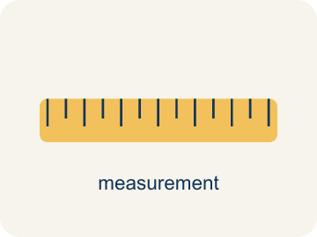 | Convert Measurement Units Convertir unidades de medida  Rename a measurement in a different unit without changing its amount.  Example: 3 feet × 12 inches per foot = 36 inches.
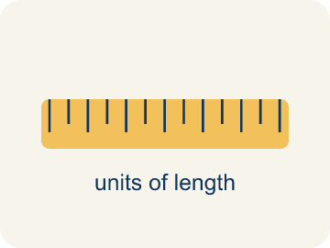 | Conversion Factor Factor de conversión  A ratio that helps you change one unit into another.  Example: 1 foot = 12 inches, so the factor is 12
 | Unit Unidad  A standard amount used to measure, like an inch or a liter.  Example: Inches, feet, pounds, ounces
 | Equivalent Equivalente  Having the same value, just in different units.  Example: 2 feet = 24 inches
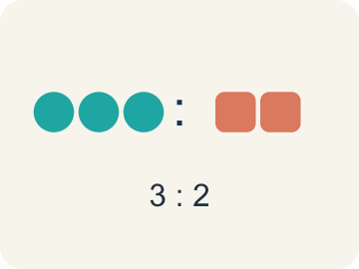 | Ratio Razón  A way to compare two amounts, like 3 to 2.  Example: 12 inches per 1 foot
 | Customary units Unidades usuales (sistema inglés)  The U.S. way of measuring, like inches, feet, and pounds.  Example: 12 inches = 1 foot, 3 feet = 1 yard, 16 ounces = 1 pound
 | Metric units Unidades métricas  A way of measuring by 10s, like meters, liters, and grams.  Example: 1 meter = 100 centimeters, 1 kilogram = 1,000 grams
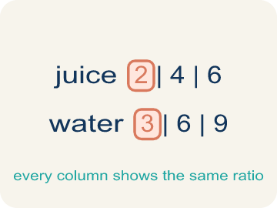 | Ratio table Tabla de razones  A table of equal ratios that shows a pattern.  Example: Cups of juice: 2, 4, 6 | Cups of water: 3, 6, 9

Guided Notes
Fill in each blank as we go. Use the Word Bank to help you.
WORD BANK
Convert Measurement Units • Conversion Factor • Unit • Equivalent • Ratio • Customary units • Metric units • Ratio table

1. Renaming a measurement in a different unit without changing the amount is to ________________ it.
2. A ratio equal to 1 that relates two units, like 12 inches / 1 foot, is a ________________.
3. A standard amount used to measure, like a foot or a gram, is a ________________.
4. Two measurements that name the same amount, like 1 foot and 12 inches, are ________________.
5. A comparison of two quantities is a ________________.
6. Units like inches, feet, and pounds used mainly in the U.S. are ________________.
7. Units like meters, grams, and liters based on tens are ________________.
8. A table that lists equivalent ratios in rows or columns is a ________________.

Write About the Math
Use the support level you need. Every level answers the same math question.

1. Understand the Question justify
Will the cabinet fit through the doorway? Show your conversion to prove it?
Your job: Answer the question. Use math evidence. Explain how the evidence proves your answer.
Responde la pregunta. Usa evidencia matemática. Explica cómo la evidencia demuestra tu respuesta.

2. Plan Your Math Words check at least two
☐ Convert Measurement Units — Rename a measurement in a different unit without changing its amount.
Convertir unidades de medida — Expresar una medida en una unidad diferente sin cambiar su cantidad.
☐ Conversion Factor — A ratio that helps you change one unit into another.
Factor de conversión — Una razón que te ayuda a cambiar una unidad por otra.
☐ Unit — A standard amount used to measure, like an inch or a liter.
Unidad — Una cantidad estándar para medir, como una pulgada o un litro.
☐ Equivalent — Having the same value, just in different units.
Equivalente — Tener el mismo valor, solo en unidades distintas.
☐ Ratio — A way to compare two amounts, like 3 to 2.
Razón — Una manera de comparar dos cantidades, como 3 a 2.
Say it first: Say your idea to a partner or quietly to yourself before you write.
7 feet = 7 × ___ = ___ inches. Since ___ inches is ___ than 80 inches, the cabinet ___ fit through the doorway.
Di tu respuesta primero: Mi respuesta es ___ porque ___.

3. Build Your Explanation choose your support
This model shows the parts of an explanation. It does not answer your writing question.
Claim: A foot is bigger than an inch, so I must convert to compare or combine the measurements.
Evidence: Students explain a foot is the larger customary unit (12 inches) and that mixed units must be converted to the same unit before working with them.
Reasoning: This evidence connects the definition of convert measurement units to the mathematical claim.

Start Most language support
Complete the frames. Use the word bank.
Completa las oraciones. Usa el banco de palabras.
7 feet = 7 × ___ = ___ inches. Since ___ inches is ___ than 80 inches, the cabinet ___ fit through the doorway.
My answer is ___.
Mi respuesta es ___.

Build Some language support
Write two connected sentences. Use because, so, or but.
Escribe dos oraciones conectadas. Usa porque, entonces o pero.
My claim is ___.
Mi afirmación es ___.
I know because ___.
Lo sé porque ___.
So ___.
Entonces ___.

Explain Light language support
Write a claim, give math evidence, and explain your reasoning.
Escribe una afirmación, da evidencia matemática y explica tu razonamiento.
My claim is ___.
Mi afirmación es ___.
My math evidence is ___.
Mi evidencia matemática es ___.
This proves ___ because ___.
Esto demuestra ___ porque ___.

4. Check Your Explanation five quick checks
☐ I answered the question.
Respondí la pregunta.
☐ I used math evidence: numbers, an equation, a model, or a comparison.
Usé evidencia matemática: números, una ecuación, un modelo o una comparación.
☐ I explained how the evidence proves my answer.
Expliqué cómo la evidencia demuestra mi respuesta.
☐ I used at least two math words.
Usé por lo menos dos palabras matemáticas.
☐ I reread complete sentences and punctuation.
Volví a leer mis oraciones completas y la puntuación.

Worked Example

Watch & Read I Do — follow along with your teacher
Arcade Builder Challenge
You're building a brand-new arcade cabinet! The blueprints use feet, but the parts catalog lists measurements in inches. The wiring instructions use yards, and the weight limits are in pounds — but the shipping labels use ounces. You need to convert between units to make sure everything fits and ships correctly.

Think about:
• Why might the blueprint and the parts catalog use different units?
• How many inches are in 1 foot? How many feet in 1 yard?
• How do you decide whether to multiply or divide when converting?
• Can you use a ratio table to help convert units?

Solved Example I Do — watch each step
Problem: How many inches are in 7 feet?
A) 84 inches
B) 72 inches
C) 70 inches
D) 96 inches
Step 1: 7 × 12 = 84 inches.
Answer: A. 84 inches

Guided Practice

Solve Together We Do — work with your class
Problem: How many feet are in 3 yards?
A) 9 feet
B) 6 feet
C) 12 feet
D) 36 feet
Step 1:

Step 2:

Answer:

The arcade is ordering a new game cabinet. The doorway is 80 inches tall. The cabinet is listed as 7 feet. Your friend says it won't fit because 7 feet is 82 inches.
Will the cabinet fit through the doorway? Show your conversion to prove it.

Sentence frame: 7 feet = 7 × ___ = ___ inches. Since ___ inches is ___ than 80 inches, the cabinet ___ fit through the doorway.

Turn & Talk discuss with a partner
1. [Launch] The cabinet blueprint uses feet but the parts catalog uses inches. Why do you have to convert, and which is the bigger unit, a foot or an inch?
Start with: I have to convert because the blueprint uses ___ but the catalog uses ___.
Tengo que convertir porque el plano usa ___ pero el catálogo usa ___.
Word bank: unit, conversion factor, customary units, equivalent
2. [Explore] How did you use a conversion factor like '1 ft = 12 in' to fill in the ratio table, and how did you decide whether to multiply or divide?
Start with: To convert ___ to ___, I ___ by ___.
Para convertir ___ a ___, ___ por ___.
Word bank: conversion factor, unit, equivalent, ratio, customary units
3. [Connect] A doorway is 80 inches tall and a new cabinet is listed as 7 feet. Your friend says it won't fit because 7 feet is 82 inches. Will it fit, and where is the error?
Start with: 7 feet = 7 x ___ = ___ inches.
7 pies = 7 x ___ = ___ pulgadas.
Word bank: conversion factor, unit, equivalent, customary units
4. [Practice] During practice on Convert Measurement Units, what strategy did you use when a problem felt tricky?
Start with: To convert ___ to ___, I ___ by ___.
Para convertir ___ a ___, ___ por ___.
Word bank: Conversion Factor, Unit, Equivalent, Ratio

Independent Practice

On Your Own You Do — show your work
Solve each problem. Show your thinking in the work box.

Level 1 Support extra scaffolding
1. How many ounces are in 4 pounds?
A) 64 ounces
B) 48 ounces
C) 32 ounces
D) 16 ounces

2. Convert 24 inches to feet.
A) 2 feet
B) 3 feet
C) 12 feet
D) 24 feet

Exit Ticket
Answer on your own. This shows what you learned today.
★ Which is the correct conversion of 5 yards to inches?
A) 180 inches
B) 60 inches
C) 15 inches
D) 540 inches

