3.1–3.3 Catch-Up — Homework
Lesson 3-3-catchup • Standard 6.AT.3a
Name: ______________________ Period: ______ Date: ____________

Today's Goals
Content: I can show I am caught up on Lessons 3.1–3.3 by using each lesson's big idea in mixed practice.
Language: I can explain which lesson's big idea I used and how, using key vocabulary from Lessons 3.1–3.3.

Key Words
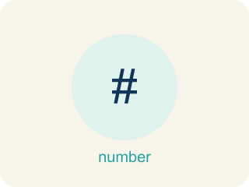
Understand Ratios (Comprender razones) — Use a ratio to compare two quantities by division.
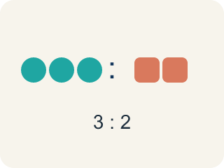
Ratio (Razón) — A way to compare two amounts, like 3 to 2.

Comparison (Comparación) — Looking at two or more amounts to see how they are related.
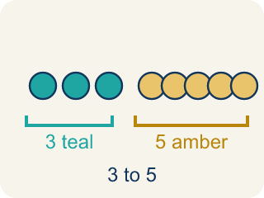
Part-to-part (Parte a parte) — A ratio comparing one part of a group to another part.
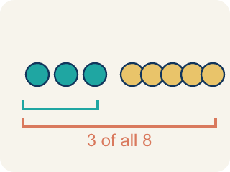
Part-to-whole (Parte a todo) — A ratio comparing one part to the whole group.

Colon notation (Notación con dos puntos) — Writing a ratio with two dots between the numbers, like 3:2.
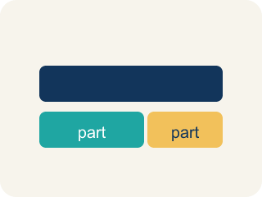
Tape diagram (Diagrama de cintas) — A bar cut into equal parts that shows how two amounts in a ratio compare, and how they make up the whole.
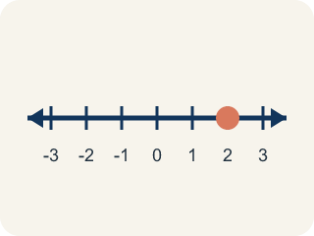
Double number line (Recta numérica doble) — Two number lines lined up so matching tick marks show the two quantities in a ratio at the same time.
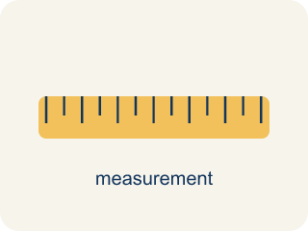
Rates and Unit Rates (Tasas y tasas unitarias) — A rate compares different units; a unit rate compares a quantity to 1 unit.

Ratio Tables (Tablas de razones) — Tables that organize pairs of equivalent ratios.
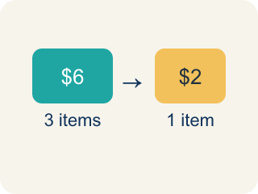
Rate (Tasa) — A ratio comparing two amounts with different units, like miles per hour.
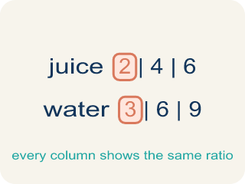
Ratio table (Tabla de razones) — A table of equal ratios that shows a pattern.

Practice
Show your work. Use the blank space under each problem.
1. (Lesson 3.1) A recipe uses 4 cups of milk and 1 cup of cream. What is the ratio of milk to cream?
A. 4:1
B. 1:4
C. 4:5
D. 5:1
______________________________________________________________________
2. (Lesson 3.1) Chef Reyes uses 6 strawberries and 2 bananas in a smoothie. What is the part-to-whole ratio of bananas to total fruit?
A. 2:8
B. 6:2
C. 2:6
D. 8:2
______________________________________________________________________
3. (Lesson 3.1) A fruit salad has 5 pieces of melon, 3 pieces of pineapple, and 2 grapes. What is the ratio of pineapple to melon?
A. 3:5
B. 5:3
C. 3:10
D. 3:2
______________________________________________________________________
4. (Lesson 3.1) A parking lot has 10 cars and 6 trucks. What is the part-to-whole ratio of trucks to total vehicles?
A. 6:16
B. 10:6
C. 6:10
D. 16:6
______________________________________________________________________
5. (Lesson 3.2) Token packs: Pack A is 20 tokens for $5.00, Pack B is 35 tokens for $7.00, and Pack C is 50 tokens for $12.50. Which pack is the best deal per token?
A. Pack A
B. Pack B
C. Pack C
D. They are all the same
______________________________________________________________________
6. (Lesson 3.2) Runner A completes 4 laps in 12 minutes. Runner B completes 5 laps in 14 minutes. Who runs more laps per minute?
A. Runner B
B. Runner A
C. Same rate
D. Cannot determine
______________________________________________________________________
7. (Lesson 3.3) In a ratio table, the ratio of sugar to butter is 3:2. If you use 12 cups of sugar, how many cups of butter do you need?
A. 8
B. 6
C. 10
D. 9
______________________________________________________________________
8. (Lesson 3.3) A ratio table shows 5:8, 10:16, 15:24. What scale factor was used from the first row to the third row?
A. 3
B. 2
C. 5
D. 8
______________________________________________________________________
9. (Lesson 3.1) Prep Bowl A: Chef Reyes stirs 7 cups of flour with 4 cups of water to make dough. What is the part-to-part ratio of flour to water?
A. 7:4
B. 4:7
C. 7:11
D. 11:4
______________________________________________________________________
10. (Lesson 3.2) The Star Blaster cabinet scored 90 points in 3 games. What is the unit rate in points per game?
A. 30 points per game
B. 270 points per game
C. 3 points per game
D. 93 points per game
______________________________________________________________________

Answer Key (Teacher)
1. A. 4:1
A ratio compares quantities in the order given. Milk to cream = 4 to 1, or 4:1.
Watch for: A common mistake in Ratio Tables is scaling only ONE part of the ratio, or adding the scale factor to a part instead of multiplying by it — for example, turning 2:3 into 6:3 (multiplying only the first number by 3 and forgetting the second) or into 4:5 (adding the scale factor 2 to the second number instead of multiplying, since 3+2=5 but 3×2=6). Before you submit, multiply BOTH numbers by the same scale factor and check that your new ratio simplifies back to the original.
2. A. 2:8
Total fruit = 6 + 2 = 8. The part-to-whole ratio of bananas to total fruit is 2:8.
Watch for: A common mistake in Ratio Tables is scaling only ONE part of the ratio, or adding the scale factor to a part instead of multiplying by it — for example, turning 2:3 into 6:3 (multiplying only the first number by 3 and forgetting the second) or into 4:5 (adding the scale factor 2 to the second number instead of multiplying, since 3+2=5 but 3×2=6). Before you submit, multiply BOTH numbers by the same scale factor and check that your new ratio simplifies back to the original.
3. A. 3:5
The ratio of pineapple to melon compares pineapple (3) to melon (5), so the ratio is 3:5.
Watch for: A common mistake in Ratio Tables is scaling only ONE part of the ratio, or adding the scale factor to a part instead of multiplying by it — for example, turning 2:3 into 6:3 (multiplying only the first number by 3 and forgetting the second) or into 4:5 (adding the scale factor 2 to the second number instead of multiplying, since 3+2=5 but 3×2=6). Before you submit, multiply BOTH numbers by the same scale factor and check that your new ratio simplifies back to the original.
4. A. 6:16
Total vehicles = 10 + 6 = 16. The ratio of trucks to total is 6:16.
Watch for: A common mistake in Ratio Tables is scaling only ONE part of the ratio, or adding the scale factor to a part instead of multiplying by it — for example, turning 2:3 into 6:3 (multiplying only the first number by 3 and forgetting the second) or into 4:5 (adding the scale factor 2 to the second number instead of multiplying, since 3+2=5 but 3×2=6). Before you submit, multiply BOTH numbers by the same scale factor and check that your new ratio simplifies back to the original.
5. B. Pack B
Pack B has a unit rate of $0.20 per token, which is the lowest cost per token.
Watch for: A common mistake in Ratio Tables is scaling only ONE part of the ratio, or adding the scale factor to a part instead of multiplying by it — for example, turning 2:3 into 6:3 (multiplying only the first number by 3 and forgetting the second) or into 4:5 (adding the scale factor 2 to the second number instead of multiplying, since 3+2=5 but 3×2=6). Before you submit, multiply BOTH numbers by the same scale factor and check that your new ratio simplifies back to the original.
6. A. Runner B
Runner A: 4÷12 ≈ 0.33 laps/min. Runner B: 5÷14 ≈ 0.36 laps/min. Runner B runs slightly more laps per minute.
Watch for: A common mistake in Ratio Tables is scaling only ONE part of the ratio, or adding the scale factor to a part instead of multiplying by it — for example, turning 2:3 into 6:3 (multiplying only the first number by 3 and forgetting the second) or into 4:5 (adding the scale factor 2 to the second number instead of multiplying, since 3+2=5 but 3×2=6). Before you submit, multiply BOTH numbers by the same scale factor and check that your new ratio simplifies back to the original.
7. A. 8
Scale factor: 12 ÷ 3 = 4. Multiply butter by 4: 2 × 4 = 8 cups of butter.
Watch for: A common mistake in Ratio Tables is scaling only ONE part of the ratio, or adding the scale factor to a part instead of multiplying by it — for example, turning 2:3 into 6:3 (multiplying only the first number by 3 and forgetting the second) or into 4:5 (adding the scale factor 2 to the second number instead of multiplying, since 3+2=5 but 3×2=6). Before you submit, multiply BOTH numbers by the same scale factor and check that your new ratio simplifies back to the original.
8. A. 3
From 5 to 15: 15 ÷ 5 = 3. From 8 to 24: 24 ÷ 8 = 3. The scale factor is 3.
Watch for: A common mistake in Ratio Tables is scaling only ONE part of the ratio, or adding the scale factor to a part instead of multiplying by it — for example, turning 2:3 into 6:3 (multiplying only the first number by 3 and forgetting the second) or into 4:5 (adding the scale factor 2 to the second number instead of multiplying, since 3+2=5 but 3×2=6). Before you submit, multiply BOTH numbers by the same scale factor and check that your new ratio simplifies back to the original.
9. A. 7:4
Part-to-part compares the two ingredients in the order named. Flour to water = 7 to 4, written 7:4.
Watch for: A common mistake in Ratio Tables is scaling only ONE part of the ratio, or adding the scale factor to a part instead of multiplying by it — for example, turning 2:3 into 6:3 (multiplying only the first number by 3 and forgetting the second) or into 4:5 (adding the scale factor 2 to the second number instead of multiplying, since 3+2=5 but 3×2=6). Before you submit, multiply BOTH numbers by the same scale factor and check that your new ratio simplifies back to the original.
10. A. 30 points per game
Divide points by games: 90 ÷ 3 = 30 points per game.
Watch for: A common mistake in Ratio Tables is scaling only ONE part of the ratio, or adding the scale factor to a part instead of multiplying by it — for example, turning 2:3 into 6:3 (multiplying only the first number by 3 and forgetting the second) or into 4:5 (adding the scale factor 2 to the second number instead of multiplying, since 3+2=5 but 3×2=6). Before you submit, multiply BOTH numbers by the same scale factor and check that your new ratio simplifies back to the original.

