UNIT 3 · LESSON 3 STANDARD 6.AT.3A

Determine Equivalent Ratios Using Tables
Student Notes Packet
Name: ______________________ Date: ____________ Period: ________
Level 2 · Standard

Today's Goals
Content: I can use a ratio table to find equivalent ratios.
Language: I can explain my table using the words ratio table, equivalent ratio, scale factor, and pattern.

Key Vocabulary
Look at the picture, read the word, then read what it means.
 | Ratio Tables Tablas de razones  Tables that organize pairs of equivalent ratios.  Example: 2:3, 4:6, and 6:9 belong in the same ratio table.
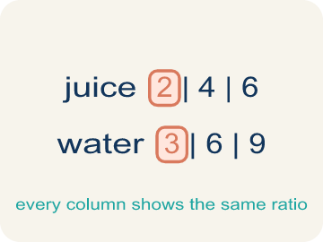 | Ratio table Tabla de razones  A table of equal ratios that shows a pattern.  Example: Cups of juice: 2, 4, 6 | Cups of water: 3, 6, 9
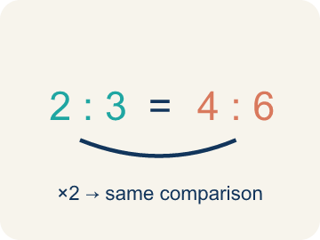 | Equivalent ratio Razón equivalente  Two ratios that mean the same thing, like 1:2 and 2:4.  Example: 2:3 = 4:6 = 6:9
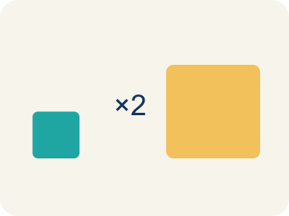 | Scale factor Factor de escala  The number you multiply both parts of a ratio by to get an equal ratio.  Example: 2:3 × 2 → 4:6 (scale factor is 2)
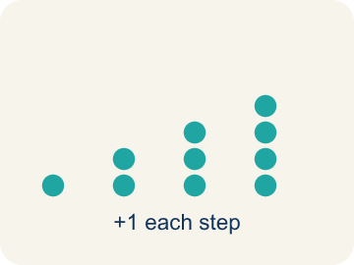 | Pattern Patrón  A rule that numbers follow again and again.  Example: Each row adds 2 cups juice and 3 cups water
 | Additive pattern Patrón aditivo  Building new rows of a ratio table by adding each column's own constant amount, so the two columns grow together.  Example: 2:3 → 4:6 → 6:9 (add 2 and 3 each time)

Guided Notes
Fill in each blank as we go. Use the Word Bank to help you.
WORD BANK
Ratio Tables • Ratio table • Equivalent ratio • Scale factor • Pattern • Additive pattern

1. A table whose every row holds the same comparison is a ________________ ________________.
2. A table that lists equivalent ratios in rows or columns is a ________________.
3. Two ratios that make the same comparison are ________________ ________________.
4. The number you multiply a ratio by to get an equivalent ratio is the ________________.
5. A rule that the numbers in a table follow is a ________________.
6. A pattern where you add the same amount each step is an ________________.

Write About the Math
Use the support level you need. Every level answers the same math question.

1. Understand the Question explain
A juice bar makes a Berry Blast smoothie with 3 scoops of frozen berries for every 2 cups of yogurt. A customer orders enough for a party of 20 people, and each person gets one serving. The juice bar needs to use a ratio table to figure out how many scoops and cups to prepare?
Your job: Answer the question. Use math evidence. Explain how the evidence proves your answer.
Responde la pregunta. Usa evidencia matemática. Explica cómo la evidencia demuestra tu respuesta.

2. Plan Your Math Words check at least two
☐ Ratio Tables — Tables that organize pairs of equivalent ratios.
Tablas de razones — Tablas que organizan pares de razones equivalentes.
☐ Ratio table — A table of equal ratios that shows a pattern.
Tabla de razones — Una tabla de razones iguales que muestra un patrón.
☐ Equivalent ratio — Two ratios that mean the same thing, like 1:2 and 2:4.
Razón equivalente — Dos razones que significan lo mismo, como 1:2 y 2:4.
☐ Scale factor — The number you multiply both parts of a ratio by to get an equal ratio.
Factor de escala — El número por el que multiplicas ambas partes de una razón para obtener una razón igual.
☐ Pattern — A rule that numbers follow again and again.
Patrón — Una regla que los números siguen una y otra vez.
Say it first: Say your idea to a partner or quietly to yourself before you write.
The recipe uses 3 scoops of berries for every ___ cups of yogurt, so 20 servings need ___ scoops of berries and ___ cups of yogurt.
Di tu respuesta primero: Mi respuesta es ___ porque ___.

3. Build Your Explanation choose your support
This model shows the parts of an explanation. It does not answer your writing question.
Claim: When the recipe gets 4 times bigger, both the mix and the milk get 4 times bigger.
Evidence: A strong answer says BOTH quantities are multiplied by the same number (4), so 2:3 becomes 8:12, keeping the ratio equivalent.
Reasoning: This evidence connects the definition of equivalent ratio to the mathematical claim.

Start Most language support
Complete the frames. Use the word bank.
Completa las oraciones. Usa el banco de palabras.
The recipe uses 3 scoops of berries for every ___ cups of yogurt, so 20 servings need ___ scoops of berries and ___ cups of yogurt.
My answer is ___.
Mi respuesta es ___.

Build Some language support
Write two connected sentences. Use because, so, or but.
Escribe dos oraciones conectadas. Usa porque, entonces o pero.
My claim is ___.
Mi afirmación es ___.
I know because ___.
Lo sé porque ___.
So ___.
Entonces ___.

Explain Light language support
Write a claim, give math evidence, and explain your reasoning.
Escribe una afirmación, da evidencia matemática y explica tu razonamiento.
My claim is ___.
Mi afirmación es ___.
My math evidence is ___.
Mi evidencia matemática es ___.
This proves ___ because ___.
Esto demuestra ___ porque ___.

4. Check Your Explanation five quick checks
☐ I answered the question.
Respondí la pregunta.
☐ I used math evidence: numbers, an equation, a model, or a comparison.
Usé evidencia matemática: números, una ecuación, un modelo o una comparación.
☐ I explained how the evidence proves my answer.
Expliqué cómo la evidencia demuestra mi respuesta.
☐ I used at least two math words.
Usé por lo menos dos palabras matemáticas.
☐ I reread complete sentences and punctuation.
Volví a leer mis oraciones completas y la puntuación.

Worked Example

Watch & Read I Do — follow along with your teacher
Chef Academy is hosting a pancake breakfast for the whole school! Chef Reyes's famous pancake batter uses 2 cups of mix for every 3 cups of milk. The team needs to scale the recipe to feed 4 times as many people. Can you help them build a ratio table to figure out how much of each ingredient they need?

Think about:
• What two quantities are being compared in the recipe?
• What happens to both quantities when you double the recipe?
• How could a table help you organize the scaling?
• What if we only needed to make half the original recipe?
• Is there a shortcut to find any row in the table without filling every row?

Solved Example I Do — watch each step
Problem: A recipe uses 3 eggs for every 5 cups of flour. How many eggs are needed for 15 cups of flour?
A) 9
B) 6
C) 10
D) 12
Step 1: The scale factor is 15 ÷ 5 = 3.
Step 2: Multiply the eggs by 3: 3 × 3 = 9 eggs.
Answer: A. 9

Guided Practice

Solve Together We Do — work with your class
Problem: Which row does NOT belong in a ratio table for 4:5?
A) 6:10
B) 8:10
C) 12:15
D) 16:20
Step 1:

Step 2:

Answer:

A juice bar makes a Berry Blast smoothie with 3 scoops of frozen berries for every 2 cups of yogurt. A customer orders enough for a party of 20 people, and each person gets one serving. The juice bar needs to use a ratio table to figure out how many scoops and cups to prepare.

Sentence frame: The recipe uses 3 scoops of berries for every ___ cups of yogurt, so 20 servings need ___ scoops of berries and ___ cups of yogurt.

Turn & Talk discuss with a partner
1. [Launch] Chef Reyes's pancake batter uses 2 cups of mix for every 3 cups of milk. To feed 4 times as many people, what happens to BOTH ingredient amounts?
Start with: When I make 4 batches, I multiply both ___ and ___ by ___.
Cuando hago 4 tandas, multiplico tanto ___ como ___ por ___.
Word bank: Ratio table, Equivalent ratio, Scale factor
2. [Explore] In your pancake ratio table, how did you find each new row from the 2:3 starting row?
Start with: I multiplied both numbers by ___ to get ___.
Multipliqué ambos números por ___ para obtener ___.
Word bank: Ratio table, Equivalent ratio, Scale factor, Pattern
3. [Connect] The juice bar makes a smoothie with 3 scoops of berries for every 2 cups of yogurt and needs enough for 20 people. How is this the same as our pancake table?
Start with: This is like our ratio table work because ___ and ___ are related by ___.
Esto es como nuestro trabajo con tablas de razones porque ___ y ___ se relacionan por ___.
Word bank: Ratio table, Equivalent ratio, Scale factor, Pattern
4. [Practice] During practice on Ratio Tables, what strategy did you use when a problem felt tricky?
Start with: I multiplied both numbers by ___ to get ___.
Multipliqué ambos números por ___ para obtener ___.
Word bank: Ratio table, Equivalent ratio, Scale factor, Pattern

Independent Practice

On Your Own You Do — show your work
Solve each problem. Show your thinking in the work box.

On Level grade-level practice
1. In a ratio table, the ratio of sugar to butter is 3:2. If you use 12 cups of sugar, how many cups of butter do you need?
A) 8
B) 6
C) 10
D) 9

2. A ratio table shows 5:8, 10:16, 15:24. What scale factor was used from the first row to the third row?
A) 3
B) 2
C) 5
D) 8

Exit Ticket
Answer on your own. This shows what you learned today.
★ A salad dressing recipe uses 2 tablespoons of oil for every 5 tablespoons of vinegar. How many tablespoons of oil are needed for 20 tablespoons of vinegar?
A) 8
B) 10
C) 7
D) 12

Answer Key & Teacher Guide
Teacher reference — remove or fold back before distributing to students.

Guided Notes (Fill-in)
Notes 1: Ratio Tables
Notes 2: Ratio table
Notes 3: Equivalent ratio
Notes 4: Scale factor
Notes 5: Pattern
Notes 6: Additive pattern

Worked Notes (I Do / We Do)
I Do: A. 9
We Do: A. 6:10

Independent Practice
Watch for this mistake: A common mistake in Ratio Tables is scaling only ONE part of the ratio, or adding the scale factor to a part instead of multiplying by it — for example, turning 2:3 into 6:3 (multiplying only the first number by 3 and forgetting the second) or into 4:5 (adding the scale factor 2 to the second number instead of multiplying, since 3+2=5 but 3×2=6). Before you submit, multiply BOTH numbers by the same scale factor and check that your new ratio simplifies back to the original.

Level 1 Support
1. A) 12:28 — The pattern adds 3 to the first value and 7 to the second each time. After 9:21: 9+3=12 and 21+7=28. The next row is 12:28.
2. A) 6:15 — The additive pattern adds 2 to the first value and 5 to the second. 4+2=6 and 10+5=15. The third row is 6:15.

On Level
3. A) 8 — Scale factor: 12 ÷ 3 = 4. Multiply butter by 4: 2 × 4 = 8 cups of butter.
4. A) 3 — From 5 to 15: 15 ÷ 5 = 3. From 8 to 24: 24 ÷ 8 = 3. The scale factor is 3.

Level 2 Enrichment
5. The last row is wrong. The pattern multiplies by the same scale factor. 4×1=4, 4×2=8, 4×3=12, so the 4th row should be 4×4=16 cups of flour and 3×4=12 cups of sugar → 16:12. The student added 2 to 12 instead of adding 4. Or: 12+4=16, not 12+2=14. — The flour column grows by 4 each row, so after 12 it should be 16, not 14 — the last row should read 16:12. The student added 2 to the flour while still adding 3 to the sugar, which breaks the 4:3 relationship.

Exit Ticket
A) 8 — Scale factor: 20 ÷ 5 = 4. Multiply oil by 4: 2 × 4 = 8 tablespoons of oil.

Math Writing Criteria
The support level changes the amount of language scaffolding, not the mathematical expectation.
☐ I answered the question.
☐ I used math evidence: numbers, an equation, a model, or a comparison.
☐ I explained how the evidence proves my answer.
☐ I used at least two math words.
☐ I reread complete sentences and punctuation.

