UNIT 3 · LESSON 4 STANDARD 6.AT.3A

Determine Equivalent Ratios Using Graphs
Student Notes Packet
Name: ______________________ Date: ____________ Period: ________
Level 2 · Standard

Today's Goals
Content: I can graph the values from a ratio table as points on the coordinate plane.
Language: I can explain my graph using the words coordinate plane, ordered pair, origin, and proportional.

Key Vocabulary
Look at the picture, read the word, then read what it means.
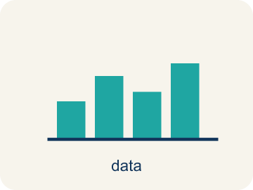 | Graph Ratio Tables Representar tablas de razones en una gráfica  Plot the paired values from a ratio table as ordered pairs.  Example: The ratio pairs 2:3 and 4:6 become points (2,3) and (4,6).
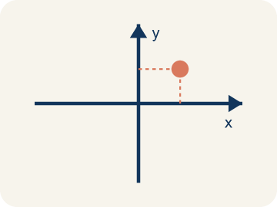 | Coordinate plane Plano cartesiano  A grid with a line going across and a line going up to plot points.  Example: A + shape made by two number lines crossing at the center point (0, 0)
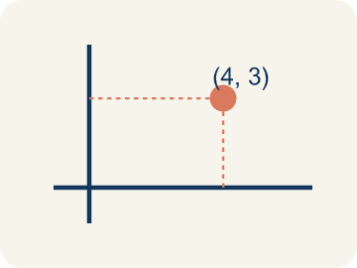 | Ordered pair Par ordenado  Two numbers (x, y) that tell where a point is on a grid.  Example: (3, 6) means go right 3, up 6
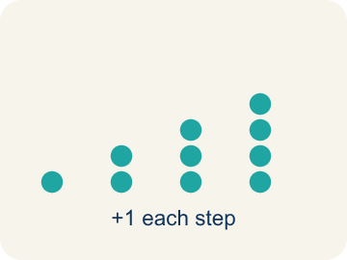 | Linear pattern Patrón lineal  Points that make a straight line on a grid.  Example: (1,2), (2,4), (3,6) all line up
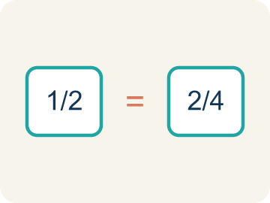 | Proportional Proporcional  Two amounts that grow together at the same rate.  Example: A straight line from (0,0) through (2,6) and (4,12)
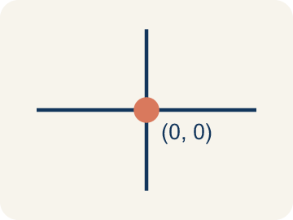 | Origin Origen  The point (0, 0) where the two grid lines cross.  Example: The starting corner of the grid at (0, 0)
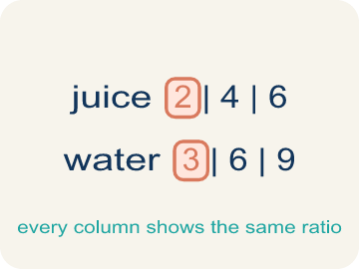 | Ratio table Tabla de razones  A table of equal ratios that shows a pattern.  Example: Cups of juice: 2, 4, 6 | Cups of water: 3, 6, 9

Guided Notes
Fill in each blank as we go. Use the Word Bank to help you.
WORD BANK
Graph Ratio Tables • Coordinate plane • Ordered pair • Linear pattern • Proportional • Origin • Ratio table

1. Each row of a ratio table becomes one ________________ ________________ on the coordinate plane.
2. The flat grid formed by a horizontal and a vertical number line is the ________________.
3. A set of two numbers (x, y) that names a point is an ________________.
4. When graphed points form a straight line, they show a ________________.
5. Two quantities that always keep the same ratio are ________________.
6. The point (0, 0) where the two axes meet is the ________________.
7. A table that lists equivalent ratios in rows or columns is a ________________.

Write About the Math
Use the support level you need. Every level answers the same math question.

1. Understand the Question explain
A food truck tracks how many tacos it sells and how much salsa it uses. After recording data for a week, the owner plots the points on a graph and notices they form a straight line. This helps the owner predict exactly how much salsa to prepare for any number of tacos?
Your job: Answer the question. Use math evidence. Explain how the evidence proves your answer.
Responde la pregunta. Usa evidencia matemática. Explica cómo la evidencia demuestra tu respuesta.

2. Plan Your Math Words check at least two
☐ Graph Ratio Tables — Plot the paired values from a ratio table as ordered pairs.
Representar tablas de razones en una gráfica — Ubicar los valores emparejados de una tabla de razones como pares ordenados.
☐ Coordinate plane — A grid with a line going across and a line going up to plot points.
Plano cartesiano — Una cuadrícula con una línea horizontal y una vertical para marcar puntos.
☐ Ordered pair — Two numbers (x, y) that tell where a point is on a grid.
Par ordenado — Dos números (x, y) que dicen dónde está un punto en una cuadrícula.
☐ Linear pattern — Points that make a straight line on a grid.
Patrón lineal — Puntos que forman una línea recta en una cuadrícula.
☐ Proportional — Two amounts that grow together at the same rate.
Proporcional — Dos cantidades que crecen juntas al mismo ritmo.
Say it first: Say your idea to a partner or quietly to yourself before you write.
Every point on the line has the same ratio — ___ taco to ___ ounces of salsa — so 10 tacos would use ___ ounces.
Di tu respuesta primero: Mi respuesta es ___ porque ___.

3. Build Your Explanation choose your support
This model shows the parts of an explanation. It does not answer your writing question.
Claim: I predict the points will line up because sundaes and sauce grow together.
Evidence: A strong answer chooses sundaes (x) and ounces of sauce (y), and predicts a straight line because each sundae always needs 2 more ounces.
Reasoning: This evidence connects the definition of graph ratio tables to the mathematical claim.

Start Most language support
Complete the frames. Use the word bank.
Completa las oraciones. Usa el banco de palabras.
Every point on the line has the same ratio — ___ taco to ___ ounces of salsa — so 10 tacos would use ___ ounces.
My answer is ___.
Mi respuesta es ___.

Build Some language support
Write two connected sentences. Use because, so, or but.
Escribe dos oraciones conectadas. Usa porque, entonces o pero.
My claim is ___.
Mi afirmación es ___.
I know because ___.
Lo sé porque ___.
So ___.
Entonces ___.

Explain Light language support
Write a claim, give math evidence, and explain your reasoning.
Escribe una afirmación, da evidencia matemática y explica tu razonamiento.
My claim is ___.
Mi afirmación es ___.
My math evidence is ___.
Mi evidencia matemática es ___.
This proves ___ because ___.
Esto demuestra ___ porque ___.

4. Check Your Explanation five quick checks
☐ I answered the question.
Respondí la pregunta.
☐ I used math evidence: numbers, an equation, a model, or a comparison.
Usé evidencia matemática: números, una ecuación, un modelo o una comparación.
☐ I explained how the evidence proves my answer.
Expliqué cómo la evidencia demuestra mi respuesta.
☐ I used at least two math words.
Usé por lo menos dos palabras matemáticas.
☐ I reread complete sentences and punctuation.
Volví a leer mis oraciones completas y la puntuación.

Worked Example

Watch & Read I Do — follow along with your teacher
Chef Academy students are tracking how much chocolate sauce they need for different numbers of sundaes. They know the recipe uses 2 ounces of sauce for every 1 sundae. Chef Reyes challenges them to plot the ratio table values on a coordinate grid to see the pattern. Will the points form a straight line?

Think about:
• What two quantities could we put on the x-axis and y-axis?
• What pattern do you see in the ratio table values?
• What do you think the graph will look like?
• What if the points did NOT form a straight line — what would that mean?
• Could we use the graph to predict amounts not in our table?

Solved Example I Do — watch each step
Problem: A ratio table shows (2, 6), (4, 12), and (6, 18). Which ordered pair comes next if the pattern continues?
A) (8, 24)
B) (7, 20)
C) (8, 22)
D) (10, 24)
Step 1: The pattern adds 2 to x and 6 to y each time.
Step 2: After (6, 18): x = 6+2 = 8, y = 18+6 = 24.
Step 3: The next point is (8, 24).
Answer: A. (8, 24)

Guided Practice

Solve Together We Do — work with your class
Problem: When you graph equivalent ratios, the points will always form what shape?
A) A straight line through the origin
B) A curved line
C) A zigzag
D) A circle
Step 1:

Step 2:

Step 3:

Answer:

A food truck tracks how many tacos it sells and how much salsa it uses. After recording data for a week, the owner plots the points on a graph and notices they form a straight line. This helps the owner predict exactly how much salsa to prepare for any number of tacos.

Sentence frame: Every point on the line has the same ratio — ___ taco to ___ ounces of salsa — so 10 tacos would use ___ ounces.

Turn & Talk discuss with a partner
1. [Launch] The sundae recipe uses 2 ounces of chocolate sauce for every 1 sundae. Before you graph, what do you predict the points will look like, and which quantity goes on each axis?
Start with: I will put ___ on the x-axis and ___ on the y-axis.
Pondré ___ en el eje x y ___ en el eje y.
Word bank: Coordinate plane, Ordered pair, Origin
2. [Explore] After plotting (1,2), (2,4), (3,6)... what pattern do you notice, and how does it show the chocolate-sauce ratio?
Start with: The points form a ___ through the ___.
Los puntos forman una ___ que pasa por el ___.
Word bank: Coordinate plane, Ordered pair, Linear pattern, Proportional, Origin
3. [Connect] The food truck plots tacos vs. salsa and gets a straight line. What does that graph tell the owner about preparing salsa for ANY number of tacos?
Start with: This is like our graphing work because ___ and ___ are related by ___.
Esto es como nuestro trabajo con gráficas porque ___ y ___ se relacionan por ___.
Word bank: Coordinate plane, Ordered pair, Proportional, Origin
4. [Practice] During practice on Graph Ratio Tables, what strategy did you use when a problem felt tricky?
Start with: The points form a ___ through the ___.
Los puntos forman una ___ que pasa por el ___.
Word bank: Coordinate plane, Ordered pair, Linear pattern, Proportional

Independent Practice

On Your Own You Do — show your work
Solve each problem. Show your thinking in the work box.

On Level grade-level practice
1. Points from a ratio table are plotted at (1, 4), (2, 8), and (3, 12). What is the ratio of y to x for each point?
A) 4:1
B) 1:4
C) 2:8
D) 3:4

2. Two students graph ratio tables. Student A plots (1,2), (2,4), (3,6). Student B plots (1,3), (2,6), (3,9). Whose line is steeper?
A) Student B
B) Student A
C) Same steepness
D) Cannot tell

Exit Ticket
Answer on your own. This shows what you learned today.
★ A ratio table shows cups of rice to cups of water: (1, 2), (2, 4), (3, 6). If you plot these points, the line passes through which point?
A) (5, 10)
B) (4, 6)
C) (5, 8)
D) (6, 10)

