UNIT 3 · LESSON 6 STANDARD 6.AT.3

Ratio Reasoning: Convert Measurements within the Same System
Student Notes Packet
Name: ______________________ Date: ____________ Period: ________
Level 2 · Standard

Today's Goals
Content: I can use ratio reasoning to convert between units within the same measurement system.
Language: I can explain a conversion using the words unit ratio, convert, measurement system, and per.

Key Vocabulary
Look at the picture, read the word, then read what it means.
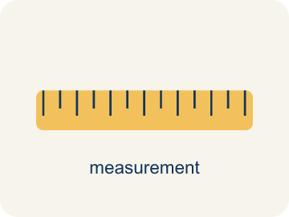 | Convert Measurements within the Same System Convertir medidas dentro del mismo sistema  Rewriting a measurement in a different unit of the SAME system, such as feet into inches or liters into milliliters.  Example: 4 feet = 48 inches; 4 liters = 4,000 milliliters
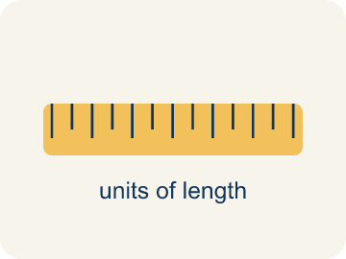 | Conversion factor Factor de conversión  The ratio that links two units in the same measurement system, such as 12 inches to 1 foot. Within one system it is exact.  Example: 1 ft = 12 in. · 1 L = 1,000 mL · 1 lb = 16 oz
 | Unit ratio Razón unitaria  A ratio that compares an amount to exactly 1 unit of another quantity, like 12 inches to 1 foot.  Example: 12 : 1 — twelve inches for every one foot
 | Convert Convertir  To change a measurement from one unit to another without changing how much it is.  Example: 4 ft and 48 in are the same height, written two ways
 | Measurement system Sistema de medidas  A family of units that go together — customary units like inches and feet, or metric units like milliliters and liters.  Example: Customary: 12 in = 1 ft · Metric: 1,000 mL = 1 L
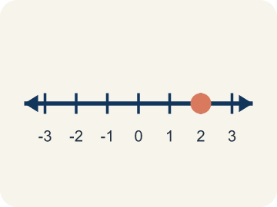 | Double number line Recta numérica doble  Two number lines lined up so matching tick marks show two units for the same amount.  Example: Liters 0, 1, 2, 3, 4 above milliliters 0, 1,000, 2,000, 3,000, 4,000
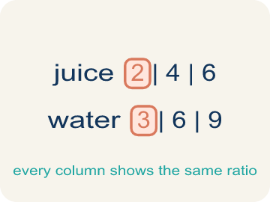 | Ratio table Tabla de razones  A table of equal ratios that lets you scale a conversion up or down one row at a time.  Example: 1 ft : 12 in, 2 ft : 24 in, 4 ft : 48 in

Guided Notes
Fill in each blank as we go. Use the Word Bank to help you.
WORD BANK
Convert Measurements within the Same System • Conversion factor • Unit ratio • Convert • Measurement system • Double number line • Ratio table

1. Feet into inches stays inside the ________________ measurement system.
2. The ratio that trades one unit for another is a ________________ ________________.
3. A ratio comparing an amount to exactly ________________ unit is a unit ratio.
4. To change a measurement to another unit without changing the amount is to ________________.
5. Inches and feet belong to the customary ________________ ________________; centimeters and meters to the metric one.
6. Two lines whose matching ticks show the same amount in two units form a ________________ ________________ ________________.
7. A table whose every column holds the same comparison is a ________________ ________________.

Write About the Math
Use the support level you need. Every level answers the same math question.

1. Understand the Question explain
How many cup-scoops of broth does the recipe need, and how do you know?
Your job: Answer the question. Use math evidence. Explain how the evidence proves your answer.
Responde la pregunta. Usa evidencia matemática. Explica cómo la evidencia demuestra tu respuesta.

2. Plan Your Math Words check at least two
☐ Convert Measurements within the Same System — Rewriting a measurement in a different unit of the SAME system, such as feet into inches or liters into milliliters.
Convertir medidas dentro del mismo sistema — Reescribir una medida en otra unidad del MISMO sistema, como pies a pulgadas o litros a mililitros.
☐ Conversion factor — The ratio that links two units in the same measurement system, such as 12 inches to 1 foot. Within one system it is exact.
Factor de conversión — La razón que relaciona dos unidades del mismo sistema de medición, como 12 pulgadas a 1 pie. Dentro de un mismo sistema es exacta.
☐ Unit ratio — A ratio that compares an amount to exactly 1 unit of another quantity, like 12 inches to 1 foot.
Razón unitaria — Una razón que compara una cantidad con exactamente 1 unidad de otra cantidad, como 12 pulgadas por 1 pie.
☐ Convert — To change a measurement from one unit to another without changing how much it is.
Convertir — Cambiar una medida de una unidad a otra sin cambiar la cantidad que representa.
☐ Measurement system — A family of units that go together — customary units like inches and feet, or metric units like milliliters and liters.
Sistema de medidas — Una familia de unidades que van juntas: unidades usuales como pulgadas y pies, o métricas como mililitros y litros.
Say it first: Say your idea to a partner or quietly to yourself before you write.
The unit ratio is ___ cups to 1 quart. Cups are ___ than quarts, so I ___ to convert. 3 × 4 = ___ cups. The amount of broth did not change — only the ___ did.
Di tu respuesta primero: Mi respuesta es ___ porque ___.

3. Build Your Explanation choose your support
This model shows the parts of an explanation. It does not answer your writing question.
Claim: Find the scale factor (120 divided by 8 = 15), then multiply each ingredient by it.
Evidence: Students find the scale factor of 15 and explain that multiplying both ingredients by 15 keeps the recipe proportional (5 cups tomatoes becomes 75, 3 cups mozzarella becomes 45).
Reasoning: This evidence connects the definition of convert measurements within the same system to the mathematical claim.

Start Most language support
Complete the frames. Use the word bank.
Completa las oraciones. Usa el banco de palabras.
The unit ratio is ___ cups to 1 quart. Cups are ___ than quarts, so I ___ to convert. 3 × 4 = ___ cups. The amount of broth did not change — only the ___ did.
My answer is ___.
Mi respuesta es ___.

Build Some language support
Write two connected sentences. Use because, so, or but.
Escribe dos oraciones conectadas. Usa porque, entonces o pero.
My claim is ___.
Mi afirmación es ___.
I know because ___.
Lo sé porque ___.
So ___.
Entonces ___.

Explain Light language support
Write a claim, give math evidence, and explain your reasoning.
Escribe una afirmación, da evidencia matemática y explica tu razonamiento.
My claim is ___.
Mi afirmación es ___.
My math evidence is ___.
Mi evidencia matemática es ___.
This proves ___ because ___.
Esto demuestra ___ porque ___.

4. Check Your Explanation five quick checks
☐ I answered the question.
Respondí la pregunta.
☐ I used math evidence: numbers, an equation, a model, or a comparison.
Usé evidencia matemática: números, una ecuación, un modelo o una comparación.
☐ I explained how the evidence proves my answer.
Expliqué cómo la evidencia demuestra mi respuesta.
☐ I used at least two math words.
Usé por lo menos dos palabras matemáticas.
☐ I reread complete sentences and punctuation.
Volví a leer mis oraciones completas y la puntuación.

Worked Example

Watch & Read I Do — follow along with your teacher
Conversion Chef
Chef Reyes writes every recipe in the units the supplier uses, but the kitchen's measuring tools are marked in different units of the same system. A stock order lists quarts; the pot is marked in cups. A height rule at the county fair ride is posted in inches; the sign-up sheet lists feet. Your job is to convert between units without changing the amount.

Think about:
• I notice the two measurements use different ___.
• I notice both units belong to the same measurement ___.
• I notice one unit is smaller, so it will take ___ of them.
• I wonder how many of the smaller unit fit in ___ of the bigger one.
• I wonder whether I should multiply or ___ to convert.

Solved Example I Do — watch each step
Problem: There are 12 inches in 1 foot. How many inches are in 5 feet?
A) 60 inches
B) 17 inches
C) 7 inches
D) 50 inches
Step 1: Inches are smaller than feet, so multiply by the unit ratio: 5 × 12 = 60 inches.
Answer: A. 60 inches

Guided Practice

Solve Together We Do — work with your class
Problem: There are 1,000 milliliters in 1 liter. How many milliliters are in 3 liters?
A) 3,000 mL
B) 1,003 mL
C) 300 mL
D) 30 mL
Step 1:

Step 2:

Answer:

Chef Reyes is making stock. The recipe calls for 3 quarts of broth, but the only measuring tool on the line is a 1-cup scoop. There are 4 cups in 1 quart.
How many cup-scoops of broth does the recipe need, and how do you know?

Sentence frame: The unit ratio is ___ cups to 1 quart. Cups are ___ than quarts, so I ___ to convert. 3 × 4 = ___ cups. The amount of broth did not change — only the ___ did.

Turn & Talk discuss with a partner
1. [Launch] Chef Reyes's recipe serves 8 people, but the banquet has 120 guests. How many times bigger is 120 than 8, and how does that scale factor help you adjust the tomatoes and mozzarella?
Start with: 120 guests is ___ times bigger than 8 because 120 divided by 8 equals ___.
120 invitados es ___ veces más que 8 porque 120 entre 8 es ___.
Word bank: proportion, scale, equivalent, unit rate, ratio
2. [Explore] You sorted ratio pairs into equivalent and not equivalent. How does ratio reasoning, like cross-multiplying, prove that 4:7 and 12:21 are equivalent?
Start with: I reasoned that 4:7 and 12:21 are ___ because ___.
Razoné que 4:7 y 12:21 son ___ porque ___.
Word bank: proportion, equivalent, scale, cross-multiply, ratio
3. [Connect] Where might ratio reasoning help you make a smart choice in real life, like shopping or cooking?
Start with: Ratio reasoning helps me when ___.
El razonamiento con razones me ayuda cuando ___.
Word bank: proportion, scale, equivalent, unit rate, ratio
4. [Practice] During practice on Use Ratio Reasoning, what strategy did you use when a problem felt tricky?
Start with: When a problem felt tricky, I found the scale factor by ___ and then ___.
Cuando un problema parecía difícil, encontré el factor de escala al ___ y luego ___.
Word bank: Proportion, Cross-multiply, Scale, Equivalent

Independent Practice

On Your Own You Do — show your work
Solve each problem. Show your thinking in the work box.

On Level grade-level practice
1. Diamond needs 4 liters of water. Her bottle holds 500 milliliters. How many times must she fill it?
A) 8 times
B) 4 times
C) 2 times
D) 40 times

2. Sort each conversion by what happens to the NUMBER.

Exit Ticket
Answer on your own. This shows what you learned today.
★ There are 4 cups in 1 quart. A soup recipe calls for 5 quarts of broth. How many cups is that, and why?
A) 20 cups, because cups are smaller so I multiply: 5 × 4
B) 1.25 cups, because I divide 5 by 4
C) 9 cups, because I add 5 + 4
D) 5 cups, because the amount does not change

