UNIT 3 · LESSON 6 STANDARD 6.AT.3

Ratio Reasoning: Convert Measurements within the Same System
Student Notes Packet
Name: ______________________ Date: ____________ Period: ________
Level 3 · Enrichment

Today's Goals
Content: I can use ratio reasoning to convert between units within the same measurement system.
Language: I can explain a conversion using the words unit ratio, convert, measurement system, and per.

Key Vocabulary
Look at the picture, read the word, then read what it means.
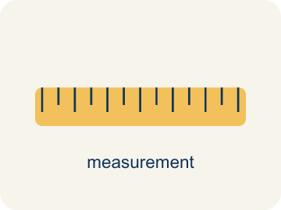 | Convert Measurements within the Same System Convertir medidas dentro del mismo sistema  Rewriting a measurement in a different unit of the SAME system, such as feet into inches or liters into milliliters.  Example: 4 feet = 48 inches; 4 liters = 4,000 milliliters
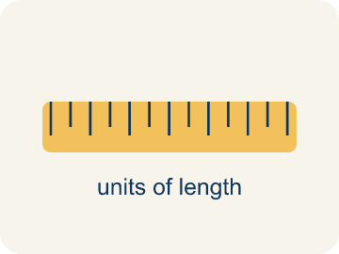 | Conversion factor Factor de conversión  The ratio that links two units in the same measurement system, such as 12 inches to 1 foot. Within one system it is exact.  Example: 1 ft = 12 in. · 1 L = 1,000 mL · 1 lb = 16 oz
 | Unit ratio Razón unitaria  A ratio that compares an amount to exactly 1 unit of another quantity, like 12 inches to 1 foot.  Example: 12 : 1 — twelve inches for every one foot
 | Convert Convertir  To change a measurement from one unit to another without changing how much it is.  Example: 4 ft and 48 in are the same height, written two ways
 | Measurement system Sistema de medidas  A family of units that go together — customary units like inches and feet, or metric units like milliliters and liters.  Example: Customary: 12 in = 1 ft · Metric: 1,000 mL = 1 L
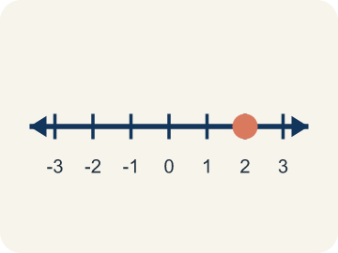 | Double number line Recta numérica doble  Two number lines lined up so matching tick marks show two units for the same amount.  Example: Liters 0, 1, 2, 3, 4 above milliliters 0, 1,000, 2,000, 3,000, 4,000
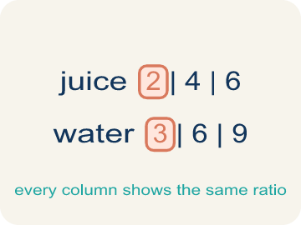 | Ratio table Tabla de razones  A table of equal ratios that lets you scale a conversion up or down one row at a time.  Example: 1 ft : 12 in, 2 ft : 24 in, 4 ft : 48 in

Guided Notes
Fill in each blank as we go. Use the Word Bank to help you.
WORD BANK
Convert Measurements within the Same System • Conversion factor • Unit ratio • Convert • Measurement system • Double number line • Ratio table

1. Feet into inches stays inside the ________________ measurement system.
2. The ratio that trades one unit for another is a ________________ ________________.
3. A ratio comparing an amount to exactly ________________ unit is a unit ratio.
4. To change a measurement to another unit without changing the amount is to ________________.
5. Inches and feet belong to the customary ________________ ________________; centimeters and meters to the metric one.
6. Two lines whose matching ticks show the same amount in two units form a ________________ ________________ ________________.
7. A table whose every column holds the same comparison is a ________________ ________________.

Write About the Math
Use the support level you need. Every level answers the same math question.

1. Understand the Question explain
How many cup-scoops of broth does the recipe need, and how do you know?
Your job: Answer the question. Use math evidence. Explain how the evidence proves your answer.
Responde la pregunta. Usa evidencia matemática. Explica cómo la evidencia demuestra tu respuesta.

2. Plan Your Math Words check at least two
☐ Convert Measurements within the Same System — Rewriting a measurement in a different unit of the SAME system, such as feet into inches or liters into milliliters.
Convertir medidas dentro del mismo sistema — Reescribir una medida en otra unidad del MISMO sistema, como pies a pulgadas o litros a mililitros.
☐ Conversion factor — The ratio that links two units in the same measurement system, such as 12 inches to 1 foot. Within one system it is exact.
Factor de conversión — La razón que relaciona dos unidades del mismo sistema de medición, como 12 pulgadas a 1 pie. Dentro de un mismo sistema es exacta.
☐ Unit ratio — A ratio that compares an amount to exactly 1 unit of another quantity, like 12 inches to 1 foot.
Razón unitaria — Una razón que compara una cantidad con exactamente 1 unidad de otra cantidad, como 12 pulgadas por 1 pie.
☐ Convert — To change a measurement from one unit to another without changing how much it is.
Convertir — Cambiar una medida de una unidad a otra sin cambiar la cantidad que representa.
☐ Measurement system — A family of units that go together — customary units like inches and feet, or metric units like milliliters and liters.
Sistema de medidas — Una familia de unidades que van juntas: unidades usuales como pulgadas y pies, o métricas como mililitros y litros.
Say it first: Say your idea to a partner or quietly to yourself before you write.
The unit ratio is ___ cups to 1 quart. Cups are ___ than quarts, so I ___ to convert. 3 × 4 = ___ cups. The amount of broth did not change — only the ___ did.
Di tu respuesta primero: Mi respuesta es ___ porque ___.

3. Build Your Explanation choose your support
This model shows the parts of an explanation. It does not answer your writing question.
Claim: Find the scale factor (120 divided by 8 = 15), then multiply each ingredient by it.
Evidence: Students find the scale factor of 15 and explain that multiplying both ingredients by 15 keeps the recipe proportional (5 cups tomatoes becomes 75, 3 cups mozzarella becomes 45).
Reasoning: This evidence connects the definition of convert measurements within the same system to the mathematical claim.

Start Most language support
Complete the frames. Use the word bank.
Completa las oraciones. Usa el banco de palabras.
The unit ratio is ___ cups to 1 quart. Cups are ___ than quarts, so I ___ to convert. 3 × 4 = ___ cups. The amount of broth did not change — only the ___ did.
My answer is ___.
Mi respuesta es ___.

Build Some language support
Write two connected sentences. Use because, so, or but.
Escribe dos oraciones conectadas. Usa porque, entonces o pero.
My claim is ___.
Mi afirmación es ___.
I know because ___.
Lo sé porque ___.
So ___.
Entonces ___.

Explain Light language support
Write a claim, give math evidence, and explain your reasoning.
Escribe una afirmación, da evidencia matemática y explica tu razonamiento.
My claim is ___.
Mi afirmación es ___.
My math evidence is ___.
Mi evidencia matemática es ___.
This proves ___ because ___.
Esto demuestra ___ porque ___.

4. Check Your Explanation five quick checks
☐ I answered the question.
Respondí la pregunta.
☐ I used math evidence: numbers, an equation, a model, or a comparison.
Usé evidencia matemática: números, una ecuación, un modelo o una comparación.
☐ I explained how the evidence proves my answer.
Expliqué cómo la evidencia demuestra mi respuesta.
☐ I used at least two math words.
Usé por lo menos dos palabras matemáticas.
☐ I reread complete sentences and punctuation.
Volví a leer mis oraciones completas y la puntuación.

Worked Example

Watch & Read I Do — follow along with your teacher
Conversion Chef
Chef Reyes writes every recipe in the units the supplier uses, but the kitchen's measuring tools are marked in different units of the same system. A stock order lists quarts; the pot is marked in cups. A height rule at the county fair ride is posted in inches; the sign-up sheet lists feet. Your job is to convert between units without changing the amount.

Think about:
• I notice the two measurements use different ___.
• I notice both units belong to the same measurement ___.
• I notice one unit is smaller, so it will take ___ of them.
• I wonder how many of the smaller unit fit in ___ of the bigger one.
• I wonder whether I should multiply or ___ to convert.

Solved Example I Do — watch each step
Problem: There are 12 inches in 1 foot. How many inches are in 5 feet?
A) 60 inches
B) 17 inches
C) 7 inches
D) 50 inches
Step 1: Inches are smaller than feet, so multiply by the unit ratio: 5 × 12 = 60 inches.
Answer: A. 60 inches

Independent Practice

On Your Own You Do — show your work
Solve each problem. Show your thinking in the work box.

Level 2 Enrichment stretch your thinking
1. Michael's mother is setting four fence posts. Each post needs 250 ounces of concrete mix, one bag holds 80 ounces, and each bag needs 1 quart of water. How many bags and how many cups of water does she need? Show your conversions.

Exit Ticket
Answer on your own. This shows what you learned today.
★ There are 4 cups in 1 quart. A soup recipe calls for 5 quarts of broth. How many cups is that, and why?
A) 20 cups, because cups are smaller so I multiply: 5 × 4
B) 1.25 cups, because I divide 5 by 4
C) 9 cups, because I add 5 + 4
D) 5 cups, because the amount does not change

Answer Key & Teacher Guide
Teacher reference — remove or fold back before distributing to students.

Guided Notes (Fill-in)
Notes 1: Convert Measurements within the Same System
Notes 2: Conversion factor
Notes 3: Unit ratio
Notes 4: Convert
Notes 5: Measurement system
Notes 6: Double number line
Notes 7: Ratio table

Worked Notes (I Do / We Do)
I Do: A. 60 inches
We Do: A. 3,000 mL

Independent Practice
Watch for this mistake: A common mistake when converting within a measurement system is choosing the operation by habit instead of by unit size — multiplying every time. Converting 36 inches to feet by multiplying gives 36 × 12 = 432 feet, taller than a 40-story building. Ask first which unit is smaller: it takes MORE small units to make the same amount, so going to a smaller unit multiplies, and going to a larger unit divides.

Level 1 Support
1. A) 3 pounds — Pounds are the LARGER unit, so divide: 48 ÷ 16 = 3 pounds.
2. A) Yes, because 4 feet = 48 inches, which is more than 44 — Convert first so both measurements use the same unit: 4 × 12 = 48 inches. 48 > 44, so the child can ride.

On Level
3. A) 8 times — Convert first: 4 L = 4,000 mL. Then solve ? × 500 = 4,000, giving 8 fills.
4. Answers vary. — Going to a smaller unit takes more of them, so the number grows. Going to a larger unit takes fewer, so the number shrinks. The amount itself never changes.

Level 2 Enrichment
5. Total mix: 4 posts × 250 ounces = 1,000 ounces. Bags needed: 1,000 ÷ 80 = 12.5, and you cannot buy half a bag, so she needs 13 bags. Water: each bag takes 1 quart, so 13 bags take 13 quarts. Converting to cups with the unit ratio 4 cups : 1 quart, 13 × 4 = 52 cups of water. The two conversions go opposite ways: ounces to bags divides (a bag is the larger unit), while quarts to cups multiplies (a cup is the smaller unit).

Exit Ticket
A) 20 cups, because cups are smaller so I multiply: 5 × 4 — The unit ratio is 4 cups : 1 quart. A cup is smaller than a quart, so it takes more of them: 5 × 4 = 20 cups.

Math Writing Criteria
The support level changes the amount of language scaffolding, not the mathematical expectation.
☐ I answered the question.
☐ I used math evidence: numbers, an equation, a model, or a comparison.
☐ I explained how the evidence proves my answer.
☐ I used at least two math words.
☐ I reread complete sentences and punctuation.

