UNIT 3 · LESSON 7 STANDARD 6.AT.3

Ratio Reasoning: Convert Measurements Between Systems
Student Notes Packet
Name: ______________________ Date: ____________ Period: ________
Level 3 · Enrichment

Today's Goals
Content: I can use ratio reasoning to convert measurements between the customary and metric systems.
Language: I can explain a conversion between systems using the words conversion factor, approximately, customary, and metric.

Key Vocabulary
Look at the picture, read the word, then read what it means.
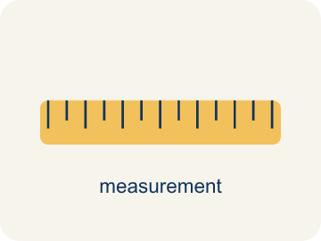 | Convert Measurements Between Systems Convertir medidas entre sistemas  Rewriting a customary measurement as a metric one, or the reverse, so two amounts can be compared.  Example: 100 kilometers ≈ 60 miles
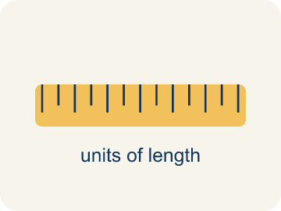 | Conversion factor Factor de conversión  The ratio that links a unit in one system to a unit in the other, such as 1 mile to about 1.609 kilometers.  Example: 1 lb ≈ 0.45 kg · 1 in ≈ 2.54 cm
 | Customary system Sistema usual  The measurement system used in the United States: inches, feet, miles, ounces, pounds, cups, quarts, gallons.  Example: in · ft · mi · oz · lb · qt · gal
 | Metric system Sistema métrico  The measurement system used in most of the world, built on tens: centimeters, meters, kilometers, grams, kilograms, liters.  Example: cm · m · km · g · kg · mL · L
 | Approximately Aproximadamente  Close to, but not exactly equal. Conversions between systems are almost always approximate, so they use the ≈ sign.  Example: 1 km ≈ 0.6 mi, not exactly 0.6
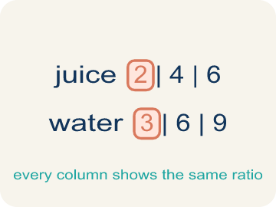 | Ratio table Tabla de razones  A table of equal ratios used to scale a conversion factor up to the amount you actually need.  Example: km: 1, 10, 100 · mi: 0.6, 6, 60

Guided Notes
Fill in each blank as we go. Use the Word Bank to help you.
WORD BANK
Convert Measurements Between Systems • Conversion factor • Customary system • Metric system • Approximately • Ratio table

1. Rewriting a customary measurement as a metric one gives an ________________ answer, not an exact one.
2. The ratio that trades one unit for another is a ________________ ________________.
3. Inches, pounds and gallons belong to the ________________ system.
4. Centimeters, grams and liters belong to the ________________ system, built on tens.
5. Close to but not exactly equal is ________________ — written with ≈.
6. A table whose every column holds the same comparison is a ________________ ________________.

Write About the Math
Use the support level you need. Every level answers the same math question.

1. Understand the Question explain
Is 100 kilometers per hour faster or slower than 100 miles per hour, and how do you know?
Your job: Answer the question. Use math evidence. Explain how the evidence proves your answer.
Responde la pregunta. Usa evidencia matemática. Explica cómo la evidencia demuestra tu respuesta.

2. Plan Your Math Words check at least two
☐ Convert Measurements Between Systems — Rewriting a customary measurement as a metric one, or the reverse, so two amounts can be compared.
Convertir medidas entre sistemas — Reescribir una medida usual como métrica, o al revés, para poder comparar dos cantidades.
☐ Conversion factor — The ratio that links a unit in one system to a unit in the other, such as 1 mile to about 1.609 kilometers.
Factor de conversión — La razón que relaciona una unidad de un sistema con una del otro, como 1 milla a unos 1.609 kilómetros.
☐ Customary system — The measurement system used in the United States: inches, feet, miles, ounces, pounds, cups, quarts, gallons.
Sistema usual — El sistema de medidas que se usa en Estados Unidos: pulgadas, pies, millas, onzas, libras, tazas, cuartos y galones.
☐ Metric system — The measurement system used in most of the world, built on tens: centimeters, meters, kilometers, grams, kilograms, liters.
Sistema métrico — El sistema de medidas que se usa en casi todo el mundo, basado en decenas: centímetros, metros, kilómetros, gramos, kilogramos y litros.
☐ Approximately — Close to, but not exactly equal. Conversions between systems are almost always approximate, so they use the ≈ sign.
Aproximadamente — Cercano, pero no exactamente igual. Las conversiones entre sistemas casi siempre son aproximadas y usan el signo ≈.
Say it first: Say your idea to a partner or quietly to yourself before you write.
The conversion factor is 1 km ≈ ___ mi. Scaling that up, 100 kilometers ≈ ___ miles, so the sign means about ___ miles per hour. That is ___ than 100 miles per hour, because in one hour you would travel ___ distance.
Di tu respuesta primero: Mi respuesta es ___ porque ___.

3. Build Your Explanation choose your support
This model shows the parts of an explanation. It does not answer your writing question.
Claim: Divide the total cost by the number of pounds to find the cost per 1 pound.
Evidence: Students divide $18 by 3 to get $6 per pound and explain the unit rate lets them find the cost of any number of pounds.
Reasoning: This evidence connects the definition of convert measurements between systems to the mathematical claim.

Start Most language support
Complete the frames. Use the word bank.
Completa las oraciones. Usa el banco de palabras.
The conversion factor is 1 km ≈ ___ mi. Scaling that up, 100 kilometers ≈ ___ miles, so the sign means about ___ miles per hour. That is ___ than 100 miles per hour, because in one hour you would travel ___ distance.
My answer is ___.
Mi respuesta es ___.

Build Some language support
Write two connected sentences. Use because, so, or but.
Escribe dos oraciones conectadas. Usa porque, entonces o pero.
My claim is ___.
Mi afirmación es ___.
I know because ___.
Lo sé porque ___.
So ___.
Entonces ___.

Explain Light language support
Write a claim, give math evidence, and explain your reasoning.
Escribe una afirmación, da evidencia matemática y explica tu razonamiento.
My claim is ___.
Mi afirmación es ___.
My math evidence is ___.
Mi evidencia matemática es ___.
This proves ___ because ___.
Esto demuestra ___ porque ___.

4. Check Your Explanation five quick checks
☐ I answered the question.
Respondí la pregunta.
☐ I used math evidence: numbers, an equation, a model, or a comparison.
Usé evidencia matemática: números, una ecuación, un modelo o una comparación.
☐ I explained how the evidence proves my answer.
Expliqué cómo la evidencia demuestra mi respuesta.
☐ I used at least two math words.
Usé por lo menos dos palabras matemáticas.
☐ I reread complete sentences and punctuation.
Volví a leer mis oraciones completas y la puntuación.

Worked Example

Watch & Read I Do — follow along with your teacher
Border-Crossing Converter
The academy's kitchen orders from suppliers in two different countries. One ships in pounds and quarts, the other in kilograms and liters. Recipes, highway signs, and even medicine doses can be written in either system — and comparing them means converting between systems first, using a conversion factor that is almost always approximate.

Think about:
• I notice one measurement uses a ___ unit and the other uses a ___ unit.
• I notice the two numbers cannot be compared until they share a ___.
• I notice the conversion factor uses the ≈ sign because it is ___.
• I wonder which amount is actually bigger once I ___ them.
• I wonder why conversions between systems are only ___.

Solved Example I Do — watch each step
Problem: 1 kilometer ≈ 0.6 mile. About how many miles is 5 kilometers?
A) 3 miles
B) 5.6 miles
C) 8 miles
D) 30 miles
Step 1: Scale the conversion factor by 5: 0.6 × 5 = 3 miles.
Answer: A. 3 miles

Independent Practice

On Your Own You Do — show your work
Solve each problem. Show your thinking in the work box.

Level 2 Enrichment stretch your thinking
1. The Golden Gate Bridge can hold about 35,924,000 pounds. An average midsize car weighs about 1,524 kilograms. Using 1 kilogram ≈ 2.2 pounds, about how many midsize cars could be on the bridge at one time? Explain each step, and say why your answer is an estimate.

Exit Ticket
Answer on your own. This shows what you learned today.
★ A highway sign in Canada reads 100 km/h. Using 1 km ≈ 0.6 mi, is that faster or slower than 100 mi/h?
A) Slower — 100 km/h is about 60 mi/h
B) Faster — 100 km/h is about 160 mi/h
C) The same, because both numbers are 100
D) You cannot compare two different systems

