UNIT 4 · LESSON 2 STANDARD 6.AT.4

Relate Fractions, Decimals, and Percentages
Student Notes Packet
Name: ______________________ Date: ____________ Period: ________
Level 1 · Support

Today's Goals
Content: I can write equivalent fractions, decimals, and percents for the same value.
Language: I can explain my conversions using the words percent, decimal, equivalent, and benchmark.

Key Vocabulary
Look at the picture, read the word, then read what it means.
 | Fractions, Decimals, and Percents Fracciones, decimales y porcentajes  Three equivalent ways to name the same part of a whole.  Example: 1/2 = 0.5 = 50%
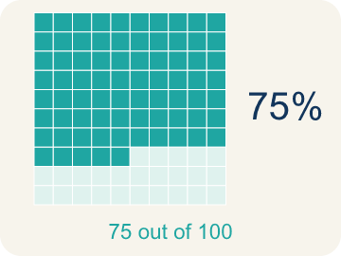 | Percent Porcentaje  A way to compare a number to 100, shown with the % sign.  Example: 25% means 25 out of 100
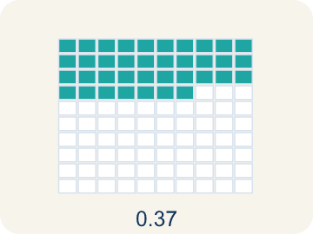 | Decimal Decimal  A number with a dot, like 0.5, that shows a part less than one.  Example: 0.75 means seventy-five hundredths
 | Equivalent Equivalente  Having the same value, just written a different way.  Example: 1/2 = 0.5 = 50%
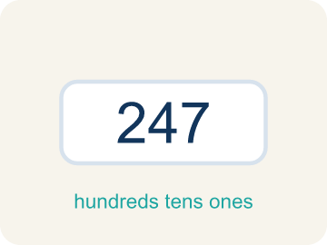 | Benchmark Referencia  A familiar number you use to guess, like 50% or 1/2.  Example: Common benchmarks: 25%, 50%, 75%
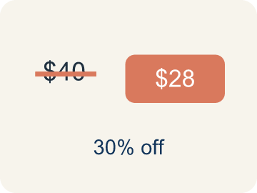 | Discount Descuento  Money taken off the first price to make it cheaper.  Example: $40 shirt at 25% off: discount = $10

Guided Notes
Fill in each blank as we go. Use the Word Bank to help you.
WORD BANK
Fractions, Decimals, and Percents • Percent • Decimal • Equivalent • Benchmark • Discount

1. Three equivalent ways to name the same part of a whole are ________________, ________________ and ________________.
2. A ratio that compares a number to 100, written with a % sign, is a ________________.
3. A number that uses a point to show parts of a whole is a ________________.
4. Having the same value but written a different way is being ________________.
5. A common, easy-to-remember value like 50% or 1/4 used for comparing is a ________________.
6. An amount taken off a price, often given as a percent, is a ________________.

Write About the Math
Use the support level you need. Every level answers the same math question.

1. Understand the Question explain
Who is correct, and how much would the game cost on sale?
Your job: Answer the question. Use math evidence. Explain how the evidence proves your answer.
Responde la pregunta. Usa evidencia matemática. Explica cómo la evidencia demuestra tu respuesta.

2. Plan Your Math Words check at least two
☐ Fractions, Decimals, and Percents — Three equivalent ways to name the same part of a whole.
Fracciones, decimales y porcentajes — Tres maneras equivalentes de nombrar la misma parte de un todo.
☐ Percent — A way to compare a number to 100, shown with the % sign.
Porcentaje — Una manera de comparar un número con 100, con el signo %.
☐ Decimal — A number with a dot, like 0.5, that shows a part less than one.
Decimal — Un número con un punto, como 0.5, que muestra una parte menor que uno.
☐ Equivalent — Having the same value, just written a different way.
Equivalente — Tener el mismo valor, escrito de otra forma.
☐ Benchmark — A familiar number you use to guess, like 50% or 1/2.
Referencia — Un número conocido que usas para estimar, como 50% o 1/2.
Say it first: Say your idea to a partner or quietly to yourself before you write.
The friend who said ___% is correct because 3/5 = ___ = ___%. The sale price is $___.
Di tu respuesta primero: Mi respuesta es ___ porque ___.

3. Build Your Explanation choose your support
This model shows the parts of an explanation. It does not answer your writing question.
Claim: 3/4, 0.75, and 75% all name the same score.
Evidence: Students give 3/4 = 0.75 = 75% and recognize these are three forms of one value, not three different scores.
Reasoning: This evidence connects the definition of percent to the mathematical claim.

Start Most language support
Complete the frames. Use the word bank.
Completa las oraciones. Usa el banco de palabras.
The friend who said ___% is correct because 3/5 = ___ = ___%. The sale price is $___.
My answer is ___.
Mi respuesta es ___.

Build Some language support
Write two connected sentences. Use because, so, or but.
Escribe dos oraciones conectadas. Usa porque, entonces o pero.
My claim is ___.
Mi afirmación es ___.
I know because ___.
Lo sé porque ___.
So ___.
Entonces ___.

Explain Light language support
Write a claim, give math evidence, and explain your reasoning.
Escribe una afirmación, da evidencia matemática y explica tu razonamiento.
My claim is ___.
Mi afirmación es ___.
My math evidence is ___.
Mi evidencia matemática es ___.
This proves ___ because ___.
Esto demuestra ___ porque ___.

4. Check Your Explanation five quick checks
☐ I answered the question.
Respondí la pregunta.
☐ I used math evidence: numbers, an equation, a model, or a comparison.
Usé evidencia matemática: números, una ecuación, un modelo o una comparación.
☐ I explained how the evidence proves my answer.
Expliqué cómo la evidencia demuestra mi respuesta.
☐ I used at least two math words.
Usé por lo menos dos palabras matemáticas.
☐ I reread complete sentences and punctuation.
Volví a leer mis oraciones completas y la puntuación.

Worked Example

Watch & Read I Do — follow along with your teacher
Arcade Builder Challenge
You're designing the scoring system for a new arcade game. Players earn points as fractions of the total possible score. The leaderboard shows scores as percentages, but the game engine uses decimals. You need to convert between all three forms to build the display!

Think about:
• What are three different ways to write the same number?
• If a player scored 3/4 of the points, what percent is that?
• Are some fractions easier to convert than others?
• How do you convert a fraction to a percent without a calculator?

Solved Example I Do — watch each step
Problem: Convert 3/5 to a percent.
A) 60%
B) 35%
C) 53%
D) 65%
Step 1: 5 × 20 = 100, so 3 × 20 = 60.
Step 2: That makes 3/5 = 60/100 = 0.6 = 60%.
Answer: A. 60%

Guided Practice

Solve Together We Do — work with your class
Problem: Convert 7/20 to a percent.
A) 35%
B) 70%
C) 20%
D) 14%
Step 1:

Step 2:

Answer:

A store has a clearance sale: 'Everything 3/5 off!' Your friend says that means 35% off. Another friend says it's 60% off. The original price of a game is $40.
Who is correct, and how much would the game cost on sale?

Sentence frame: The friend who said ___% is correct because 3/5 = ___ = ___%. The sale price is $___.

Turn & Talk discuss with a partner
1. [Launch] A player scored 3/4 of the points. The leaderboard shows percents and the game engine uses decimals. What are three different ways to write the same score?
Start with: The fraction ___ is the same as the decimal ___ and the percent ___.
La fracción ___ es igual al decimal ___ y al porcentaje ___.
Word bank: percent, decimal, equivalent, benchmark
2. [Explore] How did you turn a fraction like 3/5 into a fraction out of 100, and then into a decimal and a percent?
Start with: To make the denominator of ___ equal 100 I multiplied by ___.
Para que el denominador de ___ fuera 100 multipliqué por ___.
Word bank: percent, decimal, equivalent, benchmark
3. [Connect] Two arcade games show their loading bars differently: Game A is 0.7 loaded and Game B is 3/4 loaded. Which game is closer to fully loaded, and how do you know without a calculator?
Start with: Game ___ is closer to loaded because ___% is greater than ___%.
El juego ___ está más cerca de cargar porque ___% es mayor que ___%.
Word bank: percent, decimal, equivalent, benchmark
4. [Practice] During practice on Relate Fractions, Decimals, and Percents, what strategy did you use when a problem felt tricky?
Start with: To change ___ into a percent I multiplied the top and bottom by ___.
Para cambiar ___ a porcentaje multipliqué arriba y abajo por ___.
Word bank: Percent, Decimal, Equivalent, Benchmark

Independent Practice

On Your Own You Do — show your work
Solve each problem. Show your thinking in the work box.

Level 1 Support extra scaffolding
1. Which decimal is equivalent to 45%?
A) 0.45
B) 4.5
C) 0.045
D) 45.0

2. What fraction is equal to 0.75?
A) 3/4
B) 7/5
C) 3/5
D) 7/10

Exit Ticket
Answer on your own. This shows what you learned today.
★ Which shows 0.45 as a fraction and a percent?
A) 9/20 and 45%
B) 45/10 and 4.5%
C) 4/5 and 45%
D) 9/20 and 4.5%

Answer Key & Teacher Guide
Teacher reference — remove or fold back before distributing to students.

Guided Notes (Fill-in)
Notes 1: Fractions, Decimals, and Percents
Notes 2: Percent
Notes 3: Decimal
Notes 4: Equivalent
Notes 5: Benchmark
Notes 6: Discount

Worked Notes (I Do / We Do)
I Do: A. 60%
We Do: A. 35%

Independent Practice
Watch for this mistake: A common mistake in Relate Fractions, Decimals, and Percents is treating the numerator and denominator as the percent's digits — turning 3/5 into "35%" by just reading the 3 and the 5. Percent means out of 100, so the fix is to build an equivalent fraction with denominator 100: 5 × 20 = 100, so multiply the top by 20 too — 3/5 = 60/100 = 60%. A second version of this mistake is scaling only ONE part of the fraction (writing 3/5 = 3/100 or 60/5). Whatever you multiply the denominator by, you must multiply the numerator by the same number. When a denominator will not reach 100 evenly (8, 3, 7), divide the numerator by the denominator instead and then multiply by 100.

Level 1 Support
1. A) 0.45 — 45% means 45/100, and 45/100 written as a decimal is 0.45 (forty-five hundredths).
2. A) 3/4 — 0.75 = 75/100. Simplify by dividing both by 25: 75÷25 = 3 and 100÷25 = 4. So 0.75 = 3/4.

On Level
3. A) 87.5% — 8 does not scale to 100 by a whole number, so divide: 7 ÷ 8 = 0.875, and 0.875 × 100 = 87.5%. That is 87.5 out of 100.

Exit Ticket
A) 9/20 and 45% — 0.45 = 45/100 = 9/20 (simplified). 0.45 × 100 = 45%.

Math Writing Criteria
The support level changes the amount of language scaffolding, not the mathematical expectation.
☐ I answered the question.
☐ I used math evidence: numbers, an equation, a model, or a comparison.
☐ I explained how the evidence proves my answer.
☐ I used at least two math words.
☐ I reread complete sentences and punctuation.

