4.1–4.3 Catch-Up — Homework
Lesson 4-3-catchup • Standard 6.AT.4
Name: ______________________ Period: ______ Date: ____________

Today's Goals
Content: I can show I am caught up on Lessons 4.1–4.3 by using each lesson's big idea in mixed practice.
Language: I can explain which lesson's big idea I used and how, using key vocabulary from Lessons 4.1–4.3.

Key Words
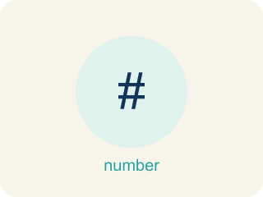
Understand Percent (Comprender el porcentaje) — A percent is a ratio that compares a number to 100, so every percent answers the question “how many out of 100?”
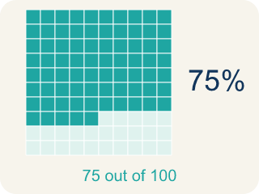
Percent (Porcentaje) — A ratio that compares a number to 100. The word means “per hundred,” and the symbol is %.

Per hundred (Por cada cien) — The meaning hidden inside the word percent: for every group of 100. It is why every percent can be written as a fraction over 100.

Decimal grid (Cuadrícula decimal) — A 10-by-10 grid of 100 squares. Shading squares shows a percent directly, one square per percent.
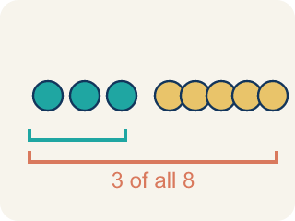
Part-to-whole (Parte a todo) — A comparison of one part against the whole amount. In a percent, the whole is always 100%.

Greater than 100% (Mayor que 100 %) — More than one whole. A percent above 100 means the amount is larger than the thing it is being compared to.

Fractions, Decimals, and Percents (Fracciones, decimales y porcentajes) — Three equivalent ways to name the same part of a whole.
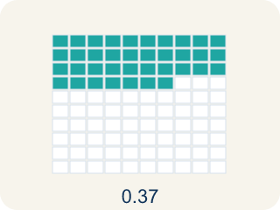
Decimal (Decimal) — A number with a dot, like 0.5, that shows a part less than one.
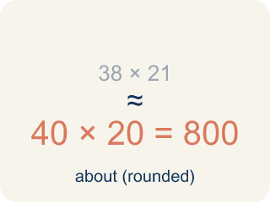
estimate (estimación) — A reasoned answer that is close enough to be useful, found without exact computation.

benchmark percent (porcentaje de referencia) — A friendly percent — 1%, 10%, 25%, 50%, 75%, 100% — used as a landmark for estimating.

Practice
Show your work. Use the blank space under each problem.
1. (Lesson 4.1) What does the word percent mean?
A. Per hundred
B. Per ten
C. Per thousand
D. Per part
______________________________________________________________________
2. (Lesson 4.1) 3 out of every 10 students walk to school. What percent is that?
A. 30%
B. 3%
C. 10%
D. 13%
______________________________________________________________________
3. (Lesson 4.1) The orange kitten weighs 1.5 times as much as the gray kitten. What percent of the gray kitten's weight is that?
A. 150%
B. 15%
C. 50%
D. 1.5%
______________________________________________________________________
4. (Lesson 4.1) Find the error
Step 1 (Setup): A player scored 150% of the weekly goal of 200 points.
Step 2 (Step 1): 150% is more than one whole.
Step 3 (Step 2): So the player scored 150 points.
Step 4 (Step 3): The player beat the 200-point goal.
Which step has the mistake? Explain and fix it:
______________________________________________________________________
______________________________________________________________________
______________________________________________________________________
5. (Lesson 4.2) A game shows your score as 7/8 complete. What percent is that?
A. 87.5%
B. 78%
C. 75%
D. 88%
______________________________________________________________________
6. (Lesson 4.2) Spot the Common Mistake
Step 1 (Convert 5/8 to a percent): 5/8
Step 2 (Divide the bottom by the top): 8 ÷ 5 = 1.6
Step 3 (Multiply by 100): 1.6 × 100 = 160%
Step 4 (Final answer): 5/8 = 160%
Which step has the mistake? Explain and fix it:
______________________________________________________________________
______________________________________________________________________
______________________________________________________________________
7. (Lesson 4.3) The Green-Team recycled 216 pounds; 8.6% was metal. Using compatible numbers 10% and 200, the estimate is:
A. 20 pounds
B. 2 pounds
C. 208 pounds
D. 86 pounds
______________________________________________________________________
8. (Lesson 4.3) Photos use 3.5 GB of the 4 GB of used storage. About what percent of the USED storage is photos?
A. About 87%
B. About 58%
C. About 35%
D. About 99%
______________________________________________________________________
9. (Lesson 4.1) What percent is 9 out of 100?
A. 9%
B. 90%
C. 0.9%
D. 19%
______________________________________________________________________
10. (Lesson 4.2) Your arcade scoreboard reads 0.25 of the level cleared. What percent and fraction match this score?
A. 25% and 1/4
B. 2.5% and 1/4
C. 25% and 1/5
D. 250% and 1/40
______________________________________________________________________

Answer Key (Teacher)
1. A. Per hundred
Percent means per hundred, which is why every percent can be written as a fraction with a denominator of 100.
Watch for: Keeping the same whole for every question — when the problem says 'of the used storage,' the whole changes from 6 GB to 4 GB, and estimates anchored to the old whole are wrong before any arithmetic happens.
2. A. 30%
Multiply both terms of the ratio by 10 to compare to 100: 3 out of 10 becomes 30 out of 100, or 30%.
Watch for: Keeping the same whole for every question — when the problem says 'of the used storage,' the whole changes from 6 GB to 4 GB, and estimates anchored to the old whole are wrong before any arithmetic happens.
3. A. 150%
The gray kitten is the whole, or 100%. One and a half wholes is 100% + 50% = 150%.
Watch for: Keeping the same whole for every question — when the problem says 'of the used storage,' the whole changes from 6 GB to 4 GB, and estimates anchored to the old whole are wrong before any arithmetic happens.
4. (Lesson 4.1) Find the error
The mistake is in Step 3.
Correct work: Step 2 reads the percent as if it were the points themselves. A percent is a comparison, not an amount: 150% of 200 points is 1.5 × 200 = 300 points.
Watch for: Step 3 even contradicts Step 2 — 150 points would fall short of a 200-point goal. A percent always needs a whole to be a percent OF.
5. A. 87.5%
8 does not scale to 100 by a whole number, so divide: 7 ÷ 8 = 0.875, and 0.875 × 100 = 87.5%. That is 87.5 out of 100.
Watch for: Keeping the same whole for every question — when the problem says 'of the used storage,' the whole changes from 6 GB to 4 GB, and estimates anchored to the old whole are wrong before any arithmetic happens.
6. (Lesson 4.2) Spot the Common Mistake
The mistake is in Step 2.
Correct work: The student divided in the wrong order. To turn a fraction into a decimal, divide the TOP by the bottom: 5 ÷ 8 = 0.625, then × 100 → 62.5%. So 5/8 = 0.625 = 62.5%. (A check: 5/8 is less than 1, so the percent must be under 100%, never 160%.)
Watch for: The fraction bar means numerator ÷ denominator, so this division is upside down. It should be 5 ÷ 8 = 0.625, and 0.625 × 100 = 62.5%. A quick check catches it: 5/8 is less than one whole, so its percent must be under 100% — 160% was impossible.
7. A. 20 pounds
10% of 200 = 0.1 × 200 = 20 pounds of metal.
Watch for: Keeping the same whole for every question — when the problem says 'of the used storage,' the whole changes from 6 GB to 4 GB, and estimates anchored to the old whole are wrong before any arithmetic happens.
8. A. About 87%
The whole is 4 GB here. 75% of 4 is 3 GB and 100% is 4 GB; 3.5 sits midway — about 87%.
Watch for: Keeping the same whole for every question — when the problem says 'of the used storage,' the whole changes from 6 GB to 4 GB, and estimates anchored to the old whole are wrong before any arithmetic happens.
9. A. 9%
A percent already compares to 100, so 9 out of 100 is exactly 9%.
Watch for: Keeping the same whole for every question — when the problem says 'of the used storage,' the whole changes from 6 GB to 4 GB, and estimates anchored to the old whole are wrong before any arithmetic happens.
10. A. 25% and 1/4
Move the decimal two places: 0.25 = 25%. As a fraction, 0.25 = 25/100 = 1/4.
Watch for: Keeping the same whole for every question — when the problem says 'of the used storage,' the whole changes from 6 GB to 4 GB, and estimates anchored to the old whole are wrong before any arithmetic happens.

