UNIT 4 · LESSON 3 STANDARD 6.AT.4

Estimate the Percent of a Number
Student Notes Packet
Name: ______________________ Date: ____________ Period: ________
Level 3 · Enrichment

Today's Goals
Content: I can estimate the percent of a number using benchmark percents, rounding, and compatible numbers.
Language: I can explain an estimate using the words about, benchmark, and compatible numbers.

Key Vocabulary
Look at the picture, read the word, then read what it means.
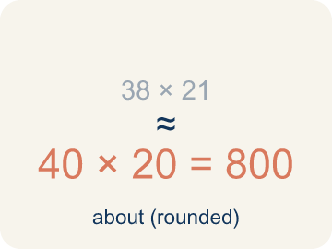 | estimate estimación  A reasoned answer that is close enough to be useful, found without exact computation.  Example: 8.6% of 216 ≈ 10% of 200 = 20 pounds of metal.
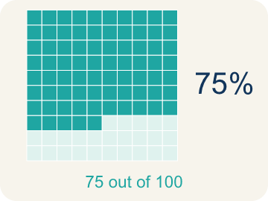 | benchmark percent porcentaje de referencia  A friendly percent — 1%, 10%, 25%, 50%, 75%, 100% — used as a landmark for estimating.  Example: 1% · 10% · 25% · 50% · 75% · 100% — the landmarks you can find mentally.
 | compatible numbers números compatibles  Numbers close to the originals that are easy to compute with mentally.  Example: 8.6% of 216 → 10% of 220: both nudged to numbers that divide nicely.
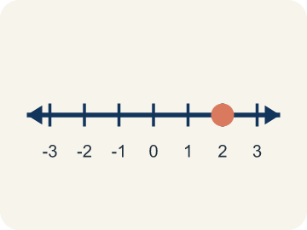 | double number line recta numérica doble  Two parallel number lines that pair amounts with their percents at the same positions.  Example: 0 · 25% · 50% · 75% · 100% above; 0 · 1.5 · 3 · 4.5 · 6 GB below.
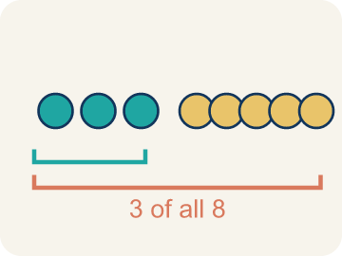 | the whole el todo  The quantity that counts as 100% in a problem — and it can change between questions.  Example: “Of the USED storage” makes 4 GB the whole — not the 6 GB total.

Guided Notes
Fill in each blank as we go. Use the Word Bank to help you.
WORD BANK
estimate • benchmark percent • compatible numbers • double number line • the whole

1. A reasoned answer close enough to be useful is an ________________.
2. A friendly percent used as a landmark, like 10% or 25%, is a ________________ ________________.
3. Numbers close to the originals that are easy to compute with are ________________ ________________.
4. Two parallel lines pairing amounts with their percents form a ________________ ________________ ________________.
5. The quantity that counts as 100% in a problem is ________________ ________________.

Write About the Math
Use the support level you need. Every level answers the same math question.

1. Understand the Question explain
Of the USED storage, approximately what percent are photos — and why does the whole change from 6 GB to 4 GB for this question?
Your job: Answer the question. Use math evidence. Explain how the evidence proves your answer.
Responde la pregunta. Usa evidencia matemática. Explica cómo la evidencia demuestra tu respuesta.

2. Plan Your Math Words check at least two
☐ estimate — A reasoned answer that is close enough to be useful, found without exact computation.
estimación — Una respuesta razonada, lo bastante cercana para ser útil, sin cálculo exacto.
☐ benchmark percent — A friendly percent — 1%, 10%, 25%, 50%, 75%, 100% — used as a landmark for estimating.
porcentaje de referencia — Un porcentaje amigable — 1%, 10%, 25%, 50%, 75%, 100% — que sirve de punto de referencia.
☐ compatible numbers — Numbers close to the originals that are easy to compute with mentally.
números compatibles — Números cercanos a los originales con los que es fácil calcular mentalmente.
☐ double number line — Two parallel number lines that pair amounts with their percents at the same positions.
recta numérica doble — Dos rectas paralelas que emparejan cantidades con sus porcentajes en las mismas posiciones.
☐ the whole — The quantity that counts as 100% in a problem — and it can change between questions.
el todo — La cantidad que representa el 100% en un problema, y puede cambiar entre preguntas.
Say it first: Say your idea to a partner or quietly to yourself before you write.
The whole for this question is ___ . Photos are about ___ % of the used storage, since 3.5 GB sits between the ___ % benchmark and the ___ % benchmark on the number line.
Di tu respuesta primero: Mi respuesta es ___ porque ___.

3. Build Your Explanation choose your support
This model shows the parts of an explanation. It does not answer your writing question.
Claim: 4 GB sits between two benchmark landmarks on the number line, closer to the 75% mark, so a reasonable estimate lands near there without computing the exact fraction.
Evidence: A strong answer names both landmark percents (50% and 75%) and explains why 4 GB sits closer to one than the other. A weak answer just says 'it's close to 70%' without placing it between benchmarks.
Reasoning: This evidence connects the definition of estimate to the mathematical claim.

Start Most language support
Complete the frames. Use the word bank.
Completa las oraciones. Usa el banco de palabras.
The whole for this question is ___ . Photos are about ___ % of the used storage, since 3.5 GB sits between the ___ % benchmark and the ___ % benchmark on the number line.
My answer is ___.
Mi respuesta es ___.

Build Some language support
Write two connected sentences. Use because, so, or but.
Escribe dos oraciones conectadas. Usa porque, entonces o pero.
My claim is ___.
Mi afirmación es ___.
I know because ___.
Lo sé porque ___.
So ___.
Entonces ___.

Explain Light language support
Write a claim, give math evidence, and explain your reasoning.
Escribe una afirmación, da evidencia matemática y explica tu razonamiento.
My claim is ___.
Mi afirmación es ___.
My math evidence is ___.
Mi evidencia matemática es ___.
This proves ___ because ___.
Esto demuestra ___ porque ___.

4. Check Your Explanation five quick checks
☐ I answered the question.
Respondí la pregunta.
☐ I used math evidence: numbers, an equation, a model, or a comparison.
Usé evidencia matemática: números, una ecuación, un modelo o una comparación.
☐ I explained how the evidence proves my answer.
Expliqué cómo la evidencia demuestra mi respuesta.
☐ I used at least two math words.
Usé por lo menos dos palabras matemáticas.
☐ I reread complete sentences and punctuation.
Volví a leer mis oraciones completas y la puntuación.

Worked Example

Watch & Read I Do — follow along with your teacher
Unit 4 · Lesson 3
Margaret checked the cloud storage on her phone: 6 GB total, 4 GB used. Approximately what percent of her storage is used — and of the used storage, approximately what percent are photos?

Solved Example I Do — watch each step
Problem: Margaret's phone has 6 GB of storage and 4 GB is used. About what percent is used?
A) About 70%
B) About 40%
C) About 25%
D) About 150%
Step 1: 4 out of 6 is 2/3, which is about 67%, so 'about 70%' is the reasonable estimate.
Answer: A. About 70%

Independent Practice

On Your Own You Do — show your work
Solve each problem. Show your thinking in the work box.

Level 2 Enrichment stretch your thinking
1. Two students estimate 8.6% of 216. Ana uses 10% of 220 = 22. Ben uses 10% of 200 = 20. Whose estimate is closer to the exact answer, 18.576?
A) Ben's — 20 is 1.4 away; Ana's 22 is 3.4 away
B) Ana's — 22 is closer to 18.576
C) They are equally close
D) Neither is a valid estimate

2. For which problem is ESTIMATING clearly the right tool, rather than exact computation?
A) Deciding if a $58 jacket at 25% off fits your $45 budget
B) Programming a bank to compute interest on every account
C) Reporting a medicine dose
D) Scoring a state test

3. Write your own estimation problem about percent, using a real situation from your life. Then solve it with a benchmark and say whether your estimate runs high or low.
4. A store marks a $79.95 item 32% off. Which mental estimate best checks the discount?
A) About one third of 80, so about $26 off
B) About 32 dollars off, because 32% means $32
C) About 3.2 dollars off
D) About half of 80, so $40 off

5. Margaret wants to know what percent of her TOTAL 6 GB is photos (photos = 3.5 GB). Estimate it, and explain why this answer differs from the 87% found earlier.

Exit Ticket
Answer on your own. This shows what you learned today.
★ Estimate 19% of 412 using benchmarks or compatible numbers.
A) About 80
B) About 8
C) About 200
D) About 40

