UNIT 4 · LESSON 3 STANDARD 6.AT.4

Estimate the Percent of a Number
Student Notes Packet
Name: ______________________ Date: ____________ Period: ________
Level 2 · Standard

Today's Goals
Content: I can estimate the percent of a number using benchmark percents, rounding, and compatible numbers.
Language: I can explain an estimate using the words about, benchmark, and compatible numbers.

Key Vocabulary
Look at the picture, read the word, then read what it means.
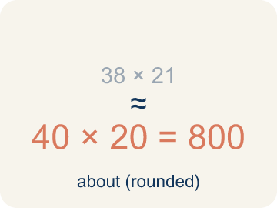 | estimate estimación  A reasoned answer that is close enough to be useful, found without exact computation.  Example: 8.6% of 216 ≈ 10% of 200 = 20 pounds of metal.
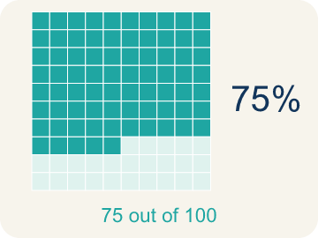 | benchmark percent porcentaje de referencia  A friendly percent — 1%, 10%, 25%, 50%, 75%, 100% — used as a landmark for estimating.  Example: 1% · 10% · 25% · 50% · 75% · 100% — the landmarks you can find mentally.
 | compatible numbers números compatibles  Numbers close to the originals that are easy to compute with mentally.  Example: 8.6% of 216 → 10% of 220: both nudged to numbers that divide nicely.
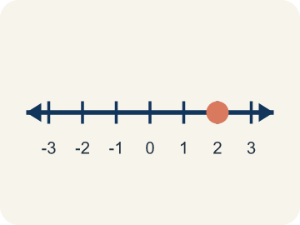 | double number line recta numérica doble  Two parallel number lines that pair amounts with their percents at the same positions.  Example: 0 · 25% · 50% · 75% · 100% above; 0 · 1.5 · 3 · 4.5 · 6 GB below.
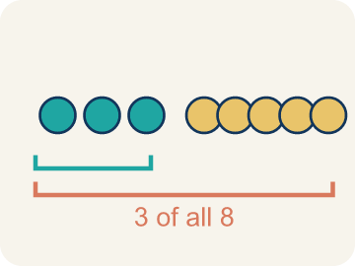 | the whole el todo  The quantity that counts as 100% in a problem — and it can change between questions.  Example: “Of the USED storage” makes 4 GB the whole — not the 6 GB total.

Guided Notes
Fill in each blank as we go. Use the Word Bank to help you.
WORD BANK
estimate • benchmark percent • compatible numbers • double number line • the whole

1. A reasoned answer close enough to be useful is an ________________.
2. A friendly percent used as a landmark, like 10% or 25%, is a ________________ ________________.
3. Numbers close to the originals that are easy to compute with are ________________ ________________.
4. Two parallel lines pairing amounts with their percents form a ________________ ________________ ________________.
5. The quantity that counts as 100% in a problem is ________________ ________________.

Write About the Math
Use the support level you need. Every level answers the same math question.

1. Understand the Question explain
Of the USED storage, approximately what percent are photos — and why does the whole change from 6 GB to 4 GB for this question?
Your job: Answer the question. Use math evidence. Explain how the evidence proves your answer.
Responde la pregunta. Usa evidencia matemática. Explica cómo la evidencia demuestra tu respuesta.

2. Plan Your Math Words check at least two
☐ estimate — A reasoned answer that is close enough to be useful, found without exact computation.
estimación — Una respuesta razonada, lo bastante cercana para ser útil, sin cálculo exacto.
☐ benchmark percent — A friendly percent — 1%, 10%, 25%, 50%, 75%, 100% — used as a landmark for estimating.
porcentaje de referencia — Un porcentaje amigable — 1%, 10%, 25%, 50%, 75%, 100% — que sirve de punto de referencia.
☐ compatible numbers — Numbers close to the originals that are easy to compute with mentally.
números compatibles — Números cercanos a los originales con los que es fácil calcular mentalmente.
☐ double number line — Two parallel number lines that pair amounts with their percents at the same positions.
recta numérica doble — Dos rectas paralelas que emparejan cantidades con sus porcentajes en las mismas posiciones.
☐ the whole — The quantity that counts as 100% in a problem — and it can change between questions.
el todo — La cantidad que representa el 100% en un problema, y puede cambiar entre preguntas.
Say it first: Say your idea to a partner or quietly to yourself before you write.
The whole for this question is ___ . Photos are about ___ % of the used storage, since 3.5 GB sits between the ___ % benchmark and the ___ % benchmark on the number line.
Di tu respuesta primero: Mi respuesta es ___ porque ___.

3. Build Your Explanation choose your support
This model shows the parts of an explanation. It does not answer your writing question.
Claim: 4 GB sits between two benchmark landmarks on the number line, closer to the 75% mark, so a reasonable estimate lands near there without computing the exact fraction.
Evidence: A strong answer names both landmark percents (50% and 75%) and explains why 4 GB sits closer to one than the other. A weak answer just says 'it's close to 70%' without placing it between benchmarks.
Reasoning: This evidence connects the definition of estimate to the mathematical claim.

Start Most language support
Complete the frames. Use the word bank.
Completa las oraciones. Usa el banco de palabras.
The whole for this question is ___ . Photos are about ___ % of the used storage, since 3.5 GB sits between the ___ % benchmark and the ___ % benchmark on the number line.
My answer is ___.
Mi respuesta es ___.

Build Some language support
Write two connected sentences. Use because, so, or but.
Escribe dos oraciones conectadas. Usa porque, entonces o pero.
My claim is ___.
Mi afirmación es ___.
I know because ___.
Lo sé porque ___.
So ___.
Entonces ___.

Explain Light language support
Write a claim, give math evidence, and explain your reasoning.
Escribe una afirmación, da evidencia matemática y explica tu razonamiento.
My claim is ___.
Mi afirmación es ___.
My math evidence is ___.
Mi evidencia matemática es ___.
This proves ___ because ___.
Esto demuestra ___ porque ___.

4. Check Your Explanation five quick checks
☐ I answered the question.
Respondí la pregunta.
☐ I used math evidence: numbers, an equation, a model, or a comparison.
Usé evidencia matemática: números, una ecuación, un modelo o una comparación.
☐ I explained how the evidence proves my answer.
Expliqué cómo la evidencia demuestra mi respuesta.
☐ I used at least two math words.
Usé por lo menos dos palabras matemáticas.
☐ I reread complete sentences and punctuation.
Volví a leer mis oraciones completas y la puntuación.

Worked Example

Watch & Read I Do — follow along with your teacher
Unit 4 · Lesson 3
Margaret checked the cloud storage on her phone: 6 GB total, 4 GB used. Approximately what percent of her storage is used — and of the used storage, approximately what percent are photos?

Solved Example I Do — watch each step
Problem: Margaret's phone has 6 GB of storage and 4 GB is used. About what percent is used?
A) About 70%
B) About 40%
C) About 25%
D) About 150%
Step 1: 4 out of 6 is 2/3, which is about 67%, so 'about 70%' is the reasonable estimate.
Answer: A. About 70%

Guided Practice

Solve Together We Do — work with your class
Problem: On the double number line for 6 GB, what amount lines up with 25%?
A) 1.5 GB
B) 2.5 GB
C) 1.25 GB
D) 4 GB
Step 1:

Step 2:

Answer:

Margaret's storage: 6 GB total, 4 GB used, and 3.5 GB of the used space is photos. The rest of the used space is mail, messages, and documents.
Of the USED storage, approximately what percent are photos — and why does the whole change from 6 GB to 4 GB for this question?

Sentence frame: The whole for this question is ___ . Photos are about ___ % of the used storage, since 3.5 GB sits between the ___ % benchmark and the ___ % benchmark on the number line.

Turn & Talk discuss with a partner
1. [Launch] Margaret's phone has 6 GB total and 4 GB used. On the double number line, 4 GB lands between the 50% mark (3 GB) and the 75% mark (4.5 GB), closer to 4.5. Why does that make 'about 70%' a reasonable estimate instead of an exact one?
Start with: 4 GB is between the ___% mark and the ___% mark, closer to ___%.
4 GB está entre la marca de ___% y la marca de ___%, más cerca de ___%.
Word bank: benchmark percent, double number line, estimate
2. [Explore] You sorted moves like 'treating 24% as 25%' and 'changing 216 pounds to 200 pounds' into benchmark percent versus compatible numbers. What's the difference between those two strategies?
Start with: Treating 24% as 25% is a benchmark percent because it changes the ___.
Tratar 24% como 25% es un porcentaje de referencia porque cambia el ___.
Word bank: benchmark percent, compatible numbers, estimate
3. [Connect] Photos take up 3.5 GB of the 4 GB of USED storage. Why does the whole change from 6 GB to 4 GB for this question, and why would using 6 GB give the wrong percent?
Start with: The whole for this question is ___ GB because the question asks 'of the ___.'
El todo para esta pregunta es ___ GB porque la pregunta dice 'de ___.'
Word bank: the whole, benchmark percent, double number line
4. [Practice] Look back at a problem where you estimated a percent using rounding. What did you round, and which direction did each rounding push your estimate?
Start with: I rounded ___ up/down to ___, which made my estimate ___ than the exact answer.
Redondeé ___ hacia arriba/abajo a ___, lo cual hizo mi estimación ___ que la respuesta exacta.
Word bank: estimate, compatible numbers, benchmark percent

Independent Practice

On Your Own You Do — show your work
Solve each problem. Show your thinking in the work box.

On Level grade-level practice
1. The Green-Team recycled 216 pounds; 8.6% was metal. Using compatible numbers 10% and 200, the estimate is:
A) 20 pounds
B) 2 pounds
C) 208 pounds
D) 86 pounds

2. Photos use 3.5 GB of the 4 GB of used storage. About what percent of the USED storage is photos?
A) About 87%
B) About 58%
C) About 35%
D) About 99%

3. Why did the whole change between the two storage questions?
A) The second question asks about the used storage, so 4 GB becomes 100%
B) The phone gained storage between the questions
C) The whole never changes in a percent problem
D) Because photos are more important than mail

4. Estimate 24% of 81 with benchmarks.
A) About 20
B) About 40
C) About 8
D) About 2

5. Your estimate for 8.6% of 216 was 22 pounds (using 10% of 220). Is the exact answer higher or lower than 22?
A) Lower, because both 10% and 220 rounded UP
B) Higher, because rounding always shrinks the answer
C) Exactly 22
D) Impossible to tell

6. Estimate 47% of 312. Show which strategy you used — benchmark, rounding, or compatible numbers — and give your estimate.

Exit Ticket
Answer on your own. This shows what you learned today.
★ Estimate 19% of 412 using benchmarks or compatible numbers.
A) About 80
B) About 8
C) About 200
D) About 40

Answer Key & Teacher Guide
Teacher reference — remove or fold back before distributing to students.

Guided Notes (Fill-in)
Notes 1: estimate
Notes 2: benchmark percent
Notes 3: compatible numbers
Notes 4: double number line
Notes 5: the whole

Worked Notes (I Do / We Do)
I Do: A. About 70%
We Do: A. 1.5 GB

Independent Practice
Watch for this mistake: Keeping the same whole for every question — when the problem says 'of the used storage,' the whole changes from 6 GB to 4 GB, and estimates anchored to the old whole are wrong before any arithmetic happens.

Level 1 Support
1. A) 0%, 25%, 50%, 75%, 100% — Multiples of 25 (and 10) are friendly landmarks because their amounts are easy to compute.
2. A) 10% of 220 — 8.6% rounds to 10% and 216 rounds to 220 — both are close to the originals and easy to compute.
3. A) 22 — 10% as a decimal is 0.1, and 0.1 × 220 = 22.
4. Answers vary.

On Level
5. A) 20 pounds — 10% of 200 = 0.1 × 200 = 20 pounds of metal.
6. A) About 87% — The whole is 4 GB here. 75% of 4 is 3 GB and 100% is 4 GB; 3.5 sits midway — about 87%.

Exit Ticket
A) About 80 — 19% is about 20%, and 412 is about 400. 20% of 400 is 0.2 × 400 = 80.

Math Writing Criteria
The support level changes the amount of language scaffolding, not the mathematical expectation.
☐ I answered the question.
☐ I used math evidence: numbers, an equation, a model, or a comparison.
☐ I explained how the evidence proves my answer.
☐ I used at least two math words.
☐ I reread complete sentences and punctuation.

