UNIT 4 · LESSON 4 STANDARD 6.AT.4

Find and Compare with Percentages
Student Notes Packet
Name: ______________________ Date: ____________ Period: ________
Level 3 · Enrichment

Today's Goals
Content: I can find the percent of a number using an equation or a model.
Language: I can explain my steps using the words percent, base, part, and equation.

Key Vocabulary
Look at the picture, read the word, then read what it means.
 | Percent of a Number Porcentaje de un número  A part of a number found by multiplying the number by the percent written as a decimal.  Example: 25% of 80 = 0.25 × 80 = 20
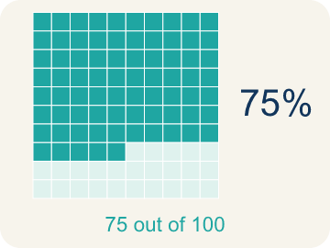 | Percent Porcentaje  A way to compare a number to 100, shown with the % sign.  Example: 30% means 30 out of 100
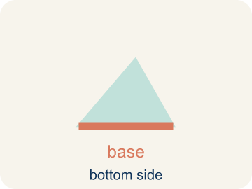 | Base Base  The whole amount you start with — the number right after the word “of.”  Example: 25% of 80 → the whole is 80.
 | Part Parte  How much of the base (the whole) you get. It is your answer.  Example: 25% of 80 = 20 → the part is 20 (20 out of the 80).
 | Equation Ecuación  A number sentence with an equal sign. The percent one is: part = percent × base.  Example: part = percent × base — like 20 = 0.25 × 80.
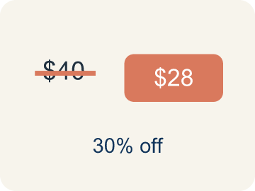 | Discount Descuento  Money taken off the first price to make it cheaper.  Example: $40 shirt at 25% off: discount = $10

Guided Notes
Fill in each blank as we go. Use the Word Bank to help you.
WORD BANK
Percent of a Number • Percent • Base • Part • Equation • Discount

1. A part found by multiplying a number by a percent in decimal form is the ________________ ________________ ________________ ________________.
2. A number out of 100 is a ________________.
3. The whole amount you start with, right after the word “of,” is the ________________.
4. The amount you get out of the whole is the ________________.
5. A number sentence with an equal sign, like part = percent × base, is an ________________.
6. An amount subtracted from a price is a ________________.

Write About the Math
Use the support level you need. Every level answers the same math question.

1. Understand the Question explain
Who is correct, and how do you know?
Your job: Answer the question. Use math evidence. Explain how the evidence proves your answer.
Responde la pregunta. Usa evidencia matemática. Explica cómo la evidencia demuestra tu respuesta.

2. Plan Your Math Words check at least two
☐ Percent of a Number — A part of a number found by multiplying the number by the percent written as a decimal.
Porcentaje de un número — Una parte de un número que se halla multiplicando el número por el porcentaje escrito como decimal.
☐ Percent — A way to compare a number to 100, shown with the % sign.
Porcentaje — Una manera de comparar un número con 100, con el signo %.
☐ Base — The whole amount you start with — the number right after the word “of.”
Base — La cantidad total con la que empiezas: el número que va después de la palabra “de”.
☐ Part — How much of the base (the whole) you get. It is your answer.
Parte — Cuánto obtienes de la base (el total). Es tu respuesta.
☐ Equation — A number sentence with an equal sign. The percent one is: part = percent × base.
Ecuación — Una oración numérica con signo de igual. La de porcentaje es: parte = porcentaje × base.
Say it first: Say your idea to a partner or quietly to yourself before you write.
The ___ is correct because 12% of 1,500 = ___ × 1,500 = ___. The mistake was ___.
Di tu respuesta primero: Mi respuesta es ___ porque ___.

3. Build Your Explanation choose your support
This model shows the parts of an explanation. It does not answer your writing question.
Claim: The base is 60 — it comes right after 'of' — and the part is the discount, 25% of 60.
Evidence: Students identify 60 as the base, the 25% discount as the part to find, and connect 'of' to the base.
Reasoning: This evidence connects the definition of percent to the mathematical claim.

Start Most language support
Complete the frames. Use the word bank.
Completa las oraciones. Usa el banco de palabras.
The ___ is correct because 12% of 1,500 = ___ × 1,500 = ___. The mistake was ___.
My answer is ___.
Mi respuesta es ___.

Build Some language support
Write two connected sentences. Use because, so, or but.
Escribe dos oraciones conectadas. Usa porque, entonces o pero.
My claim is ___.
Mi afirmación es ___.
I know because ___.
Lo sé porque ___.
So ___.
Entonces ___.

Explain Light language support
Write a claim, give math evidence, and explain your reasoning.
Escribe una afirmación, da evidencia matemática y explica tu razonamiento.
My claim is ___.
Mi afirmación es ___.
My math evidence is ___.
Mi evidencia matemática es ___.
This proves ___ because ___.
Esto demuestra ___ porque ___.

4. Check Your Explanation five quick checks
☐ I answered the question.
Respondí la pregunta.
☐ I used math evidence: numbers, an equation, a model, or a comparison.
Usé evidencia matemática: números, una ecuación, un modelo o una comparación.
☐ I explained how the evidence proves my answer.
Expliqué cómo la evidencia demuestra mi respuesta.
☐ I used at least two math words.
Usé por lo menos dos palabras matemáticas.
☐ I reread complete sentences and punctuation.
Volví a leer mis oraciones completas y la puntuación.

Worked Example

Watch & Read I Do — follow along with your teacher
Arcade Builder Challenge
It's Discount Day at the arcade! Different games are offering percent-off deals on ticket prices. The claw machine is 25% off its usual 60-ticket price, and the racing game is 40% off 80 tickets. You need to calculate the discounts to figure out how many tickets each game actually costs!

Think about:
• What information do you need to find the discount amount?
• How is finding 25% of 60 different from finding 40% of 80?
• Is there more than one way to find a percent of a number?
• How does a bar model help you see the percent of a number?

Solved Example I Do — watch each step
Problem: What is 20% of 150?
A) 30
B) 20
C) 35
D) 75
Step 1: 20% = 0.20.
Step 2: Multiply: 0.20 × 150 = 30.
Answer: A. 30

Exit Ticket
Answer on your own. This shows what you learned today.
★ What is 45% of 360?
A) 162
B) 45
C) 315
D) 180

