4.4–4.5 Catch-Up — Homework
Lesson 4-5-catchup • Standard 6.AT.4
Name: ______________________ Period: ______ Date: ____________

Today's Goals
Content: I can show I am caught up on Lessons 4.4–4.5 by using each lesson's big idea in mixed practice.
Language: I can explain which lesson's big idea I used and how, using key vocabulary from Lessons 4.4–4.5.

Key Words
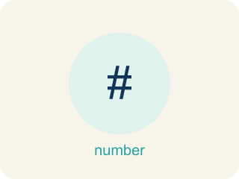
Percent of a Number (Porcentaje de un número) — A part of a number found by multiplying the number by the percent written as a decimal.
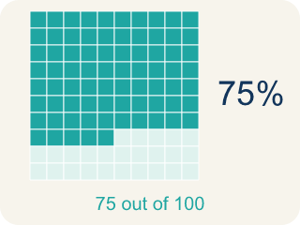
Percent (Porcentaje) — A way to compare a number to 100, shown with the % sign.
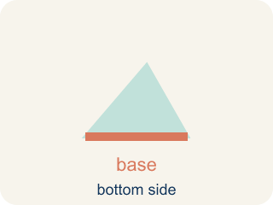
Base (Base) — The whole amount you start with — the number right after the word “of.”
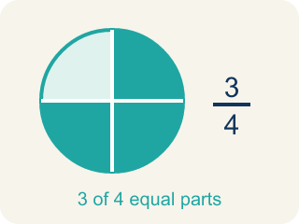
Part (Parte) — How much of the base (the whole) you get. It is your answer.
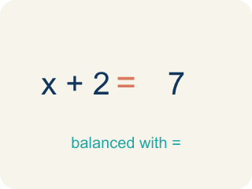
Equation (Ecuación) — A number sentence with an equal sign. The percent one is: part = percent × base.
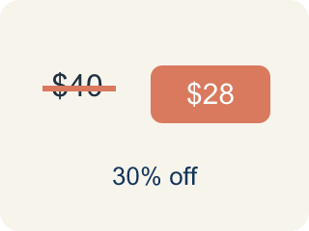
Discount (Descuento) — Money taken off the first price to make it cheaper.

Determine the Whole Given the Part and Percent (Hallar el total dados la parte y el porcentaje) — Working backwards from a part and its percent to find the whole amount it came from.

Whole (Total) — The full amount the percent is measured against. The whole is always 100%.

Practice
Show your work. Use the blank space under each problem.
1. (Lesson 4.4) What is 20% of 150?
A. 30
B. 20
C. 35
D. 75
______________________________________________________________________
2. (Lesson 4.4) What is 50% of 84?
A. 42
B. 50
C. 34
D. 168
______________________________________________________________________
3. (Lesson 4.4) An arcade prize costs 240 tickets. If you have a coupon for 15% off, how many tickets do you save?
A. 36 tickets
B. 24 tickets
C. 15 tickets
D. 204 tickets
______________________________________________________________________
4. (Lesson 4.4) A student scored 72 out of 90 on a test. What percent did they score?
A. 80%
B. 72%
C. 75%
D. 90%
______________________________________________________________________
5. (Lesson 4.5) A car is now worth $26,600, which is 70% of its purchase price. What was the purchase price?
A. $38,000
B. $18,620
C. $26,670
D. $45,200
______________________________________________________________________
6. (Lesson 4.5) Which statement correctly names the pieces of "18 students is 30% of the class"?
A. 18 is the part, 30% is the percent, the class size is the whole
B. 18 is the whole, 30% is the part
C. 30 is the part, 18 is the percent
D. The class size is the part
______________________________________________________________________
7. (Lesson 4.4) The claw machine prize is 80 tickets and today it is 25% off. How many tickets do you save?
A. 20
B. 25
C. 55
D. 16
______________________________________________________________________
8. (Lesson 4.5) $10 is 50% of what number?
A. $20
B. $5
C. $60
D. $100
______________________________________________________________________

Answer Key (Teacher)
1. A. 30
20% = 0.20. Multiply: 0.20 × 150 = 30.
Watch for: A common mistake when finding the whole is multiplying by the percent instead of dividing. For "$42 is 60% of the original price," computing 0.6 × 42 = $25.20 makes the original price SMALLER than the sale price — impossible for a discount. Since percent × whole = part, the whole is found by dividing: 42 ÷ 0.6 = $70. Whenever the percent is less than 100%, the whole must come out larger than the part, so a smaller answer is the tell.
2. A. 42
50% = 0.50. Multiply: 0.50 × 84 = 42. (Or simply divide by 2: 84 ÷ 2 = 42.)
Watch for: A common mistake when finding the whole is multiplying by the percent instead of dividing. For "$42 is 60% of the original price," computing 0.6 × 42 = $25.20 makes the original price SMALLER than the sale price — impossible for a discount. Since percent × whole = part, the whole is found by dividing: 42 ÷ 0.6 = $70. Whenever the percent is less than 100%, the whole must come out larger than the part, so a smaller answer is the tell.
3. A. 36 tickets
15% of 240 = 0.15 × 240 = 36 tickets saved.
Watch for: A common mistake when finding the whole is multiplying by the percent instead of dividing. For "$42 is 60% of the original price," computing 0.6 × 42 = $25.20 makes the original price SMALLER than the sale price — impossible for a discount. Since percent × whole = part, the whole is found by dividing: 42 ÷ 0.6 = $70. Whenever the percent is less than 100%, the whole must come out larger than the part, so a smaller answer is the tell.
4. A. 80%
72/90 simplifies to 8/10, and 10 × 10 = 100, so 8 × 10 = 80. That makes 72/90 = 80/100 = 80%.
Watch for: A common mistake when finding the whole is multiplying by the percent instead of dividing. For "$42 is 60% of the original price," computing 0.6 × 42 = $25.20 makes the original price SMALLER than the sale price — impossible for a discount. Since percent × whole = part, the whole is found by dividing: 42 ÷ 0.6 = $70. Whenever the percent is less than 100%, the whole must come out larger than the part, so a smaller answer is the tell.
5. A. $38,000
Write 0.7v = 26,600 and divide: v = 26,600 ÷ 0.7 = $38,000.
Watch for: A common mistake when finding the whole is multiplying by the percent instead of dividing. For "$42 is 60% of the original price," computing 0.6 × 42 = $25.20 makes the original price SMALLER than the sale price — impossible for a discount. Since percent × whole = part, the whole is found by dividing: 42 ÷ 0.6 = $70. Whenever the percent is less than 100%, the whole must come out larger than the part, so a smaller answer is the tell.
6. A. 18 is the part, 30% is the percent, the class size is the whole
The known count is the part, the percent describes it, and the missing class size is the whole (100%).
Watch for: A common mistake when finding the whole is multiplying by the percent instead of dividing. For "$42 is 60% of the original price," computing 0.6 × 42 = $25.20 makes the original price SMALLER than the sale price — impossible for a discount. Since percent × whole = part, the whole is found by dividing: 42 ÷ 0.6 = $70. Whenever the percent is less than 100%, the whole must come out larger than the part, so a smaller answer is the tell.
7. A. 20
25% = 0.25. Multiply: 0.25 × 80 = 20 tickets saved.
Watch for: A common mistake when finding the whole is multiplying by the percent instead of dividing. For "$42 is 60% of the original price," computing 0.6 × 42 = $25.20 makes the original price SMALLER than the sale price — impossible for a discount. Since percent × whole = part, the whole is found by dividing: 42 ÷ 0.6 = $70. Whenever the percent is less than 100%, the whole must come out larger than the part, so a smaller answer is the tell.
8. A. $20
Half of the whole is $10, so the whole is $20.
Watch for: A common mistake when finding the whole is multiplying by the percent instead of dividing. For "$42 is 60% of the original price," computing 0.6 × 42 = $25.20 makes the original price SMALLER than the sale price — impossible for a discount. Since percent × whole = part, the whole is found by dividing: 42 ÷ 0.6 = $70. Whenever the percent is less than 100%, the whole must come out larger than the part, so a smaller answer is the tell.

