UNIT 5 · LESSON 1 STANDARD 6.GR.1

Determine the Area of Parallelograms and Rhombuses
Student Notes Packet
Name: ______________________ Date: ____________ Period: ________
Level 1 · Support

Today's Goals
Content: I can find the area of a parallelogram using base × height.
Language: I can explain how I found the area using the words base, height, area, and formula.

Key Vocabulary
Look at the picture, read the word, then read what it means.
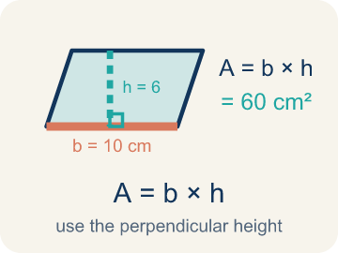 | Area of Parallelograms Área de paralelogramos  The space inside a parallelogram. Formula: A = b × h, using the perpendicular height.  Example: A = b × h; if b = 10 cm and h = 6 cm, A = 60 cm².
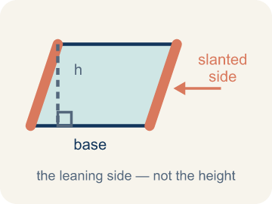 | Slanted side Lado inclinado  A side that leans instead of going straight up and down. It is not the perpendicular height.  Example: In a leaning parallelogram, use the dashed 90° height—not the slanted side—in A = b × h.
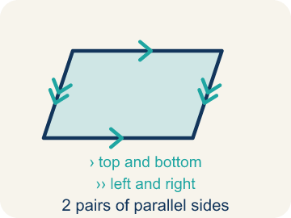 | Parallelogram Paralelogramo  A four-sided shape with two pairs of parallel sides.  Example: Think of a leaning door — the top and bottom are parallel, and the two sides are parallel, like a slanted rectangle
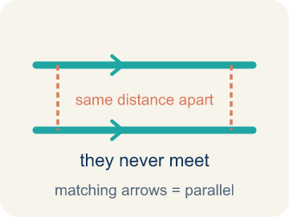 | Parallel Paralelas  Two lines or sides that stay the same distance apart and never meet.  Example: The top and bottom of a parallelogram never get closer together — matching arrowheads (›) mark one parallel pair, double arrowheads (››) mark the other.
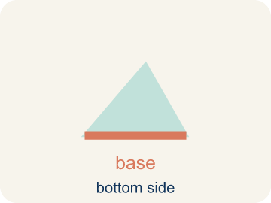 | Base Base  Any side of a parallelogram can be the base. Once you pick a base, the height must be measured perpendicular (at a 90° angle) to it.  Example: Any side can be the base: choose the 10 cm side and b = 10 cm, then draw the height at 90° to that side in A = b × h
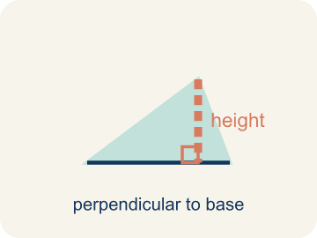 | Height Altura  The straight-up distance from the base to the top.  Example: A dashed vertical line from the top side straight down to the base, forming a 90° angle — NOT the slanted side
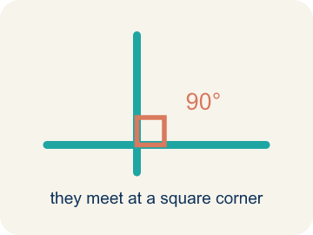 | Perpendicular Perpendicular  Two lines that meet to make a square corner (90 degrees).  Example: The dashed height meets the base at a square corner — the small 90° box is what makes it perpendicular, not slanted.
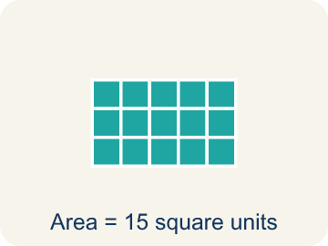 | Area Área  How much space is inside a flat shape.  Example: A 3 cm × 4 cm rectangle covers 12 square centimeters — imagine 12 tiny 1×1 squares inside it
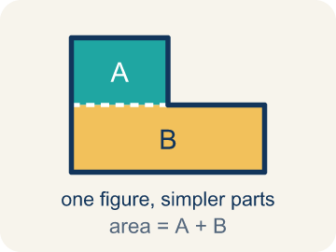 | Composite figure Figura compuesta  A shape made by putting two or more simple shapes together.  Example: An L-shaped room = a 10×8 rectangle joined to a 4×5 rectangle; total area = 80 + 20 = 100 sq ft
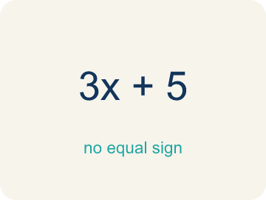 | Formula Fórmula  A math rule written with symbols.  Example: A = b × h means Area equals base times height; for a parallelogram with b = 6 and h = 4, A = 24

Guided Notes
Fill in each blank as we go. Use the Word Bank to help you.
WORD BANK
Area of Parallelograms • Slanted side • Parallelogram • Parallel • Base • Height • Perpendicular • Area • Composite figure • Formula

1. The space inside a parallelogram, found with A = b × h, is the ________________.
2. The leaning side of a parallelogram, which is NOT the height, is the ________________.
3. A quadrilateral with two pairs of parallel sides is a ________________.
4. Two sides that stay the same distance apart and never meet are ________________.
5. The side of a parallelogram you measure the height from at a 90° angle is the ________________.
6. The perpendicular distance between the base and the opposite side is the ________________.
7. Two lines that meet at a 90° square corner are ________________.
8. The amount of flat space inside a two-dimensional figure is its ________________.
9. A shape made of two or more basic shapes combined is a ________________.
10. A math rule written with symbols, like A = b × h, is a ________________.

Write About the Math
Use the support level you need. Every level answers the same math question.

1. Understand the Question explain
How many tiles does the architect need?
Your job: Answer the question. Use math evidence. Explain how the evidence proves your answer.
Responde la pregunta. Usa evidencia matemática. Explica cómo la evidencia demuestra tu respuesta.

2. Plan Your Math Words check at least two
☐ Area of Parallelograms — The space inside a parallelogram. Formula: A = b × h, using the perpendicular height.
Área de paralelogramos — El espacio dentro de un paralelogramo. Fórmula: A = b × h, usando la altura perpendicular.
☐ Slanted side — A side that leans instead of going straight up and down. It is not the perpendicular height.
Lado inclinado — Un lado que está inclinado en vez de subir y bajar verticalmente. No es la altura perpendicular.
☐ Parallelogram — A four-sided shape with two pairs of parallel sides.
Paralelogramo — Una figura de cuatro lados con dos pares de lados paralelos.
☐ Parallel — Two lines or sides that stay the same distance apart and never meet.
Paralelas — Dos líneas o lados que se mantienen a la misma distancia y nunca se cruzan.
☐ Base — Any side of a parallelogram can be the base. Once you pick a base, the height must be measured perpendicular (at a 90° angle) to it.
Base — Cualquier lado de un paralelogramo puede ser la base. Una vez que eliges la base, la altura debe medirse perpendicular (en un ángulo de 90°) a ella.
Say it first: Say your idea to a partner or quietly to yourself before you write.
The courtyard's area is ___ sq ft because A = ___ x ___ . She needs ___ tiles because ___ / 2 = ___.
Di tu respuesta primero: Mi respuesta es ___ porque ___.

3. Build Your Explanation choose your support
This model shows the parts of an explanation. It does not answer your writing question.
Claim: We use the height because it is perpendicular to the base.
Evidence: Students connect 'height' to the perpendicular (straight-up) distance from base to top, and recognize the slanted side is longer and would overstate the area.
Reasoning: This evidence connects the definition of area of parallelograms to the mathematical claim.

Start Most language support
Complete the frames. Use the word bank.
Completa las oraciones. Usa el banco de palabras.
The courtyard's area is ___ sq ft because A = ___ x ___ . She needs ___ tiles because ___ / 2 = ___.
My answer is ___.
Mi respuesta es ___.

Build Some language support
Write two connected sentences. Use because, so, or but.
Escribe dos oraciones conectadas. Usa porque, entonces o pero.
My claim is ___.
Mi afirmación es ___.
I know because ___.
Lo sé porque ___.
So ___.
Entonces ___.

Explain Light language support
Write a claim, give math evidence, and explain your reasoning.
Escribe una afirmación, da evidencia matemática y explica tu razonamiento.
My claim is ___.
Mi afirmación es ___.
My math evidence is ___.
Mi evidencia matemática es ___.
This proves ___ because ___.
Esto demuestra ___ porque ___.

4. Check Your Explanation five quick checks
☐ I answered the question.
Respondí la pregunta.
☐ I used math evidence: numbers, an equation, a model, or a comparison.
Usé evidencia matemática: números, una ecuación, un modelo o una comparación.
☐ I explained how the evidence proves my answer.
Expliqué cómo la evidencia demuestra mi respuesta.
☐ I used at least two math words.
Usé por lo menos dos palabras matemáticas.
☐ I reread complete sentences and punctuation.
Volví a leer mis oraciones completas y la puntuación.

Worked Example

Watch & Read I Do — follow along with your teacher
Blueprint Review
Your architecture firm is designing a parallelogram-shaped patio for a client's backyard. The client needs to know how many square feet of pavers to order. The patio has a base of 14 feet and a height of 9 feet.

Think about:
• What shape is the patio?
• What measurements are given?
• How is a parallelogram different from a rectangle?
• Why do we use the height instead of the slanted side to find the area?
• Can you rearrange a parallelogram into a rectangle?

Solved Example I Do — watch each step
Problem: What is the area of a parallelogram with base 10 cm and height 7 cm?
A) 70 sq cm
B) 34 sq cm
C) 17 sq cm
D) 70 cm
Step 1: A = b × h = 10 × 7 = 70 square centimeters.
Answer: A. 70 sq cm

Guided Practice

Solve Together We Do — work with your class
Problem: A parallelogram has an area of 54 sq ft and a base of 9 ft. What is the height?
A) 6 ft
B) 45 ft
C) 63 ft
D) 27 ft
Step 1:

Step 2:

Answer:

A landscape architect is tiling a parallelogram-shaped courtyard. The courtyard has a base of 18 feet and a height of 10 feet. Each tile covers 2 square feet.
How many tiles does the architect need?

Sentence frame: The courtyard's area is ___ sq ft because A = ___ x ___ . She needs ___ tiles because ___ / 2 = ___.

Turn & Talk discuss with a partner
1. [Launch] Look at the patio blueprint with a base of 14 feet and a height of 9 feet. Why do we use the height (9 ft) and not the slanted side to find the area?
Start with: We use the height because it is ___ to the base.
Usamos la altura porque es ___ a la base.
Word bank: base, height, area, parallelogram, formula
2. [Explore] On the grid you cut a triangle off one end of the parallelogram and slid it to the other side. What shape did you make, and why does that prove the area is base x height?
Start with: When I move the triangle, I get a ___.
Cuando muevo el triángulo, obtengo un ___.
Word bank: rearrange, rectangle, base, height, area
3. [Connect] The landscape architect tiles an 18 ft by 10 ft parallelogram courtyard and each tile covers 2 sq ft. Talk through how you find the number of tiles.
Start with: First I find the area: 18 times 10 equals ___ square feet.
Primero hallo el área: 18 por 10 es ___ pies cuadrados.
Word bank: area, base, height, parallelogram, tiles
4. [Practice] During practice on Area of Parallelograms, what strategy did you use when a problem felt tricky?
Start with: A strategy I used was ___ because ___.
Una estrategia que usé fue ___ porque ___.
Word bank: Parallelogram, Base, Height, Area

Independent Practice

On Your Own You Do — show your work
Solve each problem. Show your thinking in the work box.

Level 1 Support extra scaffolding
1. What is the area of a parallelogram with base 9 cm and height 5 cm?
A) 45 sq cm
B) 14 sq cm
C) 22.5 sq cm
D) 90 sq cm

2. Which measurement is the height of a parallelogram?
A) The perpendicular distance between the base and the opposite side
B) The length of the slanted side
C) The perimeter divided by 4
D) The longest side

Exit Ticket
Answer on your own. This shows what you learned today.
★ A parallelogram has a base of 13 inches and a height of 5 inches. What is its area?
A) 65 sq in
B) 36 sq in
C) 18 sq in
D) 65 in

