5.4–5.10 Catch-Up — Homework
Lesson 5-10-catchup • Standard 6.GR.2
Name: ______________________ Period: ______ Date: ____________

Today's Goals
Content: I can show I am caught up on Lessons 5.4–5.10 by using each lesson's big idea in mixed practice.
Language: I can explain which lesson's big idea I used and how, using key vocabulary from Lessons 5.4–5.10.

Key Words
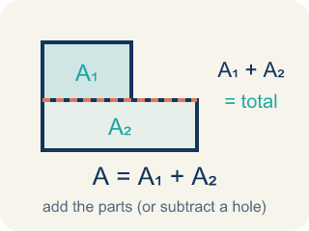
Area of Composite Figures (Área de figuras compuestas) — The total space inside a figure made of basic shapes. Formula: A = A₁ + A₂ — add the parts (or subtract a missing piece).
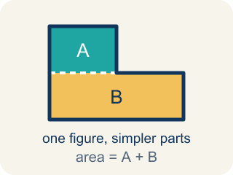
Composite Figure (Figura compuesta) — A shape made by putting two or more simple shapes together.
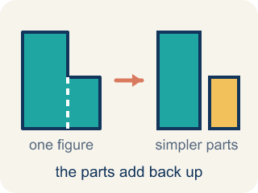
Decompose (Descomponer) — To break a shape into smaller, simpler shapes.
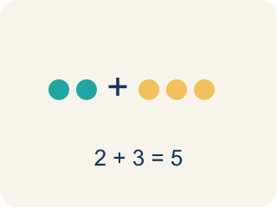
Add (Sumar) — Add up the areas of the smaller shapes to get the total.
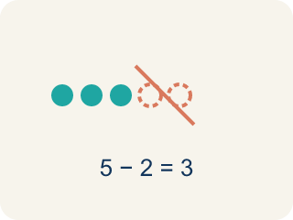
Subtract (Restar) — Take away the area of a missing piece from a bigger shape.
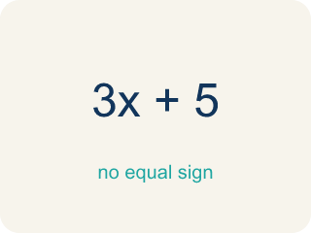
Formula (Fórmula) — A math rule written with symbols.
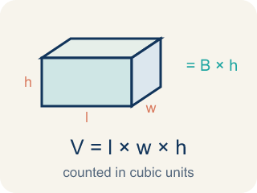
Volume with Whole-Number Edges (Volumen con aristas de números enteros) — The number of unit cubes inside a rectangular prism. Formula: V = l × w × h.

Volume (Volumen) — How much space is inside a solid shape.
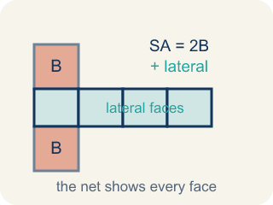
Surface Area Using Nets (Área de superficie usando redes) — The total area of all the faces of a solid. A net unfolds the solid flat so you can see every face and add their areas.

Surface Area of Prisms (Área de superficie de prismas) — The total area of all bases and lateral faces of a prism. Formula: SA = 2B + lateral area.
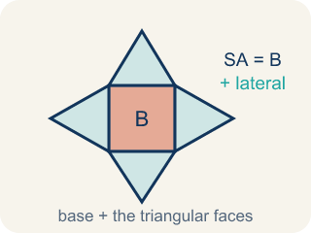
Surface Area of Pyramids (Área de superficie de pirámides) — The total area of a pyramid's base and triangular faces. Formula: SA = B + lateral area.
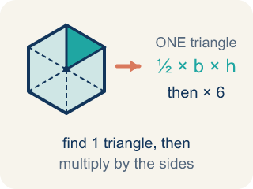
Area of Regular Polygons (Área de polígonos regulares) — The space a regular polygon covers. Split it from the center into identical triangles, find one triangle's area, then multiply by how many there are.

Volume of Rectangular Prisms (Volumen de prismas rectangulares) — The space inside a rectangular prism. Formula: V = Bh = l × w × h.
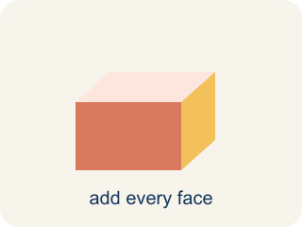
Surface area (Área de superficie) — The total area of all the flat sides of a solid.
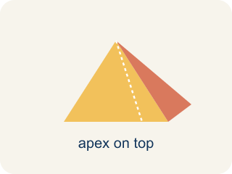
Pyramid (Pirámide) — A solid with a flat bottom and triangle sides that meet at one point on top.
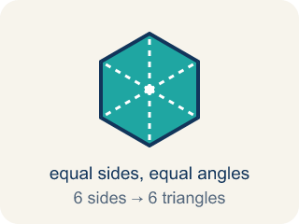
Regular Polygon (Polígono regular) — A closed flat shape made of straight sides, where every side is the same length and every angle is the same size.

Practice
Show your work. Use the blank space under each problem.
1. (Lesson 5.4) An L-shaped room is made of two rectangles: 10 ft × 6 ft and 4 ft × 3 ft. What is the total area?
A. 72 sq ft
B. 60 sq ft
C. 12 sq ft
D. 72 ft
______________________________________________________________________
2. (Lesson 5.4) A rectangular patio is 15 ft × 10 ft with a 5 ft × 4 ft rectangular flower bed cut out. What is the remaining area?
A. 130 sq ft
B. 150 sq ft
C. 20 sq ft
D. 170 sq ft
______________________________________________________________________
3. (Lesson 5.4) Spot the Common Mistake
Step 1 (Identify the shapes): A 16 ft × 9 ft floor has a 4 ft × 5 ft supply closet cut out of one corner. Find the usable floor area.
Step 2 (Find the large rectangle area): A = 16 × 9 = 144 sq ft.
Step 3 (Find the cutout area): A = 4 × 5 = 20 sq ft.
Step 4 (Find the usable area): Usable area = 144 + 20 = 164 sq ft.
Which step has the mistake? Explain and fix it:
______________________________________________________________________
______________________________________________________________________
______________________________________________________________________
4. Complete the table.
Figure | Shape 1 Area | Shape 2 Area | Operation | Total Area
L-shaped deck | 48 sq ft | 20 sq ft | Add
Floor with alcove | 90 sq ft | 15 sq ft | Add
Wall with window cutout | 120 sq ft | 18 sq ft | Subtract
Courtyard with fountain cutout | 200 sq ft | 36 sq ft | Subtract
______________________________________________________________________
5. (Lesson 5.5) Two storage bins: Bin A is 8 × 6 × 5 inches. Bin B is 9 × 4 × 7 inches. Which holds more and by how much?
A. Bin B by 12 in³
B. Bin A by 12 in³
C. Bin B by 24 in³
D. They hold the same
______________________________________________________________________
6. (Lesson 5.5) Added the Last Edge
Step 1 (Dimensions): A capsule is 6 long, 5 wide, and 3 tall
Step 2 (Formula): V = length × width × height
Step 3 (Calculate): V = 6 × 5 + 3 = 33 cubic units
Step 4 (Answer): Volume = 33 cubic units
Which step has the mistake? Explain and fix it:
______________________________________________________________________
______________________________________________________________________
______________________________________________________________________
7. (Lesson 5.6) A cube has edges of 5 cm. What is its surface area?
A. 150 cm²
B. 125 cm²
C. 150 cm³
D. 30 cm²
______________________________________________________________________
8. (Lesson 5.6) Spot the Mistake — One Pair Was Not Doubled
Step 1 (Read): A time capsule box from the net is l = 7 in, w = 5 in, h = 4 in. Find the surface area.
Step 2 (Find each face pair): Top/Bottom: 7×5 = 35, Front/Back: 7×4 = 28, Left/Right: 5×4 = 20
Step 3 (Apply the formula): SA = 2(35) + 2(28) + 20 = 70 + 56 + 20 = 146 in² (left/right pair not doubled)
Step 4 (Answer): Surface Area = 146 in²
Which step has the mistake? Explain and fix it:
______________________________________________________________________
______________________________________________________________________
______________________________________________________________________
9. (Lesson 5.7) A triangular prism has triangular bases with base 6 in and height 4 in. The prism is 10 in long and the two slant sides of the triangle are each 5 in. What is the surface area?
A. 184 in²
B. 160 in²
C. 124 in²
D. 184 in³
______________________________________________________________________
10. (Lesson 5.7) Spot the Common Mistake — Surface Area or Volume?
Step 1 (Dimensions): Rectangular prism time capsule: l = 7 in, w = 4 in, h = 3 in. Find the surface area.
Step 2 (Formula): Surface area adds all 6 faces: SA = 2lw + 2lh + 2wh.
Step 3 (Calculate): The student multiplied the three dimensions: 7 × 4 × 3 = 84, so they wrote SA = 84 in².
Which step has the mistake? Explain and fix it:
______________________________________________________________________
______________________________________________________________________
______________________________________________________________________

Answer Key (Teacher)
1. A. 72 sq ft
Area 1 = 10 × 6 = 60 sq ft. Area 2 = 4 × 3 = 12 sq ft. Total = 60 + 12 = 72 sq ft.
Watch for: A common mistake in Volume of Rectangular Prisms is rounding a fractional edge length to the nearest whole number before multiplying, instead of using the exact fraction or decimal. For a box that is 2 ft × 1.5 ft × 1 ft, a student might round 1.5 down to 1 and compute 2 × 1 × 1 = 2 ft³, but the correct volume uses the exact edge length: 2 × 1.5 × 1 = 3 ft³ — a full cubic foot larger. Before you submit, ask: 'Did I multiply using the exact fractional or decimal edge length, or did I round it off first?'
2. A. 130 sq ft
Patio = 15 × 10 = 150 sq ft. Cutout = 5 × 4 = 20 sq ft. Remaining = 150 − 20 = 130 sq ft.
Watch for: A common mistake in Volume of Rectangular Prisms is rounding a fractional edge length to the nearest whole number before multiplying, instead of using the exact fraction or decimal. For a box that is 2 ft × 1.5 ft × 1 ft, a student might round 1.5 down to 1 and compute 2 × 1 × 1 = 2 ft³, but the correct volume uses the exact edge length: 2 × 1.5 × 1 = 3 ft³ — a full cubic foot larger. Before you submit, ask: 'Did I multiply using the exact fractional or decimal edge length, or did I round it off first?'
3. (Lesson 5.4) Spot the Common Mistake
The mistake is in Step 4.
Correct work: The closet is cut out, so subtract its area instead of adding it. Usable area = 144 − 20 = 124 sq ft.
Watch for: Both areas are found correctly, 144 sq ft and 20 sq ft, but the final step adds them. The closet was cut out of the floor, so its 20 sq ft is not usable space — subtract it: 144 − 20 = 124 sq ft. An answer of 164 sq ft should also look wrong, since usable floor can never exceed the whole 144 sq ft floor.
4. Table
L-shaped deck — Total Area: 68 sq ft
Floor with alcove — Total Area: 105 sq ft
Wall with window cutout — Total Area: 102 sq ft
Courtyard with fountain cutout — Total Area: 164 sq ft

5. A. Bin B by 12 in³
Bin A: 8 × 6 × 5 = 240 in³. Bin B: 9 × 4 × 7 = 252 in³. Bin B holds 12 in³ more.
Watch for: A common mistake in Volume of Rectangular Prisms is rounding a fractional edge length to the nearest whole number before multiplying, instead of using the exact fraction or decimal. For a box that is 2 ft × 1.5 ft × 1 ft, a student might round 1.5 down to 1 and compute 2 × 1 × 1 = 2 ft³, but the correct volume uses the exact edge length: 2 × 1.5 × 1 = 3 ft³ — a full cubic foot larger. Before you submit, ask: 'Did I multiply using the exact fractional or decimal edge length, or did I round it off first?'
6. (Lesson 5.5) Added the Last Edge
The mistake is in Step 3.
Correct work: The student multiplied the first two edges correctly (6 × 5 = 30) but then added the height instead of multiplying it. Every edge must be multiplied: V = 6 × 5 × 3 = 90 cubic units.
Watch for: The Calculate step starts fine with 6 × 5 = 30, but then the student writes + 3 instead of × 3, landing on 33. Volume multiplies every edge, so the correct work is V = 6 × 5 × 3 = 90 cubic units.
7. A. 150 cm²
A cube has 6 identical faces. Each face: 5 × 5 = 25 cm². Total SA = 6 × 25 = 150 cm².
Watch for: A common mistake in Volume of Rectangular Prisms is rounding a fractional edge length to the nearest whole number before multiplying, instead of using the exact fraction or decimal. For a box that is 2 ft × 1.5 ft × 1 ft, a student might round 1.5 down to 1 and compute 2 × 1 × 1 = 2 ft³, but the correct volume uses the exact edge length: 2 × 1.5 × 1 = 3 ft³ — a full cubic foot larger. Before you submit, ask: 'Did I multiply using the exact fractional or decimal edge length, or did I round it off first?'
8. (Lesson 5.6) Spot the Mistake — One Pair Was Not Doubled
The mistake is in Step 3.
Correct work: The student doubled the first two pairs but forgot to double the left/right pair. There are two 20 in² faces, so it should be 2(20) = 40, not 20. Correct: SA = 70 + 56 + 40 = 166 in².
Watch for: The three face areas are right, but the formula line doubles only the first two pairs. The left and right faces are each 5 × 4 = 20 in², so that pair contributes 2(20) = 40 in², not 20 in². The correct total is SA = 70 + 56 + 40 = 166 in².
9. A. 184 in²
Triangular bases: 2 × (½ × 6 × 4) = 24 in². Three rectangular faces: 6(10) + 5(10) + 5(10) = 60 + 50 + 50 = 160 in². SA = 24 + 160 = 184 in².
Watch for: A common mistake in Volume of Rectangular Prisms is rounding a fractional edge length to the nearest whole number before multiplying, instead of using the exact fraction or decimal. For a box that is 2 ft × 1.5 ft × 1 ft, a student might round 1.5 down to 1 and compute 2 × 1 × 1 = 2 ft³, but the correct volume uses the exact edge length: 2 × 1.5 × 1 = 3 ft³ — a full cubic foot larger. Before you submit, ask: 'Did I multiply using the exact fractional or decimal edge length, or did I round it off first?'
10. (Lesson 5.7) Spot the Common Mistake — Surface Area or Volume?
The mistake is in Step 3.
Correct work: Multiplying l × w × h gives the VOLUME (84 in³), not surface area. Add all six faces: SA = 2(7×4) + 2(7×3) + 2(4×3) = 56 + 42 + 24 = 122 in².
Watch for: In the Calculate step the student multiplied 7 × 4 × 3, which fills the inside of the box — that is volume, 84 in³, not surface area. Surface area covers the outside, so add all six faces: 2(7×4) + 2(7×3) + 2(4×3) = 56 + 42 + 24 = 122 in².

