UNIT 5 · LESSON 10 STANDARD 6.GR.2

Volume of Rectangular Prisms
Student Notes Packet
Name: ______________________ Date: ____________ Period: ________
Level 1 · Support

Today's Goals
Content: I can find the volume of a rectangular prism, including ones with fractional edge lengths, using base area × height.
Language: I can explain my work using the words volume, rectangular prism, dimensions, and base area.

Key Vocabulary
Look at the picture, read the word, then read what it means.
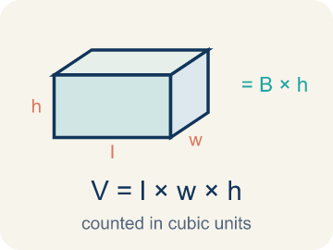 | Volume of Rectangular Prisms Volumen de prismas rectangulares  The space inside a rectangular prism. Formula: V = Bh = l × w × h.  Example: V = Bh = l × w × h
 | Volume Volumen  How much space is inside a solid shape.  Example: A box 2 × 1.5 × 1 = 3 ft³ — it holds 3 cubic feet of stuff
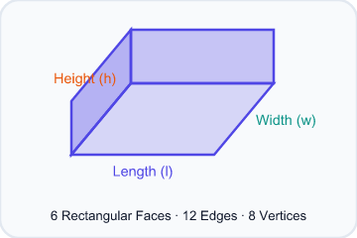 | Rectangular prism Prisma rectangular  A solid box shape with six flat rectangle sides.  Example: A tissue box, a fish tank, a brick — all rectangular prisms
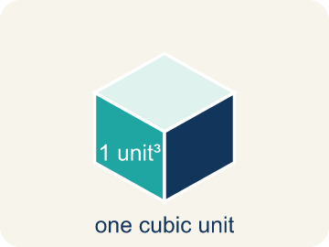 | Cubic units Unidades cúbicas  The units used to measure space inside, like cubic inches.  Example: 1 ft³ = a cube that is 1 foot on every edge
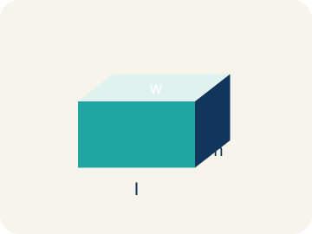 | Dimensions Dimensiones  How long, how wide, and how tall a shape is.  Example: A box with dimensions 4 × 3 × 2 means l = 4, w = 3, h = 2
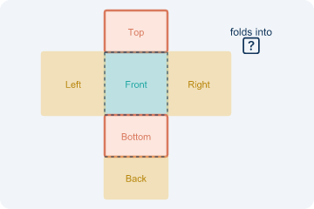 | Net Plantilla (desarrollo plano)  A flat shape that folds up into a solid.  Example: Cut a cereal box along its edges, unfold it flat — that is the net
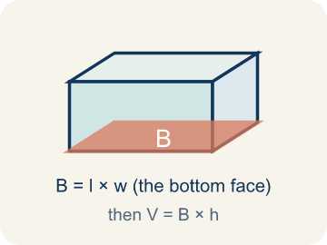 | Base area Área de la base  The area of the bottom of a solid. Volume = base area × height.  Example: If the base is 6 × 4 = 24 cm² and h = 3, then V = 24 × 3 = 72 cm³

Guided Notes
Fill in each blank as we go. Use the Word Bank to help you.
WORD BANK
Volume of Rectangular Prisms • Volume • Rectangular prism • Cubic units • Dimensions • Net • Base area

1. The space inside a rectangular prism, found with V = l × w × h, is the ________________.
2. The amount of space inside a three-dimensional solid is its ________________.
3. A solid with six rectangular faces is a ________________.
4. The unit used to measure volume is ________________.
5. The measurements of length, width, and height of a solid are its ________________.
6. A flat pattern that folds into a solid is a ________________.
7. The area of the bottom face of a prism, multiplied by height to find volume, is the ________________.

Write About the Math
Use the support level you need. Every level answers the same math question.

1. Understand the Question explain
How many gallons of water does the small tank hold?
Your job: Answer the question. Use math evidence. Explain how the evidence proves your answer.
Responde la pregunta. Usa evidencia matemática. Explica cómo la evidencia demuestra tu respuesta.

2. Plan Your Math Words check at least two
☐ Volume of Rectangular Prisms — The space inside a rectangular prism. Formula: V = Bh = l × w × h.
Volumen de prismas rectangulares — El espacio dentro de un prisma rectangular. Fórmula: V = Bh = l × w × h.
☐ Volume — How much space is inside a solid shape.
Volumen — Cuánto espacio hay dentro de una figura sólida.
☐ Rectangular prism — A solid box shape with six flat rectangle sides.
Prisma rectangular — Una figura sólida en forma de caja con seis lados rectangulares.
☐ Cubic units — The units used to measure space inside, like cubic inches.
Unidades cúbicas — Las unidades para medir el espacio interior, como pulgadas cúbicas.
☐ Dimensions — How long, how wide, and how tall a shape is.
Dimensiones — Qué tan largo, ancho y alto es una figura.
Say it first: Say your idea to a partner or quietly to yourself before you write.
The tank's volume is ___ in³ because V = ___ × ___ × ___. It holds about ___ gallons because ___ ÷ 231 ≈ ___.
Di tu respuesta primero: Mi respuesta es ___ porque ___.

3. Build Your Explanation choose your support
This model shows the parts of an explanation. It does not answer your writing question.
Claim: You still multiply length × width × height even when an edge is a fraction or decimal.
Evidence: Students explain the formula stays the same (V = l × w × h = 2 × 1.5 × 1 = 3 ft³) and that a fractional edge just means multiplying with a fraction or decimal.
Reasoning: This evidence connects the definition of volume of rectangular prisms to the mathematical claim.

Start Most language support
Complete the frames. Use the word bank.
Completa las oraciones. Usa el banco de palabras.
The tank's volume is ___ in³ because V = ___ × ___ × ___. It holds about ___ gallons because ___ ÷ 231 ≈ ___.
My answer is ___.
Mi respuesta es ___.

Build Some language support
Write two connected sentences. Use because, so, or but.
Escribe dos oraciones conectadas. Usa porque, entonces o pero.
My claim is ___.
Mi afirmación es ___.
I know because ___.
Lo sé porque ___.
So ___.
Entonces ___.

Explain Light language support
Write a claim, give math evidence, and explain your reasoning.
Escribe una afirmación, da evidencia matemática y explica tu razonamiento.
My claim is ___.
Mi afirmación es ___.
My math evidence is ___.
Mi evidencia matemática es ___.
This proves ___ because ___.
Esto demuestra ___ porque ___.

4. Check Your Explanation five quick checks
☐ I answered the question.
Respondí la pregunta.
☐ I used math evidence: numbers, an equation, a model, or a comparison.
Usé evidencia matemática: números, una ecuación, un modelo o una comparación.
☐ I explained how the evidence proves my answer.
Expliqué cómo la evidencia demuestra mi respuesta.
☐ I used at least two math words.
Usé por lo menos dos palabras matemáticas.
☐ I reread complete sentences and punctuation.
Volví a leer mis oraciones completas y la puntuación.

Worked Example

Watch & Read I Do — follow along with your teacher
Time Capsule Project
Your class is building a time capsule to bury on school grounds. The capsule is a rectangular prism that is 2 feet long, 1.5 feet wide, and 1 foot tall. You need to figure out how much stuff can fit inside — that means calculating the volume!

Think about:
• What are the three measurements of the time capsule?
• What does volume measure — length, area, or space inside?
• How is volume different from area?
• What if we made the capsule taller but narrower — would the volume change?
• What units do we use for volume versus area?

Solved Example I Do — watch each step
Problem: What is the volume of a rectangular prism with l = 4 in, w = 3 in, h = 5 in?
A) 60 in³
B) 12 in³
C) 60 in²
D) 24 in³
Step 1: V = l × w × h = 4 × 3 × 5 = 60 cubic inches.
Answer: A. 60 in³

Guided Practice

Solve Together We Do — work with your class
Problem: A box has a volume of 36 cm³. Its length is 6 cm and width is 3 cm. What is the height?
A) 2 cm
B) 6 cm
C) 3 cm
D) 12 cm
Step 1:

Step 2:

Answer:

An aquarium store sells fish tanks. A small tank is 24 inches long, 12 inches wide, and 16 inches tall. One gallon of water takes up about 231 cubic inches.
How many gallons of water does the small tank hold?

Sentence frame: The tank's volume is ___ in³ because V = ___ × ___ × ___. It holds about ___ gallons because ___ ÷ 231 ≈ ___.

Turn & Talk discuss with a partner
1. [Launch] Your time capsule is 2 ft long, 1.5 ft wide, and 1 ft tall — one edge is a fraction. Does having a fractional edge change how you find the volume? Why or why not?
Start with: A fractional edge ___ change the method because I still multiply ___ × ___ × ___.
Una arista fraccionaria ___ cambia el método porque sigo multiplicando ___ × ___ × ___.
Word bank: volume, dimensions, rectangular prism, base area, cubic units
2. [Explore] Capsule A (2 × 1.5 × 1) and Capsule B (3 × 1 × 1) both have a volume of 3 ft³. How did your multiplication produce the same volume from different dimensions?
Start with: Both capsules have V = ___ ft³ because ___ × ___ × ___ = ___ × ___ × ___.
Ambas cápsulas tienen V = ___ ft³ porque ___ × ___ × ___ = ___ × ___ × ___.
Word bank: volume, dimensions, rectangular prism, base area, cubic units
3. [Connect] A fish tank is 24 in long, 12 in wide, and 16 in tall, and one gallon takes about 231 cubic inches. Talk through how you would find how many gallons it holds.
Start with: The tank's volume is ___ in³ because 24 × 12 × 16 = ___.
El volumen del tanque es ___ in³ porque 24 × 12 × 16 = ___.
Word bank: volume, cubic units, rectangular prism, dimensions, base area
4. [Reflect] A classmate says a 5 × 3 × 2.5 m prism has volume 5 × 5.5 = 27.5 m³. How do you find and explain their mistake?
Start with: The mistake is that they ___ instead of multiplying 3 × 2.5.
El error es que ___ en lugar de multiplicar 3 × 2.5.
Word bank: volume, dimensions, rectangular prism, base area, cubic units
5. [Practice] During practice on Volume of Rectangular Prisms, what strategy did you use when a problem felt tricky?
Start with: Both capsules have V = ___ ft³ because ___ × ___ × ___ = ___ × ___ × ___.
Ambas cápsulas tienen V = ___ ft³ porque ___ × ___ × ___ = ___ × ___ × ___.
Word bank: Volume, Rectangular prism, Cubic units, Dimensions

Independent Practice

On Your Own You Do — show your work
Solve each problem. Show your thinking in the work box.

Level 1 Support extra scaffolding
1. How is volume different from area?
A) Volume measures 3D space (cubic units); area measures 2D surface (square units)
B) Volume uses square units; area uses cubic units
C) Volume only applies to cubes; area applies to all shapes
D) There is no difference

Exit Ticket
Answer on your own. This shows what you learned today.
★ A rectangular prism has l = 7 ft, w = 2 ft, h = 3 ft. What is the volume?
A) 42 ft³
B) 24 ft³
C) 42 ft²
D) 12 ft³

Answer Key & Teacher Guide
Teacher reference — remove or fold back before distributing to students.

Guided Notes (Fill-in)
Notes 1: Volume of Rectangular Prisms
Notes 2: Volume
Notes 3: Rectangular prism
Notes 4: Cubic units
Notes 5: Dimensions
Notes 6: Net
Notes 7: Base area

Worked Notes (I Do / We Do)
I Do: A. 60 in³
We Do: A. 2 cm

Independent Practice
Watch for this mistake: A common mistake in Volume of Rectangular Prisms is rounding a fractional edge length to the nearest whole number before multiplying, instead of using the exact fraction or decimal. For a box that is 2 ft × 1.5 ft × 1 ft, a student might round 1.5 down to 1 and compute 2 × 1 × 1 = 2 ft³, but the correct volume uses the exact edge length: 2 × 1.5 × 1 = 3 ft³ — a full cubic foot larger. Before you submit, ask: 'Did I multiply using the exact fractional or decimal edge length, or did I round it off first?'

Level 1 Support
1. A) Volume measures 3D space (cubic units); area measures 2D surface (square units) — Volume measures the space inside a 3D shape (cubic units like in³). Area measures a flat 2D surface (square units like in²).

On Level
2. A) Box B by 40 in³ — Box A: 10 × 5 × 4 = 200 in³. Box B: 8 × 6 × 5 = 240 in³. Box B is bigger by 40 in³.
3. C) 6 m³ — V = 1/2 × 3 × 4 = 6 m³.
4. A) 125 cm³ — A cube's volume is edge³ = 5 × 5 × 5 = 125 cm³.

Level 2 Enrichment
5. B) 15 ft³ — V = 2.5 × 2 × 3 = 15 ft³.
6. C) 6 ft — Height = V ÷ (base area) = 9 ÷ (3/4 × 2) = 9 ÷ 1.5 = 6 ft.

Exit Ticket
A) 42 ft³ — V = 7 × 2 × 3 = 42 cubic feet. Remember: volume uses cubic units (ft³).

Math Writing Criteria
The support level changes the amount of language scaffolding, not the mathematical expectation.
☐ I answered the question.
☐ I used math evidence: numbers, an equation, a model, or a comparison.
☐ I explained how the evidence proves my answer.
☐ I used at least two math words.
☐ I reread complete sentences and punctuation.

