UNIT 5 · LESSON 2 STANDARD 6.GR.1

Determine the Area of Triangles (Flagship)
Student Notes Packet
Name: ______________________ Date: ____________ Period: ________
Level 3 · Enrichment

Today's Goals
Content: I can find the area of a triangle using the formula A = ½ × base × height.
Language: I can explain my steps using the words base, height, area, and perpendicular.

Key Vocabulary
Look at the picture, read the word, then read what it means.
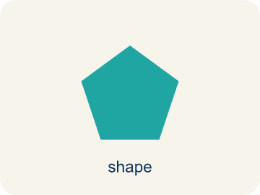 | Area of a Triangle Área de un triángulo  The space inside a triangle. A triangle is half of a rectangle with the same base and height, so A = ½ × b × h.  Example: A = ½ × b × h; if b = 8 and h = 5, then A = ½ × 8 × 5 = 20 square units
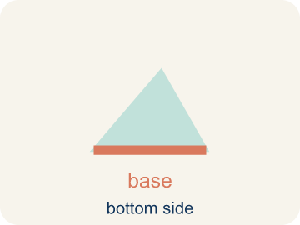 | Base Base  Any side of a triangle can be the base. Once you pick a base, the height must be measured perpendicular (at a 90° angle) to it.  Example: Any side can be the base: choose the 10 cm side and b = 10 cm, then draw the height from the opposite vertex at 90° to that side in A = ½ × b × h
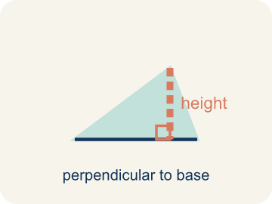 | Height Altura  The straight-up distance from the base to the top corner.  Example: A dashed vertical line from the top point straight down to the base at a 90° angle — like dropping a plumb line
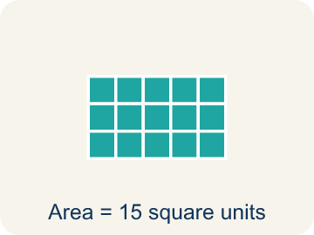 | Area Área  How much space is inside a flat shape.  Example: A triangle with b = 8 and h = 6 has area = ½ × 8 × 6 = 24 sq units — exactly half the rectangle around it
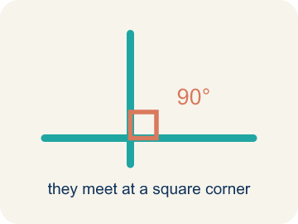 | Perpendicular Perpendicular  Two lines that meet to make a square corner (90 degrees).  Example: The corner of a book or a door frame — the edges meet at exactly 90°, shown by a small square symbol
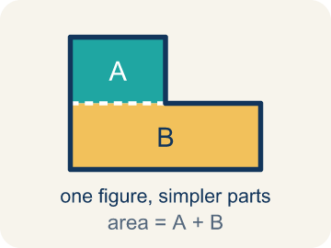 | Composite figure Figura compuesta  A shape made by putting two or more simple shapes together.  Example: A house shape = a rectangle (the walls) + a triangle (the roof); total area = rectangle area + triangle area
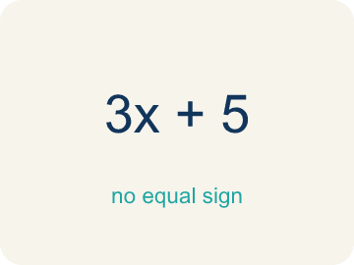 | Formula Fórmula  A math rule written with symbols.  Example: A = ½ × b × h means Area equals one-half times base times height; for b = 12 and h = 8, A = 48
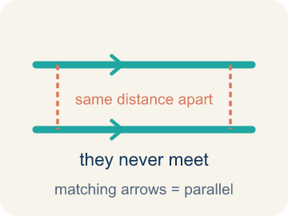 | Parallel Paralelas  Two lines or sides that stay the same distance apart and never meet.  Example: The top and bottom of a parallelogram never get closer together — matching arrowheads (›) mark one parallel pair, double arrowheads (››) mark the other.

Guided Notes
Fill in each blank as we go. Use the Word Bank to help you.
WORD BANK
Area of a Triangle • Base • Height • Area • Perpendicular • Composite figure • Formula • Parallel

1. The space inside a triangle, found with A = ½ × b × h, is the ________________.
2. The side of a triangle you measure the height from at a 90° angle is the ________________.
3. The perpendicular distance from the base to the opposite vertex is the ________________.
4. The amount of flat space inside a triangle is its ________________.
5. Two lines that meet at a 90° angle are ________________.
6. A shape made of two or more basic shapes combined is a ________________.
7. A math rule written with symbols, like A = ½ × b × h, is a ________________.
8. Two sides that stay the same distance apart and never meet are ________________.

Write About the Math
Use the support level you need. Every level answers the same math question.

1. Understand the Question explain
How many cans of paint does the homeowner need?
Your job: Answer the question. Use math evidence. Explain how the evidence proves your answer.
Responde la pregunta. Usa evidencia matemática. Explica cómo la evidencia demuestra tu respuesta.

2. Plan Your Math Words check at least two
☐ Area of a Triangle — The space inside a triangle. A triangle is half of a rectangle with the same base and height, so A = ½ × b × h.
Área de un triángulo — El espacio dentro de un triángulo. Un triángulo es la mitad de un rectángulo con la misma base y altura, por eso A = ½ × b × h.
☐ Base — Any side of a triangle can be the base. Once you pick a base, the height must be measured perpendicular (at a 90° angle) to it.
Base — Cualquier lado de un triángulo puede ser la base. Una vez que eliges la base, la altura debe medirse perpendicular (en un ángulo de 90°) a ella.
☐ Height — The straight-up distance from the base to the top corner.
Altura — La distancia recta desde la base hasta la esquina de arriba.
☐ Area — How much space is inside a flat shape.
Área — Cuánto espacio hay dentro de una figura plana.
☐ Perpendicular — Two lines that meet to make a square corner (90 degrees).
Perpendicular — Dos líneas que se unen formando una esquina recta (90 grados).
Say it first: Say your idea to a partner or quietly to yourself before you write.
The wall's area is ___ sq ft because A = 1/2 × ___ × ___. She needs ___ cans because ___ ÷ 50 = ___.
Di tu respuesta primero: Mi respuesta es ___ porque ___.

3. Build Your Explanation choose your support
This model shows the parts of an explanation. It does not answer your writing question.
Claim: The height is the perpendicular distance from the base to the top corner.
Evidence: Students identify the height as the perpendicular (straight-up, 90-degree) distance from the base to the opposite vertex, not the slanted side.
Reasoning: This evidence connects the definition of area to the mathematical claim.

Start Most language support
Complete the frames. Use the word bank.
Completa las oraciones. Usa el banco de palabras.
The wall's area is ___ sq ft because A = 1/2 × ___ × ___. She needs ___ cans because ___ ÷ 50 = ___.
My answer is ___.
Mi respuesta es ___.

Build Some language support
Write two connected sentences. Use because, so, or but.
Escribe dos oraciones conectadas. Usa porque, entonces o pero.
My claim is ___.
Mi afirmación es ___.
I know because ___.
Lo sé porque ___.
So ___.
Entonces ___.

Explain Light language support
Write a claim, give math evidence, and explain your reasoning.
Escribe una afirmación, da evidencia matemática y explica tu razonamiento.
My claim is ___.
Mi afirmación es ___.
My math evidence is ___.
Mi evidencia matemática es ___.
This proves ___ because ___.
Esto demuestra ___ porque ___.

4. Check Your Explanation five quick checks
☐ I answered the question.
Respondí la pregunta.
☐ I used math evidence: numbers, an equation, a model, or a comparison.
Usé evidencia matemática: números, una ecuación, un modelo o una comparación.
☐ I explained how the evidence proves my answer.
Expliqué cómo la evidencia demuestra mi respuesta.
☐ I used at least two math words.
Usé por lo menos dos palabras matemáticas.
☐ I reread complete sentences and punctuation.
Volví a leer mis oraciones completas y la puntuación.

Worked Example

Watch & Read I Do — follow along with your teacher
Blueprint Review
Your architecture firm is designing a park with triangular garden beds. The client wants to know exactly how much soil to order, which means calculating the area of each triangular section. The first garden has a base of 12 feet and a height of 8 feet.

Think about:
• What shape are the garden beds?
• What measurements do we need to find the area?
• How is the area of a triangle related to the area of a rectangle?
• Why do we divide by 2 when finding the area of a triangle?
• Does it matter which side we call the base?

Solved Example I Do — watch each step
Problem: What is the area of a triangle with base 10 cm and height 6 cm?
A) 30 sq cm
B) 60 sq cm
C) 16 sq cm
D) 30 cm
Step 1: A = ½ × b × h = ½ × 10 × 6 = 30 square centimeters.
Answer: A. 30 sq cm

Exit Ticket
Answer on your own. This shows what you learned today.
★ A triangle has a base of 11 inches and a height of 8 inches. What is its area?
A) 44 sq in
B) 88 sq in
C) 19 sq in
D) 44 in

Answer Key & Teacher Guide
Teacher reference — remove or fold back before distributing to students.

Guided Notes (Fill-in)
Notes 1: Area of a Triangle
Notes 2: Base
Notes 3: Height
Notes 4: Area
Notes 5: Perpendicular
Notes 6: Composite figure
Notes 7: Formula
Notes 8: Parallel

Worked Notes (I Do / We Do)
I Do: A. 30 sq cm
We Do: A. 6 ft

Independent Practice
Watch for this mistake: A common mistake in Area of Triangles is forgetting the ½ — students multiply base × height like a rectangle and stop there, or they use the triangle's slanted side instead of the perpendicular height that's already given. Always check: did I take half, and did I use the straight-up height, not the slanted side?

Level 1 Support
1. A) A triangle is exactly half of a rectangle with the same base and height — A triangle with base b and height h fits inside a rectangle with the same base and height. The triangle covers exactly half the rectangle, so A = ½ × b × h.
2. A) 42 sq ft — A = ½ × 14 × 6 = ½ × 84 = 42 sq ft.

Exit Ticket
A) 44 sq in — A = 1/2 × 11 × 8 = 1/2 × 88 = 44 square inches.

Math Writing Criteria
The support level changes the amount of language scaffolding, not the mathematical expectation.
☐ I answered the question.
☐ I used math evidence: numbers, an equation, a model, or a comparison.
☐ I explained how the evidence proves my answer.
☐ I used at least two math words.
☐ I reread complete sentences and punctuation.

