5.1–5.3 Catch-Up — Homework
Lesson 5-3-catchup • Standard 6.GR.1
Name: ______________________ Period: ______ Date: ____________

Today's Goals
Content: I can show I am caught up on Lessons 5.1–5.3 by using each lesson's big idea in mixed practice.
Language: I can explain which lesson's big idea I used and how, using key vocabulary from Lessons 5.1–5.3.

Key Words
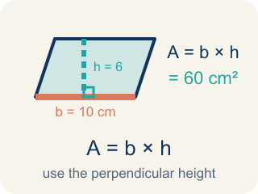
Area of Parallelograms (Área de paralelogramos) — The space inside a parallelogram. Formula: A = b × h, using the perpendicular height.
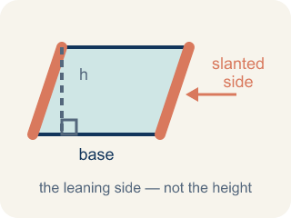
Slanted side (Lado inclinado) — A side that leans instead of going straight up and down. It is not the perpendicular height.
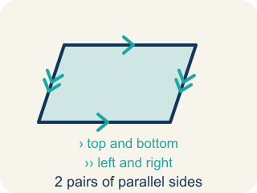
Parallelogram (Paralelogramo) — A four-sided shape with two pairs of parallel sides.
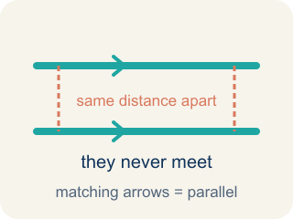
Parallel (Paralelas) — Two lines or sides that stay the same distance apart and never meet.
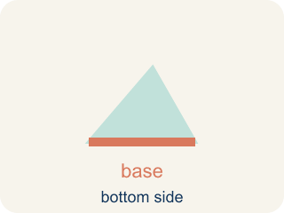
Base (Base) — Any side of a parallelogram can be the base. Once you pick a base, the height must be measured perpendicular (at a 90° angle) to it.
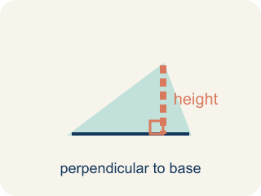
Height (Altura) — The straight-up distance from the base to the top.
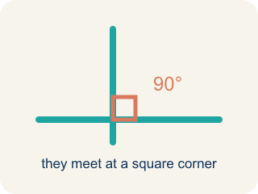
Perpendicular (Perpendicular) — Two lines that meet to make a square corner (90 degrees).
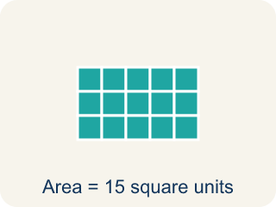
Area (Área) — How much space is inside a flat shape.
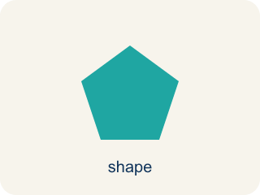
Area of a Triangle (Área de un triángulo) — The space inside a triangle. A triangle is half of a rectangle with the same base and height, so A = ½ × b × h.
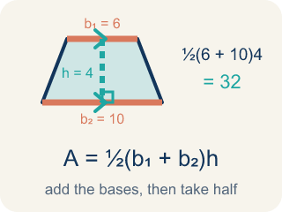
Area of Trapezoids (Área de trapecios) — The space inside a trapezoid. Formula: A = 1/2(b₁ + b₂)h.
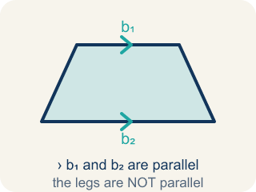
Trapezoid (Trapecio) — A four-sided shape with just one pair of parallel sides.

Practice
Show your work. Use the blank space under each problem.
1. (Lesson 5.1) What is the area of a parallelogram with base 10 cm and height 7 cm?
A. 70 sq cm
B. 34 sq cm
C. 17 sq cm
D. 70 cm
______________________________________________________________________
2. (Lesson 5.1) A parallelogram has an area of 54 sq ft and a base of 9 ft. What is the height?
A. 6 ft
B. 45 ft
C. 63 ft
D. 27 ft
______________________________________________________________________
3. (Lesson 5.1) Spot the Common Mistake
Step 1 (Read the parallelogram): base = 9 cm, slanted side = 10 cm, height = 6 cm
Step 2 (Write the formula): A = base × height
Step 3 (Substitute the values): A = 9 × 10
Step 4 (Calculate the area): A = 90 sq cm
Which step has the mistake? Explain and fix it:
______________________________________________________________________
______________________________________________________________________
______________________________________________________________________
4. Complete the table.
Parallelogram | Base | Height | Area
Patio A | 14 ft | 9 ft
Patio B | 8 ft |  | 56 sq ft
Patio C |  | 12 ft | 96 sq ft
Patio D | 15 ft | 6 ft
______________________________________________________________________
5. (Lesson 5.2) Spot the Common Mistake
Step 1 (Identify base and height): base = 12 ft, height = 7 ft
Step 2 (Write the formula): A = ½ × base × height
Step 3 (Substitute values): A = ½ × 12 × 7
Step 4 (Calculate): A = (½ × 12) × (½ × 7) = 6 × 3.5 = 21 sq ft
Which step has the mistake? Explain and fix it:
______________________________________________________________________
______________________________________________________________________
______________________________________________________________________
6. Complete the table.
Triangle | Base | Height | Area
Garden A | 12 ft | 8 ft
Garden B | 9 ft |  | 27 sq ft
Garden C |  | 10 ft | 35 sq ft
Garden D | 15 ft | 4 ft
______________________________________________________________________
7. (Lesson 5.3) Using the Wrong Height
Step 1 (Read the blueprint): A trapezoid window has b1 = 7 ft and b2 = 13 ft. The slanted side measures 10 ft, and the straight-up height between the bases is 6 ft.
Step 2 (Write the formula): A = ½ × (b1 + b2) × h
Step 3 (Substitute values): A = ½ × (7 + 13) × 10
Step 4 (Calculate): A = ½ × 20 × 10 = 100 sq ft
Which step has the mistake? Explain and fix it:
______________________________________________________________________
______________________________________________________________________
______________________________________________________________________
8. Complete the table.
Trapezoid | Base 1 | Base 2 | Height | Area
Window A | 8 ft | 4 ft | 5 ft
Window B | 12 ft | 6 ft | 4 ft
Window C | 10 ft |  | 8 ft | 72 sq ft
Window D |  | 5 ft | 6 ft | 48 sq ft
______________________________________________________________________
9. (Lesson 5.1) Cut the slanted end off a parallelogram and slide it to the other side. What shape forms, and why does that show A = base × height?
A. A rectangle with the same base and height, so its area equals base x height
B. A bigger parallelogram, so the area gets larger
C. A triangle, so the area is cut in half
D. A square, so all four sides must be equal
______________________________________________________________________
10. (Lesson 5.2) A triangular window in the firm's lobby has a base of 10 ft and a height of 6 ft. What is its area?
A. 30 sq ft
B. 60 sq ft
C. 16 sq ft
D. 32 sq ft
______________________________________________________________________

Answer Key (Teacher)
1. A. 70 sq cm
A = b × h = 10 × 7 = 70 square centimeters.
Watch for: A common mistake in Area of Trapezoids is forgetting the ½ in A = ½ × (b1 + b2) × h. After adding the bases and multiplying by the height, students stop there instead of taking half — for example, with bases 6 ft and 10 ft and a height of 4 ft, they compute (6 + 10) × 4 = 64 sq ft instead of taking half to get the correct 32 sq ft. That unhalved number is really the area of the parallelogram made from two trapezoids, not the area of one trapezoid. Before you submit, always ask: "Did I take half of my last answer?"
2. A. 6 ft
A = b × h → 54 = 9 × h → h = 54 ÷ 9 = 6 ft.
Watch for: A common mistake in Area of Trapezoids is forgetting the ½ in A = ½ × (b1 + b2) × h. After adding the bases and multiplying by the height, students stop there instead of taking half — for example, with bases 6 ft and 10 ft and a height of 4 ft, they compute (6 + 10) × 4 = 64 sq ft instead of taking half to get the correct 32 sq ft. That unhalved number is really the area of the parallelogram made from two trapezoids, not the area of one trapezoid. Before you submit, always ask: "Did I take half of my last answer?"
3. (Lesson 5.1) Spot the Common Mistake
The mistake is in Step 3.
Correct work: The height is 6 cm, not the slanted side of 10 cm. Substitute the perpendicular height: A = 9 × 6 = 54 sq cm. Only the straight-up height belongs in A = base × height.
Watch for: The substitution step uses 10 cm, which is the slanted side, instead of the 6 cm height listed in the first step. Only the perpendicular height belongs in A = base × height, so A = 9 × 6 = 54 sq cm.
4. Table
Patio A — Area: 126 sq ft
Patio B — Height: 7 ft
Patio C — Base: 8 ft
Patio D — Area: 90 sq ft

5. (Lesson 5.2) Spot the Common Mistake
The mistake is in Step 4.
Correct work: There is only ONE ½ in the formula, not two. The student halved both the base and the height. Multiply base × height first, then take half just once: 12 × 7 = 84, then ½ × 84 = 42 sq ft.
Watch for: There is only ONE ½ in A = ½ × base × height, but the calculation halved the base and the height separately. Multiply first, then halve a single time: 12 × 7 = 84, and ½ × 84 = 42 sq ft. Halving twice cuts the area to a quarter of the rectangle, which is why 21 came out as exactly half of the true answer.
6. Table
Garden A — Area: 48 sq ft
Garden B — Height: 6 ft
Garden C — Base: 7 ft
Garden D — Area: 30 sq ft

7. (Lesson 5.3) Using the Wrong Height
The mistake is in Step 4.
Correct work: The student used the slanted side (10 ft) as the height instead of the true perpendicular height (6 ft). The height in the trapezoid formula must be measured straight up between the two bases, not along the slanted side. The correct area is A = ½ × (7 + 13) × 6 = ½ × 20 × 6 = 60 sq ft, not 100 sq ft.
Watch for: The 10 ft slanted side was substituted for the height, but the height of a trapezoid is the straight-up perpendicular distance between the two bases, which is 6 ft here. Using the true height gives A = ½ × (7 + 13) × 6 = ½ × 20 × 6 = 60 sq ft; the slant is always longer, which is why 100 sq ft came out too big.
8. Table
Window A — Area: 30 sq ft
Window B — Area: 36 sq ft
Window C — Base 2: 8 ft
Window D — Base 1: 11 ft

9. A. A rectangle with the same base and height, so its area equals base x height
Sliding the cut triangle turns the parallelogram into a rectangle that keeps the same base and height. A rectangle's area is base x height, so the parallelogram's area is base x height too.
Watch for: A common mistake in Area of Trapezoids is forgetting the ½ in A = ½ × (b1 + b2) × h. After adding the bases and multiplying by the height, students stop there instead of taking half — for example, with bases 6 ft and 10 ft and a height of 4 ft, they compute (6 + 10) × 4 = 64 sq ft instead of taking half to get the correct 32 sq ft. That unhalved number is really the area of the parallelogram made from two trapezoids, not the area of one trapezoid. Before you submit, always ask: "Did I take half of my last answer?"
10. A. 30 sq ft
A = ½ × base × height = ½ × 10 × 6 = ½ × 60 = 30 sq ft. The triangle is half of the 10 × 6 = 60 rectangle it fits inside.
Watch for: A common mistake in Area of Trapezoids is forgetting the ½ in A = ½ × (b1 + b2) × h. After adding the bases and multiplying by the height, students stop there instead of taking half — for example, with bases 6 ft and 10 ft and a height of 4 ft, they compute (6 + 10) × 4 = 64 sq ft instead of taking half to get the correct 32 sq ft. That unhalved number is really the area of the parallelogram made from two trapezoids, not the area of one trapezoid. Before you submit, always ask: "Did I take half of my last answer?"

