UNIT 5 · LESSON 3 STANDARD 6.GR.1

Determine the Area of Trapezoids
Student Notes Packet
Name: ______________________ Date: ____________ Period: ________
Level 1 · Support

Today's Goals
Content: I can find the area of a trapezoid using the formula A = ½(b1 + b2) × h.
Language: I can explain my steps using the words trapezoid, base, height, and area.

Key Vocabulary
Look at the picture, read the word, then read what it means.
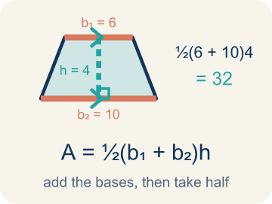 | Area of Trapezoids Área de trapecios  The space inside a trapezoid. Formula: A = 1/2(b₁ + b₂)h.  Example: A = 1/2(b₁ + b₂)h
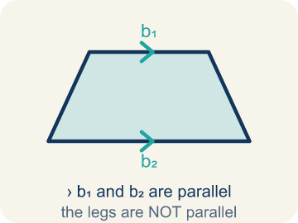 | Trapezoid Trapecio  A four-sided shape with just one pair of parallel sides.  Example: A table top wider than the bottom shelf — the top and bottom edges are parallel, the two sides slant inward
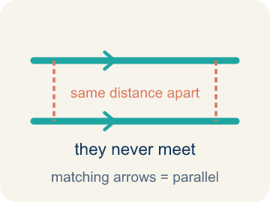 | Parallel Paralelas  Two lines or sides that stay the same distance apart and never meet.  Example: The top and bottom of a parallelogram never get closer together — matching arrowheads (›) mark one parallel pair, double arrowheads (››) mark the other.
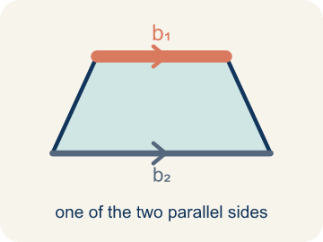 | Base 1 (b1) Base 1 (b1)  One of the two parallel sides of a trapezoid.  Example: If the bottom of the trapezoid is 10 ft, then b₁ = 10 ft in the formula A = ½(b₁ + b₂) × h
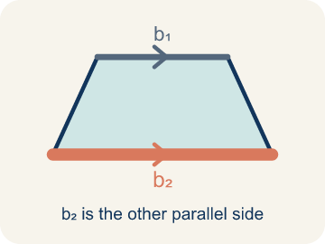 | Base 2 (b2) Base 2 (b2)  The other parallel side of a trapezoid.  Example: If the top of the trapezoid is 6 ft, then b₂ = 6 ft; both bases are parallel to each other
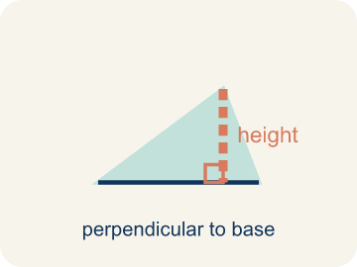 | Height Altura  The straight-up distance between the two parallel sides.  Example: A dashed vertical line from the top base straight down to the bottom base at a 90° angle — NOT the slanted side
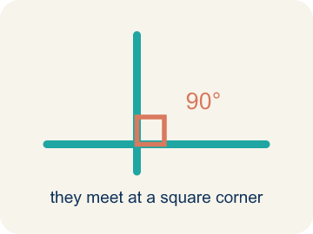 | Perpendicular Perpendicular  Two lines that meet to make a square corner (90 degrees).  Example: The dashed height meets the base at a square corner — the small 90° box is what makes it perpendicular, not slanted.
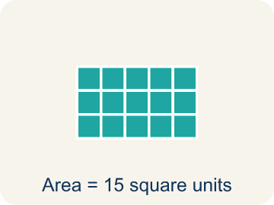 | Area Área  How much space is inside a flat shape.  Example: A trapezoid with b₁ = 10, b₂ = 6, h = 4 has area = ½(10 + 6) × 4 = 32 sq units

Guided Notes
Fill in each blank as we go. Use the Word Bank to help you.
WORD BANK
Area of Trapezoids • Trapezoid • Parallel • Base 1 (b1) • Base 2 (b2) • Height • Perpendicular • Area

1. The space inside a trapezoid, found with A = ½(b₁ + b₂)h, is the ________________.
2. A quadrilateral with exactly one pair of parallel sides is a ________________.
3. Two sides that stay the same distance apart and never meet are ________________.
4. One of the two parallel sides of a trapezoid is ________________.
5. The other parallel side of a trapezoid is ________________.
6. The perpendicular distance between the two parallel bases is the ________________.
7. Two lines that meet at a 90° square corner are ________________.
8. The amount of flat space inside the trapezoid is its ________________.

Write About the Math
Use the support level you need. Every level answers the same math question.

1. Understand the Question explain
How many bags of concrete does the builder need?
Your job: Answer the question. Use math evidence. Explain how the evidence proves your answer.
Responde la pregunta. Usa evidencia matemática. Explica cómo la evidencia demuestra tu respuesta.

2. Plan Your Math Words check at least two
☐ Area of Trapezoids — The space inside a trapezoid. Formula: A = 1/2(b₁ + b₂)h.
Área de trapecios — El espacio dentro de un trapecio. Fórmula: A = 1/2(b₁ + b₂)h.
☐ Trapezoid — A four-sided shape with just one pair of parallel sides.
Trapecio — Una figura de cuatro lados con solo un par de lados paralelos.
☐ Parallel — Two lines or sides that stay the same distance apart and never meet.
Paralelas — Dos líneas o lados que se mantienen a la misma distancia y nunca se cruzan.
☐ Base 1 (b1) — One of the two parallel sides of a trapezoid.
Base 1 (b1) — Uno de los dos lados paralelos de un trapecio.
☐ Base 2 (b2) — The other parallel side of a trapezoid.
Base 2 (b2) — El otro lado paralelo de un trapecio.
Say it first: Say your idea to a partner or quietly to yourself before you write.
The driveway's area is ___ sq ft because A = 1/2 x (___ + ___) x ___. He needs ___ bags because ___ / 6 = ___.
Di tu respuesta primero: Mi respuesta es ___ porque ___.

3. Build Your Explanation choose your support
This model shows the parts of an explanation. It does not answer your writing question.
Claim: We use both bases because the top and bottom are different lengths.
Evidence: Students explain a trapezoid has two parallel sides of different lengths, so using only one would over- or under-count the area; strong answers mention averaging the bases.
Reasoning: This evidence connects the definition of area of trapezoids to the mathematical claim.

Start Most language support
Complete the frames. Use the word bank.
Completa las oraciones. Usa el banco de palabras.
The driveway's area is ___ sq ft because A = 1/2 x (___ + ___) x ___. He needs ___ bags because ___ / 6 = ___.
My answer is ___.
Mi respuesta es ___.

Build Some language support
Write two connected sentences. Use because, so, or but.
Escribe dos oraciones conectadas. Usa porque, entonces o pero.
My claim is ___.
Mi afirmación es ___.
I know because ___.
Lo sé porque ___.
So ___.
Entonces ___.

Explain Light language support
Write a claim, give math evidence, and explain your reasoning.
Escribe una afirmación, da evidencia matemática y explica tu razonamiento.
My claim is ___.
Mi afirmación es ___.
My math evidence is ___.
Mi evidencia matemática es ___.
This proves ___ because ___.
Esto demuestra ___ porque ___.

4. Check Your Explanation five quick checks
☐ I answered the question.
Respondí la pregunta.
☐ I used math evidence: numbers, an equation, a model, or a comparison.
Usé evidencia matemática: números, una ecuación, un modelo o una comparación.
☐ I explained how the evidence proves my answer.
Expliqué cómo la evidencia demuestra mi respuesta.
☐ I used at least two math words.
Usé por lo menos dos palabras matemáticas.
☐ I reread complete sentences and punctuation.
Volví a leer mis oraciones completas y la puntuación.

Worked Example

Watch & Read I Do — follow along with your teacher
Blueprint Review
Your architecture firm is designing a trapezoidal window for a modern building. The glass supplier charges by the square foot, so the team must calculate the exact area. The window has a top edge of 4 feet, a bottom edge of 8 feet, and a height of 5 feet.

Think about:
• What shape is the window?
• How many parallel sides does it have?
• What measurements are given?
• Why does the formula use two bases instead of one?
• What would happen if both bases were the same length?

Solved Example I Do — watch each step
Problem: What is the area of a trapezoid with bases 6 cm and 10 cm, and height 4 cm?
A) 32 sq cm
B) 64 sq cm
C) 24 sq cm
D) 40 sq cm
Step 1: A = ½ × (b₁ + b₂) × h = ½ × (6 + 10) × 4 = ½ × 16 × 4 = 32 sq cm.
Answer: A. 32 sq cm

Guided Practice

Solve Together We Do — work with your class
Problem: A trapezoid has an area of 45 sq ft, bases of 7 ft and 11 ft. What is the height?
A) 5 ft
B) 9 ft
C) 3 ft
D) 10 ft
Step 1:

Step 2:

Answer:

A builder is pouring concrete for a trapezoidal driveway. The driveway has parallel edges of 20 feet and 12 feet with a height of 15 feet. One bag of concrete covers 6 square feet.
How many bags of concrete does the builder need?

Sentence frame: The driveway's area is ___ sq ft because A = 1/2 x (___ + ___) x ___. He needs ___ bags because ___ / 6 = ___.

Turn & Talk discuss with a partner
1. [Launch] The trapezoidal window has a top edge of 4 feet and a bottom edge of 8 feet. Why does the area formula use BOTH bases instead of just one?
Start with: We use both bases because the top and bottom are ___.
Usamos las dos bases porque la parte de arriba y la de abajo son ___.
Word bank: trapezoid, base 1 (b1), base 2 (b2), height, area
2. [Explore] On the grid you copied the trapezoid (bases 8 and 4, height 5), flipped it, and joined it to the original. What shape formed, and how does that explain the 1/2 in the formula?
Start with: When I flip and join the trapezoid, I make a ___.
Cuando volteo y uno el trapecio, formo un ___.
Word bank: trapezoid, parallelogram, base 1 (b1), base 2 (b2), height
3. [Connect] The builder pours concrete for a trapezoidal driveway with edges of 20 ft and 12 ft and a height of 15 ft; one bag covers 6 sq ft. Walk through finding the number of bags.
Start with: The driveway area is 1/2 times (20 plus 12) times 15, which equals ___ square feet.
El área de la entrada es 1/2 por (20 más 12) por 15, que es ___ pies cuadrados.
Word bank: trapezoid, base 1 (b1), base 2 (b2), height, area
4. [Practice] During practice on Area of Trapezoids, what strategy did you use when a problem felt tricky?
Start with: When I flip and join the trapezoid, I make a ___.
Cuando volteo y uno el trapecio, formo un ___.
Word bank: Trapezoid, Base 1 (b1), Base 2 (b2), Height

Independent Practice

On Your Own You Do — show your work
Solve each problem. Show your thinking in the work box.

Level 1 Support extra scaffolding
1. What is the first step when finding the area of a trapezoid?
A) Add the two bases together
B) Multiply the two bases
C) Subtract the shorter base from the longer base
D) Divide the height by 2

2. A trapezoid has bases of 5 in and 9 in, and a height of 6 in. What is its area?
A) 42 sq in
B) 84 sq in
C) 27 sq in
D) 30 sq in

Exit Ticket
Answer on your own. This shows what you learned today.
★ A trapezoid has bases of 9 inches and 5 inches, and a height of 6 inches. What is its area?
A) 42 sq in
B) 84 sq in
C) 27 sq in
D) 42 in

Answer Key & Teacher Guide
Teacher reference — remove or fold back before distributing to students.

Guided Notes (Fill-in)
Notes 1: Area of Trapezoids
Notes 2: Trapezoid
Notes 3: Parallel
Notes 4: Base 1 (b1)
Notes 5: Base 2 (b2)
Notes 6: Height
Notes 7: Perpendicular
Notes 8: Area

Worked Notes (I Do / We Do)
I Do: A. 32 sq cm
We Do: A. 5 ft

Independent Practice
Watch for this mistake: A common mistake in Area of Trapezoids is forgetting the ½ in A = ½ × (b1 + b2) × h. After adding the bases and multiplying by the height, students stop there instead of taking half — for example, with bases 6 ft and 10 ft and a height of 4 ft, they compute (6 + 10) × 4 = 64 sq ft instead of taking half to get the correct 32 sq ft. That unhalved number is really the area of the parallelogram made from two trapezoids, not the area of one trapezoid. Before you submit, always ask: "Did I take half of my last answer?"

Level 1 Support
1. A) Add the two bases together — The formula is A = ½ × (b₁ + b₂) × h. The first step is to add the two parallel bases.
2. A) 42 sq in — A = ½ × (5 + 9) × 6 = ½ × 14 × 6 = ½ × 84 = 42 sq in.

Exit Ticket
A) 42 sq in — A = 1/2 x (b1 + b2) x h = 1/2 x (9 + 5) x 6 = 1/2 x 14 x 6 = 42 square inches.

Math Writing Criteria
The support level changes the amount of language scaffolding, not the mathematical expectation.
☐ I answered the question.
☐ I used math evidence: numbers, an equation, a model, or a comparison.
☐ I explained how the evidence proves my answer.
☐ I used at least two math words.
☐ I reread complete sentences and punctuation.

