UNIT 5 · LESSON 4 STANDARD 6.GR.1

Apply Area Concepts to Solve Problems
Student Notes Packet
Name: ______________________ Date: ____________ Period: ________
Level 2 · Standard

Today's Goals
Content: I can find the area of a composite figure by adding or subtracting the areas of basic shapes.
Language: I can explain my steps using the words composite figure, decompose, add, and subtract.

Key Vocabulary
Look at the picture, read the word, then read what it means.
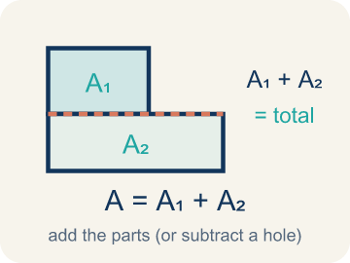 | Area of Composite Figures Área de figuras compuestas  The total space inside a figure made of basic shapes. Formula: A = A₁ + A₂ — add the parts (or subtract a missing piece).  Example: Total area = area of rectangle 1 + area of rectangle 2.
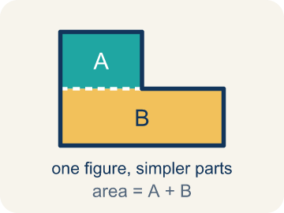 | Composite Figure Figura compuesta  A shape made by putting two or more simple shapes together.  Example: An L-shaped room = a 12×8 rectangle joined to a 6×5 rectangle; total area = 96 + 30 = 126 sq ft
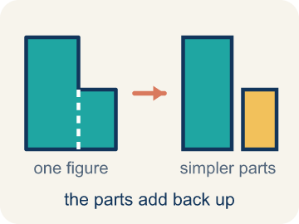 | Decompose Descomponer  To break a shape into smaller, simpler shapes.  Example: Draw a dashed line across the L-shape to split it into two rectangles — now you can find each area separately
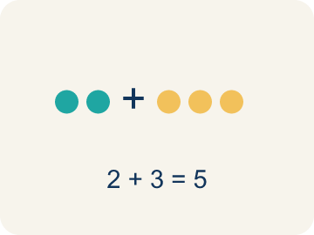 | Add Sumar  Add up the areas of the smaller shapes to get the total.  Example: T-shaped hallway: top rectangle = 30 sq ft, bottom rectangle = 28 sq ft → total = 30 + 28 = 58 sq ft
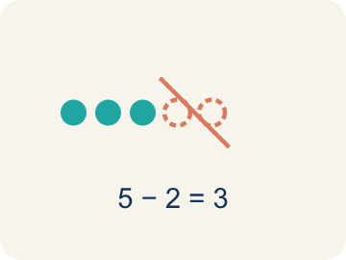 | Subtract Restar  Take away the area of a missing piece from a bigger shape.  Example: A 14×10 pool with a 6×4 cutout: 140 − 24 = 116 sq ft of water surface
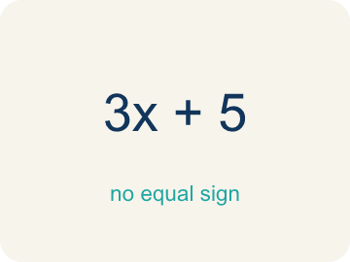 | Formula Fórmula  A math rule written with symbols.  Example: Rectangle: A = l × w; Triangle: A = ½ × b × h; use the right formula for each piece of a composite figure

Guided Notes
Fill in each blank as we go. Use the Word Bank to help you.
WORD BANK
Area of Composite Figures • Composite Figure • Decompose • Add • Subtract • Formula

1. The space inside a figure made of basic shapes, found with A = A₁ + A₂, is the ________________.
2. A shape made of two or more basic shapes combined is a ________________.
3. To break a composite figure into basic shapes is to ________________ it.
4. To find the total area of separate parts, I ________________ their areas.
5. To find the area of a shape with a piece removed, I ________________ the missing part's area.
6. A math rule written with symbols is a ________________.

Write About the Math
Use the support level you need. Every level answers the same math question.

1. Understand the Question explain
How much will the carpet cost?
Your job: Answer the question. Use math evidence. Explain how the evidence proves your answer.
Responde la pregunta. Usa evidencia matemática. Explica cómo la evidencia demuestra tu respuesta.

2. Plan Your Math Words check at least two
☐ Area of Composite Figures — The total space inside a figure made of basic shapes. Formula: A = A₁ + A₂ — add the parts (or subtract a missing piece).
Área de figuras compuestas — El espacio total dentro de una figura formada por figuras básicas. Fórmula: A = A₁ + A₂ — suma las partes (o resta la pieza que falta).
☐ Composite Figure — A shape made by putting two or more simple shapes together.
Figura compuesta — Una figura formada al juntar dos o más figuras simples.
☐ Decompose — To break a shape into smaller, simpler shapes.
Descomponer — Separar una figura en figuras más pequeñas y simples.
☐ Add — Add up the areas of the smaller shapes to get the total.
Sumar — Sumar las áreas de las figuras pequeñas para obtener el total.
☐ Subtract — Take away the area of a missing piece from a bigger shape.
Restar — Quitar el área de una parte que falta de una figura más grande.
Say it first: Say your idea to a partner or quietly to yourself before you write.
The top area is ___ sq ft and the stem area is ___ sq ft. Total = ___ + ___ = ___ sq ft. Cost = ___ x $5 = $___.
Di tu respuesta primero: Mi respuesta es ___ porque ___.

3. Build Your Explanation choose your support
This model shows the parts of an explanation. It does not answer your writing question.
Claim: We decompose the L-shape because we already know how to find a rectangle's area.
Evidence: Students explain that the L-shape is hard to measure directly, so breaking it into two rectangles lets them use A = l x w on each piece and add the results.
Reasoning: This evidence connects the definition of area of composite figures to the mathematical claim.

Start Most language support
Complete the frames. Use the word bank.
Completa las oraciones. Usa el banco de palabras.
The top area is ___ sq ft and the stem area is ___ sq ft. Total = ___ + ___ = ___ sq ft. Cost = ___ x $5 = $___.
My answer is ___.
Mi respuesta es ___.

Build Some language support
Write two connected sentences. Use because, so, or but.
Escribe dos oraciones conectadas. Usa porque, entonces o pero.
My claim is ___.
Mi afirmación es ___.
I know because ___.
Lo sé porque ___.
So ___.
Entonces ___.

Explain Light language support
Write a claim, give math evidence, and explain your reasoning.
Escribe una afirmación, da evidencia matemática y explica tu razonamiento.
My claim is ___.
Mi afirmación es ___.
My math evidence is ___.
Mi evidencia matemática es ___.
This proves ___ because ___.
Esto demuestra ___ porque ___.

4. Check Your Explanation five quick checks
☐ I answered the question.
Respondí la pregunta.
☐ I used math evidence: numbers, an equation, a model, or a comparison.
Usé evidencia matemática: números, una ecuación, un modelo o una comparación.
☐ I explained how the evidence proves my answer.
Expliqué cómo la evidencia demuestra mi respuesta.
☐ I used at least two math words.
Usé por lo menos dos palabras matemáticas.
☐ I reread complete sentences and punctuation.
Volví a leer mis oraciones completas y la puntuación.

Worked Example

Watch & Read I Do — follow along with your teacher
Blueprint Review
Your architecture firm is calculating the floor area of an L-shaped room for a client's new home. The contractor needs the total area to order the correct amount of flooring. The room can be split into two rectangles: one is 12 feet by 8 feet and the other is 6 feet by 5 feet.

Think about:
• What does the shape of the room look like?
• Can you see simpler shapes inside the L-shape?
• What measurements are given for each part?
• Is there more than one way to split this shape into rectangles?
• Could you use subtraction instead of addition to find the area?

Solved Example I Do — watch each step
Problem: An L-shaped room is made of two rectangles: 10 ft × 6 ft and 4 ft × 3 ft. What is the total area?
A) 72 sq ft
B) 60 sq ft
C) 12 sq ft
D) 72 ft
Step 1: Area 1 = 10 × 6 = 60 sq ft.
Step 2: Area 2 = 4 × 3 = 12 sq ft.
Step 3: Total = 60 + 12 = 72 sq ft.
Answer: A. 72 sq ft

Guided Practice

Solve Together We Do — work with your class
Problem: A rectangular patio is 15 ft × 10 ft with a 5 ft × 4 ft rectangular flower bed cut out. What is the remaining area?
A) 130 sq ft
B) 150 sq ft
C) 20 sq ft
D) 170 sq ft
Step 1:

Step 2:

Step 3:

Answer:

An architect is ordering carpet for a T-shaped conference room. The top of the T is 14 feet by 4 feet and the stem is 6 feet by 10 feet. Carpet costs $5 per square foot.
How much will the carpet cost?

Sentence frame: The top area is ___ sq ft and the stem area is ___ sq ft. Total = ___ + ___ = ___ sq ft. Cost = ___ x $5 = $___.

Turn & Talk discuss with a partner
1. [Launch] The L-shaped room splits into a 12 ft by 8 ft rectangle and a 6 ft by 5 ft rectangle. Why is it easier to find the area after you decompose the L into two rectangles?
Start with: We decompose the L-shape into ___ because ___.
Descomponemos la forma de L en ___ porque ___.
Word bank: composite figure, decompose, add, subtract, formula
2. [Explore] For the U-shaped pool you subtracted a 6 ft by 4 ft cutout from a 14 ft by 10 ft rectangle. How do you decide when to ADD areas and when to SUBTRACT?
Start with: I broke the figure into ___.
Dividí la figura en ___.
Word bank: composite figure, decompose, add, subtract, cutout
3. [Connect] The T-shaped conference room has a top of 14 ft by 4 ft and a stem of 6 ft by 10 ft, and carpet costs $5 per sq ft. Talk through finding the total cost.
Start with: The top area is ___ square feet and the stem area is ___ square feet.
El área de arriba es ___ pies cuadrados y el área del tronco es ___ pies cuadrados.
Word bank: composite figure, decompose, add, subtract, formula
4. [Practice] During practice on Area of Composite Figures, what strategy did you use when a problem felt tricky?
Start with: I broke the figure into ___.
Dividí la figura en ___.
Word bank: Composite Figure, Decompose, Add, Subtract

Exit Ticket
Answer on your own. This shows what you learned today.
★ A composite figure is made of a 9 ft x 7 ft rectangle and a 3 ft x 4 ft rectangle joined together. What is the total area?
A) 75 sq ft
B) 63 sq ft
C) 12 sq ft
D) 75 ft

