UNIT 5 · LESSON 5 STANDARD 6.GR.2

Determine the Volume of Rectangular Prisms (Flagship)
Student Notes Packet
Name: ______________________ Date: ____________ Period: ________
Level 2 · Standard

Today's Goals
Content: I can find the volume of a rectangular prism with whole-number edges using length × width × height.
Language: I can explain my work using the words volume, rectangular prism, cubic units, and edge.

Key Vocabulary
Look at the picture, read the word, then read what it means.
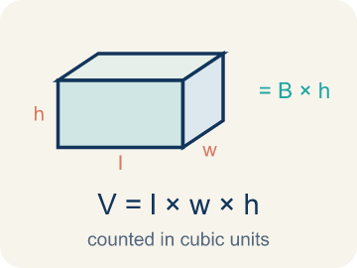 | Volume with Whole-Number Edges Volumen con aristas de números enteros  The number of unit cubes inside a rectangular prism. Formula: V = l × w × h.  Example: V = l × w × h; 3 × 4 × 5 = 60 cubic units.
 | Volume Volumen  How much space is inside a solid shape.  Example: A box 3 × 2 × 4 holds 24 unit cubes, so V = 24 cubic units
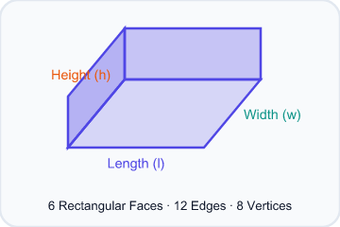 | Rectangular prism Prisma rectangular  A solid box shape with six flat rectangle sides.  Example: A cereal box or shoe box — it has length, width, and height
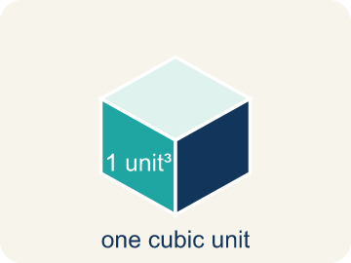 | Cubic units Unidades cúbicas  The units used to measure space inside, like cubic inches.  Example: A tiny cube that is 1 in × 1 in × 1 in = 1 in³ (one cubic inch)
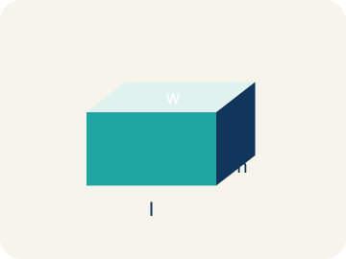 | Length, width, height Largo, ancho, altura  How long, how wide, and how tall a box is.  Example: V = l × w × h: for a box 5 × 3 × 2, volume = 30 cubic units
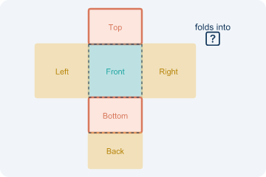 | Net Plantilla (desarrollo plano)  A flat shape that folds up into a solid.  Example: A cross-shaped pattern of 6 rectangles folds into a rectangular box
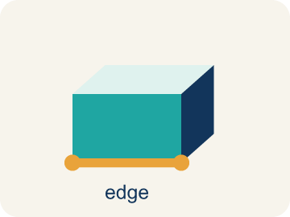 | Edge Arista  The line where two flat sides of a solid meet.  Example: A cube has 12 edges — 4 along the top, 4 along the bottom, 4 vertical

Guided Notes
Fill in each blank as we go. Use the Word Bank to help you.
WORD BANK
Volume with Whole-Number Edges • Volume • Rectangular prism • Cubic units • Length, width, height • Net • Edge

1. The number of unit cubes inside a prism, found with V = l × w × h, is the ________________.
2. The amount of space inside a three-dimensional solid is its ________________.
3. A solid with six rectangular faces, like a box, is a ________________.
4. The unit used to measure volume, like cubic centimeters, is ________________.
5. The three edge measurements of a rectangular prism are its ________________.
6. A flat pattern that folds up into a solid is a ________________.
7. A line segment where two faces of a solid meet is an ________________.

Write About the Math
Use the support level you need. Every level answers the same math question.

1. Understand the Question explain
How many more cubic inches does the large box hold than the medium box?
Your job: Answer the question. Use math evidence. Explain how the evidence proves your answer.
Responde la pregunta. Usa evidencia matemática. Explica cómo la evidencia demuestra tu respuesta.

2. Plan Your Math Words check at least two
☐ Volume with Whole-Number Edges — The number of unit cubes inside a rectangular prism. Formula: V = l × w × h.
Volumen con aristas de números enteros — La cantidad de cubos unitarios dentro de un prisma rectangular. Fórmula: V = l × w × h.
☐ Volume — How much space is inside a solid shape.
Volumen — Cuánto espacio hay dentro de una figura sólida.
☐ Rectangular prism — A solid box shape with six flat rectangle sides.
Prisma rectangular — Una figura sólida en forma de caja con seis lados rectangulares.
☐ Cubic units — The units used to measure space inside, like cubic inches.
Unidades cúbicas — Las unidades para medir el espacio interior, como pulgadas cúbicas.
☐ Length, width, height — How long, how wide, and how tall a box is.
Largo, ancho, altura — Qué tan largo, ancho y alto es una caja.
Say it first: Say your idea to a partner or quietly to yourself before you write.
The large box volume is ___ in³ because V = ___ × ___ × ___. The medium box volume is ___ in³. The large box holds ___ more cubic inches.
Di tu respuesta primero: Mi respuesta es ___ porque ___.

3. Build Your Explanation choose your support
This model shows the parts of an explanation. It does not answer your writing question.
Claim: Volume measures space in three directions, so you need length, width, and height.
Evidence: Students explain that volume is three-dimensional, so all three edges (length, width, height) are needed; two measurements only give area of one face.
Reasoning: This evidence connects the definition of volume to the mathematical claim.

Start Most language support
Complete the frames. Use the word bank.
Completa las oraciones. Usa el banco de palabras.
The large box volume is ___ in³ because V = ___ × ___ × ___. The medium box volume is ___ in³. The large box holds ___ more cubic inches.
My answer is ___.
Mi respuesta es ___.

Build Some language support
Write two connected sentences. Use because, so, or but.
Escribe dos oraciones conectadas. Usa porque, entonces o pero.
My claim is ___.
Mi afirmación es ___.
I know because ___.
Lo sé porque ___.
So ___.
Entonces ___.

Explain Light language support
Write a claim, give math evidence, and explain your reasoning.
Escribe una afirmación, da evidencia matemática y explica tu razonamiento.
My claim is ___.
Mi afirmación es ___.
My math evidence is ___.
Mi evidencia matemática es ___.
This proves ___ because ___.
Esto demuestra ___ porque ___.

4. Check Your Explanation five quick checks
☐ I answered the question.
Respondí la pregunta.
☐ I used math evidence: numbers, an equation, a model, or a comparison.
Usé evidencia matemática: números, una ecuación, un modelo o una comparación.
☐ I explained how the evidence proves my answer.
Expliqué cómo la evidencia demuestra mi respuesta.
☐ I used at least two math words.
Usé por lo menos dos palabras matemáticas.
☐ I reread complete sentences and punctuation.
Volví a leer mis oraciones completas y la puntuación.

Worked Example

Watch & Read I Do — follow along with your teacher
Time Capsule Project
Your team is building time capsule containers to store class memories. Each container is a rectangular prism, and you need to figure out how much each one can hold. That means calculating the volume using whole number dimensions!

Think about:
• What three measurements do you need to find the volume of a box?
• What does volume tell us about a container?
• How is volume different from the area of one face?
• If two containers have the same volume, must they have the same shape?
• What happens to the volume if you double just one dimension?

Solved Example I Do — watch each step
Problem: What is the volume of a rectangular prism with l = 7 in, w = 3 in, h = 4 in?
A) 84 in³
B) 14 in³
C) 84 in²
D) 42 in³
Step 1: V = l × w × h = 7 × 3 × 4 = 84 cubic inches.
Answer: A. 84 in³

Guided Practice

Solve Together We Do — work with your class
Problem: A time capsule box has a volume of 120 cm³. Its length is 10 cm and width is 4 cm. What is its height?
A) 3 cm
B) 6 cm
C) 4 cm
D) 12 cm
Step 1:

Step 2:

Answer:

A moving company uses rectangular boxes. A large box is 24 inches long, 18 inches wide, and 18 inches tall. A medium box is 18 inches long, 14 inches wide, and 12 inches tall.
How many more cubic inches does the large box hold than the medium box?

Sentence frame: The large box volume is ___ in³ because V = ___ × ___ × ___. The medium box volume is ___ in³. The large box holds ___ more cubic inches.

Turn & Talk discuss with a partner
1. [Launch] Your time capsule container is a rectangular prism. To find how much it can hold, why do you need three measurements (length, width, and height) instead of just one or two?
Start with: I need three measurements because volume fills space in ___ directions.
Necesito tres medidas porque el volumen llena el espacio en ___ direcciones.
Word bank: volume, length, width, height, rectangular prism
2. [Explore] Container C is 8 × 3 × 4 and Container B is 5 × 5 × 2. How did you count or multiply the unit cubes to find each volume, and which holds more?
Start with: I found the volume by multiplying ___ × ___ × ___, which equals ___ cubic units.
Hallé el volumen multiplicando ___ × ___ × ___, que es ___ unidades cúbicas.
Word bank: volume, cubic units, length, width, height, rectangular prism
3. [Connect] A moving company's large box is 24 × 18 × 18 in and its medium box is 18 × 14 × 12 in. Talk through how you would find how many more cubic inches the large box holds.
Start with: The large box volume is ___ in³ because 24 × 18 × 18 = ___.
El volumen de la caja grande es ___ in³ porque 24 × 18 × 18 = ___.
Word bank: volume, cubic units, rectangular prism, length, width, height
4. [Reflect] A classmate found the volume of a box and wrote the answer as 220 in². How would you correct the units, and how do you explain why volume uses cubic units?
Start with: The units should be ___ instead of in² because volume measures ___.
Las unidades deben ser ___ en lugar de in² porque el volumen mide ___.
Word bank: volume, cubic units, area, rectangular prism, edge
5. [Practice] During practice on Volume with Whole Number Edges, what strategy did you use when a problem felt tricky?
Start with: I found the volume by multiplying ___ × ___ × ___, which equals ___ cubic units.
Hallé el volumen multiplicando ___ × ___ × ___, que es ___ unidades cúbicas.
Word bank: Volume, Rectangular prism, Cubic units, Length, width, height

Independent Practice

On Your Own You Do — show your work
Solve each problem. Show your thinking in the work box.

On Level grade-level practice
1. Two storage bins: Bin A is 8 × 6 × 5 inches. Bin B is 9 × 4 × 7 inches. Which holds more and by how much?
A) Bin B by 12 in³
B) Bin A by 12 in³
C) Bin B by 24 in³
D) They hold the same

2. A rectangular prism has length 8 cm, width 5 cm, and height 4 cm. What is its volume?
A) 17 cm³
B) 160 cm³
C) 80 cm³
D) 120 cm³

3. A box has a volume of 72 in³. Its base is 6 in by 4 in. What is its height?
A) 3 in
B) 12 in
C) 2 in
D) 18 in

Exit Ticket
Answer on your own. This shows what you learned today.
★ A rectangular prism has l = 11 in, w = 5 in, h = 4 in. What is the volume?
A) 220 in³
B) 55 in³
C) 220 in²
D) 200 in³

