UNIT 5 · LESSON 6 STANDARD 6.GR.4

Represent Three-Dimensional Figures in Two Dimensions
Student Notes Packet
Name: ______________________ Date: ____________ Period: ________
Level 3 · Enrichment

Today's Goals
Content: I can find the surface area of a solid by using its net.
Language: I can explain my work using the words surface area, net, face, and two-dimensional.

Key Vocabulary
Look at the picture, read the word, then read what it means.
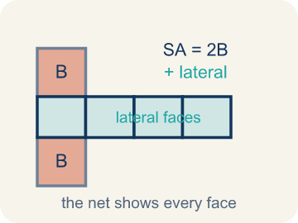 | Surface Area Using Nets Área de superficie usando redes  The total area of all the faces of a solid. A net unfolds the solid flat so you can see every face and add their areas.  Example: A box with 6 faces: 2(8×5) + 2(8×3) + 2(5×3) = 158 square units
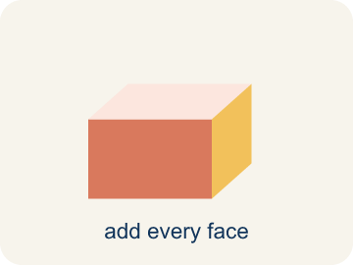 | Surface area Área de superficie  The total area of all the flat sides of a solid.  Example: A box 6 × 4 × 2: SA = 2(24) + 2(12) + 2(8) = 88 in² — like wrapping paper needed
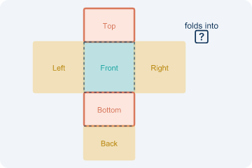 | Net Plantilla (desarrollo plano)  A flat shape that folds up into a solid.  Example: Cut along the edges of a cereal box and unfold it flat — you see all 6 faces
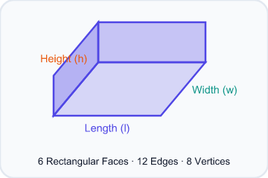 | Face Cara  One flat side of a solid shape.  Example: A rectangular prism has 6 faces: top, bottom, front, back, left, right
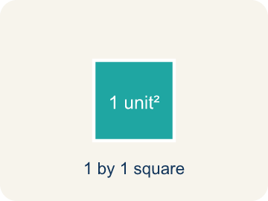 | Two-dimensional Bidimensional  A flat shape with length and width, but no thickness.  Example: A rectangle drawn on paper is 2D — it has length and width but no depth
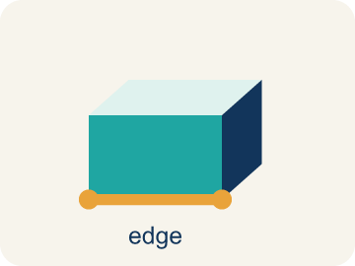 | Edge Arista  The line where two flat sides of a solid meet.  Example: A cube has 12 edges — the lines where two flat faces connect

Guided Notes
Fill in each blank as we go. Use the Word Bank to help you.
WORD BANK
Surface Area Using Nets • Surface area • Net • Face • Two-dimensional • Edge

1. The total area of every face, found by adding the faces in a net, is the ________________.
2. The total area of all the faces of a solid is its ________________.
3. A flat pattern that folds up into a solid is a ________________.
4. A flat surface of a solid figure is a ________________.
5. A flat shape with length and width but no thickness is ________________.
6. A line segment where two faces meet is an ________________.

Write About the Math
Use the support level you need. Every level answers the same math question.

1. Understand the Question explain
How many sheets of wrapping paper are needed to cover the entire box?
Your job: Answer the question. Use math evidence. Explain how the evidence proves your answer.
Responde la pregunta. Usa evidencia matemática. Explica cómo la evidencia demuestra tu respuesta.

2. Plan Your Math Words check at least two
☐ Surface Area Using Nets — The total area of all the faces of a solid. A net unfolds the solid flat so you can see every face and add their areas.
Área de superficie usando redes — El área total de todas las caras de un cuerpo. Una plantilla lo despliega para ver cada cara y sumar sus áreas.
☐ Surface area — The total area of all the flat sides of a solid.
Área de superficie — El área total de todos los lados planos de un sólido.
☐ Net — A flat shape that folds up into a solid.
Plantilla (desarrollo plano) — Una figura plana que se dobla y forma un sólido.
☐ Face — One flat side of a solid shape.
Cara — Un lado plano de una figura sólida.
☐ Two-dimensional — A flat shape with length and width, but no thickness.
Bidimensional — Una figura plana con largo y ancho, pero sin grosor.
Say it first: Say your idea to a partner or quietly to yourself before you write.
The box's surface area is ___ in² because SA = 2(___×___) + 2(___×___) + 2(___×___) = ___ + ___ + ___ = ___. You need ___ sheets because ___ ÷ 400 ≈ ___.
Di tu respuesta primero: Mi respuesta es ___ porque ___.

3. Build Your Explanation choose your support
This model shows the parts of an explanation. It does not answer your writing question.
Claim: A net lays every face flat so you can see and measure all six faces.
Evidence: Students explain a rectangular prism has 6 faces, and the net unfolds the solid into a flat (two-dimensional) pattern so every face is visible to measure.
Reasoning: This evidence connects the definition of surface area using nets to the mathematical claim.

Start Most language support
Complete the frames. Use the word bank.
Completa las oraciones. Usa el banco de palabras.
The box's surface area is ___ in² because SA = 2(___×___) + 2(___×___) + 2(___×___) = ___ + ___ + ___ = ___. You need ___ sheets because ___ ÷ 400 ≈ ___.
My answer is ___.
Mi respuesta es ___.

Build Some language support
Write two connected sentences. Use because, so, or but.
Escribe dos oraciones conectadas. Usa porque, entonces o pero.
My claim is ___.
Mi afirmación es ___.
I know because ___.
Lo sé porque ___.
So ___.
Entonces ___.

Explain Light language support
Write a claim, give math evidence, and explain your reasoning.
Escribe una afirmación, da evidencia matemática y explica tu razonamiento.
My claim is ___.
Mi afirmación es ___.
My math evidence is ___.
Mi evidencia matemática es ___.
This proves ___ because ___.
Esto demuestra ___ porque ___.

4. Check Your Explanation five quick checks
☐ I answered the question.
Respondí la pregunta.
☐ I used math evidence: numbers, an equation, a model, or a comparison.
Usé evidencia matemática: números, una ecuación, un modelo o una comparación.
☐ I explained how the evidence proves my answer.
Expliqué cómo la evidencia demuestra mi respuesta.
☐ I used at least two math words.
Usé por lo menos dos palabras matemáticas.
☐ I reread complete sentences and punctuation.
Volví a leer mis oraciones completas y la puntuación.

Worked Example

Watch & Read I Do — follow along with your teacher
Time Capsule Project
Your class is designing custom wrapping paper for time capsule boxes. To figure out how much paper you need, you have to find the total surface area of each box. The trick? Unfold the box into a net so you can see every face laid flat!

Think about:
• How many faces does a rectangular prism have?
• What shapes do you see when the box is unfolded?
• Are all the faces the same size?
• Is there more than one way to unfold a box into a net?
• How does a net help you find surface area more easily than looking at the 3D shape?

Solved Example I Do — watch each step
Problem: A rectangular prism has l = 6 in, w = 4 in, h = 2 in. What is its surface area?
A) 88 in²
B) 48 in²
C) 88 in³
D) 44 in²
Step 1: SA = 2(6×4) + 2(6×2) + 2(4×2) = 48 + 24 + 16 = 88 in².
Answer: A. 88 in²

Exit Ticket
Answer on your own. This shows what you learned today.
★ A rectangular prism has l = 9 in, w = 5 in, h = 3 in. What is the surface area?
A) 174 in²
B) 135 in²
C) 174 in³
D) 87 in²

Answer Key & Teacher Guide
Teacher reference — remove or fold back before distributing to students.

Guided Notes (Fill-in)
Notes 1: Surface Area Using Nets
Notes 2: Surface area
Notes 3: Net
Notes 4: Face
Notes 5: Two-dimensional
Notes 6: Edge

Worked Notes (I Do / We Do)
I Do: A. 88 in²
We Do: A. 6

Independent Practice
Watch for this mistake: A common mistake in Surface Area Using Nets is finding the area of only one face from each of the 3 matching pairs and forgetting to double it, instead of counting all 6 faces. For a box that is 9 in × 4 in × 5 in, a student might add just one face from each pair: (9×4) + (9×5) + (4×5) = 36 + 45 + 20 = 101 in², but the net actually has two of each face, so the correct total is 2(36) + 2(45) + 2(20) = 72 + 90 + 40 = 202 in² — exactly double. Before you submit, ask: 'Did I count both matching faces in each pair, or only one from each pair?'

Level 1 Support
1. A) Square units (in², cm², ft²) — Surface area measures flat surfaces, so it uses square units. Volume uses cubic units.

On Level
2. A) 150 cm² — A cube has 6 identical faces. Each face: 5 × 5 = 25 cm². Total SA = 6 × 25 = 150 cm².

Exit Ticket
A) 174 in² — SA = 2(9×5) + 2(9×3) + 2(5×3) = 90 + 54 + 30 = 174 in². Surface area uses square units (in²).

Math Writing Criteria
The support level changes the amount of language scaffolding, not the mathematical expectation.
☐ I answered the question.
☐ I used math evidence: numbers, an equation, a model, or a comparison.
☐ I explained how the evidence proves my answer.
☐ I used at least two math words.
☐ I reread complete sentences and punctuation.

