UNIT 5 · LESSON 8 STANDARD 6.GR.4

Determine Surface Area of Pyramids
Student Notes Packet
Name: ______________________ Date: ____________ Period: ________
Level 3 · Enrichment

Today's Goals
Content: I can find the surface area of a pyramid by adding the base area and the lateral faces.
Language: I can explain my work using the words pyramid, slant height, lateral face, and base.

Key Vocabulary
Look at the picture, read the word, then read what it means.
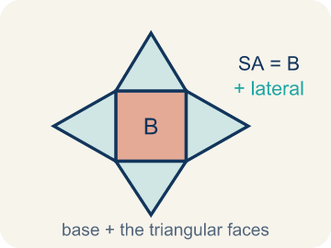 | Surface Area of Pyramids Área de superficie de pirámides  The total area of a pyramid's base and triangular faces. Formula: SA = B + lateral area.  Example: Square base 6×6 with 4 triangles of ½ × 6 × 5: 36 + 60 = 96 square units
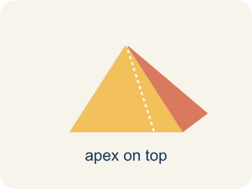 | Pyramid Pirámide  A solid with a flat bottom and triangle sides that meet at one point on top.  Example: Like the Great Pyramid of Giza — a square on the bottom, 4 triangles slanting up to a point
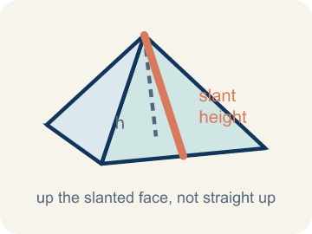 | Slant height Altura inclinada (apotema)  The height of a side triangle, measured along its slanted face.  Example: If you slide your finger from the bottom edge up the triangle face to the top point — that distance is the slant height
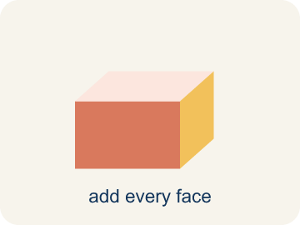 | Lateral face Cara lateral  A triangle side of a pyramid, not the bottom.  Example: A square pyramid has 4 lateral faces — one triangle for each side of the square base
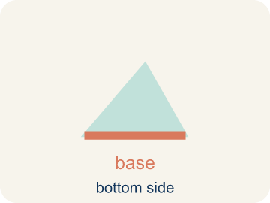 | Base Base  The flat bottom of a pyramid.  Example: A square pyramid sits on a square base; base area = side × side
 | Apex Ápice  The point at the top of a pyramid where the sides meet.  Example: The pointy top of a pyramid — all the slanted edges connect here
 | Lateral area Área lateral  The total area of just the side triangles, not the bottom.  Example: For a square pyramid: lateral area = 4 × (½ × base edge × slant height)

Guided Notes
Fill in each blank as we go. Use the Word Bank to help you.
WORD BANK
Surface Area of Pyramids • Pyramid • Slant height • Lateral face • Base • Apex • Lateral area

1. The total area of a pyramid's faces, found with SA = B + lateral area, is the ________________.
2. A solid with a polygon base and triangular faces meeting at one point is a ________________.
3. The height of a triangular face of a pyramid, measured along the slanted side, is the ________________.
4. A triangular side face of a pyramid is a ________________.
5. The polygon on the bottom of a pyramid is the ________________.
6. The single top point where the triangular faces of a pyramid meet is the ________________.
7. The combined area of all the side faces, not counting the base, is the ________________.

Write About the Math
Use the support level you need. Every level answers the same math question.

1. Understand the Question explain
How much will the glass for all 4 triangular sides cost? (The base is open — no glass needed.)?
Your job: Answer the question. Use math evidence. Explain how the evidence proves your answer.
Responde la pregunta. Usa evidencia matemática. Explica cómo la evidencia demuestra tu respuesta.

2. Plan Your Math Words check at least two
☐ Surface Area of Pyramids — The total area of a pyramid's base and triangular faces. Formula: SA = B + lateral area.
Área de superficie de pirámides — El área total de la base y las caras triangulares de una pirámide. Fórmula: SA = B + área lateral.
☐ Pyramid — A solid with a flat bottom and triangle sides that meet at one point on top.
Pirámide — Un sólido con un fondo plano y lados triangulares que se unen en un punto arriba.
☐ Slant height — The height of a side triangle, measured along its slanted face.
Altura inclinada (apotema) — La altura de un triángulo lateral, medida por su cara inclinada.
☐ Lateral face — A triangle side of a pyramid, not the bottom.
Cara lateral — Un lado triangular de una pirámide, no el fondo.
☐ Base — The flat bottom of a pyramid.
Base — El fondo plano de una pirámide.
Say it first: Say your idea to a partner or quietly to yourself before you write.
Each triangular face has area = ½ × ___ × ___ = ___ ft². Four faces: 4 × ___ = ___ ft². Cost: ___ × $12 = $___.
Di tu respuesta primero: Mi respuesta es ___ porque ___.

3. Build Your Explanation choose your support
This model shows the parts of an explanation. It does not answer your writing question.
Claim: Surface area of a pyramid is the base area plus the areas of all the triangular lateral faces.
Evidence: Students explain a square pyramid's surface area = base area + the four triangular lateral faces, and that you add every face together.
Reasoning: This evidence connects the definition of surface area of pyramids to the mathematical claim.

Start Most language support
Complete the frames. Use the word bank.
Completa las oraciones. Usa el banco de palabras.
Each triangular face has area = ½ × ___ × ___ = ___ ft². Four faces: 4 × ___ = ___ ft². Cost: ___ × $12 = $___.
My answer is ___.
Mi respuesta es ___.

Build Some language support
Write two connected sentences. Use because, so, or but.
Escribe dos oraciones conectadas. Usa porque, entonces o pero.
My claim is ___.
Mi afirmación es ___.
I know because ___.
Lo sé porque ___.
So ___.
Entonces ___.

Explain Light language support
Write a claim, give math evidence, and explain your reasoning.
Escribe una afirmación, da evidencia matemática y explica tu razonamiento.
My claim is ___.
Mi afirmación es ___.
My math evidence is ___.
Mi evidencia matemática es ___.
This proves ___ because ___.
Esto demuestra ___ porque ___.

4. Check Your Explanation five quick checks
☐ I answered the question.
Respondí la pregunta.
☐ I used math evidence: numbers, an equation, a model, or a comparison.
Usé evidencia matemática: números, una ecuación, un modelo o una comparación.
☐ I explained how the evidence proves my answer.
Expliqué cómo la evidencia demuestra mi respuesta.
☐ I used at least two math words.
Usé por lo menos dos palabras matemáticas.
☐ I reread complete sentences and punctuation.
Volví a leer mis oraciones completas y la puntuación.

Worked Example

Watch & Read I Do — follow along with your teacher
Time Capsule Project
Your class is building a pyramid-shaped display to showcase the time capsule at the school entrance. The pyramid will be covered in gold leaf to make it shine. To figure out how much gold leaf you need, you must calculate the total surface area — the base plus all the triangular faces!

Think about:
• How many faces does a square pyramid have?
• What shape is the base? What shape are the side faces?
• What is the difference between the height of the pyramid and the slant height?
• Why do we use slant height instead of regular height for the triangular faces?
• Would a taller pyramid always need more gold leaf than a shorter one?

Solved Example I Do — watch each step
Problem: A square pyramid has a base edge of 5 in and a slant height of 7 in. What is the surface area?
A) 95 in²
B) 70 in²
C) 95 in³
D) 120 in²
Step 1: Base: 5 × 5 = 25 in².
Step 2: Each lateral face: ½ × 5 × 7 = 17.5 in².
Step 3: Four faces: 4 × 17.5 = 70 in².
Step 4: SA = 25 + 70 = 95 in².
Answer: A. 95 in²

Exit Ticket
Answer on your own. This shows what you learned today.
★ A square pyramid has a base edge of 6 in and a slant height of 5 in. What is the total surface area?
A) 96 in²
B) 60 in²
C) 96 in³
D) 36 in²

Answer Key & Teacher Guide
Teacher reference — remove or fold back before distributing to students.

Guided Notes (Fill-in)
Notes 1: Surface Area of Pyramids
Notes 2: Pyramid
Notes 3: Slant height
Notes 4: Lateral face
Notes 5: Base
Notes 6: Apex
Notes 7: Lateral area

Worked Notes (I Do / We Do)
I Do: A. 95 in²
We Do: A. 4

Independent Practice
Watch for this mistake: A common mistake in Surface Area of Pyramids is finding the four triangular lateral faces correctly (½ × base edge × slant height, times 4) and then stopping — forgetting to add the base area at the end. This leaves the total surface area too small by exactly the base's area. Before you submit, ask: 'Did I add the base area to the four lateral faces, or did I stop after the sides?'

Level 1 Support
1. A) 24 in² — Area of a triangle = ½ × base × height = ½ × 8 × 6 = 24 in².

On Level
2. A) 133 cm² — SA = Base Area + Lateral Area = 49 + 84 = 133 cm².

Exit Ticket
A) 96 in² — Base: 6 × 6 = 36 in². Each lateral face: ½ × 6 × 5 = 15 in². Four faces: 4 × 15 = 60 in². SA = 36 + 60 = 96 in². Surface area uses square units (in²).

Math Writing Criteria
The support level changes the amount of language scaffolding, not the mathematical expectation.
☐ I answered the question.
☐ I used math evidence: numbers, an equation, a model, or a comparison.
☐ I explained how the evidence proves my answer.
☐ I used at least two math words.
☐ I reread complete sentences and punctuation.

