UNIT 5 · LESSON 9 STANDARD 6.GR.1

Area of Regular Polygons
Student Notes Packet
Name: ______________________ Date: ____________ Period: ________
Level 2 · Standard

Today's Goals
Content: I can find the area of a regular polygon by decomposing it into triangles.
Language: I can explain my steps using the words regular polygon, decompose, triangle, and composite.

Key Vocabulary
Look at the picture, read the word, then read what it means.
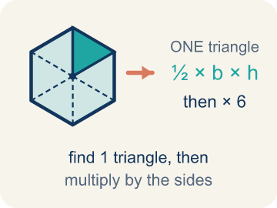 | Area of Regular Polygons Área de polígonos regulares  The space a regular polygon covers. Split it from the center into identical triangles, find one triangle's area, then multiply by how many there are.  Example: A hexagon splits into 6 identical triangles: (½ × 4 × 3.5) × 6 = 42 square units
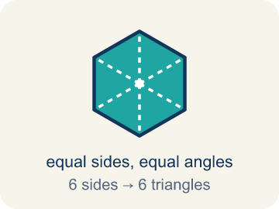 | Regular Polygon Polígono regular  A closed flat shape made of straight sides, where every side is the same length and every angle is the same size.  Example: A stop sign is a regular octagon — all 8 sides are the same length and all 8 angles are equal
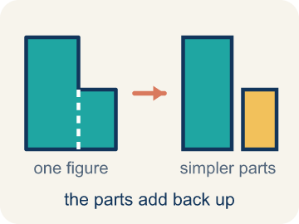 | Decompose Descomponer  To break a shape into smaller, simpler shapes.  Example: Draw lines from the center of a hexagon to each corner → you get 6 equal triangles you can find the area of
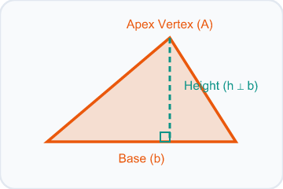 | Triangle Triángulo  A shape with three sides.  Example: Each triangle inside a decomposed hexagon has a base = one side of the hexagon and height = distance from center to side
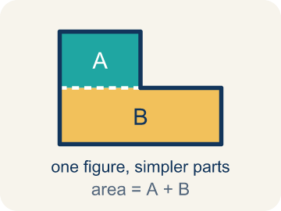 | Composite Compuesto  Made by putting two or more simple shapes together.  Example: 6 triangles, each with area 15 sq ft, combine to form a hexagon with total area = 6 × 15 = 90 sq ft
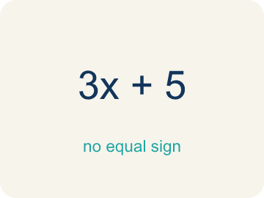 | Formula Fórmula  A math rule written with symbols.  Example: For a regular hexagon: Total Area = 6 × (½ × b × h), where b = side length and h = height of each triangle

Guided Notes
Fill in each blank as we go. Use the Word Bank to help you.
WORD BANK
Area of Regular Polygons • Regular Polygon • Decompose • Triangle • Composite • Formula

1. The space inside a regular polygon, found with A = (½bh) × n, is the ________________.
2. A polygon with all sides and all angles equal is a ________________.
3. To break a shape into smaller shapes is to ________________ it.
4. A three-sided polygon is a ________________.
5. Made of two or more shapes combined, a figure is ________________.
6. A math rule written with symbols is a ________________.

Write About the Math
Use the support level you need. Every level answers the same math question.

1. Understand the Question explain
How much will the gazebo flooring cost?
Your job: Answer the question. Use math evidence. Explain how the evidence proves your answer.
Responde la pregunta. Usa evidencia matemática. Explica cómo la evidencia demuestra tu respuesta.

2. Plan Your Math Words check at least two
☐ Area of Regular Polygons — The space a regular polygon covers. Split it from the center into identical triangles, find one triangle's area, then multiply by how many there are.
Área de polígonos regulares — El espacio que cubre un polígono regular. Divídelo desde el centro en triángulos idénticos, halla el área de uno y multiplícala por cuántos hay.
☐ Regular Polygon — A closed flat shape made of straight sides, where every side is the same length and every angle is the same size.
Polígono regular — Una figura plana cerrada de lados rectos, donde todos los lados miden lo mismo y todos los ángulos son iguales.
☐ Decompose — To break a shape into smaller, simpler shapes.
Descomponer — Separar una figura en figuras más pequeñas y simples.
☐ Triangle — A shape with three sides.
Triángulo — Una figura de tres lados.
☐ Composite — Made by putting two or more simple shapes together.
Compuesto — Formada al juntar dos o más figuras simples.
Say it first: Say your idea to a partner or quietly to yourself before you write.
One triangle's area is ___ sq ft. The octagon has ___ triangles, so total area = ___ sq ft. The cost is ___ x $3 = $___.
Di tu respuesta primero: Mi respuesta es ___ porque ___.

3. Build Your Explanation choose your support
This model shows the parts of an explanation. It does not answer your writing question.
Claim: We decompose the hexagon into triangles because we already know how to find a triangle's area.
Evidence: Students explain that splitting the hexagon into 6 equal triangles lets them use the triangle area formula they already know, then combine the parts.
Reasoning: This evidence connects the definition of area of regular polygons to the mathematical claim.

Start Most language support
Complete the frames. Use the word bank.
Completa las oraciones. Usa el banco de palabras.
One triangle's area is ___ sq ft. The octagon has ___ triangles, so total area = ___ sq ft. The cost is ___ x $3 = $___.
My answer is ___.
Mi respuesta es ___.

Build Some language support
Write two connected sentences. Use because, so, or but.
Escribe dos oraciones conectadas. Usa porque, entonces o pero.
My claim is ___.
Mi afirmación es ___.
I know because ___.
Lo sé porque ___.
So ___.
Entonces ___.

Explain Light language support
Write a claim, give math evidence, and explain your reasoning.
Escribe una afirmación, da evidencia matemática y explica tu razonamiento.
My claim is ___.
Mi afirmación es ___.
My math evidence is ___.
Mi evidencia matemática es ___.
This proves ___ because ___.
Esto demuestra ___ porque ___.

4. Check Your Explanation five quick checks
☐ I answered the question.
Respondí la pregunta.
☐ I used math evidence: numbers, an equation, a model, or a comparison.
Usé evidencia matemática: números, una ecuación, un modelo o una comparación.
☐ I explained how the evidence proves my answer.
Expliqué cómo la evidencia demuestra mi respuesta.
☐ I used at least two math words.
Usé por lo menos dos palabras matemáticas.
☐ I reread complete sentences and punctuation.
Volví a leer mis oraciones completas y la puntuación.

Worked Example

Watch & Read I Do — follow along with your teacher
Blueprint Review
Your architecture firm is designing a hexagonal skylight for the lobby of a new museum. The glass fabricator needs to know the total area so they can cut the correct amount of glass. Each side of the hexagon is 6 feet, and the height of each triangle formed from the center is 5.2 feet.

Think about:
• What shape is the skylight?
• How many sides does a hexagon have?
• Can you see smaller shapes inside the hexagon?
• How can we break a hexagon into shapes whose area we already know?
• Does this strategy work for other regular polygons?

Solved Example I Do — watch each step
Problem: A regular hexagon is divided into 6 equal triangles from the center. Each triangle has a base of 6 ft and a height of 5.2 ft. What is the area of one triangle?
A) 15.6 sq ft
B) 31.2 sq ft
C) 11.2 sq ft
D) 15.6 ft
Step 1: A = ½ × b × h = ½ × 6 × 5.2 = 15.6 square feet.
Answer: A. 15.6 sq ft

Guided Practice

Solve Together We Do — work with your class
Problem: Using the triangle from the previous question, what is the total area of the hexagonal skylight?
A) 93.6 sq ft
B) 15.6 sq ft
C) 187.2 sq ft
D) 62.4 sq ft
Step 1:

Step 2:

Answer:

The parks department hired your firm to finish a regular octagonal gazebo at the center of Patterson Park. Seen from above, the gazebo floor decomposes into 8 congruent triangles that meet at the center point, and each triangle has a base of 5 feet and a height of 6 feet. The flooring contractor charges $3 per square foot and needs a total price before Friday's budget meeting.
How much will the gazebo flooring cost?

Sentence frame: One triangle's area is ___ sq ft. The octagon has ___ triangles, so total area = ___ sq ft. The cost is ___ x $3 = $___.

Turn & Talk discuss with a partner
1. [Launch] The hexagonal skylight has sides of 6 feet, and each triangle from the center has a height of 5.2 feet. Why is it helpful to break a hexagon into triangles to find its area?
Start with: We decompose the hexagon into ___ because ___.
Descomponemos el hexágono en ___ porque ___.
Word bank: regular polygon, decompose, triangle, composite, formula
2. [Explore] You matched each regular polygon to its number of center triangles. What pattern connects the number of SIDES to the number of TRIANGLES, and why?
Start with: I split each polygon into ___ triangles.
Dividí cada polígono en ___ triángulos.
Word bank: regular polygon, decompose, triangle, composite, formula
3. [Connect] The octagonal gazebo has 8 center triangles, each with base 5 ft and height 6 ft, and flooring costs $3 per sq ft. Walk through finding the total cost.
Start with: One triangle's area is 1/2 times 5 times 6, which equals ___ square feet.
El área de un triángulo es 1/2 por 5 por 6, que es ___ pies cuadrados.
Word bank: regular polygon, decompose, triangle, composite, formula
4. [Practice] During practice on Area of Regular Polygons, what strategy did you use when a problem felt tricky?
Start with: I split each polygon into ___ triangles.
Dividí cada polígono en ___ triángulos.
Word bank: Regular Polygon, Decompose, Triangle, Composite

Exit Ticket
Answer on your own. This shows what you learned today.
★ A regular pentagon is decomposed into 5 triangles from its center. Each triangle has a base of 7 inches and a height of 4.8 inches. What is the total area of the pentagon?
A) 84 sq in
B) 16.8 sq in
C) 168 sq in
D) 84 in

