UNIT 6 · LESSON 1 STANDARD 6.NOS.1

Division Expressions with Fractions and Whole Numbers (Flagship)
Student Notes Packet
Name: ______________________ Date: ____________ Period: ________
Level 3 · Enrichment

Today's Goals
Content: I can use models to divide a whole number by a fraction and a fraction by a whole number.
Language: I can explain a division model using the words dividend, divisor, quotient, and how many fit.

Key Vocabulary
Look at the picture, read the word, then read what it means.
 | Division of Fractions División de fracciones  Finding how many groups of one fraction fit inside another amount.  Example: 3 ÷ 1/2 asks how many halves fit in 3; the answer is 6.
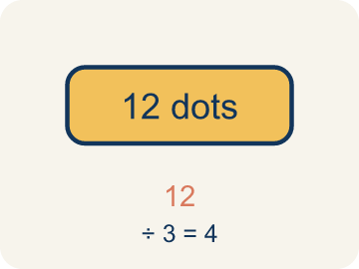 | Dividend Dividendo  The number you are splitting up in a division problem.  Example: In 3 ÷ 1/4 = 12, the dividend is 3 — it is the total being split
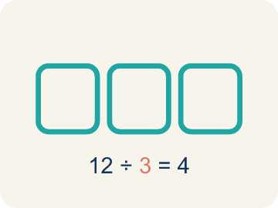 | Divisor Divisor  The number you split by in a division problem.  Example: In 3 ÷ 1/4 = 12, the divisor is 1/4 — it is the size of each piece
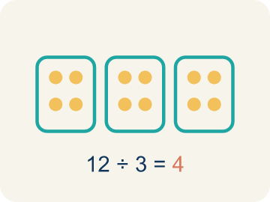 | Quotient Cociente  The answer when you divide.  Example: In 3 ÷ 1/4 = 12, the quotient is 12 — there are 12 quarter-size pieces in 3
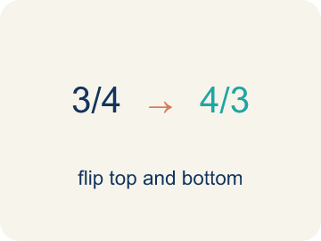 | Reciprocal Recíproco  A fraction turned upside down.  Example: The reciprocal of 1/4 is 4/1 = 4. Multiplying by the reciprocal gives the same result as dividing.
 | Unit fraction Fracción unitaria  A fraction with 1 on top, like 1/4.  Example: 1/2, 1/3, 1/4, 1/5 — each represents one equal part of a whole

Guided Notes
Fill in each blank as we go. Use the Word Bank to help you.
WORD BANK
Division of Fractions • Dividend • Divisor • Quotient • Reciprocal • Unit fraction

1. Dividing asks how many groups of one ________________ fit inside another amount.
2. In 6 ÷ 1/2, the number 6 being divided is the ________________.
3. In 6 ÷ 1/2, the number 1/2 we divide by is the ________________.
4. The answer to a division problem is the ________________.
5. The fraction you get by flipping the numerator and denominator is the ________________.
6. A fraction with a numerator of 1, like 1/5, is a ________________.

Write About the Math
Use the support level you need. Every level answers the same math question.

1. Understand the Question explain
How does interpreting fraction division help the detective?
Your job: Answer the question. Use math evidence. Explain how the evidence proves your answer.
Responde la pregunta. Usa evidencia matemática. Explica cómo la evidencia demuestra tu respuesta.

2. Plan Your Math Words check at least two
☐ Division of Fractions — Finding how many groups of one fraction fit inside another amount.
División de fracciones — Hallar cuántos grupos de una fracción caben dentro de otra cantidad.
☐ Dividend — The number you are splitting up in a division problem.
Dividendo — El número que estás repartiendo en una división.
☐ Divisor — The number you split by in a division problem.
Divisor — El número entre el que divides en una división.
☐ Quotient — The answer when you divide.
Cociente — La respuesta cuando divides.
☐ Reciprocal — A fraction turned upside down.
Recíproco — Una fracción volteada de arriba abajo.
Say it first: Say your idea to a partner or quietly to yourself before you write.
The detective can mark ___ sections because 6 ÷ 1/3 = ___.
Di tu respuesta primero: Mi respuesta es ___ porque ___.

3. Build Your Explanation choose your support
This model shows the parts of an explanation. It does not answer your writing question.
Claim: There will be more than 3 sections because each piece is smaller than a whole foot.
Evidence: Students reason that dividing by a number less than 1 gives a quotient greater than the dividend, so there are more than 3 sections.
Reasoning: This evidence connects the definition of division of fractions to the mathematical claim.

Start Most language support
Complete the frames. Use the word bank.
Completa las oraciones. Usa el banco de palabras.
The detective can mark ___ sections because 6 ÷ 1/3 = ___.
My answer is ___.
Mi respuesta es ___.

Build Some language support
Write two connected sentences. Use because, so, or but.
Escribe dos oraciones conectadas. Usa porque, entonces o pero.
My claim is ___.
Mi afirmación es ___.
I know because ___.
Lo sé porque ___.
So ___.
Entonces ___.

Explain Light language support
Write a claim, give math evidence, and explain your reasoning.
Escribe una afirmación, da evidencia matemática y explica tu razonamiento.
My claim is ___.
Mi afirmación es ___.
My math evidence is ___.
Mi evidencia matemática es ___.
This proves ___ because ___.
Esto demuestra ___ porque ___.

4. Check Your Explanation five quick checks
☐ I answered the question.
Respondí la pregunta.
☐ I used math evidence: numbers, an equation, a model, or a comparison.
Usé evidencia matemática: números, una ecuación, un modelo o una comparación.
☐ I explained how the evidence proves my answer.
Expliqué cómo la evidencia demuestra mi respuesta.
☐ I used at least two math words.
Usé por lo menos dos palabras matemáticas.
☐ I reread complete sentences and punctuation.
Volví a leer mis oraciones completas y la puntuación.

Worked Example

Watch & Read I Do — follow along with your teacher
Detective Agency Case File
Agent Reyes finds a 3-foot strip of tape at the crime scene. The lab needs the tape cut into 1/4-foot sections for analysis. How many sections can be made? The answer cracks the code to the locked evidence vault.

Think about:
• What total length is being divided?
• What is the size of each section?
• Will the answer be greater than or less than 3?
• What does it mean to divide by a fraction?
• Why does dividing by 1/4 give a bigger number?

Solved Example I Do — watch each step
Problem: What does 3 ÷ 1/4 mean?
A) How many 1/4-size pieces fit into 3
B) 3 groups of 1/4
C) 3 minus 1/4
D) 1/4 of 3
Step 1: 3 ÷ 1/4 asks: how many 1/4-size pieces fit into 3?
Step 2: The answer is 12, because each whole has 4 fourths, and 3 × 4 = 12.
Answer: A. How many 1/4-size pieces fit into 3

Exit Ticket
Answer on your own. This shows what you learned today.
★ What does 5 ÷ 1/4 mean, and what is the quotient?
A) How many 1/4-size pieces fit into 5; quotient is 20
B) 5 groups of 1/4; quotient is 5/4
C) 1/4 of 5; quotient is 5/4
D) 5 minus 1/4; quotient is 4 3/4

Answer Key & Teacher Guide
Teacher reference — remove or fold back before distributing to students.

Guided Notes (Fill-in)
Notes 1: Division of Fractions
Notes 2: Dividend
Notes 3: Divisor
Notes 4: Quotient
Notes 5: Reciprocal
Notes 6: Unit fraction

Worked Notes (I Do / We Do)
I Do: A. How many 1/4-size pieces fit into 3
We Do: A. 2 ÷ 1/3

Independent Practice
Watch for this mistake: A common mistake in Interpret Division of Fractions is assuming that dividing always makes the answer smaller. For 4 ÷ 1/3, students reason 'dividing shrinks the number' and compute 4 ÷ 3 ≈ 1.3 instead of asking how many 1/3-foot pieces fit into 4 feet (each whole foot holds 3 thirds, so 4 × 3 = 12). Before you submit, check: if the divisor is a fraction smaller than 1, the quotient must be BIGGER than the dividend, not smaller.

Level 1 Support
1. A) 8 pieces — 4 ÷ 1/2 = 4 × 2 = 8 pieces. Each whole foot contains 2 halves, and 4 × 2 = 8.
2. A) 1/8 — This is 1/2 ÷ 4. Cutting the half into 4 equal parts makes eighths, so each person gets 1/8 of the whole pan.
3. A) 30 — 6 ÷ 1/5 means how many 1/5-size pieces fit into 6. Each whole has 5 fifths, so 6 × 5 = 30.

On Level
4. A) 5 ÷ 1/4 = 20 books — You are finding how many 1/4-foot pieces fit into 5 feet, which is 5 ÷ 1/4 = 5 × 4 = 20 books.

Exit Ticket
A) How many 1/4-size pieces fit into 5; quotient is 20 — 5 ÷ 1/4 means 'how many 1/4-size pieces fit into 5.' Since each whole has 4 fourths, 5 × 4 = 20.

Math Writing Criteria
The support level changes the amount of language scaffolding, not the mathematical expectation.
☐ I answered the question.
☐ I used math evidence: numbers, an equation, a model, or a comparison.
☐ I explained how the evidence proves my answer.
☐ I used at least two math words.
☐ I reread complete sentences and punctuation.

