UNIT 6 · LESSON 10 STANDARD 6.NOS.1

Divide Mixed Numbers
Student Notes Packet
Name: ______________________ Date: ____________ Period: ________
Level 1 · Support

Today's Goals
Content: I can divide mixed numbers by first changing them to improper fractions.
Language: I can explain my steps using the words mixed number, improper fraction, convert, reciprocal, and simplify.

Key Vocabulary
Look at the picture, read the word, then read what it means.
 | Divide Mixed Numbers Dividir números mixtos  Change mixed numbers to improper fractions, then multiply by the reciprocal.  Example: 2 1/2 ÷ 1 1/4 = 5/2 ÷ 5/4 = 5/2 × 4/5 = 2
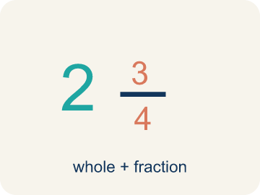 | Mixed Number Número mixto  A whole number plus a fraction, like 2 1/3.  Example: 2 1/3 means 2 wholes and 1/3 more — picture 2 full circles and 1/3 of another
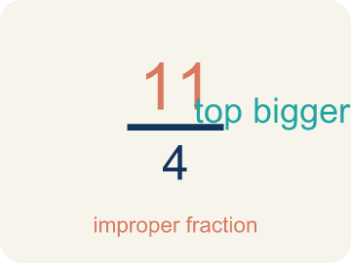 | Improper Fraction Fracción impropia  A fraction where the top is bigger than or equal to the bottom, like 7/4.  Example: 7/3 is improper because 7 > 3. It equals 2 1/3 as a mixed number.
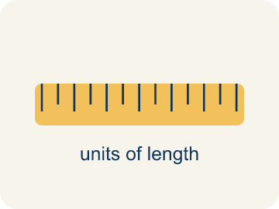 | Convert Convertir  To change a number to a new form but keep the same value.  Example: 2 1/3 → multiply 2 × 3 = 6, add 1 → 7/3. Same value, different form.
 | Simplify Simplificar  To make a fraction smaller using the same parts, like 2/4 = 1/2.  Example: 8/6: GCF is 2 → 8÷2 / 6÷2 = 4/3 = 1 1/3
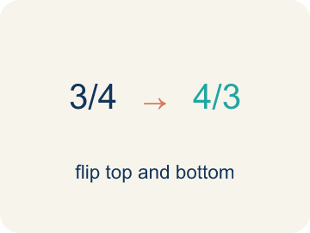 | Reciprocal Recíproco  A fraction turned upside down. You use it in keep-change-flip.  Example: The reciprocal of 3/4 is 4/3. To divide by 3/4, multiply by 4/3.

Guided Notes
Fill in each blank as we go. Use the Word Bank to help you.
WORD BANK
Divide Mixed Numbers • Mixed Number • Improper Fraction • Convert • Simplify • Reciprocal

1. Rewrite each mixed number as an ________________ ________________ before you flip and multiply.
2. A number with a whole number and a fraction, like 2 1/3, is a ________________.
3. A fraction whose numerator is greater than or equal to its denominator, like 7/3, is an ________________.
4. Changing a mixed number into an improper fraction is to ________________ it.
5. Writing a fraction in its smallest equal form is to ________________ it.
6. To divide by a fraction, I multiply by its ________________.

Write About the Math
Use the support level you need. Every level answers the same math question.

1. Understand the Question explain
How does dividing mixed numbers help the detective?
Your job: Answer the question. Use math evidence. Explain how the evidence proves your answer.
Responde la pregunta. Usa evidencia matemática. Explica cómo la evidencia demuestra tu respuesta.

2. Plan Your Math Words check at least two
☐ Divide Mixed Numbers — Change mixed numbers to improper fractions, then multiply by the reciprocal.
Dividir números mixtos — Cambiar los números mixtos a fracciones impropias y luego multiplicar por el recíproco.
☐ Mixed Number — A whole number plus a fraction, like 2 1/3.
Número mixto — Un número entero más una fracción, como 2 1/3.
☐ Improper Fraction — A fraction where the top is bigger than or equal to the bottom, like 7/4.
Fracción impropia — Una fracción donde el número de arriba es mayor o igual al de abajo, como 7/4.
☐ Convert — To change a number to a new form but keep the same value.
Convertir — Cambiar un número a otra forma sin cambiar su valor.
☐ Simplify — To make a fraction smaller using the same parts, like 2/4 = 1/2.
Simplificar — Hacer una fracción más pequeña con las mismas partes, como 2/4 = 1/2.
Say it first: Say your idea to a partner or quietly to yourself before you write.
The detective can cut ___ pieces because 5 1/4 ÷ 3/4 = 21/4 × 4/3 = 84/12 = ___.
Di tu respuesta primero: Mi respuesta es ___ porque ___.

3. Build Your Explanation choose your support
This model shows the parts of an explanation. It does not answer your writing question.
Claim: A mixed number must first become an improper fraction so I can flip and multiply.
Evidence: Students explain that the mixed number must be converted to an improper fraction (7/2) before applying Keep, Change, Flip.
Reasoning: This evidence connects the definition of divide mixed numbers to the mathematical claim.

Start Most language support
Complete the frames. Use the word bank.
Completa las oraciones. Usa el banco de palabras.
The detective can cut ___ pieces because 5 1/4 ÷ 3/4 = 21/4 × 4/3 = 84/12 = ___.
My answer is ___.
Mi respuesta es ___.

Build Some language support
Write two connected sentences. Use because, so, or but.
Escribe dos oraciones conectadas. Usa porque, entonces o pero.
My claim is ___.
Mi afirmación es ___.
I know because ___.
Lo sé porque ___.
So ___.
Entonces ___.

Explain Light language support
Write a claim, give math evidence, and explain your reasoning.
Escribe una afirmación, da evidencia matemática y explica tu razonamiento.
My claim is ___.
Mi afirmación es ___.
My math evidence is ___.
Mi evidencia matemática es ___.
This proves ___ because ___.
Esto demuestra ___ porque ___.

4. Check Your Explanation five quick checks
☐ I answered the question.
Respondí la pregunta.
☐ I used math evidence: numbers, an equation, a model, or a comparison.
Usé evidencia matemática: números, una ecuación, un modelo o una comparación.
☐ I explained how the evidence proves my answer.
Expliqué cómo la evidencia demuestra mi respuesta.
☐ I used at least two math words.
Usé por lo menos dos palabras matemáticas.
☐ I reread complete sentences and punctuation.
Volví a leer mis oraciones completas y la puntuación.

Worked Example

Watch & Read I Do — follow along with your teacher
Detective Agency Case File
Agent Chen is mapping a suspect's route. The total distance is 3 1/2 miles, and each segment between landmarks is 1/4 mile. She needs to know how many segments are on the route to place surveillance cameras at every landmark.

Think about:
• What is the total distance of the route?
• How long is each segment?
• Will the number of segments be more or less than 3?
• Why do we need to convert mixed numbers before dividing?
• Can you divide mixed numbers without converting first?

Solved Example I Do — watch each step
Problem: What is 1 1/2 ÷ 3/4?
A) 2
B) 1 1/8
C) 3/4
D) 9/8
Step 1: 1 1/2 = 3/2.
Step 2: Then 3/2 ÷ 3/4 = 3/2 × 4/3 = 12/6 = 2.
Answer: A. 2

Guided Practice

Solve Together We Do — work with your class
Problem: Convert 3 2/5 to an improper fraction.
A) 17/5
B) 15/5
C) 6/5
D) 32/5
Step 1:

Step 2:

Answer:

A detective has a rope that is 5 1/4 feet long. She needs to cut it into pieces that are each 3/4 of a foot for tying evidence tags. How many pieces can she cut?
How does dividing mixed numbers help the detective?

Sentence frame: The detective can cut ___ pieces because 5 1/4 ÷ 3/4 = 21/4 × 4/3 = 84/12 = ___.

Turn & Talk discuss with a partner
1. [Launch] Agent Chen maps a 3 1/2-mile route divided into 1/4-mile segments. Why can't she just divide 3 1/2 by 1/4 while it is still a mixed number?
Start with: I cannot divide yet because 3 1/2 is a ___ and I need an ___.
No puedo dividir todavía porque 3 1/2 es un ___ y necesito una ___.
Word bank: mixed number, improper fraction, convert
2. [Explore] Walk your partner through how you changed the mixed numbers before dividing.
Start with: First I converted ___ into the improper fraction ___.
Primero convertí ___ en la fracción impropia ___.
Word bank: mixed number, improper fraction, reciprocal, simplify
3. [Connect] When would dividing mixed numbers come up in a real project, like building or cooking?
Start with: I would divide mixed numbers when ___.
Dividiría números mixtos cuando ___.
Word bank: mixed number, improper fraction, convert
4. [Practice] During practice on Divide Mixed Numbers, what strategy did you use when a problem felt tricky?
Start with: First I converted ___ into the improper fraction ___.
Primero convertí ___ en la fracción impropia ___.
Word bank: Mixed Number, Improper Fraction, Convert, Simplify

Independent Practice

On Your Own You Do — show your work
Solve each problem. Show your thinking in the work box.

Level 1 Support extra scaffolding
1. What is 2 1/4 ÷ 3/4?
A) 3
B) 1 1/2
C) 9/16
D) 2 1/3

2. What is 3 1/2 ÷ 1/4?
A) 14
B) 3 1/8
C) 7/8
D) 13/4

Exit Ticket
Answer on your own. This shows what you learned today.
★ What is 2 2/3 ÷ 2/3?
A) 4
B) 2/3
C) 8/3
D) 1 7/9

Answer Key & Teacher Guide
Teacher reference — remove or fold back before distributing to students.

Guided Notes (Fill-in)
Notes 1: Divide Mixed Numbers
Notes 2: Mixed Number
Notes 3: Improper Fraction
Notes 4: Convert
Notes 5: Simplify
Notes 6: Reciprocal

Worked Notes (I Do / We Do)
I Do: A. 2
We Do: A. 17/5

Independent Practice
Watch for this mistake: A common mistake in Divide Mixed Numbers is dividing the whole-number parts and fraction parts separately instead of converting first — for example, treating 4 1/2 ÷ 1 1/2 as (4 ÷ 1) + (1/2 ÷ 1/2) = 5. Always convert each mixed number to one improper fraction first, then divide using Keep, Change, Flip: 4 1/2 ÷ 1 1/2 = 9/2 ÷ 3/2 = 9/2 × 2/3 = 3.

Level 1 Support
1. A) 3 — 2 1/4 = 9/4. Then 9/4 ÷ 3/4 = 9/4 × 4/3 = 36/12 = 3.
2. A) 14 — 3 1/2 = 7/2. Then 7/2 ÷ 1/4 = 7/2 × 4/1 = 28/2 = 14.

On Level
3. A) 3 batches — Convert 2 1/4 = 9/4. Then 2 1/4 ÷ 3/4 = 9/4 × 4/3 = 36/12 = 3 batches.

Exit Ticket
A) 4 — 2 2/3 = 8/3. Then 8/3 ÷ 2/3 = 8/3 × 3/2 = 24/6 = 4.

Math Writing Criteria
The support level changes the amount of language scaffolding, not the mathematical expectation.
☐ I answered the question.
☐ I used math evidence: numbers, an equation, a model, or a comparison.
☐ I explained how the evidence proves my answer.
☐ I used at least two math words.
☐ I reread complete sentences and punctuation.

