UNIT 6 · LESSON 13 STANDARD 6.NOS.4

Prime Factorization (Flagship)
Student Notes Packet
Name: ______________________ Date: ____________ Period: ________
Level 3 · Enrichment

Today's Goals
Content: I can write a number as a product of its prime factors using a factor tree.
Language: I can explain how I broke a number down using the words prime number, composite number, factor, and exponent.

Key Vocabulary
Look at the picture, read the word, then read what it means.
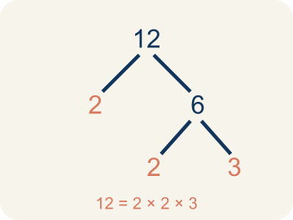 | Prime Factorization Factorización prima  Writing a whole number as a product of only prime numbers.  Example: 36 = 2 × 2 × 3 × 3 = 2² × 3²
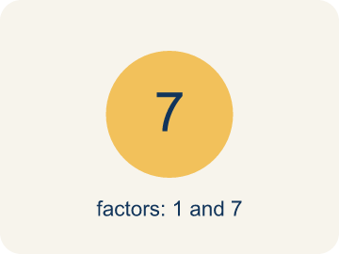 | Prime number Número primo  A number bigger than 1 that you can only divide by 1 and itself.  Example: 7 has only two factors: 1 × 7. So 7 is prime.
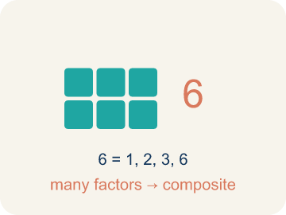 | Composite number Número compuesto  A number bigger than 1 that you can divide by more than just 1 and itself.  Example: 12 = 1 × 12, 2 × 6, 3 × 4 — six factors, so 12 is composite
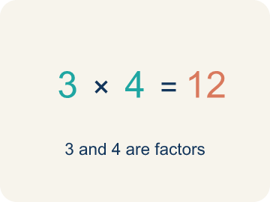 | Factor Factor  A factor of a whole number divides it evenly, with no remainder. For example, 3 is a factor of 12 because 12 ÷ 3 = 4.  Example: Factors of 12: 1, 2, 3, 4, 6, 12 — each divides 12 evenly.
 | Factor tree Árbol de factores  A picture that splits a number into its prime numbers, step by step.  Example: 24 → 4 × 6 → (2 × 2) × (2 × 3) → 2 × 2 × 2 × 3
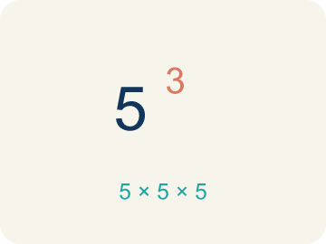 | Exponent Exponente  A small number that tells how many times to multiply a number by itself.  Example: 2³ means 2 × 2 × 2 = 8

Guided Notes
Fill in each blank as we go. Use the Word Bank to help you.
WORD BANK
Prime Factorization • Prime number • Composite number • Factor • Factor tree • Exponent

1. Writing a number as ________________ numbers multiplied together is its prime factorization.
2. A whole number greater than 1 with exactly two factors, 1 and itself, is a ________________ number.
3. A whole number greater than 1 that has more than two factors is a ________________ number.
4. A number that divides evenly into another number is called a ________________.
5. I can break a number into its prime factors step by step using a ________________.
6. In 2³, the small number 3 is the ________________ and it shows 2 is multiplied 3 times.

Write About the Math
Use the support level you need. Every level answers the same math question.

1. Understand the Question explain
Starting from its prime factorization, how can the gardener use the factors of 72 to decide which rectangular grids will use all 72 seed pods?
Your job: Answer the question. Use math evidence. Explain how the evidence proves your answer.
Responde la pregunta. Usa evidencia matemática. Explica cómo la evidencia demuestra tu respuesta.

2. Plan Your Math Words check at least two
☐ Prime Factorization — Writing a whole number as a product of only prime numbers.
Factorización prima — Escribir un número entero como un producto de solo números primos.
☐ Prime number — A number bigger than 1 that you can only divide by 1 and itself.
Número primo — Un número mayor que 1 que solo se puede dividir entre 1 y sí mismo.
☐ Composite number — A number bigger than 1 that you can divide by more than just 1 and itself.
Número compuesto — Un número mayor que 1 que se puede dividir entre más números, no solo 1 y sí mismo.
☐ Factor — A factor of a whole number divides it evenly, with no remainder. For example, 3 is a factor of 12 because 12 ÷ 3 = 4.
Factor — Un factor de un número entero lo divide exactamente, sin dejar residuo. Por ejemplo, 3 es un factor de 12 porque 12 ÷ 3 = 4.
☐ Factor tree — A picture that splits a number into its prime numbers, step by step.
Árbol de factores — Un dibujo que separa un número en sus números primos, paso a paso.
Say it first: Say your idea to a partner or quietly to yourself before you write.
Because 72 = ___, I can multiply combinations of those prime factors to get factors like ___, so a grid that works is ___ by ___.
Di tu respuesta primero: Mi respuesta es ___ porque ___.

3. Build Your Explanation choose your support
This model shows the parts of an explanation. It does not answer your writing question.
Claim: 60 is composite because it has more than two factors.
Evidence: Students say 60 is composite because it has more than two factors (it is divisible by numbers other than 1 and 60, such as 2, 3, 5, 6), so it can be broken down.
Reasoning: This evidence connects the definition of prime factorization to the mathematical claim.

Start Most language support
Complete the frames. Use the word bank.
Completa las oraciones. Usa el banco de palabras.
Because 72 = ___, I can multiply combinations of those prime factors to get factors like ___, so a grid that works is ___ by ___.
My answer is ___.
Mi respuesta es ___.

Build Some language support
Write two connected sentences. Use because, so, or but.
Escribe dos oraciones conectadas. Usa porque, entonces o pero.
My claim is ___.
Mi afirmación es ___.
I know because ___.
Lo sé porque ___.
So ___.
Entonces ___.

Explain Light language support
Write a claim, give math evidence, and explain your reasoning.
Escribe una afirmación, da evidencia matemática y explica tu razonamiento.
My claim is ___.
Mi afirmación es ___.
My math evidence is ___.
Mi evidencia matemática es ___.
This proves ___ because ___.
Esto demuestra ___ porque ___.

4. Check Your Explanation five quick checks
☐ I answered the question.
Respondí la pregunta.
☐ I used math evidence: numbers, an equation, a model, or a comparison.
Usé evidencia matemática: números, una ecuación, un modelo o una comparación.
☐ I explained how the evidence proves my answer.
Expliqué cómo la evidencia demuestra mi respuesta.
☐ I used at least two math words.
Usé por lo menos dos palabras matemáticas.
☐ I reread complete sentences and punctuation.
Volví a leer mis oraciones completas y la puntuación.

Worked Example

Watch & Read I Do — follow along with your teacher
Space Station Cargo Breakdown
The space station received 60 supply crates. Mission Control needs to break this quantity into its prime components so the sorting robots can distribute them into equally sized pods. Help the crew find the prime factorization of 60!

Think about:
• What number are we breaking down into factors?
• What's the difference between a factor and a prime factor?
• How many different ways can we start breaking 60 apart?
• Will we always get the same prime factors no matter how we start?

Solved Example I Do — watch each step
Problem: Which of the following is a prime number?
A) 17
B) 15
C) 21
D) 9
Step 1: 17 has exactly two factors: 1 and 17.
Step 2: 15 = 3 × 5, 21 = 3 × 7, and 9 = 3 × 3, so they are all composite.
Answer: A. 17

Exit Ticket
Answer on your own. This shows what you learned today.
★ What is the prime factorization of 40?
A) 2 × 2 × 2 × 5
B) 4 × 10
C) 5 × 8
D) 2 × 20

Answer Key & Teacher Guide
Teacher reference — remove or fold back before distributing to students.

Guided Notes (Fill-in)
Notes 1: Prime Factorization
Notes 2: Prime number
Notes 3: Composite number
Notes 4: Factor
Notes 5: Factor tree
Notes 6: Exponent

Worked Notes (I Do / We Do)
I Do: A. 17
We Do: A. 2 × 3 × 5

Independent Practice
Watch for this mistake: A common mistake in Prime Factorization is stopping the factor tree too soon — leaving a composite number like 4, 6, 8, or 9 in the final answer instead of continuing to split it. For example, writing 20 = 4 × 5 as the prime factorization (4 is composite) instead of finishing with 20 = 2 × 2 × 5. Before you submit, check every number in your final answer: if any factor can still be broken into smaller factors, the tree isn't finished yet.

Level 1 Support
1. A) 2 × 3 × 3 — 18 = 2 × 9 = 2 × 3 × 3. Both 2 and 3 are prime, so 2 × 3 × 3 is the prime factorization.
2. A) 27 — 27 = 3 × 9 = 3 × 3 × 3, so it has more than two factors. 23, 29, and 31 are all prime.

On Level
3. A) Both get the same prime factorization: 2 × 2 × 3 × 5 — The Fundamental Theorem of Arithmetic says every composite number has exactly one prime factorization. No matter how you start the factor tree, you always end with 2 × 2 × 3 × 5.

Exit Ticket
A) 2 × 2 × 2 × 5 — 40 = 2 × 20 = 2 × 2 × 10 = 2 × 2 × 2 × 5. All factors (2, 2, 2, 5) are prime.

Math Writing Criteria
The support level changes the amount of language scaffolding, not the mathematical expectation.
☐ I answered the question.
☐ I used math evidence: numbers, an equation, a model, or a comparison.
☐ I explained how the evidence proves my answer.
☐ I used at least two math words.
☐ I reread complete sentences and punctuation.

