UNIT 6 · LESSON 14 STANDARD 6.AT.7

The Distributive Property
Student Notes Packet
Name: ______________________ Date: ____________ Period: ________
Level 3 · Enrichment

Today's Goals
Content: I can use the distributive property to expand and factor expressions.
Language: I can explain my steps using the words distributive property, factor, expand, and equivalent.

Key Vocabulary
Look at the picture, read the word, then read what it means.
 | The Distributive Property La propiedad distributiva  Multiply a factor by every term inside parentheses.  Example: 3(x + 4) = 3x + 12
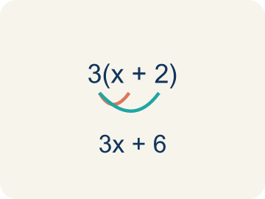 | Distributive Property Propiedad distributiva  Multiplying a number by everything inside the parentheses: a(b + c) = ab + ac.  Example: 3(4 + 5) = 3×4 + 3×5 = 12 + 15 = 27 — the 3 gets 'distributed' to both the 4 and the 5
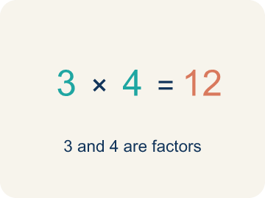 | Factor Factor  A factor of a whole number divides it evenly, with no remainder. For example, 3 is a factor of 12 because 12 ÷ 3 = 4.  Example: In 3(x + 2), the 3 is the factor outside the parentheses that multiplies each term inside
 | Expand Desarrollar  To multiply out the parentheses in an expression.  Example: Expand 2(n + 6): multiply 2 × n = 2n and 2 × 6 = 12, so 2(n + 6) = 2n + 12
 | Equivalent Equivalente  Expressions that always have the same value.  Example: 3(x + 4) and 3x + 12 always give the same answer: when x = 2, both = 18; when x = 10, both = 42
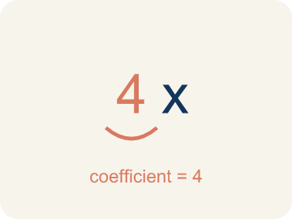 | Coefficient Coeficiente  The number in front of a letter, like the 3 in 3x.  Example: In 6x + 15, the coefficient of x is 6 — it came from distributing in 3(2x + 5)
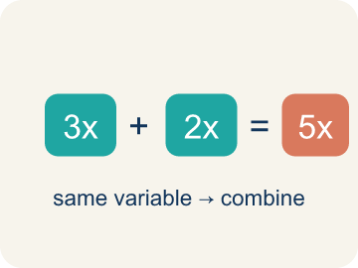 | Like terms Términos semejantes  Terms with the same letter raised to the same power, like 2x and 5x.  Example: 4x + 2x = 6x (combine coefficients); 4x + 2y cannot be combined (different variables)

Guided Notes
Fill in each blank as we go. Use the Word Bank to help you.
WORD BANK
The Distributive Property • Distributive Property • Factor • Expand • Equivalent • Coefficient • Like terms

1. a(b + c) = ab + ________________ — the factor reaches ________________ term.
2. The rule that a(b + c) = ab + ac is the ________________.
3. To rewrite a sum as a product, like 3x + 12 = 3(x + 4), is to ________________.
4. To multiply out a product over a sum, like 3(x + 4) = 3x + 12, is to ________________.
5. Two expressions that always have the same value are ________________.
6. A number multiplied by a variable is a ________________.
7. Terms with the same variable part are ________________.

Write About the Math
Use the support level you need. Every level answers the same math question.

1. Understand the Question explain
Use the distributive property to find the total cost. Which way of calculating is easier for you?
Your job: Answer the question. Use math evidence. Explain how the evidence proves your answer.
Responde la pregunta. Usa evidencia matemática. Explica cómo la evidencia demuestra tu respuesta.

2. Plan Your Math Words check at least two
☐ The Distributive Property — Multiply a factor by every term inside parentheses.
La propiedad distributiva — Multiplicar un factor por cada término dentro de los paréntesis.
☐ Distributive Property — Multiplying a number by everything inside the parentheses: a(b + c) = ab + ac.
Propiedad distributiva — Multiplicar un número por todo lo que está dentro del paréntesis: a(b + c) = ab + ac.
☐ Factor — A factor of a whole number divides it evenly, with no remainder. For example, 3 is a factor of 12 because 12 ÷ 3 = 4.
Factor — Un factor de un número entero lo divide exactamente, sin dejar residuo. Por ejemplo, 3 es un factor de 12 porque 12 ÷ 3 = 4.
☐ Expand — To multiply out the parentheses in an expression.
Desarrollar — Multiplicar lo que está dentro del paréntesis en una expresión.
☐ Equivalent — Expressions that always have the same value.
Equivalente — Expresiones que siempre tienen el mismo valor.
Say it first: Say your idea to a partner or quietly to yourself before you write.
8(12 + 9) = 8 × ___ + 8 × ___ = ___ + ___ = ___. I think the ___ form is easier because ___.
Di tu respuesta primero: Mi respuesta es ___ porque ___.

3. Build Your Explanation choose your support
This model shows the parts of an explanation. It does not answer your writing question.
Claim: The distributive property multiplies the 3 by each item, giving the same total.
Evidence: Students explain the 3 distributes to both the ticket and the snack (3 × 15 + 3 × 5 = 45 + 15 = 60), matching 3 × 20, and use the word equivalent.
Reasoning: This evidence connects the definition of the distributive property to the mathematical claim.

Start Most language support
Complete the frames. Use the word bank.
Completa las oraciones. Usa el banco de palabras.
8(12 + 9) = 8 × ___ + 8 × ___ = ___ + ___ = ___. I think the ___ form is easier because ___.
My answer is ___.
Mi respuesta es ___.

Build Some language support
Write two connected sentences. Use because, so, or but.
Escribe dos oraciones conectadas. Usa porque, entonces o pero.
My claim is ___.
Mi afirmación es ___.
I know because ___.
Lo sé porque ___.
So ___.
Entonces ___.

Explain Light language support
Write a claim, give math evidence, and explain your reasoning.
Escribe una afirmación, da evidencia matemática y explica tu razonamiento.
My claim is ___.
Mi afirmación es ___.
My math evidence is ___.
Mi evidencia matemática es ___.
This proves ___ because ___.
Esto demuestra ___ porque ___.

4. Check Your Explanation five quick checks
☐ I answered the question.
Respondí la pregunta.
☐ I used math evidence: numbers, an equation, a model, or a comparison.
Usé evidencia matemática: números, una ecuación, un modelo o una comparación.
☐ I explained how the evidence proves my answer.
Expliqué cómo la evidencia demuestra mi respuesta.
☐ I used at least two math words.
Usé por lo menos dos palabras matemáticas.
☐ I reread complete sentences and punctuation.
Volví a leer mis oraciones completas y la puntuación.

Worked Example

Watch & Read I Do — follow along with your teacher
Ticket Pricing
You're selling concert bundles at the music studio. Each bundle includes a ticket ($15) and a snack ($5). If 3 people each buy a bundle, you can calculate the total as 3(15 + 5) OR as 3 × 15 + 3 × 5. Either way, the total is the same — $60! This is the distributive property.

Think about:
• Why do both methods give the same total?
• What does the 3 represent in 3(15 + 5)?
• How is 3(15 + 5) related to 3 × 15 + 3 × 5?
• What if 10 people bought bundles — which way would be faster to calculate?
• Does this work with subtraction too, like 4(20 − 3)?

Solved Example I Do — watch each step
Problem: Expand 6(n + 3) using the distributive property.
A) 6n + 18
B) 6n + 3
C) n + 18
D) 6n + 9
Step 1: 6(n + 3) = 6 × n + 6 × 3 = 6n + 18.
Answer: A. 6n + 18

Exit Ticket
Answer on your own. This shows what you learned today.
★ Which expression is equivalent to 7(x + 3)?
A) 7x + 21
B) 7x + 3
C) x + 21
D) 7x + 10

Answer Key & Teacher Guide
Teacher reference — remove or fold back before distributing to students.

Guided Notes (Fill-in)
Notes 1: The Distributive Property
Notes 2: Distributive Property
Notes 3: Factor
Notes 4: Expand
Notes 5: Equivalent
Notes 6: Coefficient
Notes 7: Like terms

Worked Notes (I Do / We Do)
I Do: A. 6n + 18
We Do: A. 12

Independent Practice
Watch for this mistake: The most common mistake in The Distributive Property is multiplying the outside factor by only the FIRST term inside the parentheses and forgetting the second — for example, writing 3(x + 4) = 3x + 4 instead of 3x + 12. Before you submit, check: did the outside number reach BOTH terms inside the parentheses?

Level 1 Support
1. A) 3x + 12 — 3(x + 4) = 3 × x + 3 × 4 = 3x + 12.
2. A) Both b and c — The distributive property says a(b + c) = ab + ac. You multiply the outside factor by EACH term inside the parentheses.

Exit Ticket
A) 7x + 21 — 7(x + 3) = 7 × x + 7 × 3 = 7x + 21. The 7 must multiply BOTH terms — multiplying only the x gives 7x + 3, multiplying only the 3 gives x + 21, and adding 7 + 3 instead of multiplying gives 7x + 10.

Math Writing Criteria
The support level changes the amount of language scaffolding, not the mathematical expectation.
☐ I answered the question.
☐ I used math evidence: numbers, an equation, a model, or a comparison.
☐ I explained how the evidence proves my answer.
☐ I used at least two math words.
☐ I reread complete sentences and punctuation.

