UNIT 6 · LESSON 15 STANDARD 6.AT.7

Simplify Algebraic Expressions
Student Notes Packet
Name: ______________________ Date: ____________ Period: ________
Level 1 · Support

Today's Goals
Content: I can simplify algebraic expressions by combining like terms.
Language: I can explain my steps using the words like terms, combine, simplify, and coefficient.

Key Vocabulary
Look at the picture, read the word, then read what it means.
 | Simplify Algebraic Expressions Simplificar expresiones algebraicas  Rewrite an expression in a shorter equivalent form by combining like terms and using properties.  Example: 3x + 2 + 4x − 1 = 7x + 1
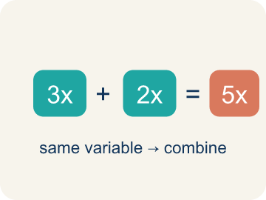 | Like Terms Términos semejantes  Terms with the same letter raised to the same power, like 2x and 5x.  Example: 5x and 3x are like terms (both x); 5x and 5y are NOT (different variables); 2x and 2x² are NOT (different powers)
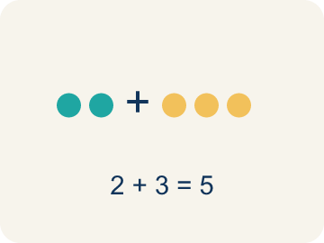 | Combine Combinar  To add or subtract terms with the same letter into one.  Example: 8m + 3m = 11m — add the coefficients (8 + 3 = 11) and keep the variable (m)
 | Simplify Simplificar  To write an expression in its shortest form.  Example: 2a + 5a + 3 simplifies to 7a + 3 — the two a-terms combine, the constant stays
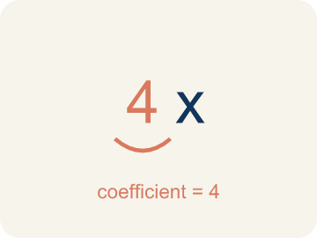 | Coefficient Coeficiente  The number in front of a letter, like the 3 in 3x.  Example: In 9x, the coefficient is 9 — it tells you 'nine groups of x'; if x = 2, then 9x = 18
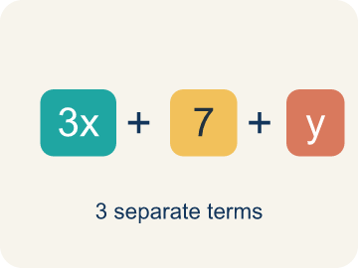 | Term Término  A single number, variable, or product of them, separated by + or − signs.  Example: In 3x + 5 − 2x, the terms are 3x, 5, and 2x.
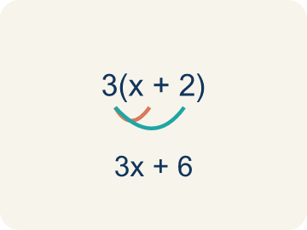 | Distributive property Propiedad distributiva  Multiplying a number by everything inside the parentheses: a(b + c) = ab + ac.  Example: 3(x + 4) = 3·x + 3·4 = 3x + 12.

Guided Notes
Fill in each blank as we go. Use the Word Bank to help you.
WORD BANK
Simplify Algebraic Expressions • Like Terms • Combine • Simplify • Coefficient • Term • Distributive property

1. Combine ________________ ________________ to write a shorter expression with the same value.
2. Terms with the same variable part, like 3y and 8y, are ________________.
3. To add or subtract like terms into a single term is to ________________ them.
4. To write an expression in its shortest equal form is to ________________ it.
5. The number multiplied by a variable is the ________________.
6. A number or variable separated by + or − signs is a ________________.
7. Multiplying each part of a sum by a number uses the ________________ property.

Write About the Math
Use the support level you need. Every level answers the same math question.

1. Understand the Question explain
Simplify the total order expression. What does each part of the simplified expression tell you?
Your job: Answer the question. Use math evidence. Explain how the evidence proves your answer.
Responde la pregunta. Usa evidencia matemática. Explica cómo la evidencia demuestra tu respuesta.

2. Plan Your Math Words check at least two
☐ Simplify Algebraic Expressions — Rewrite an expression in a shorter equivalent form by combining like terms and using properties.
Simplificar expresiones algebraicas — Reescribir una expresión en una forma equivalente más corta combinando términos semejantes y usando propiedades.
☐ Like Terms — Terms with the same letter raised to the same power, like 2x and 5x.
Términos semejantes — Términos con la misma letra elevada a la misma potencia, como 2x y 5x.
☐ Combine — To add or subtract terms with the same letter into one.
Combinar — Sumar o restar términos con la misma letra en uno solo.
☐ Simplify — To write an expression in its shortest form.
Simplificar — Escribir una expresión en su forma más corta.
☐ Coefficient — The number in front of a letter, like the 3 in 3x.
Coeficiente — El número frente a una letra, como el 3 en 3x.
Say it first: Say your idea to a partner or quietly to yourself before you write.
The total order simplifies to ___m + ___. The ___ tells us ___ and the ___ tells us ___.
Di tu respuesta primero: Mi respuesta es ___ porque ___.

3. Build Your Explanation choose your support
This model shows the parts of an explanation. It does not answer your writing question.
Claim: You can only combine items of the same type, just like like terms.
Evidence: Students explain microphones combine with microphones (4 + 2 + 6 = 12) but not with stands, connecting this to combining like terms in algebra.
Reasoning: This evidence connects the definition of simplify algebraic expressions to the mathematical claim.

Start Most language support
Complete the frames. Use the word bank.
Completa las oraciones. Usa el banco de palabras.
The total order simplifies to ___m + ___. The ___ tells us ___ and the ___ tells us ___.
My answer is ___.
Mi respuesta es ___.

Build Some language support
Write two connected sentences. Use because, so, or but.
Escribe dos oraciones conectadas. Usa porque, entonces o pero.
My claim is ___.
Mi afirmación es ___.
I know because ___.
Lo sé porque ___.
So ___.
Entonces ___.

Explain Light language support
Write a claim, give math evidence, and explain your reasoning.
Escribe una afirmación, da evidencia matemática y explica tu razonamiento.
My claim is ___.
Mi afirmación es ___.
My math evidence is ___.
Mi evidencia matemática es ___.
This proves ___ because ___.
Esto demuestra ___ porque ___.

4. Check Your Explanation five quick checks
☐ I answered the question.
Respondí la pregunta.
☐ I used math evidence: numbers, an equation, a model, or a comparison.
Usé evidencia matemática: números, una ecuación, un modelo o una comparación.
☐ I explained how the evidence proves my answer.
Expliqué cómo la evidencia demuestra mi respuesta.
☐ I used at least two math words.
Usé por lo menos dos palabras matemáticas.
☐ I reread complete sentences and punctuation.
Volví a leer mis oraciones completas y la puntuación.

Worked Example

Watch & Read I Do — follow along with your teacher
Equipment Order
The music studio is placing supply orders for three rehearsal rooms. Room A needs 4 microphones and 3 stands. Room B needs 2 microphones and 5 stands. Room C needs 6 microphones and 1 stand. Instead of ordering separately, you can combine: (4 + 2 + 6) microphones and (3 + 5 + 1) stands = 12 microphones and 9 stands. That's simplifying by combining like items!

Think about:
• Why can you add the microphones together but not mix microphones with stands?
• What makes microphones and stands 'different types' of items?
• How is this like combining like terms in algebra?
• What if some rooms returned equipment — would you subtract?
• Can you always simplify an expression, or are some already as simple as possible?

Solved Example I Do — watch each step
Problem: Simplify 7x + 3x.
A) 10x
B) 10x²
C) 21x
D) 73x
Step 1: 7x + 3x = 10x.
Step 2: Add the coefficients: 7 + 3 = 10.
Answer: A. 10x

Guided Practice

Solve Together We Do — work with your class
Problem: Simplify 9n + 4 + 2n.
A) 11n + 4
B) 15n
C) 11n² + 4
D) 92n + 4
Step 1:

Step 2:

Answer:

A music festival needs supplies for 3 stages. Stage 1 needs 8m + 5 cables, Stage 2 needs 3m + 7 cables, and Stage 3 needs 4m + 2 cables, where m represents the number of microphones per stage. The total order is (8m + 5) + (3m + 7) + (4m + 2).
Simplify the total order expression. What does each part of the simplified expression tell you?

Sentence frame: The total order simplifies to ___m + ___. The ___ tells us ___ and the ___ tells us ___.

Turn & Talk discuss with a partner
1. [Launch] Three rooms need microphones and stands. Why can you add all the microphones together (4 + 2 + 6) but not mix microphones with stands?
Start with: I can add the microphones because they are the ___ type.
Puedo sumar los micrófonos porque son del ___ tipo.
Word bank: Like Terms, Combine, Simplify, Coefficient
2. [Explore] To simplify 6x + 4 + 2x + 7, which are the like terms, and how do you combine them?
Start with: The like terms are ___ and ___.
Los términos semejantes son ___ y ___.
Word bank: Like Terms, Combine, Simplify, Coefficient
3. [Connect] The festival order is (8m + 5) + (3m + 7) + (4m + 2), where m is microphones per stage. What does the simplified expression tell you?
Start with: The total simplifies to ___m + ___.
El total se simplifica a ___m + ___.
Word bank: Like Terms, Combine, Simplify, Coefficient
4. [Practice] During practice on Simplify Algebraic Expressions, what strategy did you use when a problem felt tricky?
Start with: The like terms are ___ and ___.
Los términos semejantes son ___ y ___.
Word bank: Like Terms, Combine, Simplify, Coefficient

Independent Practice

On Your Own You Do — show your work
Solve each problem. Show your thinking in the work box.

Level 1 Support extra scaffolding
1. Which pair are like terms?
A) 6x and 2x
B) 6x and 6y
C) 6x and 6
D) 6x and 2x²

2. Simplify 5a + 3 + 2a.
A) 7a + 3
B) 10a
C) 7a² + 3
D) 52a + 3

Exit Ticket
Answer on your own. This shows what you learned today.
★ Simplify 6x + 3 + 2x + 5.
A) 8x + 8
B) 8x² + 8
C) 62x + 35
D) 16x

