UNIT 6 · LESSON 2 STANDARD 6.NOS.1

Division Expressions with Fractions and Mixed Numbers
Student Notes Packet
Name: ______________________ Date: ____________ Period: ________
Level 2 · Standard

Today's Goals
Content: I can divide a fraction by a fraction and divide with mixed numbers by multiplying by the reciprocal.
Language: I can explain the steps using the words reciprocal, improper fraction, mixed number, and simplify.

Key Vocabulary
Look at the picture, read the word, then read what it means.
 | Divide Fractions Dividir fracciones  Multiply the first fraction by the reciprocal of the second fraction.  Example: 2/3 ÷ 1/4 = 2/3 × 4/1 = 8/3
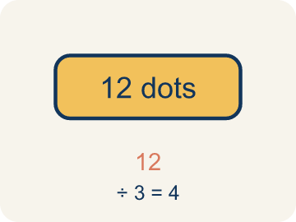 | Dividend Dividendo  The number you are splitting up in a division problem.  Example: In 3/4 ÷ 1/2, the dividend is 3/4 — the total amount being split
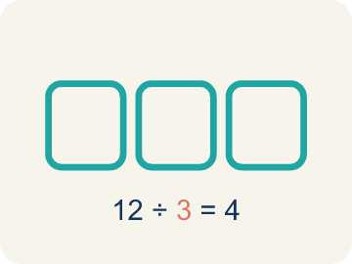 | Divisor Divisor  The number you split by in a division problem.  Example: In 3/4 ÷ 1/2, the divisor is 1/2 — the size of each group
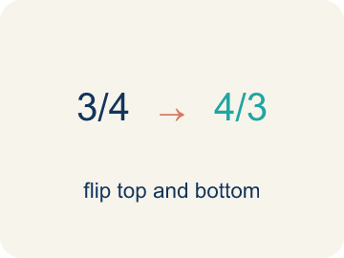 | Reciprocal Recíproco  A fraction turned upside down.  Example: The reciprocal of 2/3 is 3/2. To divide by 2/3, multiply by 3/2.
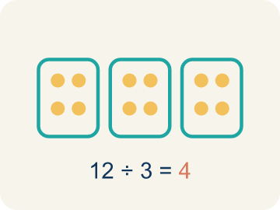 | Quotient Cociente  The answer when you divide.  Example: In 3/4 ÷ 1/4 = 3, the quotient is 3 — three 1/4-size pieces fit into 3/4
 | Simplify Simplificar  To make a fraction smaller using the same parts, like 2/4 = 1/2.  Example: 8/12 → GCF is 4 → 8÷4 / 12÷4 = 2/3
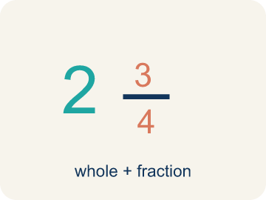 | Mixed number Número mixto  A whole number and a fraction written together, like 2 1/2. It must be rewritten as an improper fraction before dividing.  Example: 2 1/2 = 5/2
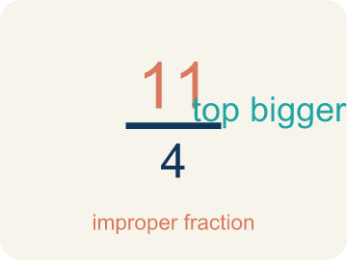 | Improper fraction Fracción impropia  A fraction whose numerator is greater than or equal to its denominator, like 5/2.  Example: 5/2 is the same amount as 2 1/2

Guided Notes
Fill in each blank as we go. Use the Word Bank to help you.
WORD BANK
Divide Fractions • Dividend • Divisor • Reciprocal • Quotient • Simplify • Mixed number • Improper fraction

1. Keep the first fraction, change ÷ to ×, and flip the ________________.
2. In 3/4 ÷ 1/2, the fraction 3/4 being divided is the ________________.
3. In 3/4 ÷ 1/2, the fraction 1/2 we divide by is the ________________.
4. To divide by 1/2, I multiply by its ________________, which is 2.
5. The answer to a division problem is the ________________.
6. Writing a fraction in its smallest equal form, like 4/8 = 1/2, is to ________________ it.
7. A whole number and a fraction written together is a ________________ ________________.
8. A fraction whose numerator is at least its denominator is an ________________ ________________.

Write About the Math
Use the support level you need. Every level answers the same math question.

1. Understand the Question explain
How does dividing fractions help the carpenter?
Your job: Answer the question. Use math evidence. Explain how the evidence proves your answer.
Responde la pregunta. Usa evidencia matemática. Explica cómo la evidencia demuestra tu respuesta.

2. Plan Your Math Words check at least two
☐ Divide Fractions — Multiply the first fraction by the reciprocal of the second fraction.
Dividir fracciones — Multiplicar la primera fracción por el recíproco de la segunda fracción.
☐ Dividend — The number you are splitting up in a division problem.
Dividendo — El número que estás repartiendo en una división.
☐ Divisor — The number you split by in a division problem.
Divisor — El número entre el que divides en una división.
☐ Reciprocal — A fraction turned upside down.
Recíproco — Una fracción volteada de arriba abajo.
☐ Quotient — The answer when you divide.
Cociente — La respuesta cuando divides.
Say it first: Say your idea to a partner or quietly to yourself before you write.
The carpenter can cut ___ pieces because 5/6 ÷ 1/12 = ___.
Di tu respuesta primero: Mi respuesta es ___ porque ___.

3. Build Your Explanation choose your support
This model shows the parts of an explanation. It does not answer your writing question.
Claim: She will get many portions because 1/8 pound is much smaller than 3/4 pound.
Evidence: Students recognize the divisor 1/8 is smaller than the dividend 3/4, so the quotient is greater than 1.
Reasoning: This evidence connects the definition of mixed number to the mathematical claim.

Start Most language support
Complete the frames. Use the word bank.
Completa las oraciones. Usa el banco de palabras.
The carpenter can cut ___ pieces because 5/6 ÷ 1/12 = ___.
My answer is ___.
Mi respuesta es ___.

Build Some language support
Write two connected sentences. Use because, so, or but.
Escribe dos oraciones conectadas. Usa porque, entonces o pero.
My claim is ___.
Mi afirmación es ___.
I know because ___.
Lo sé porque ___.
So ___.
Entonces ___.

Explain Light language support
Write a claim, give math evidence, and explain your reasoning.
Escribe una afirmación, da evidencia matemática y explica tu razonamiento.
My claim is ___.
Mi afirmación es ___.
My math evidence is ___.
Mi evidencia matemática es ___.
This proves ___ because ___.
Esto demuestra ___ porque ___.

4. Check Your Explanation five quick checks
☐ I answered the question.
Respondí la pregunta.
☐ I used math evidence: numbers, an equation, a model, or a comparison.
Usé evidencia matemática: números, una ecuación, un modelo o una comparación.
☐ I explained how the evidence proves my answer.
Expliqué cómo la evidencia demuestra mi respuesta.
☐ I used at least two math words.
Usé por lo menos dos palabras matemáticas.
☐ I reread complete sentences and punctuation.
Volví a leer mis oraciones completas y la puntuación.

Worked Example

Watch & Read I Do — follow along with your teacher
Detective Agency Case File
Agent Rivera is dividing a 3/4-pound evidence bag into portions that each weigh 1/8 pound. She needs to know exactly how many portions she can make for testing. Can you solve the case?

Think about:
• What is the total weight being divided?
• What is the size of each portion?
• Will the answer be more or less than 1?
• How is dividing fractions different from multiplying them?
• Why does 'keep, change, flip' work?

Solved Example I Do — watch each step
Problem: What is the reciprocal of 3/5?
A) 5/3
B) 3/5
C) 5/5
D) 1/3
Step 1: To find the reciprocal, flip the fraction.
Step 2: The reciprocal of 3/5 is 5/3.
Answer: A. 5/3

Guided Practice

Solve Together We Do — work with your class
Problem: What is 1/2 ÷ 1/4?
A) 2
B) 1/8
C) 4
D) 1/2
Step 1:

Step 2:

Answer:

A carpenter has a board that is 5/6 of a foot long. She needs to cut pieces that are each 1/12 of a foot. She wants to know how many pieces she can cut from the board.
How does dividing fractions help the carpenter?

Sentence frame: The carpenter can cut ___ pieces because 5/6 ÷ 1/12 = ___.

Turn & Talk discuss with a partner
1. [Launch] Agent Rivera splits a 3/4-pound evidence bag into 1/8-pound portions. Will she get more or fewer than 1 portion? Estimate before solving.
Start with: She will get ___ than 1 portion because ___.
Ella obtendrá ___ que 1 porción porque ___.
Word bank: dividend, divisor, quotient
2. [Explore] Why do we multiply by the reciprocal when we divide one fraction by another?
Start with: I flipped the divisor to its reciprocal because ___.
Volteé el divisor a su recíproco porque ___.
Word bank: reciprocal, divisor, quotient, simplify
3. [Connect] How could dividing fractions help you share food or materials fairly?
Start with: Dividing fractions helps when ___.
Dividir fracciones ayuda cuando ___.
Word bank: dividend, divisor, simplify
4. [Practice] During practice on Divide Fractions, what strategy did you use when a problem felt tricky?
Start with: I flipped the divisor to its reciprocal because ___.
Volteé el divisor a su recíproco porque ___.
Word bank: Dividend, Divisor, Reciprocal, Quotient

Independent Practice

On Your Own You Do — show your work
Solve each problem. Show your thinking in the work box.

On Level grade-level practice
1. A recipe needs 2/3 cup of sugar. You only have a 1/6-cup scoop. How many scoops do you need?
A) 4 scoops
B) 3 scoops
C) 6 scoops
D) 2 scoops

Exit Ticket
Answer on your own. This shows what you learned today.
★ What is 5/6 ÷ 1/12?
A) 10
B) 5/72
C) 5/6
D) 72/5

Answer Key & Teacher Guide
Teacher reference — remove or fold back before distributing to students.

Guided Notes (Fill-in)
Notes 1: Divide Fractions
Notes 2: Dividend
Notes 3: Divisor
Notes 4: Reciprocal
Notes 5: Quotient
Notes 6: Simplify
Notes 7: Mixed number
Notes 8: Improper fraction

Worked Notes (I Do / We Do)
I Do: A. 5/3
We Do: A. 2

Independent Practice
Watch for this mistake: A common mistake in Divide Fractions is flipping the wrong fraction: students flip the dividend (the first fraction) instead of the divisor (the second fraction). For example, solving 3/4 ÷ 5/8 by flipping 3/4 to 4/3 and keeping 5/8 gives 4/3 × 5/8 = 20/24 = 5/6 — but only the divisor gets flipped. Keep 3/4, change ÷ to ×, and flip only the divisor 5/8 to its reciprocal 8/5: 3/4 × 8/5 = 24/20 = 6/5. Before you submit, check that the fraction you kept (the dividend) is still facing the same way it started.

Level 1 Support
1. A) 6 — 3/4 ÷ 1/8 = 3/4 × 8/1 = 24/4 = 6. Six 1/8-size pieces fit into 3/4.
2. A) Rewrite 2 1/2 as the improper fraction 5/2 — A mixed number cannot be flipped or multiplied as it stands, so rewrite it first: 2 1/2 = 5/2. Then Keep, Change, Flip gives 5/2 × 4/1 = 10.
3. A) 2 — 2/3 ÷ 1/3 = 2/3 × 3/1 = 6/3 = 2. Two 1/3-size pieces fit into 2/3.

On Level
4. A) 4 scoops — 2/3 ÷ 1/6 = 2/3 × 6/1 = 12/3 = 4 scoops.

Exit Ticket
A) 10 — 5/6 ÷ 1/12 = 10. Using the reciprocal, 5/6 × 12/1 = 60/6 = 10. Since 5/6 = 10/12, ten 1/12-foot pieces fit into the board.

Math Writing Criteria
The support level changes the amount of language scaffolding, not the mathematical expectation.
☐ I answered the question.
☐ I used math evidence: numbers, an equation, a model, or a comparison.
☐ I explained how the evidence proves my answer.
☐ I used at least two math words.
☐ I reread complete sentences and punctuation.

