6.1–6.3 Catch-Up — Homework
Lesson 6-3-catchup • Standard 6.AT.5
Name: ______________________ Period: ______ Date: ____________

Today's Goals
Content: I can show I am caught up on Lessons 6.1–6.3 by using each lesson's big idea in mixed practice.
Language: I can explain which lesson's big idea I used and how, using key vocabulary from Lessons 6.1–6.3.

Key Words
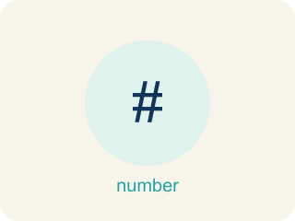
Division of Fractions (División de fracciones) — Finding how many groups of one fraction fit inside another amount.
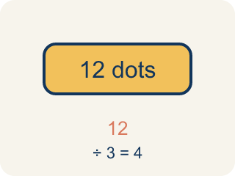
Dividend (Dividendo) — The number you are splitting up in a division problem.
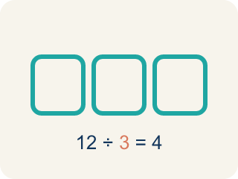
Divisor (Divisor) — The number you split by in a division problem.
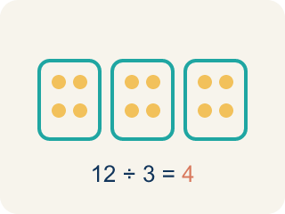
Quotient (Cociente) — The answer when you divide.
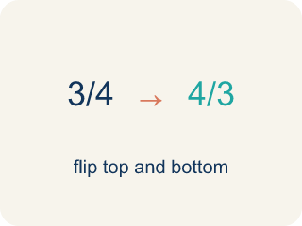
Reciprocal (Recíproco) — A fraction turned upside down.
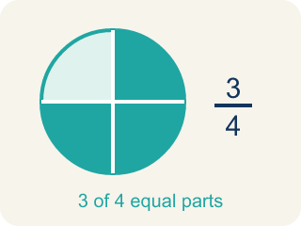
Unit fraction (Fracción unitaria) — A fraction with 1 on top, like 1/4.
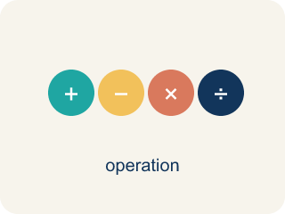
Divide Fractions (Dividir fracciones) — Multiply the first fraction by the reciprocal of the second fraction.

Simplify (Simplificar) — To write a fraction with smaller numbers that names the same amount, like 2/4 = 1/2.

Powers and Exponents (Potencias y exponentes) — A power uses a base and an exponent to show repeated multiplication.
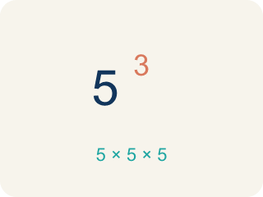
Exponent (Exponente) — A small number that tells how many times to multiply a number by itself.

Practice
Show your work. Use the blank space under each problem.
1. (Lesson 6.1) What does 3 ÷ 1/4 mean?
A. How many 1/4-size pieces fit into 3
B. 3 groups of 1/4
C. 3 minus 1/4
D. 1/4 of 3
______________________________________________________________________
2. (Lesson 6.1) Which expression means 'how many 1/3-size pieces are in 2'?
A. 2 ÷ 1/3
B. 2 × 1/3
C. 1/3 ÷ 2
D. 2 + 1/3
______________________________________________________________________
3. (Lesson 6.1) A shelf is 5 feet long. Books are each 1/4 foot wide. How many books fit on the shelf? Which expression represents this?
A. 5 ÷ 1/4 = 20 books
B. 5 × 1/4 = 1 1/4 books
C. 1/4 ÷ 5 = 1/20 book
D. 5 + 1/4 = 5 1/4 books
______________________________________________________________________
4. (Lesson 6.1) Spot the Common Mistake
Step 1 (Problem): How many 1/5-cup scoops fill a 6-cup container? Find 6 ÷ 1/5.
Step 2 (Student writes): I will flip the first number instead of the divisor: 6 ÷ 1/5 = 1/6 × 5 = 5/6 scoop.
Step 3 (Student's answer): 5/6 of a scoop
Which step has the mistake? Explain and fix it:
______________________________________________________________________
______________________________________________________________________
______________________________________________________________________
5. (Lesson 6.2) A recipe needs 2/3 cup of sugar. You only have a 1/6-cup scoop. How many scoops do you need?
A. 4 scoops
B. 3 scoops
C. 6 scoops
D. 2 scoops
______________________________________________________________________
6. (Lesson 6.2) Spot the Common Mistake
Step 1 (Problem): 2/3 ÷ 1/2
Step 2 (Change ÷ to × (but forgot to flip)): 2/3 × 1/2
Step 3 (Multiply): 2/6
Step 4 (Simplify): 1/3
Which step has the mistake? Explain and fix it:
______________________________________________________________________
______________________________________________________________________
______________________________________________________________________
7. (Lesson 6.3) Spot the Common Mistake
Step 1 (Expression): 2⁴
Step 2 (Student's thinking): 2 × 4
Step 3 (Calculate): = 8
Which step has the mistake? Explain and fix it:
______________________________________________________________________
______________________________________________________________________
______________________________________________________________________
8. (Lesson 6.3) Evaluate each exponential expression. Show the repeated multiplication and the final value.
Power | Repeated Multiplication | Value
4³ | 4 × 4 × 4
2⁶ | 2 × 2 × 2 × 2 × 2 × 2
5³ | 5 × 5 × 5
10⁴ | 10 × 10 × 10 × 10
______________________________________________________________________
9. (Lesson 6.1) Agent Cole has 8 feet of evidence rope and cuts it into 1/3-foot pieces for tagging. What does 8 ÷ 1/3 mean?
A. How many 1/3-foot pieces fit into 8 feet
B. 1/3 of the 8 feet of rope
C. 8 feet shortened by 1/3 of a foot
D. 8 pieces that are each 1/3 foot long
______________________________________________________________________
10. (Lesson 6.2) What is (3/4) ÷ (1/2)?
A. 3/2
B. 3/8
C. 1/2
D. 2/3
______________________________________________________________________

Answer Key (Teacher)
1. A. How many 1/4-size pieces fit into 3
3 ÷ 1/4 asks: how many 1/4-size pieces fit into 3? The answer is 12, because each whole has 4 fourths, and 3 × 4 = 12.
Watch for: A common mistake in Powers and Exponents is multiplying the base by the exponent instead of using the base as a repeated factor — for example, thinking 2³ = 2 × 3 = 6 instead of 2³ = 2 × 2 × 2 = 8. Before you submit, rewrite the power as repeated multiplication first, then multiply step by step.
2. A. 2 ÷ 1/3
Finding how many 1/3-size pieces fit into 2 is represented by 2 ÷ 1/3. The answer is 6.
Watch for: A common mistake in Powers and Exponents is multiplying the base by the exponent instead of using the base as a repeated factor — for example, thinking 2³ = 2 × 3 = 6 instead of 2³ = 2 × 2 × 2 = 8. Before you submit, rewrite the power as repeated multiplication first, then multiply step by step.
3. A. 5 ÷ 1/4 = 20 books
You are finding how many 1/4-foot pieces fit into 5 feet, which is 5 ÷ 1/4 = 5 × 4 = 20 books.
Watch for: A common mistake in Powers and Exponents is multiplying the base by the exponent instead of using the base as a repeated factor — for example, thinking 2³ = 2 × 3 = 6 instead of 2³ = 2 × 2 × 2 = 8. Before you submit, rewrite the power as repeated multiplication first, then multiply step by step.
4. (Lesson 6.1) Spot the Common Mistake
The mistake is in Step 2.
Correct work: To divide, multiply by the reciprocal of the DIVISOR (1/5), not the dividend. The reciprocal of 1/5 is 5, so 6 ÷ 1/5 = 6 × 5 = 30 scoops.
Watch for: In the "Student writes" step the reciprocal was taken of the dividend 6 instead of the divisor 1/5. Only the divisor gets flipped: the reciprocal of 1/5 is 5, so 6 ÷ 1/5 = 6 × 5 = 30 scoops. That matches the story too — each cup holds 5 one-fifth scoops, and there are 6 cups.
5. A. 4 scoops
2/3 ÷ 1/6 = 2/3 × 6/1 = 12/3 = 4 scoops.
Watch for: A common mistake in Powers and Exponents is multiplying the base by the exponent instead of using the base as a repeated factor — for example, thinking 2³ = 2 × 3 = 6 instead of 2³ = 2 × 2 × 2 = 8. Before you submit, rewrite the power as repeated multiplication first, then multiply step by step.
6. (Lesson 6.2) Spot the Common Mistake
The mistake is in Step 2.
Correct work: The student changed ÷ to × but forgot to flip the divisor. Keep 2/3, change ÷ to ×, and flip the divisor 1/2 to its reciprocal 2/1: 2/3 × 2/1 = 4/3 = 1 1/3. The correct quotient is 4/3 (1 1/3), not 1/3.
Watch for: The step that changed ÷ to × left the divisor as 1/2 instead of flipping it, so the problem turned into multiplication of the original fractions. Keep, Change, Flip turns the divisor into 2/1, giving 2/3 × 2/1 = 4/3 = 1 1/3. That size makes sense, because 1/2 is smaller than 2/3, so more than one copy fits.
7. (Lesson 6.3) Spot the Common Mistake
The mistake is in Step 2.
Correct work: 2⁴ does NOT mean 2 × 4. The exponent 4 tells you to use the base 2 as a factor 4 times: 2 × 2 × 2 × 2 = 16. So 2⁴ = 16, not 8.
Watch for: The "Student's thinking" step turns 2⁴ into 2 × 4. The exponent 4 is a count, not a factor: it says to use the base 2 four times, giving 2 × 2 × 2 × 2. Doubling step by step gives 2, 4, 8, 16, so 2⁴ = 16, not 8.
8. (Lesson 6.3) Evaluate each exponential expression. Show the repeated multiplication and the final value.
4³ — Value: 64
2⁶ — Value: 64
5³ — Value: 125
10⁴ — Value: 10000

9. A. How many 1/3-foot pieces fit into 8 feet
Dividing by 1/3 asks how many 1/3-foot pieces fit into 8 feet. Each foot holds 3 thirds, so 8 × 3 = 24 pieces.
Watch for: A common mistake in Powers and Exponents is multiplying the base by the exponent instead of using the base as a repeated factor — for example, thinking 2³ = 2 × 3 = 6 instead of 2³ = 2 × 2 × 2 = 8. Before you submit, rewrite the power as repeated multiplication first, then multiply step by step.
10. A. 3/2
(3/4) ÷ (1/2) = (3/4) × (2/1) = 6/4 = 3/2.
Watch for: A common mistake in Powers and Exponents is multiplying the base by the exponent instead of using the base as a repeated factor — for example, thinking 2³ = 2 × 3 = 6 instead of 2³ = 2 × 2 × 2 = 8. Before you submit, rewrite the power as repeated multiplication first, then multiply step by step.

